Smart Hospital Management System

Team
Vishakha Parmar, Meet Patel, Yashvi Purohit, Tanish Patel, Man Prajapati, Mahek Patel

Project Overview
Smart Hospital is a role-based Flutter mobile application designed to simplify hospital operations through a single app interface for Admin, Doctor, and User/Patient roles. The project is organized into core utilities, authentication, dashboard flows, doctor and patient management, appointment booking, models, and services.
The application uses Flutter with Dart as the development framework and programming language, while state management is implemented with the provider package and local persistence support is prepared through shared_preferences. The application entry point is main.dart, where AppProvider and AuthProvider are registered using MultiProvider, and the app starts from the login route.
Objectives
The primary objective of the Smart Hospital application is to provide a simple digital workflow for healthcare appointment and user management. The app supports authentication, doctor listing, patient record handling, appointment booking, and role-based dashboards for different users of the system.
The project also aims to demonstrate practical Flutter concepts such as route-based navigation, state management with providers, modular folder organization, reusable widgets, data modeling, and service-layer abstraction. The project is structured to separate UI, business logic, data models, and helper components into dedicated directories.
Scope
The current scope of the application includes login and signup screens, admin doctor and patient management, patient appointment booking, viewing doctors, and appointment tracking. The code also includes application theme setup, reusable UI widgets, JSON-capable models, and a basic data service layer with dummy in-memory data.
The application is suitable as an academic project, prototype, or demonstration app for hospital workflow management. It can be extended in the future with persistent storage, analytics, scheduling enhancements, and more advanced healthcare records management.
Technology Stack
Component | Technology | Purpose
Framework | Flutter | Cross-platform mobile app development
Language | Dart | Application logic and UI implementation
State Management | Provider | Global and authentication state handling
Local Storage | Shared Preferences | Prepared support for appointment
UI Design | Material Design | Standard Flutter interface components
Navigation | Named Routes | Screen transition and route organization
Folder Structure

lib/
├── core/
│ ├── providers/
│ │ └── app_provider.dart
│ ├── routes/
│ │ └── app_routes.dart
│ ├── theme/
│ │ └── app_theme.dart
│ ├── utils/
│ └── widgets/
│ ├── custom_button.dart
│ ├── custom_text_field.dart
│ ├── dashboard_card.dart
│ └── stats_card.dart
├── features/
│ ├── appointment/
│ │ └── screens/
│ │ ├── appointment_screen.dart
│ │ └── user_appointments_screen.dart
│ ├── auth/
│ │ ├── providers/
│ │ │ └── auth_provider.dart
│ │ └── screens/
│ │ ├── login_screen.dart
│ │ └── signup_screen.dart
│ ├── dashboard/
│ │ └── screens/
│ │ ├── dashboard_screen.dart
│ │ └── home_screen.dart
│ ├── doctor/
│ │ └── screens/
│ │ ├── all_doctors_screen.dart
│ │ └── doctor_screen.dart
│ └── patient/
│ └── screens/
│ └── patient_screen.dart
├── models/
│ ├── appointment.dart
│ ├── doctor.dart
│ ├── patient.dart
│ └── user.dart
├── services/
│ ├── appointment_service.dart
│ └── data_service.dart
└── main.dart

This structure includes main files of the application
System Modules
Authentication Module
The authentication module includes login_screen.dart, signup_screen.dart, and auth_provider.dart. It supports user login by email, password, and selected role, while signup creates a new user with the default User role if the email does not already exist.
AuthProvider maintains the current user, login state, signup behavior, and logout behavior. The provider also synchronizes with DataService.currentUser, which helps keep user information available across the application.
Dashboard Module
The dashboard module includes dashboard_screen.dart and home_screen.dart. DashboardScreen renders different cards and statistics depending on whether the current role is Admin, Doctor, or User, while HomeScreen controls the bottom navigation and page switching for each role.
The dashboard for admins displays doctor, patient, and appointment counts through StatsCard, and provides management links to doctors and patients. For users, it provides access to booking appointments, viewing doctors, and checking appointment history.
Doctor Module
The doctor module includes doctor_screen.dart and all_doctors_screen.dart. The admin-facing doctor management screen allows adding and deleting doctors, while the public doctor listing screen displays all doctors and allows users to book appointments by passing the selected doctor as a route argument.
Doctor data is represented by the Doctor model, which includes name and specialization fields and supports JSON conversion. This model is reused in appointment booking and doctor management functionality.
Patient Module
The patient module is implemented in patient_screen.dart. It provides admin-facing functionality for adding patient records with a name and age, listing all patients, and removing records from the in-memory data store.
The patient model is simple and contains name and age fields. This design is suitable for the current academic project and can be expanded in future versions.
Appointment Module
The appointment module includes appointment_screen.dart and user_appointments_screen.dart. It enables users to select a date, select a time, enter a problem description, and confirm an appointment with a selected doctor.
The appointment data includes doctor details, patient name, age, gender, problem description, date, time, status, prescription, and user email. UserAppointmentsScreen filters appointment data using the logged-in user's email to show only the current user's appointments.

Core Components
App Provider
AppProvider stores global application state such as dark mode preference, loading state, and the currently active role. The provider exposes methods like toggleTheme(), setLoading(bool), and setRole(String) to update and notify listeners across the app.
Routes
AppRoutes centralizes route name declarations and maps route names to widget builders. Defined routes include login, signup, home, dashboard, doctor, all doctors, patient, appointment, and user appointments screens.
Theme
AppTheme defines a light Material 3 theme with a seed color of 0xFF4A90E2, a light scaffold background, customized text theme, button theme, input decoration theme, card theme, and app bar theme. This ensures consistent visual styling across the application.
Reusable Widgets
The project contains several reusable UI components in the core/widgets directory, including CustomButton, CustomTextField, DashboardCard, and StatsCard. These components reduce repetition and create a cleaner presentation layer.

Service Layer
The project contains two service-related files: data_service.dart and appointment_service.dart. DataService provides dummy in-memory datasets for users, doctors, patients, and appointments, while AppointmentService uses shared_preferences to save and retrieve serialized appointment data.
This shows that the current application uses in-memory lists for demonstration purposes, while appointment persistence support has also been added. This design is suitable for an academic project and can be extended later with permanent storage.

Application Workflow
The application starts from the login screen, where a user selects a role and submits email and password credentials. On successful login, the app navigates to the home route, where navigation content changes dynamically depending on the user role.
For a patient workflow, the user can view available doctors, choose a doctor, book an appointment, and later view appointment history. For an admin workflow, the administrator can manage doctors and patients while monitoring dashboard counts.

Data Models
The application uses four primary models: User, Doctor, Patient, and Appointment. The Appointment and Doctor models include JSON serialization and deserialization methods, while User and Patient are simpler data holder classes in the project.
Model | Key Fields
User | name, email, password, role
Doctor | name, specialization
Patient | name, age
Appointment | doctor, patientName, age, gender, problem, date, time, status, prescription, userEmail
App Images
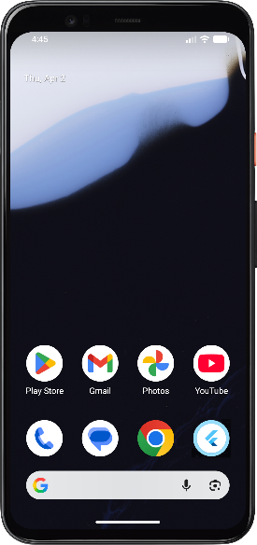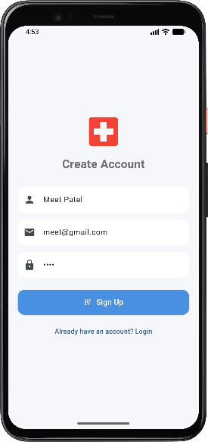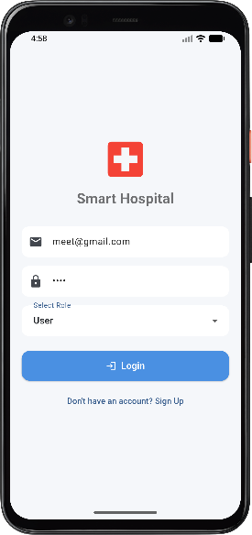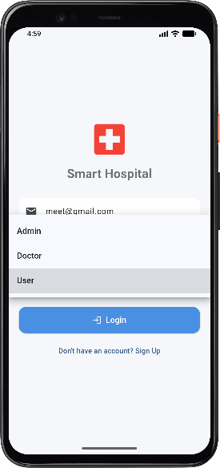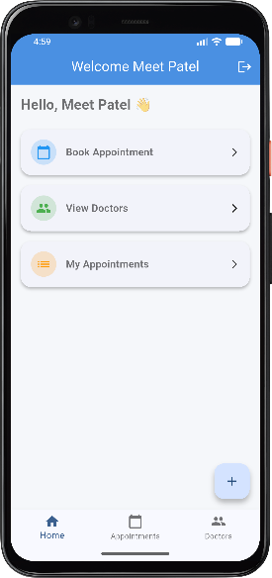

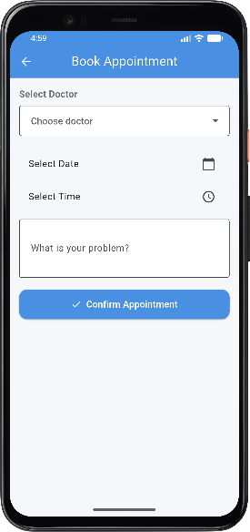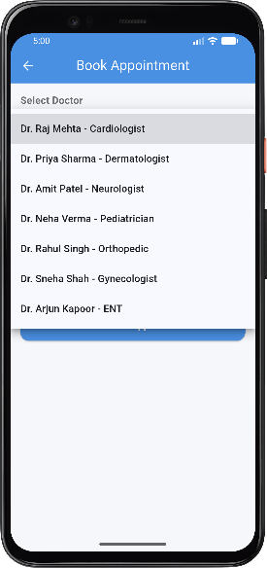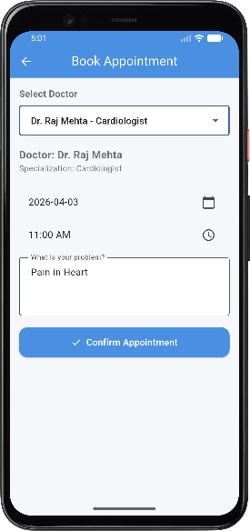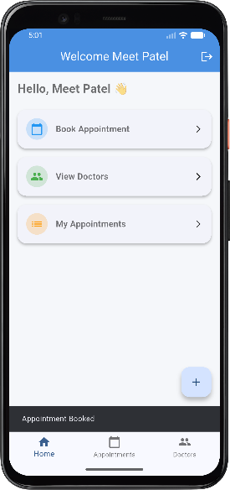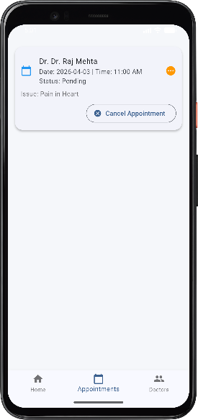

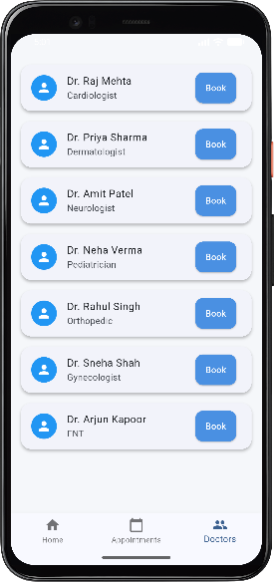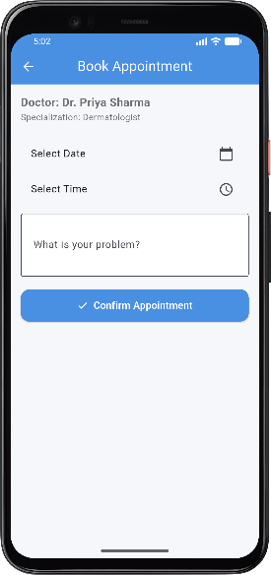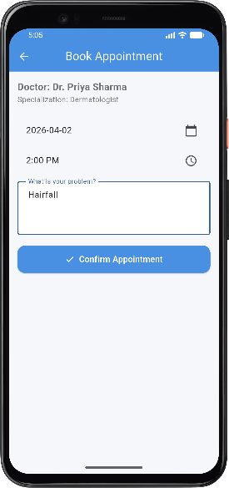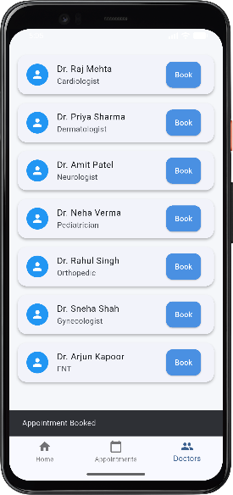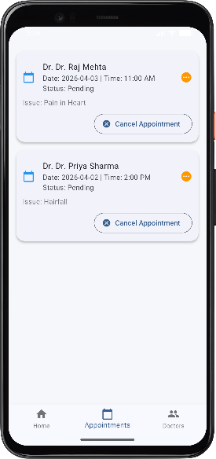

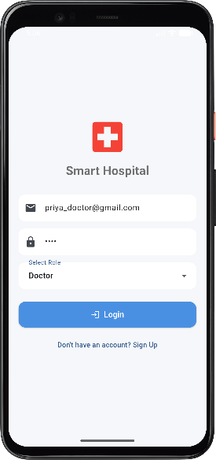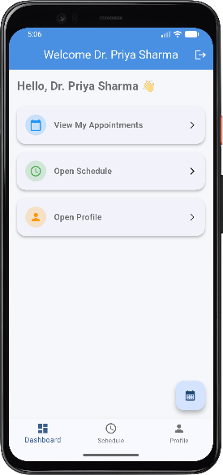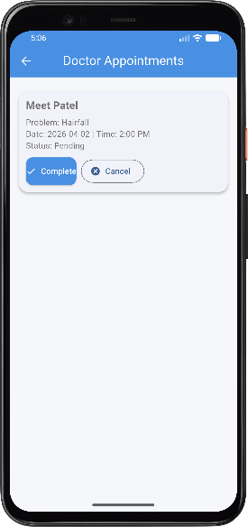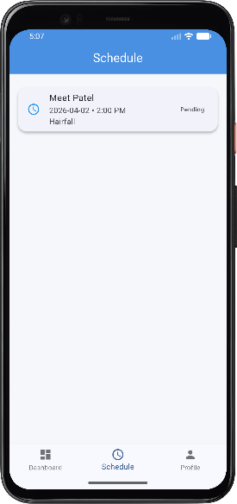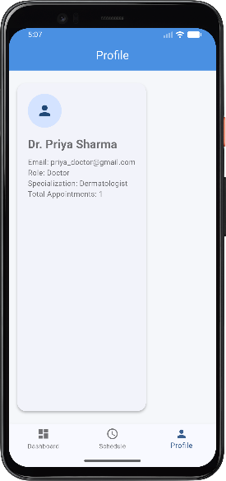

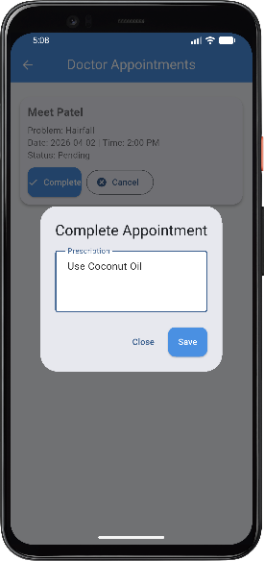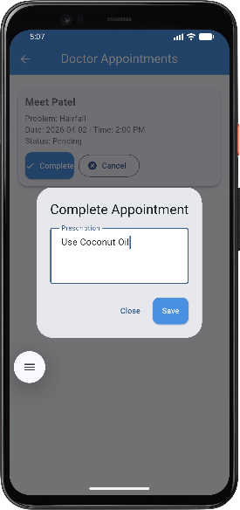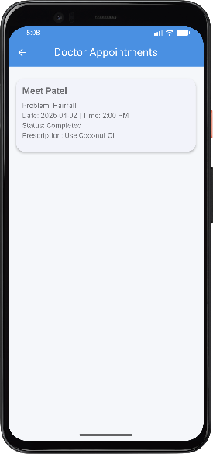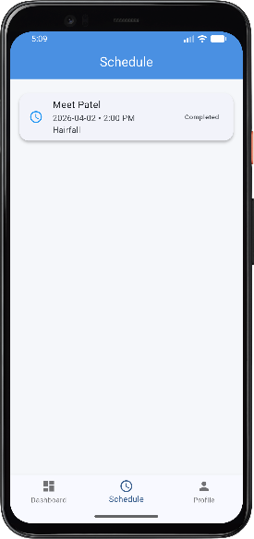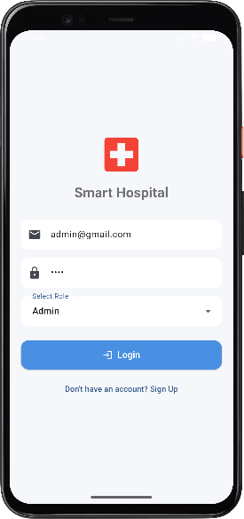
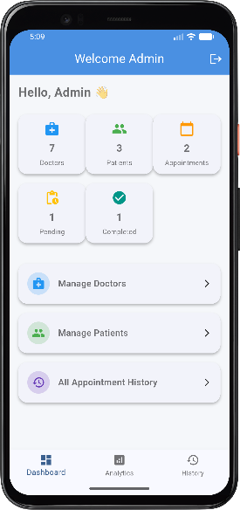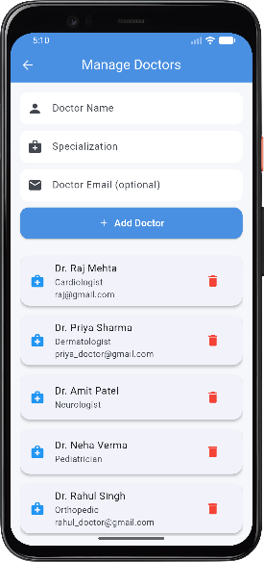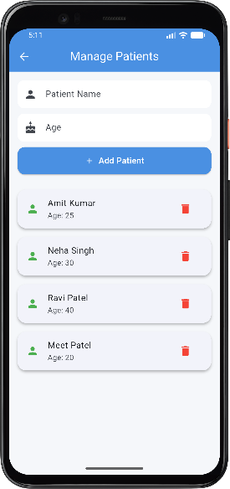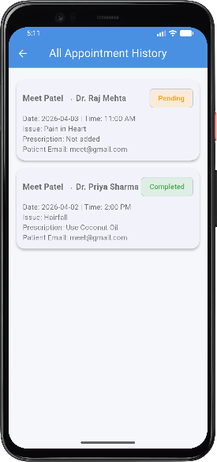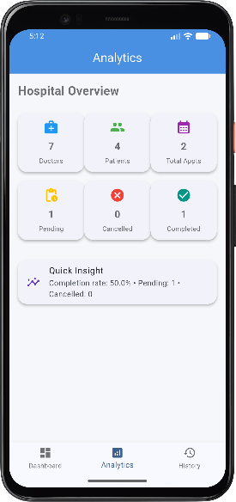

Current Strengths
- Clear modular folder structure.
- Separation of UI, providers, models, and services.
- Reusable widgets for buttons, text fields, and cards.
- Role-based dashboards and navigation logic.
- JSON-ready appointment and doctor models for future storage integration.

Limitations
The current version of the project has a few limitations that can be improved in future development. constants.dart is currently empty, Patient and User models do not yet include JSON serialization, and the project uses dummy in-memory data along with partially implemented local storage for appointments.
The dashboard and home navigation also contain some placeholder pages such as doctor schedule, profile, admin analytics, and settings. These can be further developed in later versions of the application.

Testing Considerations
- Login validation for Admin, Doctor, and User roles.
- Signup validation for duplicate email prevention.
- Doctor add and delete functionality.
- Patient add and delete functionality.
- Appointment booking with required field validation.
- User-specific appointment filtering by email.

Future Enhancements
- Integrate Firebase or a real backend database.
- Add full doctor scheduling and appointment approval workflows.
- Support edit/update operations in addition to add and delete.
- Add profile management, prescription history, and notifications.
- Implement stronger validation, secure authentication, and encrypted storage.
These enhancements can make the project more complete while preserving the existing modular codebase.
Conclusion
Smart Hospital is a well-structured Flutter project for hospital workflow management that demonstrates role-based access, reusable UI components, modular architecture, and appointment handling. The project has separate layers for presentation, state management, data models, and services.
The project is suitable for documentation, presentation, and further enhancement into a real-world healthcare application. Its modular organization makes it especially useful for explaining architecture, feature flow, and code structure in a professional project report.
Codes
lib/main.dart:

import 'package:flutter/material.dart';
import 'package:provider/provider.dart';
import 'core/theme/app_theme.dart';
import 'core/routes/app_routes.dart';
import 'core/providers/app_provider.dart';
import 'features/auth/providers/auth_provider.dart';
void main() {
runApp(const MyApp());
}
class MyApp extends StatelessWidget {
const MyApp({super.key});
@override
Widget build(BuildContext context) {
return MultiProvider(
providers: [
ChangeNotifierProvider(create: (_) => AppProvider()),
ChangeNotifierProvider(create: (_) => AuthProvider()),
],
child: MaterialApp(
debugShowCheckedModeBanner: false,
title: 'Smart Hospital',
theme: AppTheme.lightTheme,
initialRoute: AppRoutes.login,
routes: AppRoutes.routes,
),
);
}
}
lib/core/providers/app_provider.dart:

import 'package:flutter/material.dart';
class AppProvider extends ChangeNotifier {
bool _isDarkMode = false;
bool get isDarkMode => _isDarkMode;
void toggleTheme() {
_isDarkMode = !_isDarkMode;
notifyListeners();
}
bool _isLoading = false;
bool get isLoading => _isLoading;
void setLoading(bool value) {
_isLoading = value;
notifyListeners();
}
String _currentRole = '';
String get currentRole => _currentRole;
void setRole(String role) {
_currentRole = role;
notifyListeners();
}
}
lib/core/routes/app_routes.dart:

import 'package:flutter/material.dart';
import '../../features/auth/screens/login_screen.dart';
import '../../features/auth/screens/signup_screen.dart';
import '../../features/dashboard/screens/home_screen.dart';
import '../../features/doctor/screens/doctor_screen.dart';
import '../../features/doctor/screens/all_doctors_screen.dart';
import '../../features/patient/screens/patient_screen.dart';
import '../../features/appointment/screens/appointment_screen.dart';
class AppRoutes {
static const String login = '/login';
static const String signup = '/signup';
static const String home = '/home';
static const String doctor = '/doctor';
static const String allDoctors = '/all-doctors';
static const String patient = '/patient';
static const String appointment = '/appointment';
static Map<String, WidgetBuilder> get routes {
return {
login: (context) => const LoginScreen(),
signup: (context) => const SignupScreen(),
home: (context) => const HomeScreen(),
doctor: (context) => const DoctorScreen(),
allDoctors: (context) => const AllDoctorsScreen(showAppBar: true),
patient: (context) => const PatientScreen(),
appointment: (context) => const AppointmentScreen(),
};
}
}
lib/core/theme/app_theme.dart:

import 'package:flutter/material.dart';
class AppTheme {
static ThemeData get lightTheme {
return ThemeData(
useMaterial3: true,
primaryColor: const Color(0xFF4A90E2),
colorScheme: ColorScheme.fromSeed(
seedColor: const Color(0xFF4A90E2),
brightness: Brightness.light,
),
scaffoldBackgroundColor: const Color(0xFFF5F7FA),
textTheme: const TextTheme(
headlineLarge: TextStyle(fontSize: 26, fontWeight: FontWeight.bold, color: Colors.black),
headlineMedium: TextStyle(fontSize: 22, fontWeight: FontWeight.bold),
bodyLarge: TextStyle(fontSize: 16, color: Colors.black87),
bodyMedium: TextStyle(fontSize: 14, color: Colors.black54),
),
elevatedButtonTheme: ElevatedButtonThemeData(
style: ElevatedButton.styleFrom(
backgroundColor: const Color(0xFF4A90E2),
foregroundColor: Colors.white,
padding: const EdgeInsets.symmetric(vertical: 14),
shape: RoundedRectangleBorder(borderRadius: BorderRadius.circular(12)),
),
),
inputDecorationTheme: InputDecorationTheme(
filled: true,
fillColor: Colors.white,
contentPadding: const EdgeInsets.symmetric(horizontal: 16, vertical: 14),
border: OutlineInputBorder(
borderRadius: BorderRadius.circular(12),
borderSide: BorderSide.none,
),
),
cardTheme: CardThemeData(
elevation: 3,
shape: RoundedRectangleBorder(borderRadius: BorderRadius.circular(16)),
margin: const EdgeInsets.symmetric(vertical: 8),
),
appBarTheme: const AppBarTheme(
elevation: 0,
centerTitle: true,
backgroundColor: Color(0xFF4A90E2),
foregroundColor: Colors.white,
),
);
}
}
lib/core/widgets/custom_button.dart:

import 'package:flutter/material.dart';
class CustomButton extends StatelessWidget {
final String text;
final VoidCallback onPressed;
final bool isLoading;
final IconData? icon;
const CustomButton({
super.key,
required this.text,
required this.onPressed,
this.isLoading = false,
this.icon,
});
@override
Widget build(BuildContext context) {
return SizedBox(
width: double.infinity,
child: ElevatedButton(
onPressed: isLoading ? null : onPressed,
style: ElevatedButton.styleFrom(
padding: const EdgeInsets.symmetric(vertical: 14),
shape: RoundedRectangleBorder(borderRadius: BorderRadius.circular(14)),
),
child: isLoading
? const SizedBox(
height: 20,
width: 20,
child: CircularProgressIndicator(strokeWidth: 2, color: Colors.white),
)
: Row(
mainAxisAlignment: MainAxisAlignment.center,
children: [
if (icon != null) ...[
Icon(icon, size: 18),
const SizedBox(width: 8),
],
Text(text, style: const TextStyle(fontSize: 16, fontWeight: FontWeight.w600)),
],
),
),
);
}
}
lib/core/widgets/custom_textfield.dart:

import 'package:flutter/material.dart';
class CustomTextField extends StatelessWidget {
final TextEditingController controller;
final String hintText;
final IconData? icon;
final bool isPassword;
final TextInputType keyboardType;
const CustomTextField({
super.key,
required this.controller,
required this.hintText,
this.icon,
this.isPassword = false,
this.keyboardType = TextInputType.text,
});
@override
Widget build(BuildContext context) {
return TextField(
controller: controller,
obscureText: isPassword,
keyboardType: keyboardType,
decoration: InputDecoration(
hintText: hintText,
prefixIcon: icon != null ? Icon(icon) : null,
contentPadding: const EdgeInsets.symmetric(horizontal: 16, vertical: 14),
border: OutlineInputBorder(
borderRadius: BorderRadius.circular(12),
borderSide: BorderSide.none,
),
),
);
}
}
lib/core/widgets/dashboard_card.dart:

import 'package:flutter/material.dart';
class DashboardCard extends StatelessWidget {
final String title;
final IconData icon;
final Color color;
final VoidCallback onTap;
const DashboardCard({
super.key,
required this.title,
required this.icon,
required this.color,
required this.onTap,
});
@override
Widget build(BuildContext context) {
return GestureDetector(
onTap: onTap,
child: Card(
child: Padding(
padding: const EdgeInsets.all(16),
child: Row(
children: [
CircleAvatar(
backgroundColor: color.withOpacity(0.2),
child: Icon(icon, color: color),
),
const SizedBox(width: 15),
Expanded(
child: Text(title, style: const TextStyle(fontSize: 16, fontWeight: FontWeight.w600)),
),
const Icon(Icons.arrow_forward_ios, size: 16),
],
),
),
),
);
}
}
lib/core/widgets/stats_card.dart:

import 'package:flutter/material.dart';
class StatsCard extends StatelessWidget {
final String title;
final int count;
final IconData icon;
final Color color;
const StatsCard({
super.key,
required this.title,
required this.count,
required this.icon,
required this.color,
});
@override
Widget build(BuildContext context) {
return Expanded(
child: Card(
child: Padding(
padding: const EdgeInsets.all(12),
child: Column(
children: [
Icon(icon, color: color, size: 28),
const SizedBox(height: 8),
Text(count.toString(), style: const TextStyle(fontSize: 18, fontWeight: FontWeight.bold)),
const SizedBox(height: 4),
Text(title, style: const TextStyle(fontSize: 12)),
],
),
),
),
);
}
}
lib/features/admin/screens/admin_analytics_screen.dart:

import 'package:flutter/material.dart';
import '../../../core/widgets/stats_card.dart';
import '../../../services/data_service.dart';
class AdminAnalyticsScreen extends StatelessWidget {
const AdminAnalyticsScreen({super.key});
@override
Widget build(BuildContext context) {
final total = DataService.appointments.length;
final pending = DataService.appointments.where((a) => a.status == 'Pending').length;
final cancelled = DataService.appointments.where((a) => a.status == 'Cancelled').length;
final completed = DataService.appointments.where((a) => a.status == 'Completed').length;
return Scaffold(
appBar: AppBar(title: const Text('Analytics')),
body: Padding(
padding: const EdgeInsets.all(16),
child: Column(
crossAxisAlignment: CrossAxisAlignment.start,
children: [
const Text('Hospital Overview', style: TextStyle(fontSize: 22, fontWeight: FontWeight.bold)),
const SizedBox(height: 16),
Row(
children: [
StatsCard(title: 'Doctors', count: DataService.doctors.length, icon: Icons.medical_services, color: Colors.blue),
StatsCard(title: 'Patients', count: DataService.patients.length, icon: Icons.people, color: Colors.green),
StatsCard(title: 'Total Appts', count: total, icon: Icons.calendar_month, color: Colors.purple),
],
),
Row(
children: [
StatsCard(title: 'Pending', count: pending, icon: Icons.pending_actions, color: Colors.amber),
StatsCard(title: 'Cancelled', count: cancelled, icon: Icons.cancel, color: Colors.red),
StatsCard(title: 'Completed', count: completed, icon: Icons.check_circle, color: Colors.teal),
],
),
const SizedBox(height: 20),
Card(
child: ListTile(
leading: const Icon(Icons.insights, color: Colors.deepPurple),
title: const Text('Quick Insight'),
subtitle: Text(
total == 0
? 'No appointments booked yet.'
: 'Completion rate: ${((completed / total) * 100).toStringAsFixed(1)}% • Pending: $pending • Cancelled: $cancelled',
),
),
),
],
),
),
);
}
}
lib/features/admin/screens/all_appointment_history_screen.dart:

import 'package:flutter/material.dart';
import '../../../services/data_service.dart';
class AllAppointmentHistoryScreen extends StatelessWidget {
final bool showAppBar;
const AllAppointmentHistoryScreen({super.key, this.showAppBar = true});
Color _statusColor(String status) {
switch (status) {
case 'Completed':
return Colors.green;
case 'Cancelled':
return Colors.red;
default:
return Colors.orange;
}
}
@override
Widget build(BuildContext context) {
final appointments = DataService.appointments;
return Scaffold(
appBar: showAppBar ? AppBar(title: const Text('All Appointment History')) : null,
body: appointments.isEmpty
? const Center(child: Text('No appointment history found'))
: ListView.builder(
padding: const EdgeInsets.all(16),
itemCount: appointments.length,
itemBuilder: (context, index) {
final appt = appointments[index];
return Card(
child: Padding(
padding: const EdgeInsets.all(12),
child: Column(
crossAxisAlignment: CrossAxisAlignment.start,
children: [
Row(
children: [
Expanded(
child: Text(
'${appt.patientName} → ${appt.doctor.name}',
style: const TextStyle(fontSize: 16, fontWeight: FontWeight.bold),
),
),
Chip(
label: Text(appt.status),
backgroundColor: _statusColor(appt.status).withOpacity(0.15),
labelStyle: TextStyle(color: _statusColor(appt.status)),
),
],
),
const SizedBox(height: 6),
Text('Date: ${appt.date} | Time: ${appt.time}'),
Text('Issue: ${appt.problem}'),
Text('Prescription: ${appt.prescription.isEmpty ? 'Not added' : appt.prescription}'),
Text('Patient Email: ${appt.userEmail}'),
],
),
),
);
},
),
);
}
}
lib/features/appointment/screens/appointment_screen.dart:

import 'package:flutter/material.dart';
import 'package:provider/provider.dart';
import '../../../models/doctor.dart';
import '../../../models/appointment.dart';
import '../../../services/data_service.dart';
import '../../auth/providers/auth_provider.dart';
import '../../../core/widgets/custom_button.dart';
class AppointmentScreen extends StatefulWidget {
const AppointmentScreen({super.key});
@override
State<AppointmentScreen> createState() => _AppointmentScreenState();
}
class _AppointmentScreenState extends State<AppointmentScreen> {
DateTime? selectedDate;
TimeOfDay? selectedTime;
final problemController = TextEditingController();
Doctor? selectedDoctor;
void bookAppointment(Doctor doctor) {
if (selectedDate == null || selectedTime == null || problemController.text.isEmpty) {
ScaffoldMessenger.of(context).showSnackBar(const SnackBar(content: Text('Please fill all fields')));
return;
}
final user = Provider.of<AuthProvider>(context, listen: false).currentUser;
final appointment = Appointment(
doctor: doctor,
patientName: user?.name ?? 'Unknown',
age: 0,
gender: 'Not Specified',
problem: problemController.text.trim(),
date: selectedDate.toString().split(' ')[0],
time: selectedTime!.format(context),
userEmail: user?.email ?? 'Unknown',
);
setState(() {
DataService.appointments.add(appointment);
});
ScaffoldMessenger.of(context).showSnackBar(const SnackBar(content: Text('Appointment Booked')));
Navigator.pop(context);
}
@override
Widget build(BuildContext context) {
final Doctor? routeDoctor = ModalRoute.of(context)!.settings.arguments as Doctor?;
selectedDoctor ??= routeDoctor;
return Scaffold(
appBar: AppBar(title: const Text('Book Appointment')),
body: Padding(
padding: const EdgeInsets.all(16),
child: SingleChildScrollView(
child: Column(
crossAxisAlignment: CrossAxisAlignment.start,
children: [
if (routeDoctor == null) ...[
const Text('Select Doctor', style: TextStyle(fontSize: 16, fontWeight: FontWeight.bold)),
const SizedBox(height: 8),
DropdownButtonFormField<Doctor>(
value: selectedDoctor,
items: DataService.doctors
.map((doctor) => DropdownMenuItem<Doctor>(
value: doctor,
child: Text('${doctor.name} - ${doctor.specialization}'),
))
.toList(),
onChanged: (value) => setState(() => selectedDoctor = value),
decoration: const InputDecoration(border: OutlineInputBorder(), hintText: 'Choose doctor'),
),
const SizedBox(height: 20),
],
if (selectedDoctor != null) ...[
Text('Doctor: ${selectedDoctor!.name}', style: const TextStyle(fontSize: 18, fontWeight: FontWeight.bold)),
Text('Specialization: ${selectedDoctor!.specialization}'),
const SizedBox(height: 20),
],
ListTile(
title: Text(selectedDate == null ? 'Select Date' : selectedDate.toString().split(' ')[0]),
trailing: const Icon(Icons.calendar_today),
onTap: () async {
DateTime? picked = await showDatePicker(
context: context,
initialDate: DateTime.now(),
firstDate: DateTime.now(),
lastDate: DateTime(2100),
);
if (picked != null) setState(() => selectedDate = picked);
},
),
ListTile(
title: Text(selectedTime == null ? 'Select Time' : selectedTime!.format(context)),
trailing: const Icon(Icons.access_time),
onTap: () async {
TimeOfDay? picked = await showTimePicker(context: context, initialTime: TimeOfDay.now());
if (picked != null) setState(() => selectedTime = picked);
},
),
const SizedBox(height: 10),
TextField(
controller: problemController,
decoration: const InputDecoration(labelText: 'What is your problem?', border: OutlineInputBorder()),
maxLines: 3,
),
const SizedBox(height: 20),
CustomButton(
text: 'Confirm Appointment',
icon: Icons.check,
onPressed: () {
if (selectedDoctor == null) {
ScaffoldMessenger.of(context).showSnackBar(const SnackBar(content: Text('Please select a doctor')));
return;
}
bookAppointment(selectedDoctor!);
},
),
],
),
),
),
);
}
}
lib/features/appointment/screens/user_appointments_screen.dart:

import 'package:flutter/material.dart';
import 'package:provider/provider.dart';
import '../../../models/appointment.dart';
import '../../../services/data_service.dart';
import '../../auth/providers/auth_provider.dart';
class UserAppointmentsScreen extends StatefulWidget {
final bool showAppBar;
const UserAppointmentsScreen({super.key, this.showAppBar = true});
@override
State<UserAppointmentsScreen> createState() => _UserAppointmentsScreenState();
}
class _UserAppointmentsScreenState extends State<UserAppointmentsScreen> {
@override
Widget build(BuildContext context) {
final user = Provider.of<AuthProvider>(context).currentUser;
final List<Appointment> myAppointments = DataService.appointments.where((appt) => appt.userEmail == user?.email).toList();
return Scaffold(
appBar: widget.showAppBar ? AppBar(title: const Text('My Appointments')) : null,
body: Padding(
padding: const EdgeInsets.all(16),
child: myAppointments.isEmpty
? const Center(child: Text('No appointments yet'))
: ListView.builder(
itemCount: myAppointments.length,
itemBuilder: (context, index) {
final appt = myAppointments[index];
final isCompleted = appt.status == 'Completed';
final isCancelled = appt.status == 'Cancelled';
return Card(
child: Padding(
padding: const EdgeInsets.all(12),
child: Column(
crossAxisAlignment: CrossAxisAlignment.start,
children: [
ListTile(
contentPadding: EdgeInsets.zero,
leading: const Icon(Icons.calendar_today, color: Colors.blue),
title: Text('Dr. ${appt.doctor.name}'),
subtitle: Text('Date: ${appt.date} | Time: ${appt.time}\nStatus: ${appt.status}'),
trailing: Icon(
isCompleted
? Icons.check_circle
: isCancelled
? Icons.cancel
: Icons.pending,
color: isCompleted
? Colors.green
: isCancelled
? Colors.red
: Colors.orange,
),
),
Text('Issue: ${appt.problem}'),
if (appt.prescription.isNotEmpty) Text('Prescription: ${appt.prescription}'),
const SizedBox(height: 8),
if (appt.status == 'Pending')
Align(
alignment: Alignment.centerRight,
child: OutlinedButton.icon(
onPressed: () => setState(() => appt.status = 'Cancelled'),
icon: const Icon(Icons.cancel),
label: const Text('Cancel Appointment'),
),
),
],
),
),
);
},
),
),
);
}
}
lib/features/auth/providers/auth_provider.dart:

import 'package:flutter/material.dart';
import '../../../models/user.dart';
import '../../../services/data_service.dart';
class AuthProvider extends ChangeNotifier {
User? _currentUser;
User? get currentUser => _currentUser;
bool get isLoggedIn => _currentUser != null;
bool login(String email, String password, String role) {
try {
final user = DataService.users.firstWhere(
(u) => u.email == email && u.password == password && u.role == role,
);
_currentUser = user;
DataService.currentUser = user;
notifyListeners();
return true;
} catch (e) {
return false;
}
}
bool signup(String name, String email, String password) {
bool exists = DataService.users.any((user) => user.email == email);
if (exists) return false;
final newUser = User(name: name, email: email, password: password, role: 'User');
DataService.users.add(newUser);
notifyListeners();
return true;
}
void logout() {
_currentUser = null;
DataService.currentUser = null;
notifyListeners();
}
}
lib/features/auth/screens/login_screen.dart:

import 'package:flutter/material.dart';
import 'package:provider/provider.dart';
import '../providers/auth_provider.dart';
import '../../../core/widgets/custom_button.dart';
import '../../../core/widgets/custom_textfield.dart';
import '../../../core/routes/app_routes.dart';
import '../../../core/providers/app_provider.dart';
class LoginScreen extends StatefulWidget {
const LoginScreen({super.key});
@override
State<LoginScreen> createState() => _LoginScreenState();
}
class _LoginScreenState extends State<LoginScreen> {
final emailController = TextEditingController();
final passwordController = TextEditingController();
String selectedRole = 'User';
void handleLogin() async {
final authProvider = Provider.of<AuthProvider>(context, listen: false);
final appProvider = Provider.of<AppProvider>(context, listen: false);
appProvider.setLoading(true);
await Future.delayed(const Duration(milliseconds: 500));
bool success = authProvider.login(
emailController.text.trim(),
passwordController.text.trim(),
selectedRole,
);
appProvider.setLoading(false);
if (success) {
Navigator.pushReplacementNamed(context, AppRoutes.home);
} else {
ScaffoldMessenger.of(context).showSnackBar(
const SnackBar(content: Text('Invalid credentials')),
);
}
}
@override
Widget build(BuildContext context) {
final isLoading = Provider.of<AppProvider>(context).isLoading;
return Scaffold(
body: SafeArea(
child: Padding(
padding: const EdgeInsets.all(20),
child: Column(
mainAxisAlignment: MainAxisAlignment.center,
children: [
const Icon(Icons.local_hospital, size: 80, color: Colors.red),
const SizedBox(height: 10),
const Text('Smart Hospital', style: TextStyle(fontSize: 24, fontWeight: FontWeight.bold)),
const SizedBox(height: 30),
CustomTextField(controller: emailController, hintText: 'Enter Email', icon: Icons.email),
const SizedBox(height: 15),
CustomTextField(controller: passwordController, hintText: 'Enter Password', icon: Icons.lock, isPassword: true),
const SizedBox(height: 15),
DropdownButtonFormField<String>(
value: selectedRole,
items: ['Admin', 'Doctor', 'User']
.map((role) => DropdownMenuItem(value: role, child: Text(role)))
.toList(),
onChanged: (value) => setState(() => selectedRole = value!),
decoration: const InputDecoration(labelText: 'Select Role'),
),
const SizedBox(height: 25),
CustomButton(text: 'Login', icon: Icons.login, isLoading: isLoading, onPressed: handleLogin),
const SizedBox(height: 10),
TextButton(
onPressed: () => Navigator.pushNamed(context, AppRoutes.signup),
child: const Text("Don't have an account? Sign Up"),
),
],
),
),
),
);
}
}
lib/features/auth/screens/signup_screen.dart:

import 'package:flutter/material.dart';
import 'package:provider/provider.dart';
import '../providers/auth_provider.dart';
import '../../../core/widgets/custom_button.dart';
import '../../../core/widgets/custom_textfield.dart';
import '../../../core/providers/app_provider.dart';
class SignupScreen extends StatefulWidget {
const SignupScreen({super.key});
@override
State<SignupScreen> createState() => _SignupScreenState();
}
class _SignupScreenState extends State<SignupScreen> {
final nameController = TextEditingController();
final emailController = TextEditingController();
final passwordController = TextEditingController();
void handleSignup() async {
final authProvider = Provider.of<AuthProvider>(context, listen: false);
final appProvider = Provider.of<AppProvider>(context, listen: false);
if (nameController.text.isEmpty || emailController.text.isEmpty || passwordController.text.isEmpty) {
ScaffoldMessenger.of(context).showSnackBar(const SnackBar(content: Text('Fill all fields')));
return;
}
appProvider.setLoading(true);
await Future.delayed(const Duration(milliseconds: 500));
bool success = authProvider.signup(
nameController.text.trim(),
emailController.text.trim(),
passwordController.text.trim(),
);
appProvider.setLoading(false);
if (success) {
ScaffoldMessenger.of(context).showSnackBar(const SnackBar(content: Text('Signup successful')));
Navigator.pop(context);
} else {
ScaffoldMessenger.of(context).showSnackBar(const SnackBar(content: Text('User already exists')));
}
}
@override
Widget build(BuildContext context) {
final isLoading = Provider.of<AppProvider>(context).isLoading;
return Scaffold(
body: SafeArea(
child: Padding(
padding: const EdgeInsets.all(20),
child: Column(
mainAxisAlignment: MainAxisAlignment.center,
children: [
const Icon(Icons.local_hospital, size: 80, color: Colors.red),
const SizedBox(height: 10),
const Text('Create Account', style: TextStyle(fontSize: 24, fontWeight: FontWeight.bold)),
const SizedBox(height: 30),
CustomTextField(controller: nameController, hintText: 'Enter Name', icon: Icons.person),
const SizedBox(height: 15),
CustomTextField(controller: emailController, hintText: 'Enter Email', icon: Icons.email),
const SizedBox(height: 15),
CustomTextField(controller: passwordController, hintText: 'Enter Password', icon: Icons.lock, isPassword: true),
const SizedBox(height: 25),
CustomButton(text: 'Sign Up', icon: Icons.app_registration, isLoading: isLoading, onPressed: handleSignup),
const SizedBox(height: 10),
TextButton(onPressed: () => Navigator.pop(context), child: const Text('Already have an account? Login')),
],
),
),
),
);
}
}
lib/features/dashboard/screens/dashboard_screen.dart:

import 'package:flutter/material.dart';
import 'package:provider/provider.dart';
import '../../auth/providers/auth_provider.dart';
import '../../../core/widgets/dashboard_card.dart';
import '../../../core/widgets/stats_card.dart';
import '../../../core/routes/app_routes.dart';
import '../../../services/data_service.dart';
import '../../doctor/screens/doctor_appointments_screen.dart';
import '../../admin/screens/all_appointment_history_screen.dart';
class DashboardScreen extends StatelessWidget {
final ValueChanged<int>? onNavigateToTab;
const DashboardScreen({super.key, this.onNavigateToTab});
@override
Widget build(BuildContext context) {
final user = Provider.of<AuthProvider>(context).currentUser;
final role = user?.role ?? 'User';
final pendingCount = DataService.appointments.where((a) => a.status == 'Pending').length;
final completedCount = DataService.appointments.where((a) => a.status == 'Completed').length;
return Scaffold(
appBar: AppBar(
title: Text('Welcome ${user?.name ?? ''}'),
actions: [
IconButton(
icon: const Icon(Icons.logout),
onPressed: () {
Provider.of<AuthProvider>(context, listen: false).logout();
Navigator.pushReplacementNamed(context, AppRoutes.login);
},
)
],
),
body: Padding(
padding: const EdgeInsets.all(16),
child: SingleChildScrollView(
child: Column(
crossAxisAlignment: CrossAxisAlignment.start,
children: [
Text('Hello, ${user?.name ?? ''} 👋', style: const TextStyle(fontSize: 22, fontWeight: FontWeight.bold)),
const SizedBox(height: 15),
if (role == 'Admin') ...[
Row(
children: [
StatsCard(title: 'Doctors', count: DataService.doctors.length, icon: Icons.medical_services, color: Colors.blue),
StatsCard(title: 'Patients', count: DataService.patients.length, icon: Icons.people, color: Colors.green),
StatsCard(title: 'Appointments', count: DataService.appointments.length, icon: Icons.calendar_today, color: Colors.orange),
],
),
Row(
children: [
StatsCard(title: 'Pending', count: pendingCount, icon: Icons.pending_actions, color: Colors.amber),
StatsCard(title: 'Completed', count: completedCount, icon: Icons.check_circle, color: Colors.teal),
const Spacer(),
],
),
const SizedBox(height: 20),
DashboardCard(
title: 'Manage Doctors',
icon: Icons.medical_services,
color: Colors.blue,
onTap: () => Navigator.pushNamed(context, AppRoutes.doctor),
),
DashboardCard(
title: 'Manage Patients',
icon: Icons.people,
color: Colors.green,
onTap: () => Navigator.pushNamed(context, AppRoutes.patient),
),
DashboardCard(
title: 'All Appointment History',
icon: Icons.history,
color: Colors.deepPurple,
onTap: () {
Navigator.push(context, MaterialPageRoute(builder: (_) => const AllAppointmentHistoryScreen(showAppBar: true)));
},
),
],
if (role == 'Doctor') ...[
DashboardCard(
title: 'View My Appointments',
icon: Icons.calendar_today,
color: Colors.blue,
onTap: () {
Navigator.push(context, MaterialPageRoute(builder: (_) => const DoctorAppointmentsScreen()));
},
),
DashboardCard(
title: 'Open Schedule',
icon: Icons.schedule,
color: Colors.green,
onTap: () => onNavigateToTab?.call(1),
),
DashboardCard(
title: 'Open Profile',
icon: Icons.person,
color: Colors.orange,
onTap: () => onNavigateToTab?.call(2),
),
],
if (role == 'User') ...[
DashboardCard(
title: 'Book Appointment',
icon: Icons.calendar_today,
color: Colors.blue,
onTap: () => Navigator.pushNamed(context, AppRoutes.appointment),
),
DashboardCard(
title: 'View Doctors',
icon: Icons.people,
color: Colors.green,
onTap: () => onNavigateToTab?.call(2),
),
DashboardCard(
title: 'My Appointments',
icon: Icons.list,
color: Colors.orange,
onTap: () => onNavigateToTab?.call(1),
),
],
],
),
),
),
);
}
}
lib/features/dashboard/screens/home_screen.dart:

import 'package:flutter/material.dart';
import 'package:provider/provider.dart';
import '../../auth/providers/auth_provider.dart';
import 'dashboard_screen.dart';
import '../../appointment/screens/user_appointments_screen.dart';
import '../../doctor/screens/all_doctors_screen.dart';
import '../../doctor/screens/doctor_appointments_screen.dart';
import '../../doctor/screens/doctor_schedule_screen.dart';
import '../../doctor/screens/doctor_profile_screen.dart';
import '../../admin/screens/admin_analytics_screen.dart';
import '../../admin/screens/all_appointment_history_screen.dart';
import '../../../core/routes/app_routes.dart';
class HomeScreen extends StatefulWidget {
const HomeScreen({super.key});
@override
State<HomeScreen> createState() => _HomeScreenState();
}
class _HomeScreenState extends State<HomeScreen> {
int _selectedIndex = 0;
void switchTab(int index) {
setState(() {
_selectedIndex = index;
});
}
List<Widget> _buildPages(String role) {
if (role == 'Admin') {
return [
DashboardScreen(onNavigateToTab: switchTab),
const AdminAnalyticsScreen(),
const AllAppointmentHistoryScreen(showAppBar: false),
];
} else if (role == 'Doctor') {
return [
DashboardScreen(onNavigateToTab: switchTab),
const DoctorScheduleScreen(),
const DoctorProfileScreen(),
];
} else {
return [
DashboardScreen(onNavigateToTab: switchTab),
const UserAppointmentsScreen(showAppBar: false),
const AllDoctorsScreen(showAppBar: false),
];
}
}
List<BottomNavigationBarItem> _buildNavItems(String role) {
if (role == 'Admin') {
return const [
BottomNavigationBarItem(icon: Icon(Icons.dashboard), label: 'Dashboard'),
BottomNavigationBarItem(icon: Icon(Icons.analytics), label: 'Analytics'),
BottomNavigationBarItem(icon: Icon(Icons.history), label: 'History'),
];
} else if (role == 'Doctor') {
return const [
BottomNavigationBarItem(icon: Icon(Icons.dashboard), label: 'Dashboard'),
BottomNavigationBarItem(icon: Icon(Icons.schedule), label: 'Schedule'),
BottomNavigationBarItem(icon: Icon(Icons.person), label: 'Profile'),
];
} else {
return const [
BottomNavigationBarItem(icon: Icon(Icons.home), label: 'Home'),
BottomNavigationBarItem(icon: Icon(Icons.calendar_today), label: 'Appointments'),
BottomNavigationBarItem(icon: Icon(Icons.people), label: 'Doctors'),
];
}
}
@override
Widget build(BuildContext context) {
final role = Provider.of<AuthProvider>(context).currentUser?.role ?? 'User';
final pages = _buildPages(role);
return Scaffold(
body: pages[_selectedIndex],
bottomNavigationBar: BottomNavigationBar(
currentIndex: _selectedIndex,
onTap: switchTab,
items: _buildNavItems(role),
),
floatingActionButton: role == 'User' && _selectedIndex == 0
? FloatingActionButton(
onPressed: () => Navigator.pushNamed(context, AppRoutes.appointment),
child: const Icon(Icons.add),
)
: role == 'Doctor' && _selectedIndex == 0
? FloatingActionButton(
onPressed: () {
Navigator.push(context, MaterialPageRoute(builder: (_) => const DoctorAppointmentsScreen()));
},
child: const Icon(Icons.calendar_month),
)
: null,
);
}
}
lib/features/doctor/screens/all_doctors_screen.dart:

import 'package:flutter/material.dart';
import '../../../models/doctor.dart';
import '../../../services/data_service.dart';
import '../../../core/routes/app_routes.dart';
class AllDoctorsScreen extends StatelessWidget {
final bool showAppBar;
const AllDoctorsScreen({super.key, this.showAppBar = true});
@override
Widget build(BuildContext context) {
final List<Doctor> doctors = DataService.doctors;
return Scaffold(
appBar: showAppBar ? AppBar(title: const Text('All Doctors')) : null,
body: Padding(
padding: const EdgeInsets.all(16),
child: doctors.isEmpty
? const Center(child: Text('No doctors available'))
: ListView.builder(
itemCount: doctors.length,
itemBuilder: (context, index) {
final doctor = doctors[index];
return Card(
child: ListTile(
leading: const CircleAvatar(
backgroundColor: Colors.blue,
child: Icon(Icons.person, color: Colors.white),
),
title: Text(doctor.name),
subtitle: Text(doctor.specialization),
trailing: ElevatedButton(
onPressed: () {
Navigator.pushNamed(context, AppRoutes.appointment, arguments: doctor);
},
child: const Text('Book'),
),
),
);
},
),
),
);
}
}
lib/features/doctor/screens/doctor_appointments_screen.dart:

import 'package:flutter/material.dart';
import 'package:provider/provider.dart';
import '../../../services/data_service.dart';
import '../../auth/providers/auth_provider.dart';
import '../../../models/appointment.dart';
class DoctorAppointmentsScreen extends StatefulWidget {
const DoctorAppointmentsScreen({super.key});
@override
State<DoctorAppointmentsScreen> createState() => _DoctorAppointmentsScreenState();
}
class _DoctorAppointmentsScreenState extends State<DoctorAppointmentsScreen> {
void _showCompleteDialog(Appointment appt) {
final controller = TextEditingController(text: appt.prescription);
showDialog(
context: context,
builder: (context) {
return AlertDialog(
title: const Text('Complete Appointment'),
content: TextField(
controller: controller,
maxLines: 3,
decoration: const InputDecoration(
labelText: 'Prescription',
border: OutlineInputBorder(),
),
),
actions: [
TextButton(onPressed: () => Navigator.pop(context), child: const Text('Close')),
ElevatedButton(
onPressed: () {
setState(() {
appt.status = 'Completed';
appt.prescription = controller.text.trim();
});
Navigator.pop(context);
},
child: const Text('Save'),
),
],
);
},
);
}
@override
Widget build(BuildContext context) {
final user = Provider.of<AuthProvider>(context).currentUser;
final myAppointments = DataService.appointments.where((appt) {
return appt.doctor.name == user?.name || (appt.doctor.email.isNotEmpty && appt.doctor.email == user?.email);
}).toList();
return Scaffold(
appBar: AppBar(title: const Text('Doctor Appointments')),
body: Padding(
padding: const EdgeInsets.all(16),
child: myAppointments.isEmpty
? const Center(child: Text('No appointments assigned yet'))
: ListView.builder(
itemCount: myAppointments.length,
itemBuilder: (context, index) {
final appt = myAppointments[index];
return Card(
child: Padding(
padding: const EdgeInsets.all(12),
child: Column(
crossAxisAlignment: CrossAxisAlignment.start,
children: [
Text(appt.patientName, style: const TextStyle(fontSize: 18, fontWeight: FontWeight.bold)),
const SizedBox(height: 6),
Text('Problem: ${appt.problem}'),
Text('Date: ${appt.date} | Time: ${appt.time}'),
Text('Status: ${appt.status}'),
if (appt.prescription.isNotEmpty) Text('Prescription: ${appt.prescription}'),
const SizedBox(height: 10),
Wrap(
spacing: 8,
children: [
if (appt.status == 'Pending')
ElevatedButton.icon(
onPressed: () => _showCompleteDialog(appt),
icon: const Icon(Icons.check),
label: const Text('Complete'),
),
if (appt.status == 'Pending')
OutlinedButton.icon(
onPressed: () => setState(() => appt.status = 'Cancelled'),
icon: const Icon(Icons.cancel),
label: const Text('Cancel'),
),
],
)
],
),
),
);
},
),
),
);
}
}
lib/features/doctor/screens/doctor_profile_screen.dart:

import 'package:flutter/material.dart';
import 'package:provider/provider.dart';
import '../../../services/data_service.dart';
import '../../auth/providers/auth_provider.dart';
import '../../../models/doctor.dart';
class DoctorProfileScreen extends StatelessWidget {
const DoctorProfileScreen({super.key});
@override
Widget build(BuildContext context) {
final user = Provider.of<AuthProvider>(context).currentUser;
final List<Doctor> matchedDoctors = DataService.doctors.where((d) => d.name == user?.name || (user?.email != null && d.email == user?.email)).toList();
final matched = matchedDoctors.isNotEmpty ? matchedDoctors.first : null;
final appointmentCount = DataService.appointments.where((a) => a.doctor.name == user?.name || (user?.email != null && a.doctor.email == user?.email)).length;
return Scaffold(
appBar: AppBar(title: const Text('Profile')),
body: Padding(
padding: const EdgeInsets.all(16),
child: Card(
child: Padding(
padding: const EdgeInsets.all(20),
child: Column(
crossAxisAlignment: CrossAxisAlignment.start,
children: [
const CircleAvatar(radius: 32, child: Icon(Icons.person, size: 32)),
const SizedBox(height: 16),
Text(user?.name ?? 'Doctor', style: const TextStyle(fontSize: 22, fontWeight: FontWeight.bold)),
const SizedBox(height: 8),
Text('Email: ${user?.email ?? '-'}'),
Text('Role: ${user?.role ?? 'Doctor'}'),
Text('Specialization: ${matched?.specialization ?? 'Not linked'}'),
Text('Total Appointments: $appointmentCount'),
],
),
),
),
),
);
}
}
lib/features/doctor/screens/doctor_schedule_screen.dart:

import 'package:flutter/material.dart';
import 'package:provider/provider.dart';
import '../../../services/data_service.dart';
import '../../auth/providers/auth_provider.dart';
class DoctorScheduleScreen extends StatelessWidget {
const DoctorScheduleScreen({super.key});
@override
Widget build(BuildContext context) {
final user = Provider.of<AuthProvider>(context).currentUser;
final items = DataService.appointments.where((appt) {
return appt.doctor.name == user?.name || (appt.doctor.email.isNotEmpty && appt.doctor.email == user?.email);
}).toList();
return Scaffold(
appBar: AppBar(title: const Text('Schedule')),
body: items.isEmpty
? const Center(child: Text('No scheduled appointments'))
: ListView.builder(
padding: const EdgeInsets.all(16),
itemCount: items.length,
itemBuilder: (context, index) {
final appt = items[index];
return Card(
child: ListTile(
leading: const Icon(Icons.schedule, color: Colors.blue),
title: Text(appt.patientName),
subtitle: Text('${appt.date} • ${appt.time}\n${appt.problem}'),
trailing: Text(appt.status),
),
);
},
),
);
}
}
lib/features/doctor/screens/doctor_screen.dart:

import 'package:flutter/material.dart';
import '../../../models/doctor.dart';
import '../../../services/data_service.dart';
import '../../../core/widgets/custom_button.dart';
import '../../../core/widgets/custom_textfield.dart';
class DoctorScreen extends StatefulWidget {
const DoctorScreen({super.key});
@override
State<DoctorScreen> createState() => _DoctorScreenState();
}
class _DoctorScreenState extends State<DoctorScreen> {
final nameController = TextEditingController();
final specializationController = TextEditingController();
final emailController = TextEditingController();
void addDoctor() {
if (nameController.text.isEmpty || specializationController.text.isEmpty) {
ScaffoldMessenger.of(context).showSnackBar(const SnackBar(content: Text('Fill all fields')));
return;
}
final doctor = Doctor(
name: nameController.text.trim(),
specialization: specializationController.text.trim(),
email: emailController.text.trim(),
);
setState(() {
DataService.doctors.add(doctor);
});
nameController.clear();
specializationController.clear();
emailController.clear();
}
void deleteDoctor(Doctor doctor) {
setState(() {
DataService.doctors.remove(doctor);
});
}
@override
Widget build(BuildContext context) {
final doctors = DataService.doctors;
return Scaffold(
appBar: AppBar(title: const Text('Manage Doctors')),
body: Padding(
padding: const EdgeInsets.all(16),
child: Column(
children: [
CustomTextField(controller: nameController, hintText: 'Doctor Name', icon: Icons.person),
const SizedBox(height: 10),
CustomTextField(controller: specializationController, hintText: 'Specialization', icon: Icons.medical_services),
const SizedBox(height: 10),
CustomTextField(controller: emailController, hintText: 'Doctor Email (optional)', icon: Icons.email),
const SizedBox(height: 10),
CustomButton(text: 'Add Doctor', icon: Icons.add, onPressed: addDoctor),
const SizedBox(height: 20),
Expanded(
child: doctors.isEmpty
? const Center(child: Text('No doctors added'))
: ListView.builder(
itemCount: doctors.length,
itemBuilder: (context, index) {
final doc = doctors[index];
return Card(
child: ListTile(
leading: const Icon(Icons.medical_services, color: Colors.blue),
title: Text(doc.name),
subtitle: Text('${doc.specialization}${doc.email.isNotEmpty ? '\n${doc.email}' : ''}'),
trailing: IconButton(
icon: const Icon(Icons.delete, color: Colors.red),
onPressed: () => deleteDoctor(doc),
),
),
);
},
),
),
],
),
),
);
}
}
lib/features/patient/screens/patient_screen.dart:

import 'package:flutter/material.dart';
import '../../../models/patient.dart';
import '../../../services/data_service.dart';
import '../../../core/widgets/custom_button.dart';
import '../../../core/widgets/custom_textfield.dart';
class PatientScreen extends StatefulWidget {
const PatientScreen({super.key});
@override
State<PatientScreen> createState() => _PatientScreenState();
}
class _PatientScreenState extends State<PatientScreen> {
final nameController = TextEditingController();
final ageController = TextEditingController();
void addPatient() {
if (nameController.text.isEmpty || ageController.text.isEmpty) {
ScaffoldMessenger.of(context).showSnackBar(const SnackBar(content: Text('Fill all fields')));
return;
}
final patient = Patient(name: nameController.text.trim(), age: int.tryParse(ageController.text) ?? 0);
setState(() {
DataService.patients.add(patient);
});
nameController.clear();
ageController.clear();
}
void deletePatient(Patient patient) {
setState(() {
DataService.patients.remove(patient);
});
}
@override
Widget build(BuildContext context) {
final patients = DataService.patients;
return Scaffold(
appBar: AppBar(title: const Text('Manage Patients')),
body: Padding(
padding: const EdgeInsets.all(16),
child: Column(
children: [
CustomTextField(controller: nameController, hintText: 'Patient Name', icon: Icons.person),
const SizedBox(height: 10),
CustomTextField(controller: ageController, hintText: 'Age', icon: Icons.cake, keyboardType: TextInputType.number),
const SizedBox(height: 10),
CustomButton(text: 'Add Patient', icon: Icons.add, onPressed: addPatient),
const SizedBox(height: 20),
Expanded(
child: patients.isEmpty
? const Center(child: Text('No patients added'))
: ListView.builder(
itemCount: patients.length,
itemBuilder: (context, index) {
final p = patients[index];
return Card(
child: ListTile(
leading: const Icon(Icons.person, color: Colors.green),
title: Text(p.name),
subtitle: Text('Age: ${p.age}'),
trailing: IconButton(
icon: const Icon(Icons.delete, color: Colors.red),
onPressed: () => deletePatient(p),
),
),
);
},
),
),
],
),
),
);
}
}
lib/models/appointment.dart:
import 'doctor.dart';
class Appointment {
Doctor doctor;
String patientName;
int age;
String gender;
String problem;
String date;
String time;
String status;
String prescription;
String userEmail;
Appointment({
required this.doctor,
required this.patientName,
required this.age,
required this.gender,
required this.problem,
required this.date,
required this.time,
required this.userEmail,
this.status = 'Pending',
this.prescription = '',
});
Map<String, dynamic> toJson() {
return {
'doctor': doctor.toJson(),
'patientName': patientName,
'age': age,
'gender': gender,
'problem': problem,
'date': date,
'time': time,
'status': status,
'prescription': prescription,
'userEmail': userEmail,
};
}
factory Appointment.fromJson(Map<String, dynamic> json) {
return Appointment(
doctor: Doctor.fromJson(json['doctor']),
patientName: json['patientName'],
age: json['age'],
gender: json['gender'],
problem: json['problem'],
date: json['date'],
time: json['time'],
userEmail: json['userEmail'],
status: json['status'] ?? 'Pending',
prescription: json['prescription'] ?? '',
);
}
}

lib/models/doctor.dart:

class Doctor {
String name;
String specialization;
String email;
Doctor({required this.name, required this.specialization, this.email = ''});
Map<String, dynamic> toJson() {
return {'name': name, 'specialization': specialization, 'email': email};
}
factory Doctor.fromJson(Map<String, dynamic> json) {
return Doctor(
name: json['name'],
specialization: json['specialization'],
email: json['email'] ?? '',
);
}
}

lib/models/patient.dart:

class Patient {
String name;
int age;
Patient({required this.name, required this.age});
}

lib/models/user.dart:
class User {
String name;
String email;
String password;
String role;
User({required this.name, required this.email, required this.password, required this.role});
}

lib/services/data_service.dart:
import '../models/doctor.dart';
import '../models/patient.dart';
import '../models/appointment.dart';
import '../models/user.dart';
class DataService {
static List<User> users = [
User(name: 'Admin', email: 'admin@gmail.com', password: '1234', role: 'Admin'),
User(name: 'Dr. Raj Mehta', email: 'raj@gmail.com', password: '1234', role: 'Doctor'),
User(name: 'Dr. Priya Sharma', email: 'priya_doctor@gmail.com', password: '1234', role: 'Doctor'),
User(name: 'Dr. Rahul Singh', email: 'rahul_doctor@gmail.com', password: '1234', role: 'Doctor'),
User(name: 'John Doe', email: 'user@gmail.com', password: '1234', role: 'User'),
];
static User? currentUser;
static List<Doctor> doctors = [
Doctor(name: 'Dr. Raj Mehta', specialization: 'Cardiologist', email: 'raj@gmail.com'),
Doctor(name: 'Dr. Priya Sharma', specialization: 'Dermatologist', email: 'priya_doctor@gmail.com'),
Doctor(name: 'Dr. Amit Patel', specialization: 'Neurologist'),
Doctor(name: 'Dr. Neha Verma', specialization: 'Pediatrician'),
Doctor(name: 'Dr. Rahul Singh', specialization: 'Orthopedic', email: 'rahul_doctor@gmail.com'),
Doctor(name: 'Dr. Sneha Shah', specialization: 'Gynecologist'),
Doctor(name: 'Dr. Arjun Kapoor', specialization: 'ENT'),
];
static List<Patient> patients = [
Patient(name: 'Amit Kumar', age: 25),
Patient(name: 'Neha Singh', age: 30),
Patient(name: 'Ravi Patel', age: 40),
];
static List<Appointment> appointments = [];
}

pubspec.yaml:

name: smart_hospital_app
version: 1.0.0+1
publish_to: 'none'
environment:
sdk: '>=3.0.0 <4.0.0'
dependencies:
flutter:
sdk: flutter
cupertino_icons: ^1.0.8
provider: ^6.1.2
shared_preferences: ^2.2.3
dev_dependencies:
flutter_test:
sdk: flutter
flutter_lints: ^3.0.0
flutter:
uses-material-design: true

