Software Requirements Specification (SRS)

Bus Ticket Booking

1. Introduction

The document contains the Software Requirements Specification of Bus ticket Booking (BTB), which can be used for the all of the internet users. Bus Reservation System provides bus transportation system, a facility to reserved seats, cancellation of seats and different types of enquiry which need an instant and quick reservation. This system can be used by the users in performing online reservation via internet This application will automate the reservation of tickets and Enquiries about availability of the tickets. The plan will include a summary of the system functionality, the scope of the project, scheduling and delivery estimates, project risks and how those risks will be mitigated.

* 1. Purpose

The goal of this project is to provide a mobile application for bus passengers and personnel and Company's administrators, to build an online system to manages buses, fares and their schedules and passengers to ease the bus service management. Bus Ticket Reservation System enables the customer to buy bus ticket, make payment, and ask for information online easily. Customer can buy the bus ticket over the Internet, 24 hours a day, 7 days a week and the bus ticket can't be lost, stolen or left behind. In addition, the online system lets the customers check the availability of the bus ticket before they buy bus ticket.

* 1. Scope

The current bus booking system relies on buying tickets from the conductor for commuting to and fro from a location through public transportation . The task can be tedious if the number of commuters is large. Also, payment in cash can be difficult if the payable denominations are uneven. Online Bus Booking system allows the computer to either have a specific amount of money on his Android Based mobile, from which the ticket can be charged. Or, the commute can buy the ticket on the bus. The application should be free to download from either a mobile phone application store or similar services.

A person should be able to

• Login to the system through the first page of the application

• Change the password after logging into the system

• Query the buses for two weeks (Only two weeks advance reservation is available).

• No reservation before two days can be done.

• See his/her current reservations on different buses along with the details.

• Able to choose the seats which can are available for a certain class

1. Overall Description

This covers the general description of factors that affect the product and its requirements. This section does not state specific requirements. Instead it provides a background for those requirements, which are defined in the specification requirements and makes them easier to understand.

2.1) Product Perspective

All system information is maintained in a database, which is located on a web server. This includes user and admin information as well as information about buses i e their routes and fare An Internet connection is necessary to access the system, to fetch and display results and to sign up and log in.Since this is a data-centric product it will need somewhere to store the data For that, a database will be used. All of the database communication will go over the Internet.The mobile application has some restrictions about the resource allocation To avoid problems with overloading the operating system the application. Also there will be a database which will keep all the records that done by user while visiting the page.

2.2) Product Functions

•USER REGISTRATION & WELCOME :-

only appears once (the first time the application is run)

Allows the user to register with the server

Enables the user to customize his/her account settings and preferences

•SEARCH BUS ROUTE :-

Destination is entered

According to the route number is fetched from server and displayed in addition the fare for the journey is also displayed.

•COMPLAINTS ;_

Allows user to register complain regarding any application issue or any travelling issue.

•QUERIES:-

With the mobile applications, the users will be able to search for bus routes.The result will be based on the source and destination of location the user inputs. The result of the search will be viewed in a Tabular view with bus number and fare as the output.

• A mail should be send to the concerned person about the confirmation of the ticket to the specified email address.

2.3) User Characteristics

The user types that would use the BTB are as follows:

• Administrator: Administrators shall usually do anything on the site, in all pages. Administrator is responsible for updating and the maintenance of the web site content such as adding/removing information about the company, adding/removing links onto the main bar, adding/removing medias in the content menu, adding/removing/updating links on the event calendar and the menu, changing the logo.

• Customer: Customers are people who shall use BTB. To use this service people should have the basic computer using ability. They shall see the buses information which is belong to current time. User can see all general information, FAQ can use search.

• External Users: External users are people who have not got any user account for the web site. They shall use the general information, FAQ.

It is also important that the application be as user-friendly as possible ,Most importantly, the application must be reliable.

**Module Description**

**Admin Module**

This module deals with addition and deletion of routes, buses available, pick up points, dropping points, bus codes, passenger details and bus details. He has the complete control over the application. Only admin can perform these functionalities.

**Bookings**

The following functionalities are included in this module

* Search routes
* Select bus
* Select seats and pick up points
* Provide information and payment gateway
* Print booked ticket

2.4) Constraints

a. Regulatory Policies: There are no regulatory policies.

b. Hardware Limitations: There are no hardware limitations.

c. Interfaces to other Applications: There shall be no interfaces.

d. Parallel Operations: There are no parallel operations.

e. Audit Functions: There shall be no audit functions.

f. Control Functions: There shall be no control functions

g. Higher-order Language Functions: The PHP shall be used for developing the web pages with the help of Macromedia Dreamveawer. For the database information, SQL shall be used.

h. Signal Handshake Protocols: This is no signal handshake protocols.

i. Reliability Requirements: Total number of bugs in the system shall not exceed %1 of the total line number of code, except connection reliability which is out of our range.

j. Criticality of the Application: The server applications shall be available 365 days.

k. Safety and Security Considerations: The password and a valid username are the security issues. Data protection shall be satisfied by the back up process at the server side.

2.5) Assumptions and Dependencies

The System will run on Web Server with Internet Connectivity.

The product shall be based on web and has to be run from a web server.

The product shall take initial load time depending on internet connection strength which also depends on the media from which the product is run.

The performance shall depend upon hardware components of the client/customer.

2.6) USE CASE DIAGRAM –

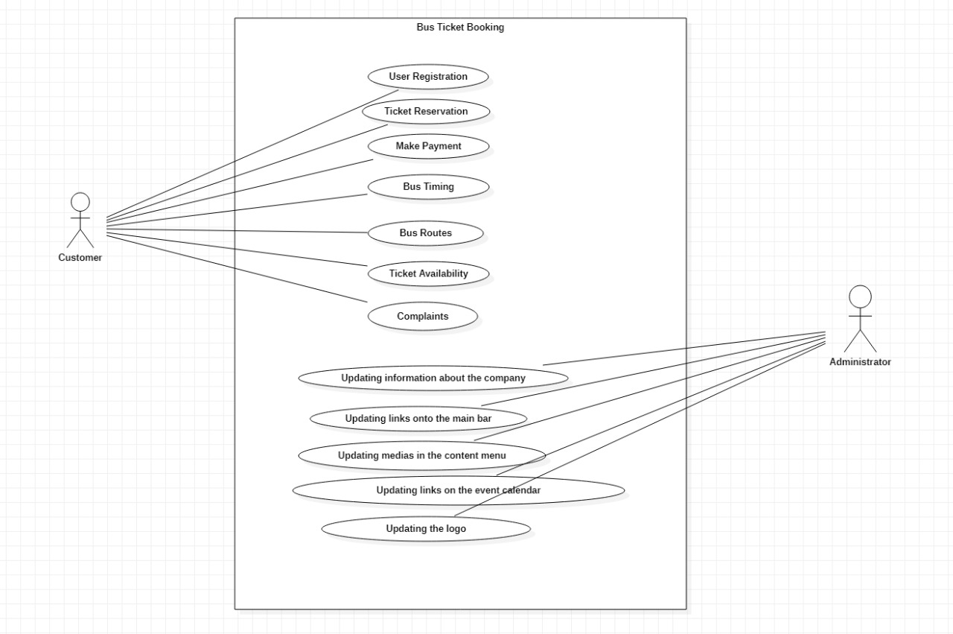

1. User interface

The Application will have an interactive and instant access interface. Following Screens will be provided:

1. Home Screen- Displays Introduction of Software. CONTINUE button to proceed further.

• Login Screen: User can access their respective account by entering their User name and Password.

1. Registration Screen : User can create their account by providing details such as First name, Last name, Username,contact no., Security question, Residential address and password
2. Option Screen – for user and admin

• Update account

• Track

1. My account Screen – for user

• Change address

• Change contact no

**FUNCTIONAL REQUIREMENTS:-**

This following section consists of the Software Requirements and its details inclusive of the System's Design, detailed enough for testers to test the same.

**EXTERNAL INTERFACES**

The hardware and operating system requires a screen resolution of at least 1024 X 768 pixels.

**FUNCTIONS**

• System shall support generalized enquiry for run time parameters indicatively such as Real time / history of the routes that bus travelled that are more than an "X" minutes late (x input runtime by the user). Real time / history of all stops and distance between two points with a feature to playback.

• Based on real time enquiry of a bus location based on bus number and to know next or required place.

• System shall support real time enquiry based on Bus Stops/Pickup point, Bus Stand, trip id, bus no etc., to find out whether the bus passed a pickup point/stop/bus stand/place, to find out the nearby landmark to a given place/location/pickup point bound to specified destination (which have not passed), to find out the nearby vehicle/s to a given vehicle which have not passed/just passed/on the same route or on different route. The output shall be possible both on map and text based display.

• Response to the query shall be appropriate to the channel from which the enquiry was received such as SMS/ Web. SMS response will be perhaps a limited text message while that from the web shall have relevant text output / Table and vehicle locations of the bus on a web page with an overlay on the map.

4)SYSTEM FEATURES :

4.1 RELIABILITY

The system shall operate 95% of the time. The number of defect should not exceed 10 per function. In addition, before the submission of the final release the calendar must be tested in case of the defects over 10 per function.

4.2 AVAILABILITY

The availability of the OBTRS is up to the internet connection of the client. Since this is client-server related web-site, web-site shall be attainable all the time. User should have an account to enter the system, if user does not have an account; for the availability of the OBTRS user should sign up to the system by clicking the sign up link from the home page.

4.3 SECURITY

The authorization mechanism of the system will block the unwanted attempts to the server and also let the system decide on which privileges may the user have. The system has different types of users so there are different levels of authorization.

4.4 MAINTAINABILITY

The requirements, modules that are explained in this document are enough to satisfy the customers’ needs and wants. In case of a change or addition demand after completing the system or in development processes of the system, a new agreement shall be done between the acquirer and FERSOFT Dev Group. The maintainability shall be easily done by integrating new modules and offering new software solutions for the system.

4.5 PORTABILITY

The OBTRS is an online service. So, anyone can use the service. One and only the server of the system must have the required software including MySQL, Apache.

NONFUNCTIONAL REQUIREMENTS :

5.1 PERFORMANCE REQUIREMENTS :

Performance should not be an issue because all of our server queries involve small pieces of data. Changing screens will require very little computation and thus will occur very quickly.

Server updates should only take a few seconds as long as the phone can maintain a steady signal. The fare calculation algorithms used by in application will be highly efficient, taking only a fraction of a second to compute .

5.2 SAFETY REQUIREMENTS :

Train app will not affect data stored outside of its servers nor will it affect any other applications installed on the user’s phone. It cannot cause any damage to the phone or its internal components.

The customer’s web browser shall never display a customer’s password. It shall always be echoed with special characters representing typed characters. The system’s back-end servers shall never display a customer’s password.

The customer’s password may be reset but never shown.

The system’s back-end servers shall only be accessible to authenticated administrators.

The system’s back-end databases shall be encrypted.

5.3 SECURITY REQUIREMENTS :

This application assumes that only the user or whoever he/she allows will have access to his/her Android handset. With that being said, only a Google email or user id address is required to verify the identity of the user upon opening the app. Since it is not connected to any payment transaction methods it and only used for look up this does not pose a threat to privacy violation.

The system shall use secure sockets in all transactions that include any confidential customer information.

The system shall automatically log out all customers after a period of inactivity .

The system shall not leave any cookies on the customer’s computer containing the user’s password.

5.4 SOFTWARE QUALITY ATTRIBUTES :

The graphical user interface of train app is to be designed with usability as the first priority. The app will be presented and organized in a manner

that is both visually appealing and easy for the user to navigate. There will be feedbacks and visual cues such as notifications to inform users of updates .

To ensure reliability and correctness, there will be zero tolerance for errors in the algorithm that computes fare To maintain flexibility and adaptability, the app will take into account situations in which a user loses internet connection or for whatever reason cannot establish a connection with the server. These users will still be able to use the application.

With BUS app being ported solely for the Android platform, this software application has the advantage of being portable and convenient to use whenever and wherever. Overall, the app balances both the ease of use and the ease of learning. The layout and UI of the app will be simple enough that users will take no time to learn its features and navigate through it with little difficulty .

**WBS**

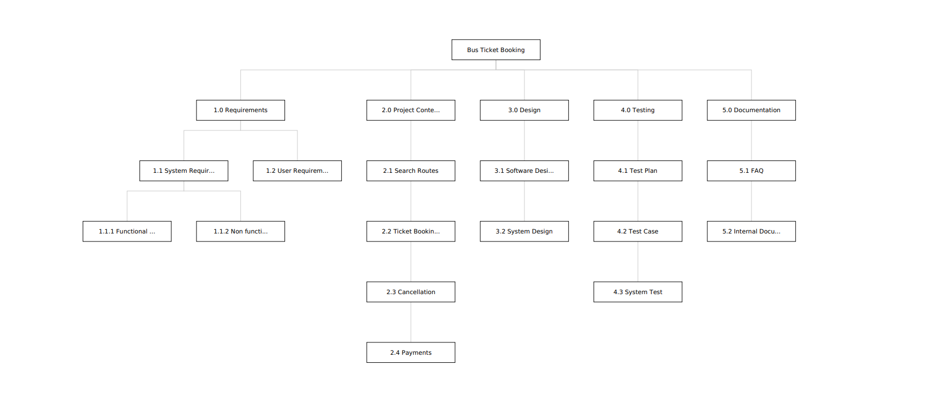

**GHANT CHART**

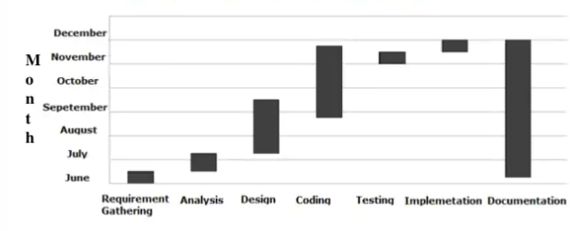

**DFD**

**LEVEL 0**

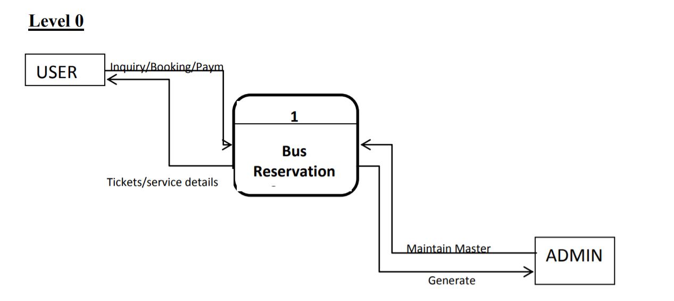

**LEVEL 1**

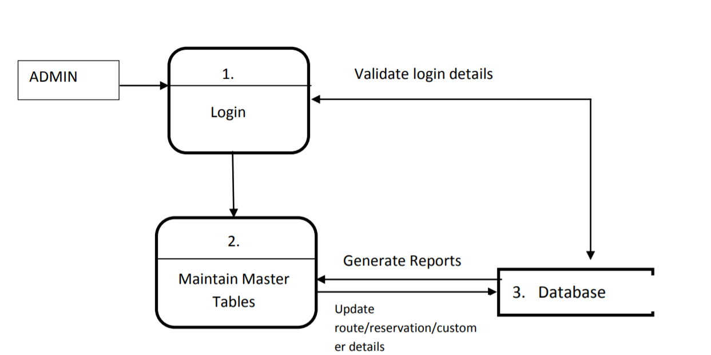

**LEVEL 2**

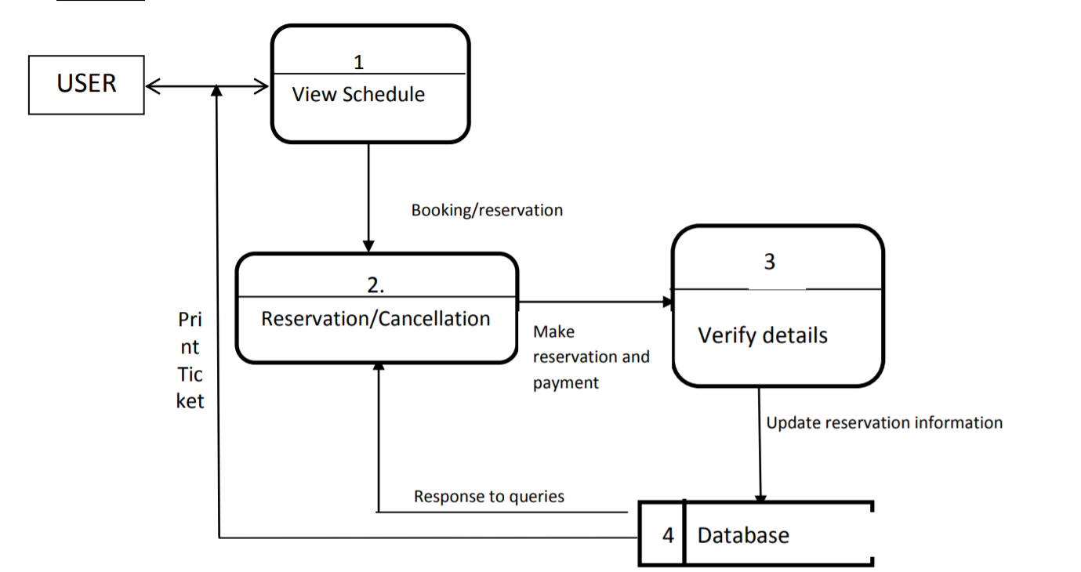**CUSTOMER**

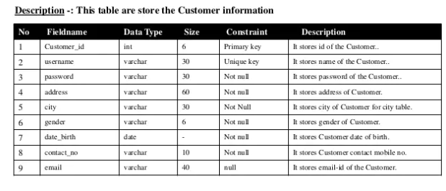**ROUTE DETAILS**

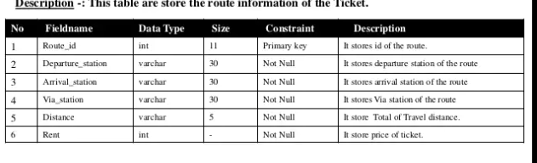

**SEQUENCE DIAGRAM**

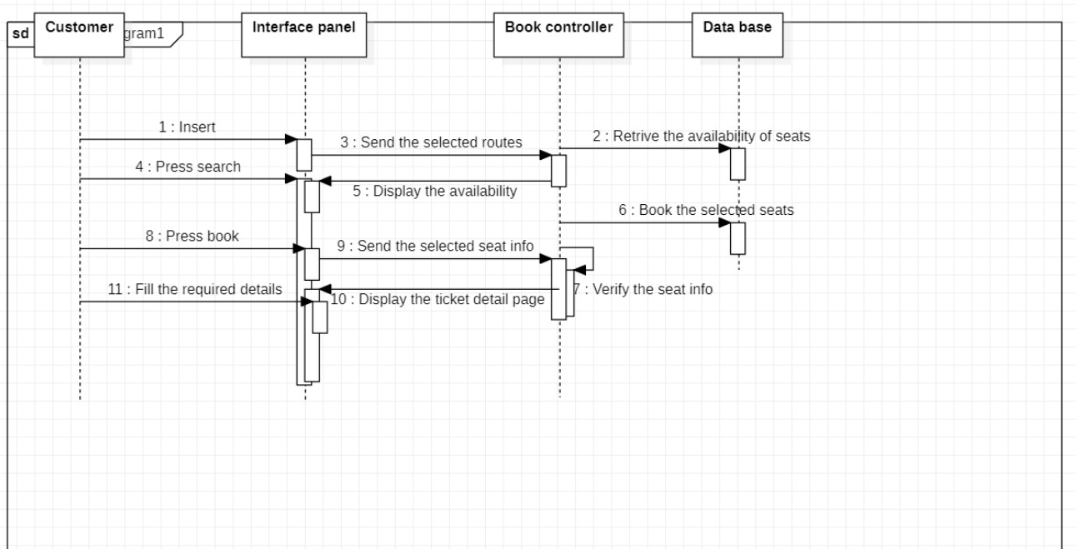

SCREENSHOTS: -

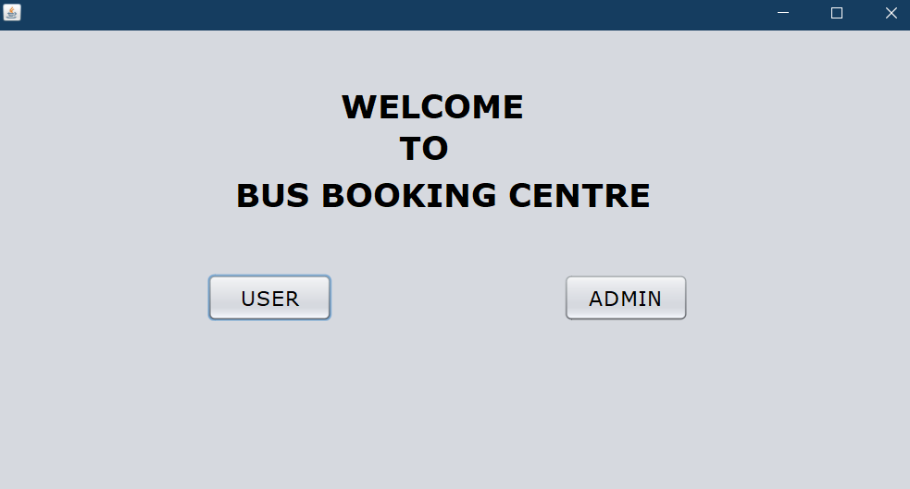

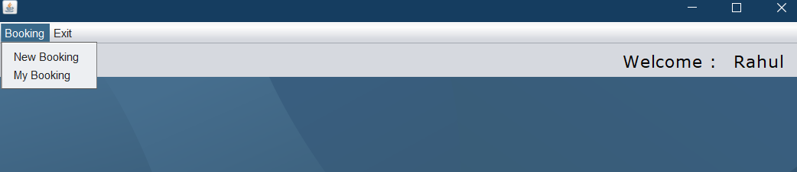

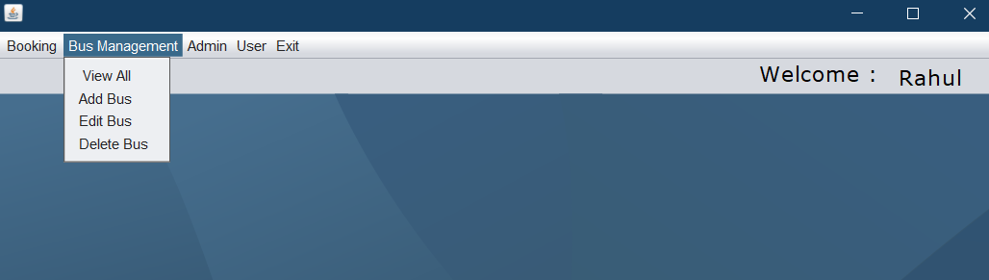

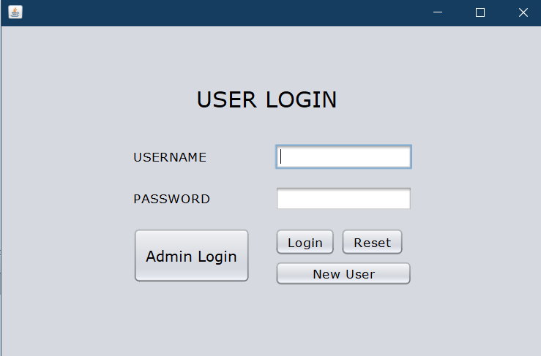

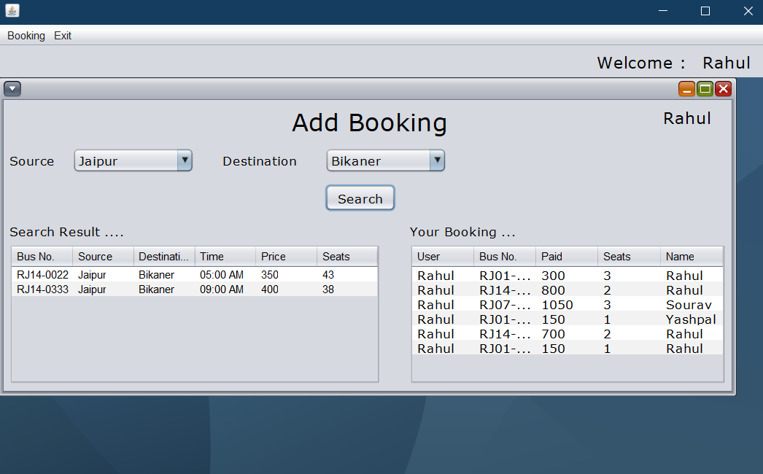

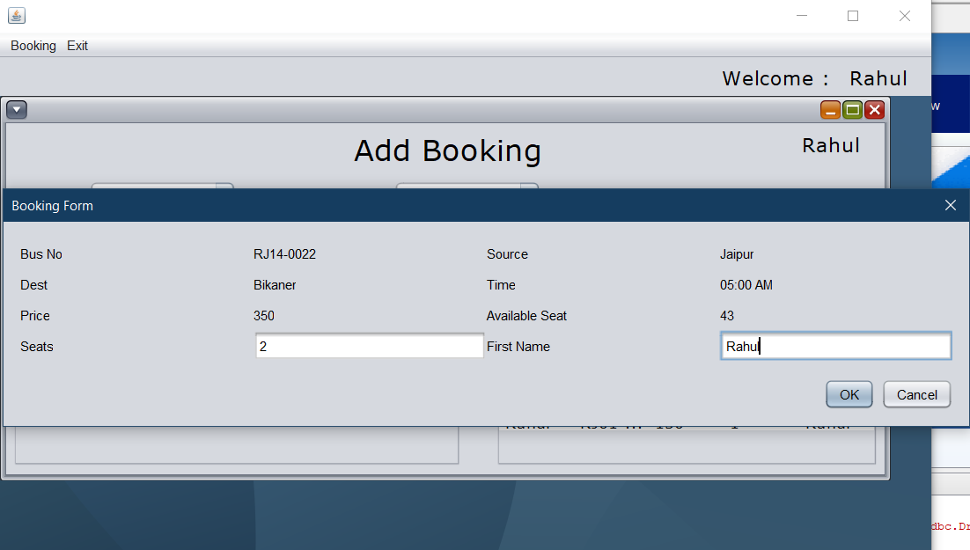

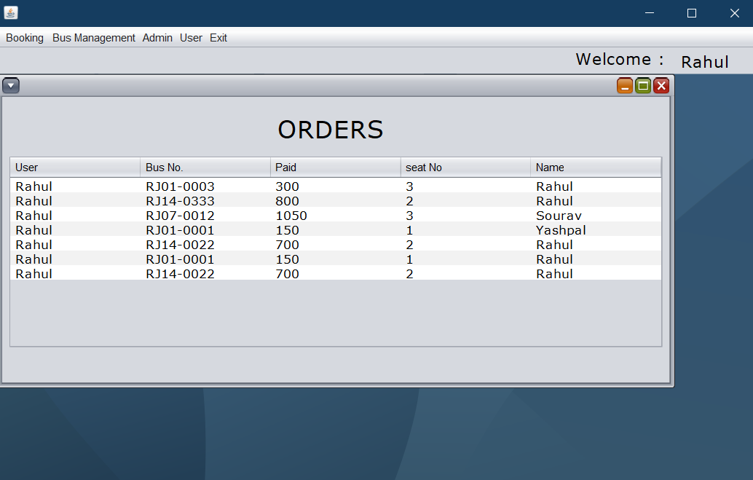

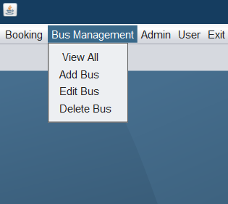

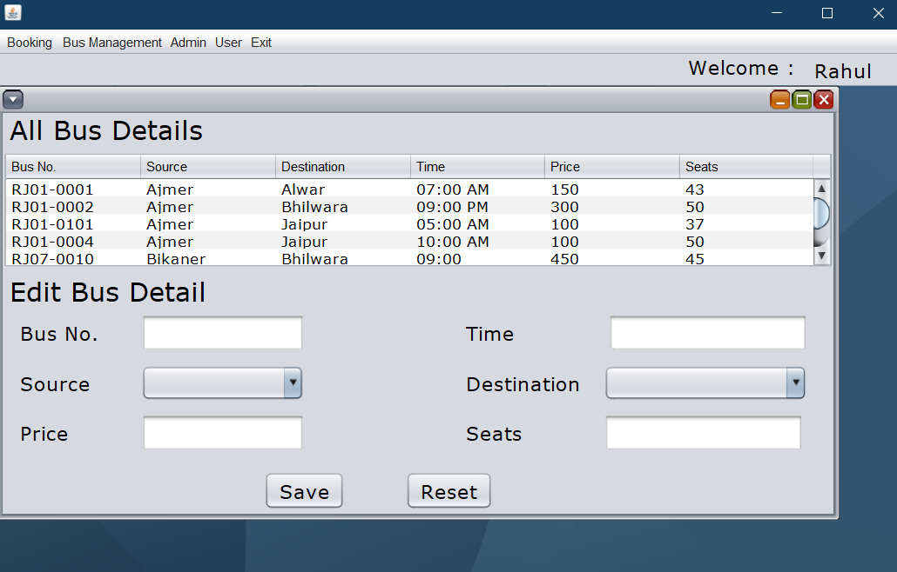

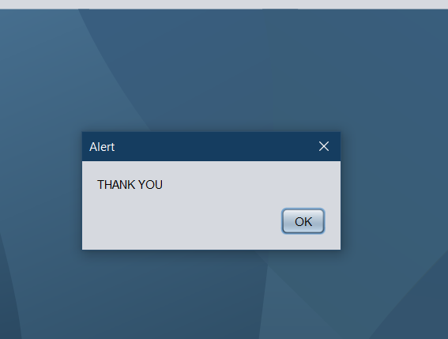

Thank you