Meet Hitesh Sonagara

122208226

msonagara@mySeneca.ca  
Activity of File Compression And Back-Up

1.

2.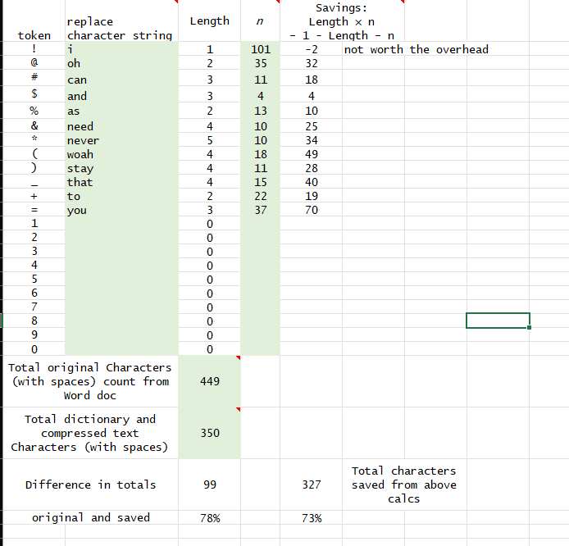

3.

4.

5.

6.

7.  
The file name macaw.gif has the lowest ratio of compression, Which is 0%. Zip files is the one that can be compressed with the same information as the original file. Among all the files, The ratio of GIF file contains less data, so the compression ratio is very low. This file can be shared faster.

8.  
The File with the highest compression ratio are text files because they have the repeated words and have fixed structure.

9.

10.  
I do my backup every week in different location to secure my data such as, OneDrive, Cloud. It is good to take back up regularly in case device failure we can restore our data very easily. To ensure my data is current I regularly check the modify date at the backup location.

11.  
My backup routine is quite simple and convenient and can be operate from any of my devices as well as it also fulfill the 3-2-1 backup.

12.  
In that case, I will save my backup into any cloud storage so my backups will be safe and protected and in case I have no laptop I will access my backups via cloud storage to any of my devices like smartphone or computer.

13.

Nowadays, creating a cloud backup is more easy and convenient, So, if there is a due by tomorrow I will just open my cloud storage search my assignment in it and just upload it on blackboard.