1. 读取data_multivar_cluster.txt数据，使用scatter（）将样本数据可视化，根据画图确定簇的个数，使用K-means聚类算法训练样本数据，输出样本label及label的个数，聚类后的中心点，并将中心点画在原来的样本图中。

import numpy as np  
import matplotlib.pyplot as plt  
from sklearn.cluster import KMeans  
  
# 读取数据  
data = np.loadtxt('data_multivar_cluster.txt',delimiter=',')  
  
# 将数据可视化  
plt.figure(figsize=(8, 6))  
plt.scatter(data[:, 0], data[:, 1], s=50)  
plt.title('Scatter Plot of Sample Data')  
plt.xlabel('Feature 1')  
plt.ylabel('Feature 2')  
plt.grid(True)  
plt.show()  
# 使用K-means算法聚类数据  
k = 4 # 簇的个数  
kmeans = KMeans(n_clusters=k)  
kmeans.fit(data)  
  
# 输出样本label及label的个数  
labels = kmeans.labels_  
unique_labels, label_counts = np.unique(labels, return_counts=True)  
print("Sample labels:", unique_labels)  
print("Number of samples in each cluster:", label_counts)  
  
# 输出聚类后的中心点  
centroids = kmeans.cluster_centers_  
print("Cluster centroids:")  
print(centroids)  
  
# 可视化聚类结果  
plt.figure(figsize=(8, 6))  
plt.scatter(data[:, 0], data[:, 1], c=labels, s=50, cmap='viridis')  
plt.scatter(centroids[:, 0], centroids[:, 1], marker='x', s=200, color='red', label='Centroids')  
plt.title('Clustering Result with K-means')  
plt.xlabel('Feature 1')  
plt.ylabel('Feature 2')  
plt.legend()  
plt.grid(True)  
plt.show()

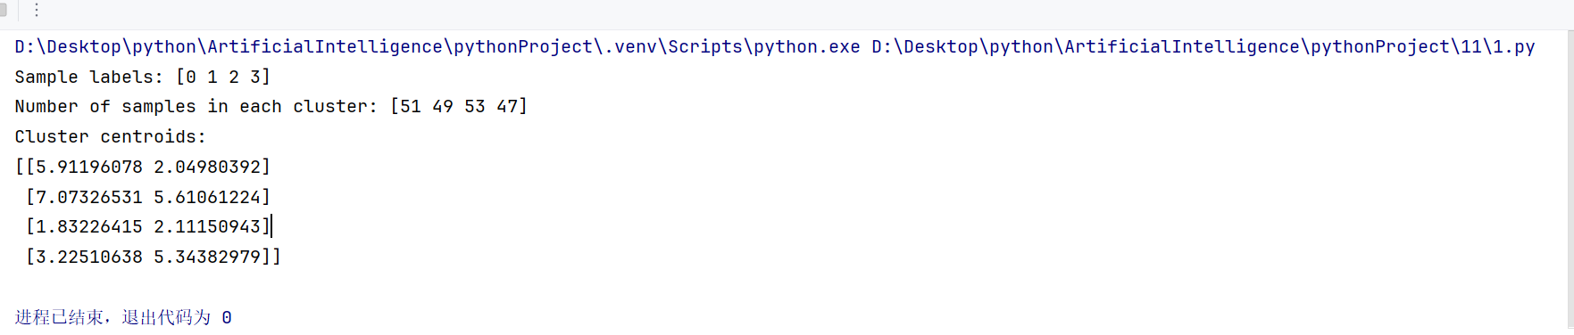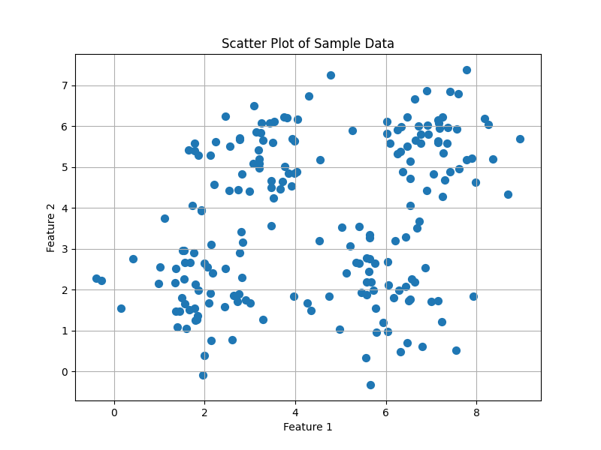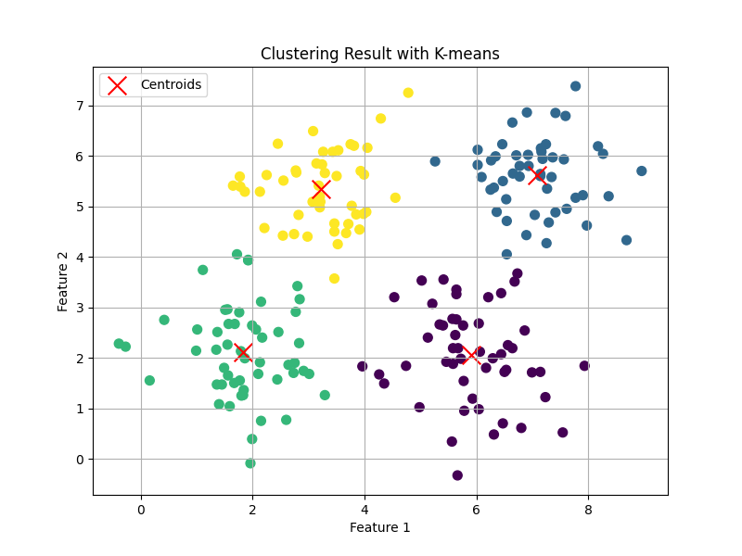

1. 使用mean-shift聚类算法训练data_multivar.txt数据，输出样本label及label的个数，聚类后的中心点，一并画出样本数据及中心点

import numpy as np  
import matplotlib.pyplot as plt  
from sklearn.cluster import MeanShift, estimate_bandwidth  
  
# 读取数据  
data = np.loadtxt('data_multivar_cluster.txt',delimiter=',')  
  
# 估计带宽（bandwidth）  
bandwidth = estimate_bandwidth(data, quantile=0.2, n_samples=500)  
  
# 使用mean-shift算法聚类数据  
ms = MeanShift(bandwidth=bandwidth, bin_seeding=True)  
ms.fit(data)  
  
# 输出样本label及label的个数  
labels = ms.labels_  
unique_labels, label_counts = np.unique(labels, return_counts=True)  
print("Sample labels:", unique_labels)  
print("Number of samples in each cluster:", label_counts)  
  
# 输出聚类后的中心点  
centroids = ms.cluster_centers_  
print("Cluster centroids:")  
print(centroids)  
  
# 可视化聚类结果  
plt.figure(figsize=(8, 6))  
plt.scatter(data[:, 0], data[:, 1], c=labels, s=50, cmap='viridis')  
plt.scatter(centroids[:, 0], centroids[:, 1], marker='x', s=200, color='red', label='Centroids')  
plt.title('Clustering Result with Mean Shift')  
plt.xlabel('Feature 1')  
plt.ylabel('Feature 2')  
plt.legend()  
plt.grid(True)  
plt.show()

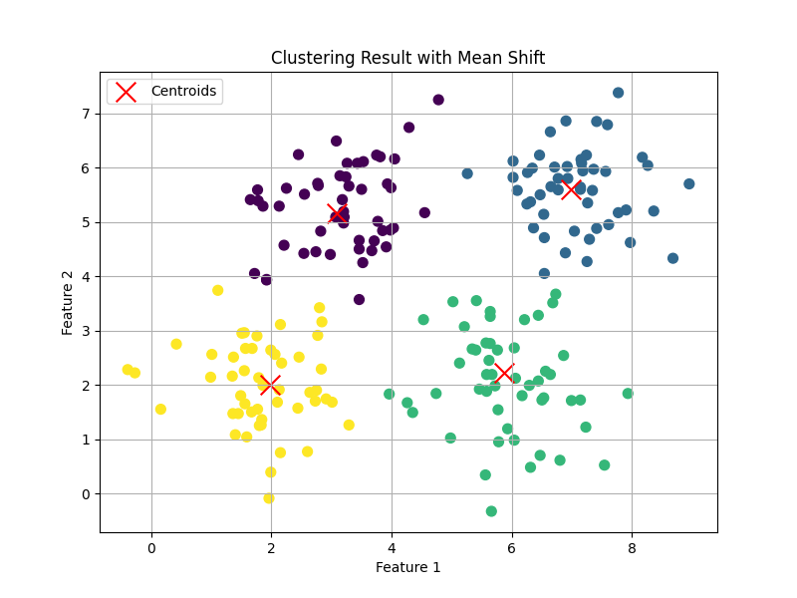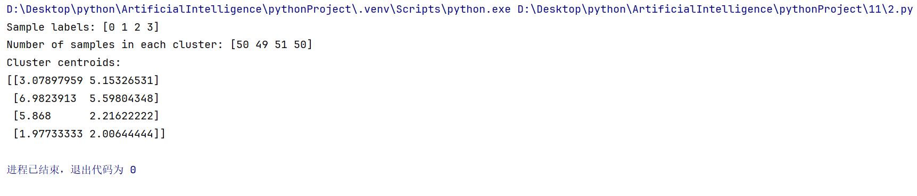

1. 分别读取data_multivar.txt和data_perf.txt数据，使用轮廓系数得分评估k-means ，输出在簇个数分别为2-10上的得分，使用条形图显示得分结果

import numpy as np  
import matplotlib.pyplot as plt  
from sklearn.cluster import KMeans  
from sklearn.metrics import silhouette_score  
  
# 读取数据  
data_multivar = np.loadtxt('data_multivar_cluster.txt', delimiter=',')  
data_perf = np.loadtxt('data_perf.txt', delimiter=',')  
  
  
def calculate_silhouette_scores(data, min_clusters=2, max_clusters=10):  
 silhouette_scores = []  
 for n_clusters in range(min_clusters, max_clusters + 1):  
 kmeans = KMeans(n_clusters=n_clusters)  
 labels = kmeans.fit_predict(data)  
 silhouette_avg = silhouette_score(data, labels)  
 silhouette_scores.append(silhouette_avg)  
 return silhouette_scores  
  
  
min_clusters = 2  
max_clusters = 10  
  
silhouette_scores_multivar = calculate_silhouette_scores(data_multivar, min_clusters, max_clusters)  
silhouette_scores_perf = calculate_silhouette_scores(data_perf, min_clusters, max_clusters)  
plt.figure(figsize=(12, 6))  
  
plt.subplot(1, 2, 1)  
plt.bar(range(min_clusters, max_clusters + 1), silhouette_scores_multivar)  
plt.title('Silhouette Scores for data_multivar')  
plt.xlabel('Number of clusters')  
plt.ylabel('Silhouette Score')  
print('Silhouette Scores for data_multivar')  
print('Number of clusters : Silhouette Score')  
for i in range(min_clusters, max_clusters + 1):  
 print(f'{i}: {silhouette_scores_multivar[i-min_clusters]}')  
plt.xticks(range(min_clusters, max_clusters + 1))  
plt.grid(True)  
  
plt.subplot(1, 2, 2)  
plt.bar(range(min_clusters, max_clusters + 1), silhouette_scores_perf)  
plt.title('Silhouette Scores for data_perf')  
plt.xlabel('Number of clusters')  
plt.ylabel('Silhouette Score')  
print('Silhouette Scores for data_perf')  
print('Number of clusters : Silhouette Score')  
for i in range(min_clusters, max_clusters + 1):  
 print(f'{i}: {silhouette_scores_perf[i-min_clusters]}')  
plt.xticks(range(min_clusters, max_clusters + 1))  
plt.grid(True)  
  
plt.tight_layout()  
plt.show()

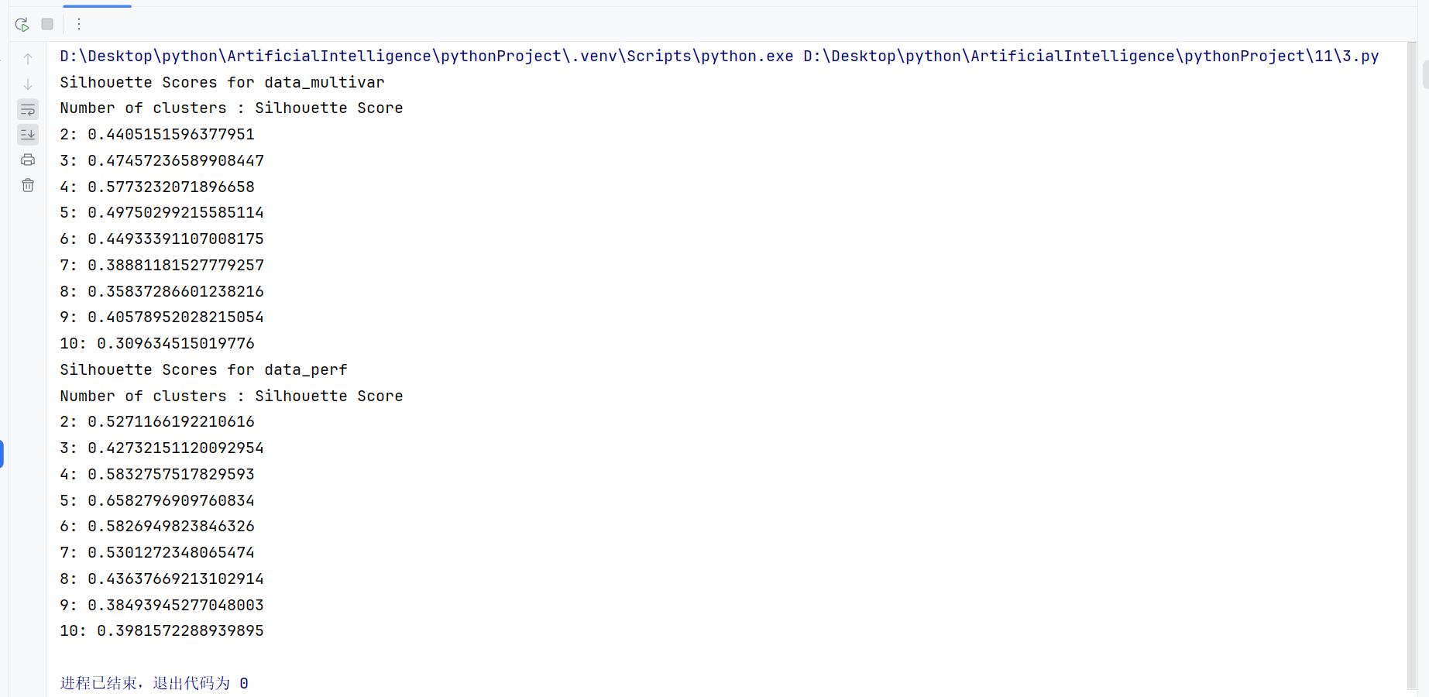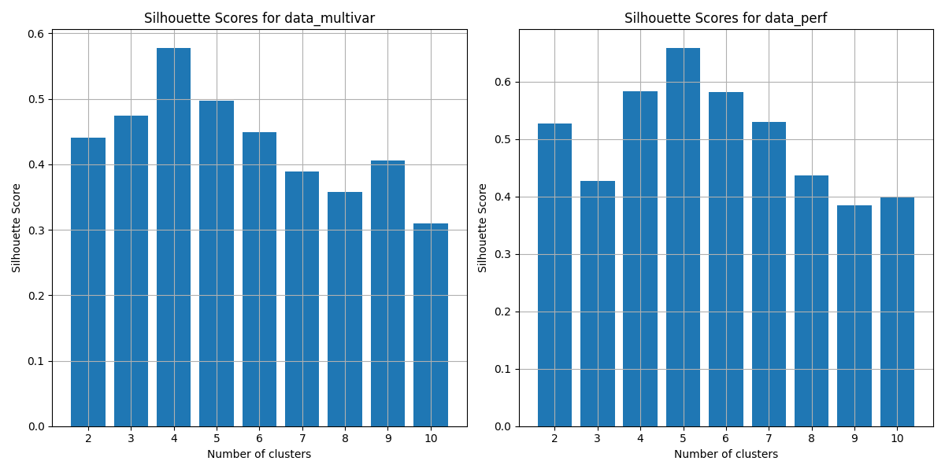

4、使用DBSCAN模型对数据data_perf.txt数据聚类，

（1）分别使用10个距离参数统计轮廓系数得分（将10个轮廓系数得分画条形图）

（2）返回轮廓系数得分最大的距离参数值，model，labels，

（3）查找labels中是否有未聚类的点（labels为-1）,输出最终聚类的个数

（4）分别不用不同的marker（根据类别个数）画出样本数据，未聚类的使用标记’.‘

import numpy as np  
import matplotlib.pyplot as plt  
from sklearn.cluster import DBSCAN  
from sklearn.metrics import silhouette_score  
  
# 读取数据  
data_perf = np.loadtxt('data_perf.txt', delimiter=',')  
  
def calculate_silhouette_scores(data, epsilon_values):  
 """  
 计算不同距离参数值下的轮廓系数得分  
 """  
 silhouette_scores = []  
 for epsilon in epsilon_values:  
 dbscan = DBSCAN(eps=epsilon)  
 labels = dbscan.fit_predict(data)  
 if len(np.unique(labels)) > 1: # 至少有两个类别才能计算轮廓系数  
 silhouette_avg = silhouette_score(data, labels)  
 else:  
 silhouette_avg = -1 # 如果只有一个类别，则轮廓系数为-1  
 silhouette_scores.append(silhouette_avg)  
 return silhouette_scores  
  
def find_best_epsilon(data, epsilon_values):  
 """  
 找到轮廓系数得分最大的距离参数值  
 """  
 best_epsilon = None  
 best_score = -1  
 best_model = None  
 best_labels = None  
 for epsilon in epsilon_values:  
 dbscan = DBSCAN(eps=epsilon)  
 labels = dbscan.fit_predict(data)  
 if len(np.unique(labels)) > 1: # 至少有两个类别才能计算轮廓系数  
 silhouette_avg = silhouette_score(data, labels)  
 if silhouette_avg > best_score:  
 best_score = silhouette_avg  
 best_epsilon = epsilon  
 best_model = dbscan  
 best_labels = labels  
 return best_epsilon, best_model, best_labels  
  
def check_unclustered_points(labels):  
 """  
 检查标签中是否有未聚类的点，并输出最终聚类的个数  
 """  
 unique_labels = np.unique(labels)  
 if -1 in unique_labels:  
 num_clusters = len(unique_labels) - 1  
 else:  
 num_clusters = len(unique_labels)  
 return num_clusters  
  
  
def plot_clusters(data, labels):  
 """  
 绘制聚类结果  
 """  
 unique_labels = np.unique(labels)  
 num_clusters = len(unique_labels) - 1 if -1 in unique_labels else len(unique_labels)  
 markers = ['o', 's', '^', 'x', '+', '*', 'p', 'h', 'd', '|']  
 colors = plt.cm.get_cmap('tab10', num_clusters)  
 for i, label in enumerate(unique_labels):  
 if label == -1:  
 plt.scatter(data[labels == label, 0], data[labels == label, 1], marker='.', color='k', label='Noise')  
 else:  
 plt.scatter(data[labels == label, 0], data[labels == label, 1], marker=markers[i], color=colors(i),  
 label=f'Cluster {label}')  
 plt.xlabel('Feature 1')  
 plt.ylabel('Feature 2')  
 plt.title('DBSCAN Clustering Result')  
 plt.legend()  
 plt.grid(True)  
 plt.show()  
  
# 使用10个距离参数统计轮廓系数得分  
epsilon_values = np.linspace(0.1, 2.0, 10)  
silhouette_scores = calculate_silhouette_scores(data_perf, epsilon_values)  
  
# 绘制轮廓系数得分条形图  
plt.figure(figsize=(10, 6))  
plt.bar(epsilon_values, silhouette_scores, width=0.1)  
plt.xlabel('Epsilon')  
plt.ylabel('Silhouette Score')  
plt.title('Silhouette Scores for Different Epsilon Values')  
plt.grid(True)  
plt.show()  
  
# 返回轮廓系数得分最大的距离参数值，model，labels  
best_epsilon, best_model, best_labels = find_best_epsilon(data_perf, epsilon_values)  
# print(f"Best epsilon value: {best_epsilon}")  
  
# 查找labels中是否有未聚类的点，输出最终聚类的个数  
num_clusters = check_unclustered_points(best_labels)  
print(f"Number of clusters: {num_clusters}")  
  
# 分别不用不同的marker（根据类别个数）画出样本数据，未聚类的使用标记’.‘  
plot_clusters(data_perf, best_labels)

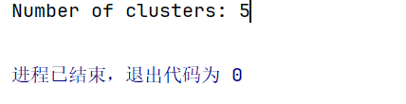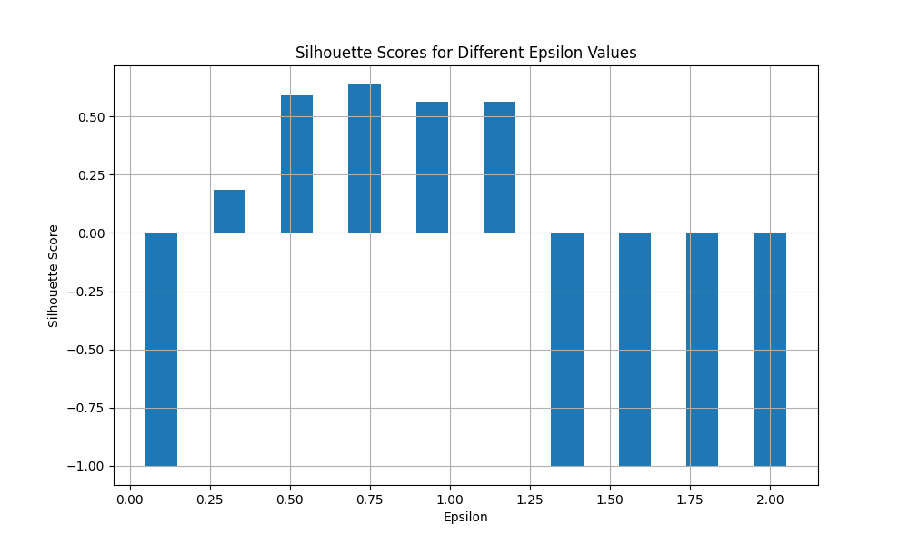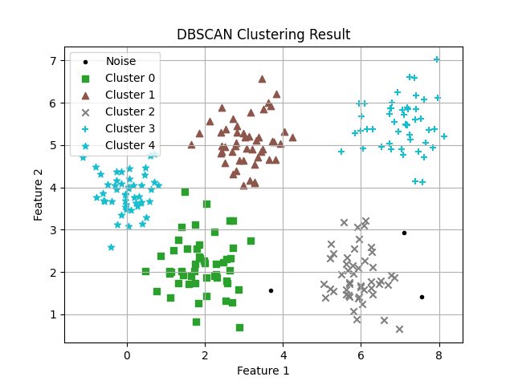

5使用AGNES模型训练分别聚类三种生成的数据，参数connectivitys使用两种方式任选其一，画出聚类后的数据样本图，并分别计算其轮廓系数得分输出.

import numpy as np  
import matplotlib.pyplot as plt  
from sklearn.metrics import silhouette_score  
  
  
def train_and_evaluate(data, connectivity=None):  
 """  
 训练 AGNES 模型并计算轮廓系数得分  
 """  
 # 训练 AGNES 模型  
 AgglomerativeClustering()  
 agnes = AgglomerativeClustering(n_clusters=5, connectivity=connectivity)  
 labels = agnes.fit_predict(data)  
  
 # 计算轮廓系数得分  
 silhouette_avg = silhouette_score(data, labels)  
  
 # 绘制聚类结果  
 plt.scatter(data[:, 0], data[:, 1], c=labels, cmap='viridis')  
 plt.title('Agglomerative Clustering Result')  
 plt.xlabel('Feature 1')  
 plt.ylabel('Feature 2')  
 plt.colorbar(label='Cluster')  
 plt.grid(True)  
 plt.show()  
  
 return silhouette_avg  
  
  
# 生成三种不同形状的数据  
from sklearn.cluster import AgglomerativeClustering  
  
def add_noise(x, y, amplitude):  
 X = np.concatenate((x, y))  
 X += amplitude * np.random.randn(2, X.shape[1])  
 return X.T  
def get_spiral(t, noise_amplitude=0.5):  
 r = t  
 x = r * np.cos(t)  
 y = r * np.sin(t)  
 return add_noise(x, y, noise_amplitude)  
def get_rose(t, noise_amplitude=0.02):  
 # Equation for "rose" (or rhodonea curve); if k is odd, then  
 # the curve will have k petals, else it will have 2k petals  
 k = 5  
 r = np.cos(k*t) + 0.25  
 x = r * np.cos(t)  
 y = r * np.sin(t)  
 return add_noise(x, y, noise_amplitude)  
def get_hypotrochoid(t, noise_amplitude=0):  
 a, b, h = 10.0, 2.0, 4.0  
 x = (a - b) * np.cos(t) + h * np.cos((a - b) / b * t)  
 y = (a - b) * np.sin(t) - h * np.sin((a - b) / b * t)  
 return add_noise(x, y, 0)  
  
  
n_samples=500  
np.random.seed(2)  
t = 2.5 * np.pi * (1 + 2 * np.random.rand(1, n_samples))  
# X = get_spiral(t)  
X = get_rose(t)  
# X = get_hypotrochoid(t)  
  
silhouette_score = train_and_evaluate(X)  
  
# 输出轮廓系数得分  
print("Silhouette Score for Data:", silhouette_score)

