案例1：银行客户流失预测

# 数据来源：匿名处理后的国外银行真实数据，共有14个特征，保存在Churn-Modelling-new.csv中

样本特征说明

RowNumber：行号 ×

CustomerID：用户编号 ×

Surname：用户姓名 ×

CreditScore：信用分数

Geography：用户所在国家/地区 ×

Gender：用户性别

Age：年龄

Tenure：当了本银行多少年用户

Balance：存贷款情况

NumOfProducts：使用产品数量

HasCrCard：是否有本行信用卡

IsActiveMember：是否活跃用户

EstimatedSalary：估计收入

Exited：是否已流失，这将作为我们的标签数据

具体要求：

（1）非特征值处理：Geography与Gender两列为非数值类型特征，需将其转换为数值型特征

（2）连续性变量离散化处理：决策树算法需要处理离散化的数据，需要将连续型变量先转化为离散型变量，

具体为信用分数（小于584为0，584到718之间为1，大于718为2）、

年龄（20以下为0，20到40之间1，大于40为2）、

存贷款情况（小于48000为0，48000到97198之间为1，大于97198为2）、

估计收入（小于51002为0，51002到149388之间为1，大于149388为2），等进行转换

（3）数据筛选：由于原数据集中训练数据类别不均衡，为了达到较好的模型效果，可以采用简单的欠采样方法，将多余的类别数据删掉。（也可使用其他方法解决类别不平衡问题）

（4）数据预处理：第1列为编号，对决策树模型无意义，去除，将剩余列作为特征项，其中标签数据为 Exited列

（5）划分训练集和测试集，将数据集按4:1分为训练集和测试集

（6）定义决策树模型，训练数据，输出模型得分，并进行模型优化。

（7）模型评估，画混淆矩阵图、ROC曲线图，输出精确率、召回率和正确率

（8）定义SVM模型，训练数据，画混淆矩阵，ROC曲线，输出精确率、召回率和正确率，并进行模型优化。

（9）比较两种模型的性能，选择一种模型进行K折交叉验证，将5折、10折、15折交叉验证的正确率(精确率)使用折线图（不同子图）显示

import pandas as pd  
from sklearn.model_selection import train_test_split  
from sklearn.preprocessing import LabelEncoder  
import matplotlib.pyplot as plt  
from sklearn.metrics import confusion_matrix, roc_curve, auc, classification_report  
from sklearn.tree import DecisionTreeClassifier  
from sklearn.svm import SVC  
from sklearn.model_selection import cross_val_score  
import matplotlib.font_manager as fm  
  
# 设置字体为 SimHei，以支持中文  
plt.rcParams['font.sans-serif'] = ['SimHei'] # 用来正常显示中文标签  
plt.rcParams['axes.unicode_minus'] = False # 用来正常显示负号  
# 导入数据  
data = pd.read_csv('Churn-Modelling-new.csv',sep=',')  
# print(data.info)  
  
data.dropna(inplace=True)  
  
# print("缺失值检查:\n", data.isna().sum())  
# 删除无意义列  
data.drop(['RowNumber', 'CustomerId', 'Surname',], axis=1, inplace=True)  
  
# 使用LabelEncoder将非数值特征转化为数值特征  
le_geography = LabelEncoder()  
le_gender = LabelEncoder()  
  
data['Geography'] = le_geography.fit_transform(data['Geography'])  
data['Gender'] = le_gender.fit_transform(data['Gender'])  
  
# 信用分数离散化  
data['CreditScore'] = pd.cut(data['CreditScore'], bins=[0, 584, 718, float('inf')], labels=[0, 1, 2])  
  
# 年龄离散化  
data['Age'] = pd.cut(data['Age'], bins=[0, 20, 40, float('inf')], labels=[0, 1, 2])  
  
# 存贷款情况离散化  
# print((data['Balance'] == 0).sum())  
# print(data['Balance'].describe())  
data['Balance'] = pd.cut(data['Balance'], bins=[-1, 48000, 97198, float('inf')], labels=[0, 1, 2])  
# print(data['Balance'].unique())  
# 估计收入离散化  
data['EstimatedSalary'] = pd.cut(data['EstimatedSalary'], bins=[0, 51002, 149388, float('inf')], labels=[0, 1, 2])  
  
# 分离特征与标签  
X = data.drop('Exited', axis=1)  
y = data['Exited']  
  
# 使用欠采样方法处理类别不平衡问题  
class_counts = data['Exited'].value_counts()  
# print("每个类别的样本数量:\n", class_counts)  
  
# 假设标签0的数量更多，即 class_0 是多数类，class_1 是少数类  
if class_counts[0] > class_counts[1]:  
 majority_class = 0  
 minority_class = 1  
else:  
 majority_class = 1  
 minority_class = 0  
  
# 提取不同类别的样本  
class_majority = data[data['Exited'] == majority_class]  
class_minority = data[data['Exited'] == minority_class]  
  
# 下采样  
class_majority_under = class_majority.sample(len(class_minority))  
data_under = pd.concat([class_majority_under, class_minority], axis=0)  
  
# 分离特征和标签  
X = data_under.drop('Exited', axis=1)  
y = data_under['Exited']  
  
  
# 划分训练集和测试集  
X_train, X_test, y_train, y_test = train_test_split(X, y, test_size=0.2, random_state=42)  
  
# 决策树模型  
dt_model = DecisionTreeClassifier(criterion="gini",max_depth=6,min_samples_split=200,random_state=42)  
dt_model.fit(X_train, y_train)  
y_pred_dt = dt_model.predict(X_test)  
  
conf_matrix_dt = confusion_matrix(y_test, y_pred_dt)  
fpr_dt, tpr_dt, _ = roc_curve(y_test, dt_model.predict_proba(X_test)[:, 1])  
roc_auc_dt = auc(fpr_dt, tpr_dt)  
  
print("决策树模型分类报告:\n", classification_report(y_test, y_pred_dt, zero_division=1))  
  
# 绘制决策树混淆矩阵  
plt.figure()  
plt.matshow(conf_matrix_dt, cmap=plt.cm.Blues)  
plt.title('决策树混淆矩阵')  
plt.colorbar()  
plt.ylabel('真实标签')  
plt.xlabel('预测标签')  
plt.show()  
  
# 绘制决策树ROC曲线  
plt.figure()  
plt.plot(fpr_dt, tpr_dt, color='darkorange', lw=2, label='ROC曲线 (area = %0.2f)' % roc_auc_dt)  
plt.plot([0, 1], [0, 1], color='navy', lw=2, linestyle='--')  
plt.xlim([0.0, 1.0])  
plt.ylim([0.0, 1.05])  
plt.xlabel('假阳性率')  
plt.ylabel('真阳性率')  
plt.title('决策树ROC曲线')  
plt.legend(loc="lower right")  
plt.show()  
  
# print(X.isna().sum())  
# SVM模型  
  
# print(X.shape)  
svm_model = SVC(C=10,gamma=0.1,probability=True, random_state=42)  
svm_model.fit(X_train, y_train)  
y_pred_svm = svm_model.predict(X_test)  
  
conf_matrix_svm = confusion_matrix(y_test, y_pred_svm)  
fpr_svm, tpr_svm, _ = roc_curve(y_test, svm_model.predict_proba(X_test)[:, 1])  
roc_auc_svm = auc(fpr_svm, tpr_svm)  
  
print("SVM模型分类报告:\n", classification_report(y_test, y_pred_svm, zero_division=1))  
  
# 绘制SVM混淆矩阵  
plt.figure()  
plt.matshow(conf_matrix_svm, cmap=plt.cm.Blues)  
plt.title('SVM混淆矩阵')  
plt.colorbar()  
plt.ylabel('真实标签')  
plt.xlabel('预测标签')  
plt.show()  
  
# 绘制SVM ROC曲线  
plt.figure()  
plt.plot(fpr_svm, tpr_svm, color='darkorange', lw=2, label='ROC曲线 (area = %0.2f)' % roc_auc_svm)  
plt.plot([0, 1], [0, 1], color='navy', lw=2, linestyle='--')  
plt.xlim([0.0, 1.0])  
plt.ylim([0.0, 1.05])  
plt.xlabel('假阳性率')  
plt.ylabel('真阳性率')  
plt.title('SVM ROC曲线')  
plt.legend(loc="lower right")  
plt.show()  
  
# 决策树交叉验证  
dt_scores = cross_val_score(dt_model, X, y, cv=5)  
dt_scores_10 = cross_val_score(dt_model, X, y, cv=10)  
dt_scores_15 = cross_val_score(dt_model, X, y, cv=15)  
  
# SVM交叉验证  
svm_scores = cross_val_score(svm_model, X, y, cv=5)  
svm_scores_10 = cross_val_score(svm_model, X, y, cv=10)  
svm_scores_15 = cross_val_score(svm_model, X, y, cv=15)  
  
# 绘制交叉验证结果  
plt.figure(figsize=(12, 6))  
  
plt.subplot(1, 3, 1)  
plt.plot(range(1, 6), dt_scores, marker='o', label='决策树')  
plt.plot(range(1, 6), svm_scores, marker='x', label='SVM')  
plt.xlabel('折数')  
plt.ylabel('准确率')  
plt.title('5折交叉验证准确率')  
plt.legend()  
  
plt.subplot(1, 3, 2)  
plt.plot(range(1, 11), dt_scores_10, marker='o', label='决策树')  
plt.plot(range(1, 11), svm_scores_10, marker='x', label='SVM')  
plt.xlabel('折数')  
plt.ylabel('准确率')  
plt.title('10折交叉验证准确率')  
plt.legend()  
  
plt.subplot(1, 3, 3)  
plt.plot(range(1, 16), dt_scores_15, marker='o', label='决策树')  
plt.plot(range(1, 16), svm_scores_15, marker='x', label='SVM')  
plt.xlabel('折数')  
plt.ylabel('准确率')  
plt.title('15折交叉验证准确率')  
plt.legend()  
  
plt.tight_layout()  
plt.show()

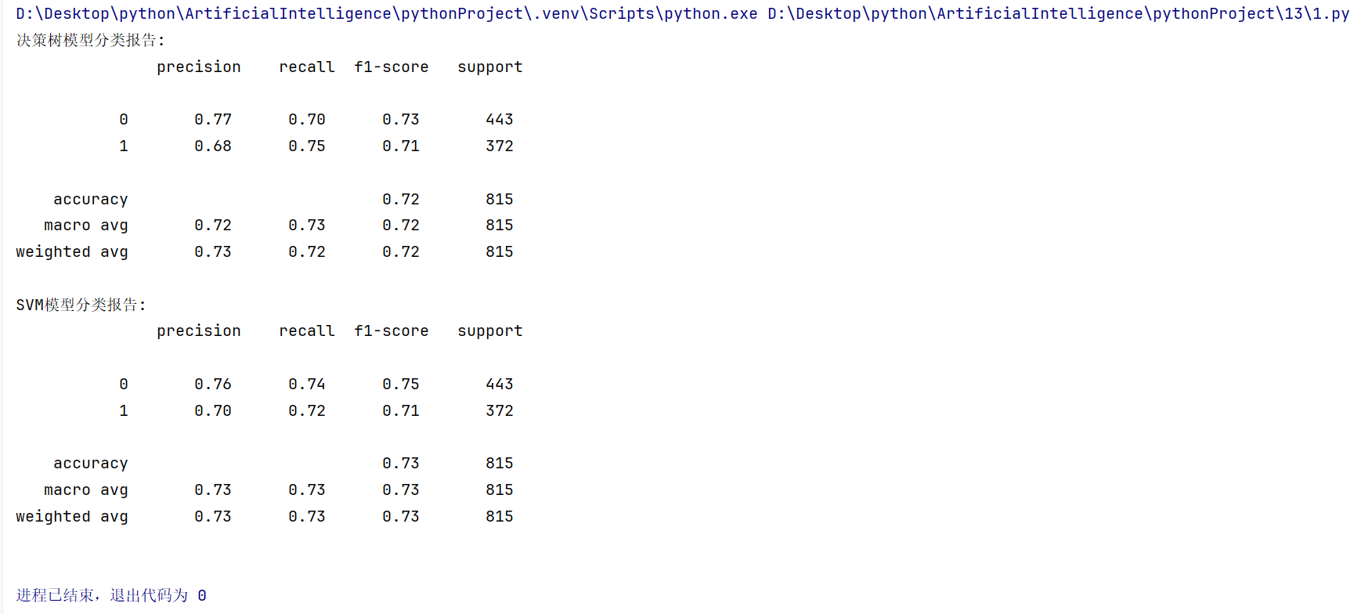

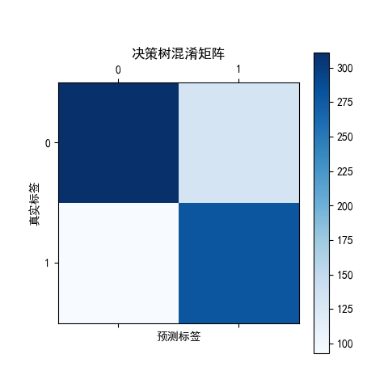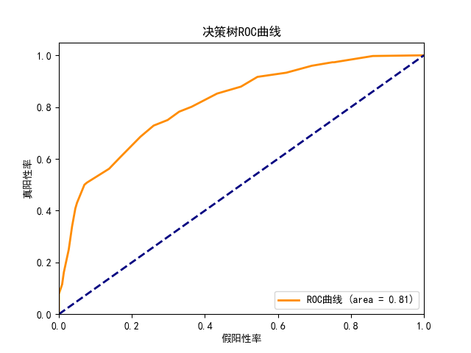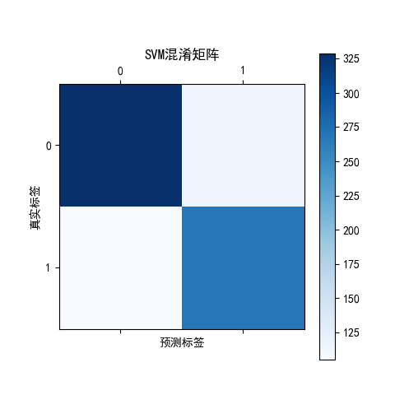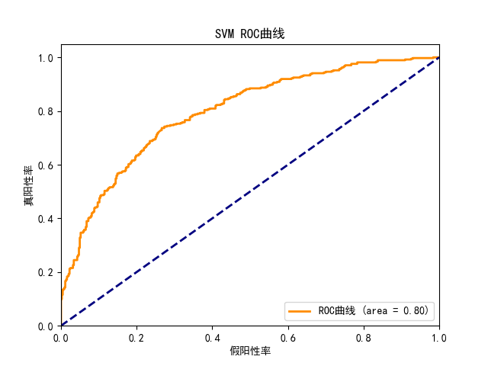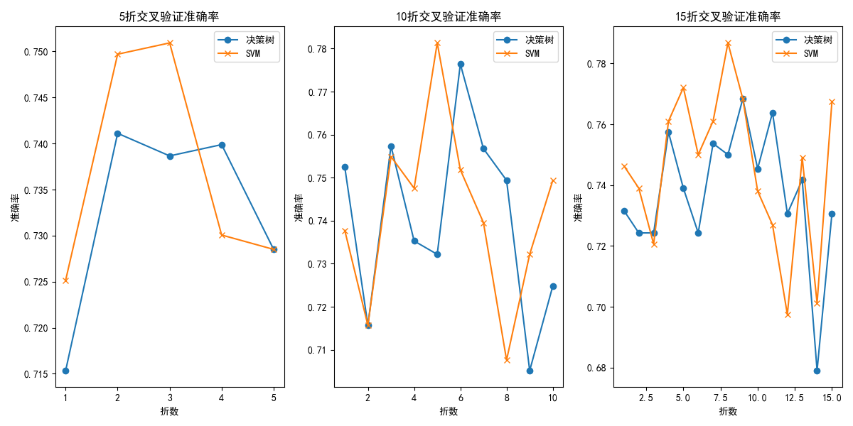

案例2：电影推荐算法

具体要求：

（1）读取数据(json格式转换为字典格式/excel格式数据合并)

（2）选择两个用户，判断两个用户是否有共同评过分的电影，如果有，计算欧式距离，寻找数据集中的相似用户

（3）选择两个用户，判断两个用户是否有共同评过分的电影，如果有，计算皮尔孙相关系数，寻找数据集中的相似用户

（4）给定其中一个用户，任选一种方法为给定用户生成2部电影推荐。

## json格式

import json  
import math  
  
import numpy as np  
from scipy.stats import pearsonr  
  
# def load_data(json_data):  
# return json.loads(json_data)  
import os  
  
  
def load_data(filepath):  
 if not os.path.exists(filepath):  
 raise FileNotFoundError(f"No such file: '{filepath}'")  
  
 with open(filepath, 'r', encoding='utf-8') as file:  
 json_data = file.read()  
  
 if not json_data.strip(): # 检查文件是否为空  
 raise ValueError("File is empty")  
  
 return json.loads(json_data)  
  
  
import math  
from scipy.stats import pearsonr  
  
def sort_movie_ratings_desc(data):  
 sorted_data = {user: dict(sorted(ratings.items(), key=lambda x: x[1], reverse=True))  
 for user, ratings in data.items()}  
 return sorted_data  
  
import numpy as np  
  
def euclidean_distance(user1_ratings, user2_ratings):  
 common_movies = set(user1_ratings.keys()).intersection(set(user2_ratings.keys()))  
 if not common_movies:  
 return float('inf') # No common movies, distance is infinite  
  
 squared_differences = []  
 for movie in common_movies:  
 squared_differences.append(np.square(user1_ratings[movie] - user2_ratings[movie]))  
 return 1 / (1 + np.sqrt(np.sum(squared_differences)))  
  
  
  
def pearson_correlation(user1_ratings, user2_ratings):  
 # 找到共同评分的项目  
 common_movies = set(user1_ratings.keys()).intersection(set(user2_ratings.keys()))  
 if len(common_movies) < 2:  
 return 0 # 如果共同评分项少于2，返回0表示无效相关性  
  
 # 提取共同评分项的评分  
 user1_scores = [user1_ratings[movie] for movie in common_movies]  
 user2_scores = [user2_ratings[movie] for movie in common_movies]  
  
 # 检查是否为常量数组  
 if np.all(np.array(user1_scores) == user1_scores[0]) or np.all(np.array(user2_scores) == user2_scores[0]):  
 return 0 # 如果数组是常量数组，返回0表示无效相关性  
  
 # 计算并返回 Pearson 相关系数  
 correlation, _ = pearsonr(user1_scores, user2_scores)  
 return correlation  
  
def find_most_similar_users(data, target_user, k=1, method='euclidean'):  
 distances = []  
 for user in data:  
 if user != target_user:  
 if method == 'euclidean':  
 distance = euclidean_distance(data[target_user], data[user])  
 elif method == 'pearson':  
 distance = pearson_correlation(data[target_user], data[user])  
 distances.append((user, distance))  
  
 if method == 'euclidean':  
 # For Euclidean distance, the smaller the distance, the more similar the users  
 distances.sort(key=lambda x: x[1])  
 elif method == 'pearson':  
 # For Pearson correlation, the larger the correlation, the more similar the users  
 distances.sort(key=lambda x: x[1], reverse=True)  
  
 # Return the top k most similar users  
 return distances[:k]  
  
  
def recommend_movies(data, target_user, k, method='euclidean', num_recommendations=2):  
 # print(k)  
 similar_users = find_most_similar_users(data, target_user, k, method)  
 # print(similar_users)  
 similar_user_names = [user for user, _ in similar_users]  
  
 movie_recommendations = {}  
 for user in similar_user_names:  
 for movie, rating in data[user].items():  
 if movie not in data[target_user]:  
 if movie not in movie_recommendations:  
 movie_recommendations[movie] = []  
 movie_recommendations[movie].append(rating)  
  
 for movie in movie_recommendations:  
 movie_recommendations[movie] = np.mean(movie_recommendations[movie])  
  
 recommended_movies = sorted(movie_recommendations.items(), key=lambda x: x[1], reverse=True)  
  
 return [name for name,_ in recommended_movies[:num_recommendations]]  
  
  
def print_similiar_users(data, target_user, k=2,method='euclidean'):  
 similar_users = find_most_similar_users(data, target_user, k,method)  
 # 取出前 k 个最相似用户的名称  
 top_k_similar_users = [user for user, _ in similar_users[:k]]  
 print(f"{target_user}的最相似的两个用户：{top_k_similar_users}")  
  
  
# Example usage  
if __name__ == "__main__":  
 # 测试加载 JSON 数据  
 try:  
 data = load_data('movie_ratings.json')  
 # print(data)  
 except Exception as e:  
 print(f"An error occurred: {e}")  
 data=sort_movie_ratings_desc(data)  
 # print(data)  
 user1 = 'John Carson'  
 user2 = 'Michael Henry'  
  
 # Calculate Euclidean distance  
 euclidean_dist = euclidean_distance(data[user1], data[user2])  
 if euclidean_dist != float('inf'):  
 print(f"Euclidean Distance between {user1} and {user2}: {euclidean_dist}")  
 print_similiar_users(data, user1)  
 print_similiar_users(data, user2)  
 print()  
 # Calculate Pearson correlation  
 pearson_corr = pearson_correlation(data[user1], data[user2])  
 if pearson_corr != 0:  
 print(f"Pearson Correlation between {user1} and {user2}: {pearson_corr}")  
 print_similiar_users(data, user1,method='pearson')  
 print_similiar_users(data, user2,method='pearson')  
 print()  
  
 # Generate movie recommendations  
 target_user = user2  
 recommendations = recommend_movies(data, target_user,k=len(data),method='euclidean')  
 print(f"Recommendations for {target_user} using Euclidean method:")  
 for i, recommendation in enumerate(recommendations, start=1):  
 print(f"{i}: {recommendation}")

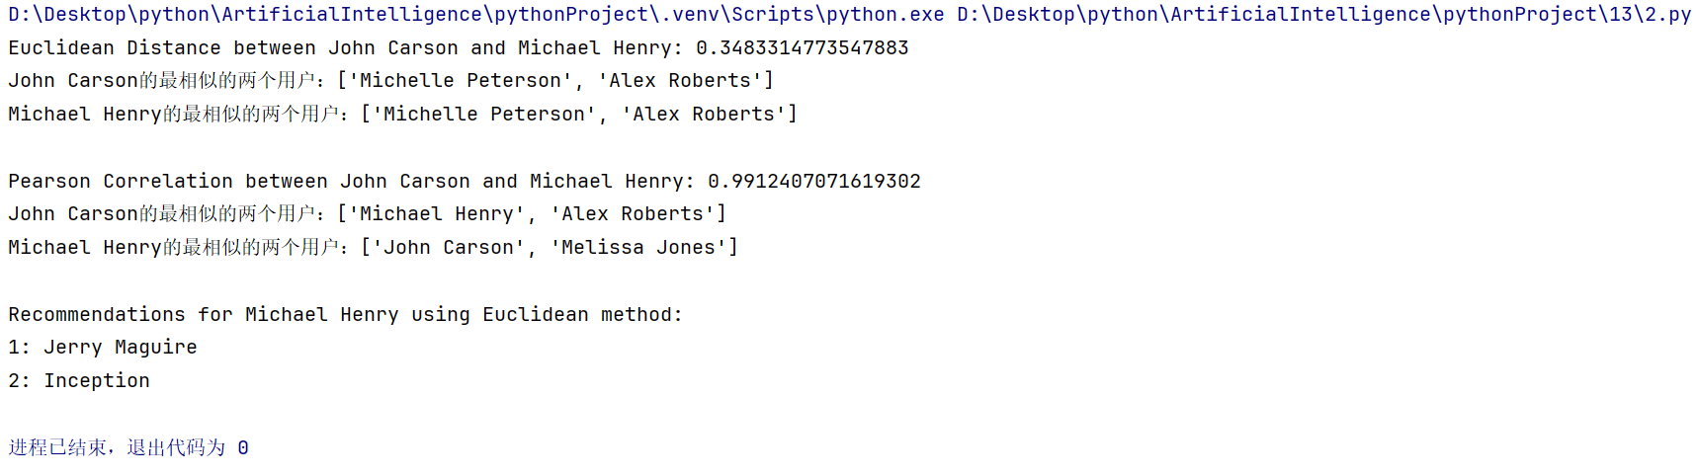

## excel格式

# import pandas as pd  
#  
import os  
  
import numpy as np  
import pandas as pd  
import json  
from scipy.stats import pearsonr  
  
  
# 读取 CSV 数据  
def load_data(csv_file):  
 df = pd.read_csv(csv_file)  
 return df  
  
  
from scipy.stats import pearsonr  
  
  
def sort_movie_ratings_desc(data):  
 sorted_data = {user: dict(sorted(ratings.items(), key=lambda x: x[1], reverse=True))  
 for user, ratings in data.items()}  
 return sorted_data  
  
  
  
def euclidean_distance(user1_ratings, user2_ratings):  
 common_movies = set(user1_ratings.keys()).intersection(set(user2_ratings.keys()))  
 if not common_movies:  
 return float('inf') # No common movies, distance is infinite  
  
 squared_differences = []  
 for movie in common_movies:  
 squared_differences.append(np.square(user1_ratings[movie] - user2_ratings[movie]))  
 return 1 / (1 + np.sqrt(np.sum(squared_differences)))  
  
  
def pearson_correlation(user1_ratings, user2_ratings):  
 # 找到共同评分的项目  
 common_movies = set(user1_ratings.keys()).intersection(set(user2_ratings.keys()))  
 if len(common_movies) < 2:  
 return 0 # 如果共同评分项少于2，返回0表示无效相关性  
  
 # 提取共同评分项的评分  
 user1_scores = [user1_ratings[movie] for movie in common_movies]  
 user2_scores = [user2_ratings[movie] for movie in common_movies]  
  
 # 检查是否为常量数组  
 if np.all(np.array(user1_scores) == user1_scores[0]) or np.all(np.array(user2_scores) == user2_scores[0]):  
 return 0 # 如果数组是常量数组，返回0表示无效相关性  
  
 # 计算并返回 Pearson 相关系数  
 correlation, _ = pearsonr(user1_scores, user2_scores)  
 return correlation  
  
  
def find_most_similar_users(data, target_user, k=1, method='euclidean'):  
 distances = []  
 for user in data:  
 if user != target_user:  
 if method == 'euclidean':  
 distance = euclidean_distance(data[target_user], data[user])  
 elif method == 'pearson':  
 distance = pearson_correlation(data[target_user], data[user])  
 distances.append((user, distance))  
  
 if method == 'euclidean':  
 # For Euclidean distance, the smaller the distance, the more similar the users  
 distances.sort(key=lambda x: x[1])  
 elif method == 'pearson':  
 # For Pearson correlation, the larger the correlation, the more similar the users  
 distances.sort(key=lambda x: x[1], reverse=True)  
  
 # Return the top k most similar users  
 return distances[:k]  
  
  
def recommend_movies(data, target_user, k, method='euclidean', num_recommendations=2):  
 # print(k)  
 similar_users = find_most_similar_users(data, target_user, k, method)  
 # print(similar_users)  
 similar_user_names = [user for user, _ in similar_users]  
  
 movie_recommendations = {}  
 for user in similar_user_names:  
 for movie, rating in data[user].items():  
 if movie not in data[target_user]:  
 if movie not in movie_recommendations:  
 movie_recommendations[movie] = []  
 movie_recommendations[movie].append(rating)  
  
 for movie in movie_recommendations:  
 movie_recommendations[movie] = np.mean(movie_recommendations[movie])  
  
 recommended_movies = sorted(movie_recommendations.items(), key=lambda x: x[1], reverse=True)  
  
 return [name for name, _ in recommended_movies[:num_recommendations]]  
  
  
def print_similiar_users(data, target_user, k=2, method='euclidean'):  
 similar_users = find_most_similar_users(data, target_user, k, method)  
 # 取出前 k 个最相似用户的名称  
 top_k_similar_users = [user for user, _ in similar_users[:k]]  
 print(f"{target_user}的最相似的两个用户：{top_k_similar_users}")  
def load_data_json(filepath):  
 if not os.path.exists(filepath):  
 raise FileNotFoundError(f"No such file: '{filepath}'")  
  
 with open(filepath, 'r', encoding='utf-8') as file:  
 json_data = file.read()  
  
 if not json_data.strip(): # 检查文件是否为空  
 raise ValueError("File is empty")  
  
 return json.loads(json_data)  
  
  
# 将 CSV 数据转换为用户-电影评分的字典格式  
def convert_to_dict(df):  
 user_ratings = {}  
 for user_id, group in df.groupby('userId'):  
 user_ratings[user_id] = group.set_index('title')['rating'].to_dict()  
 return user_ratings  
  
  
# 示例代码  
if __name__ == "__main__":  
 # 读取movies.csv和ratings.csv文件  
 movies_df = pd.read_csv('movies.csv')  
 ratings_df = pd.read_csv('ratings.csv')  
  
 # 合并两个DataFrame，使用movieId作为关联键  
 merged_df = pd.merge(ratings_df, movies_df, on='movieId')  
  
 # 将合并后的DataFrame保存为新的CSV文件  
 merged_df.to_csv('merged_movies_ratings.csv', index=False)  
 csv_file = 'merged_movies_ratings.csv'  
 data = load_data(csv_file)  
 user_ratings = convert_to_dict(data)  
 # 将字典数据写入JSON文件  
 filename = 'data.json'  
 with open(filename, 'w', encoding='utf-8') as file:  
 json.dump(user_ratings, file, ensure_ascii=False, indent=4)  
 print(user_ratings)  
  
 data=load_data_json('data.json')  
 data = sort_movie_ratings_desc(data)  
 with open(filename, 'w', encoding='utf-8') as file:  
 json.dump(data, file, ensure_ascii=False, indent=4)  
 data = load_data_json('data.json')  
   
 user1 = "1"  
 user2 = "7"  
  
 euclidean_dist = euclidean_distance(data[user1], data[user2])  
 if euclidean_dist != float('inf'):  
 print(f"Euclidean Distance between {user1} and {user2}: {euclidean_dist}")  
 print_similiar_users(data, user1)  
 print_similiar_users(data, user2)  
 print()  
 # Calculate Pearson correlation  
 pearson_corr = pearson_correlation(data[user1], data[user2])  
 if pearson_corr != 0:  
 print(f"Pearson Correlation between {user1} and {user2}: {pearson_corr}")  
 print_similiar_users(data, user1, method='pearson')  
 print_similiar_users(data, user2, method='pearson')  
 print()  
  
 # Generate movie recommendations  
 target_user = user2  
 recommendations = recommend_movies(data, target_user, k=12, method='euclidean',num_recommendations=2)  
 print(f"Recommendations for {target_user} using Euclidean method:")  
 for i, recommendation in enumerate(recommendations, start=1):  
 print(f"{i}: {recommendation}")

