1、读取data_multivar.txt数据，输出样本特征的均值移除、范围缩放、归一化、二值化（阈值为均值）结果

from sklearn import preprocessing  
import numpy as np  
  
# 读取数据  
data = np.loadtxt('data_multivar.txt', delimiter=',')  
  
# 均值移除（Mean Removal）  
data_standard = preprocessing.scale(data)  
# print(data_standard.mean(axis=0))  
# 范围缩放（Min-Max Scaling）  
data_scaler = preprocessing.MinMaxScaler(feature_range=(0, 1))  
data_scaled = data_scaler.fit_transform(data)  
  
# 归一化（Normalization）  
data_normalized = preprocessing.normalize(data, norm='l1')  
  
# 二值化（Binarization）  
threshold = np.mean(data_standard.mean(axis=0), axis=0)  
# print(threshold)  
data_binarizer = preprocessing.Binarizer(threshold=threshold)  
data_binarized = data_binarizer.transform(data)  
  
# 打印结果  
print("均值移除后的数据：")  
print(data_standard)  
print("\n范围缩放后的数据：")  
print(data_scaled)  
print("\n归一化后的数据：")  
print(data_normalized)  
print("\n二值化后的数据：")  
print(data_binarized)

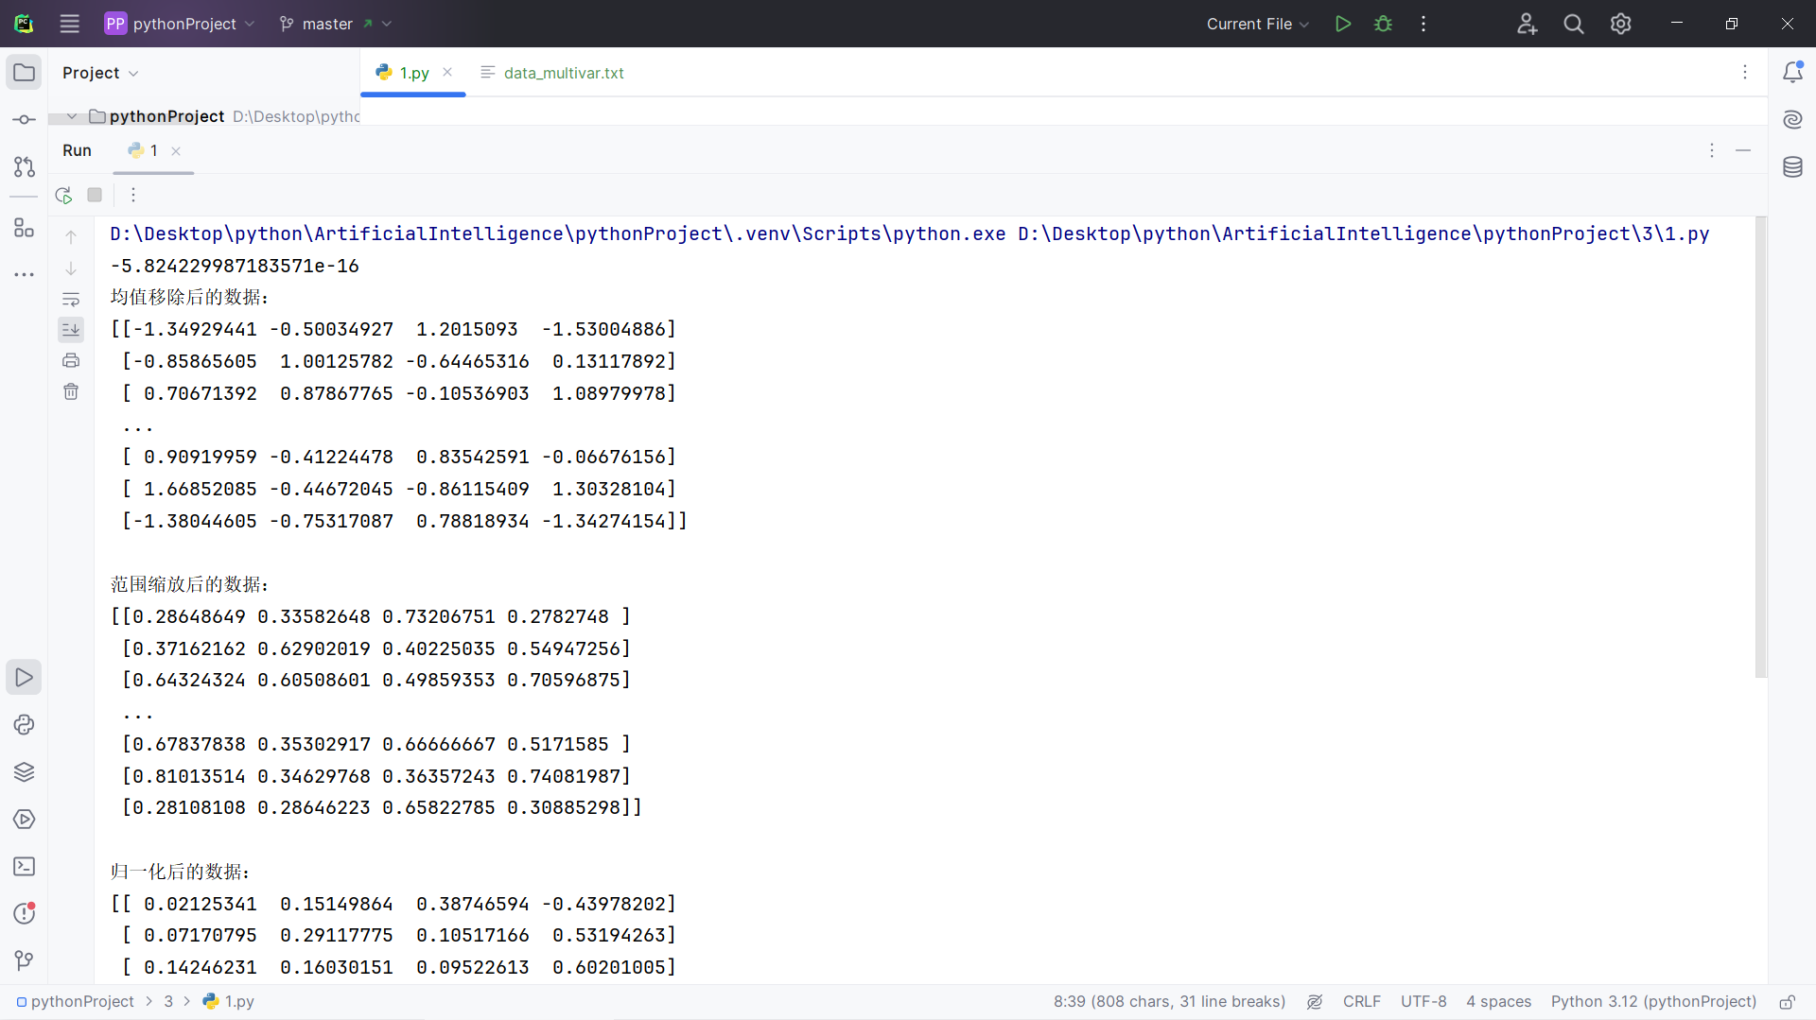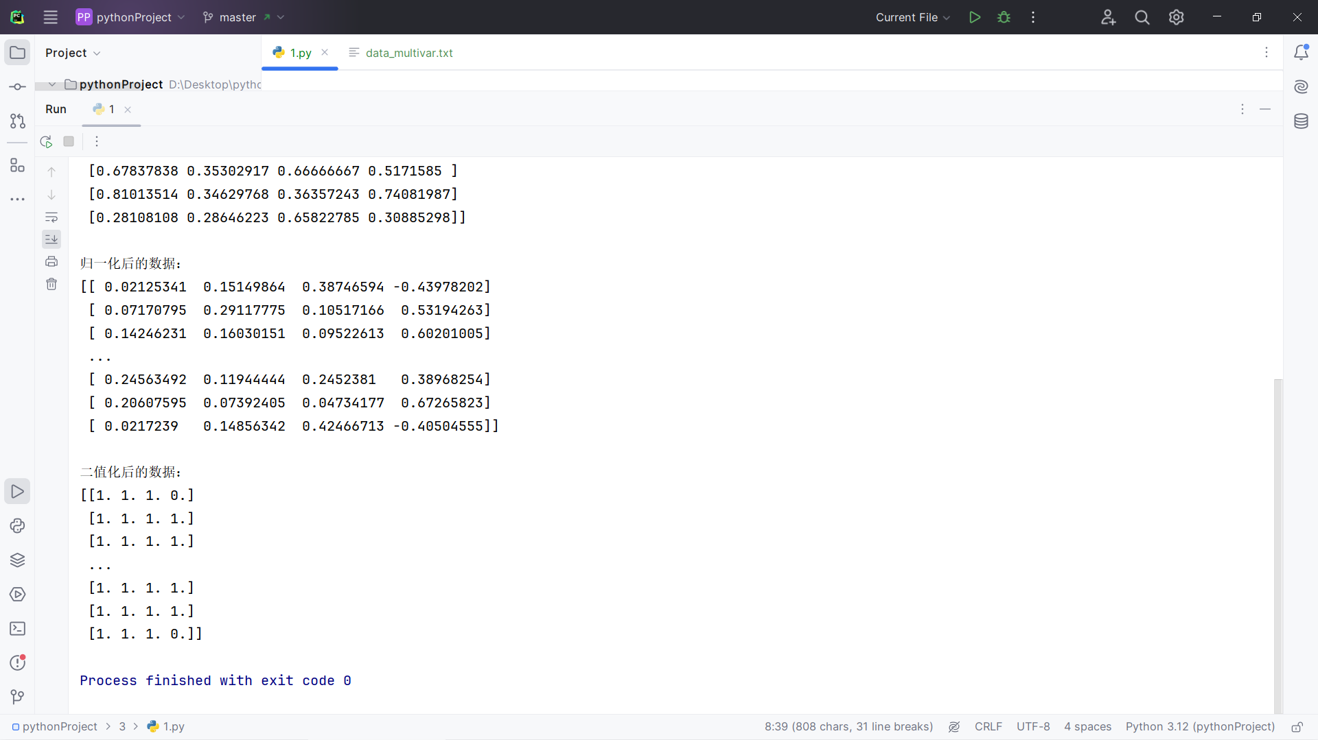

2、读取car.txt数据，将样本的所有特征及最后一列进行labelEncoder和OnehotEncoder编码，输出编码后的数据，并输入任意一个样本反向解码

import numpy as np  
from sklearn.preprocessing import LabelEncoder, OneHotEncoder  
  
# 读取数据  
with open('car.txt', 'r') as file:  
 lines = file.readlines()  
  
# 提取特征和标签  
data = []  
labels = []  
for line in lines:  
 line = line.strip().split(',')  
 data.append(line[:-1]) # 提取特征  
 labels.append(line[-1]) # 提取标签  
  
data = np.array(data)  
labels = np.array(labels)  
  
# 对特征进行 LabelEncoder 编码和 OneHotEncoder 编码  
label_encoders = []  
data_encoded1 = None  
for i in range(data.shape[1]):  
 label_encoder = LabelEncoder()  
 data_encoded_column = label_encoder.fit_transform(data[:, i])  
 if data_encoded1 is None:  
 data_encoded1 = data_encoded_column.reshape(-1, 1)  
 else:  
 data_encoded1 = np.hstack((data_encoded1, data_encoded_column.reshape(-1, 1)))  
 label_encoders.append(label_encoder)  
  
onehot_encoder = OneHotEncoder()  
data_encoded2 = onehot_encoder.fit_transform(data_encoded1)  
  
# 对标签进行 LabelEncoder 编码  
label_encoder_label = LabelEncoder()  
labels_encoded = label_encoder_label.fit_transform(labels)  
  
# 输出编码后的数据  
print("编码后的特征数据（使用LabelEncoder编码后的数据）：")  
print(data_encoded1)  
  
print("编码后的特征数据（使用OneHotEncoder编码后的数据）：")  
print(data_encoded2.toarray())  
  
print("\n编码后的标签数据：")  
print(labels_encoded)  
  
# 反向解码示例  
sample_index = 0 # 假设要解码的是第一个样本  
decoded_label = label_encoder_label.inverse_transform([labels_encoded[sample_index]])[0]  
print("\n反向解码的标签：")  
print(decoded_label)

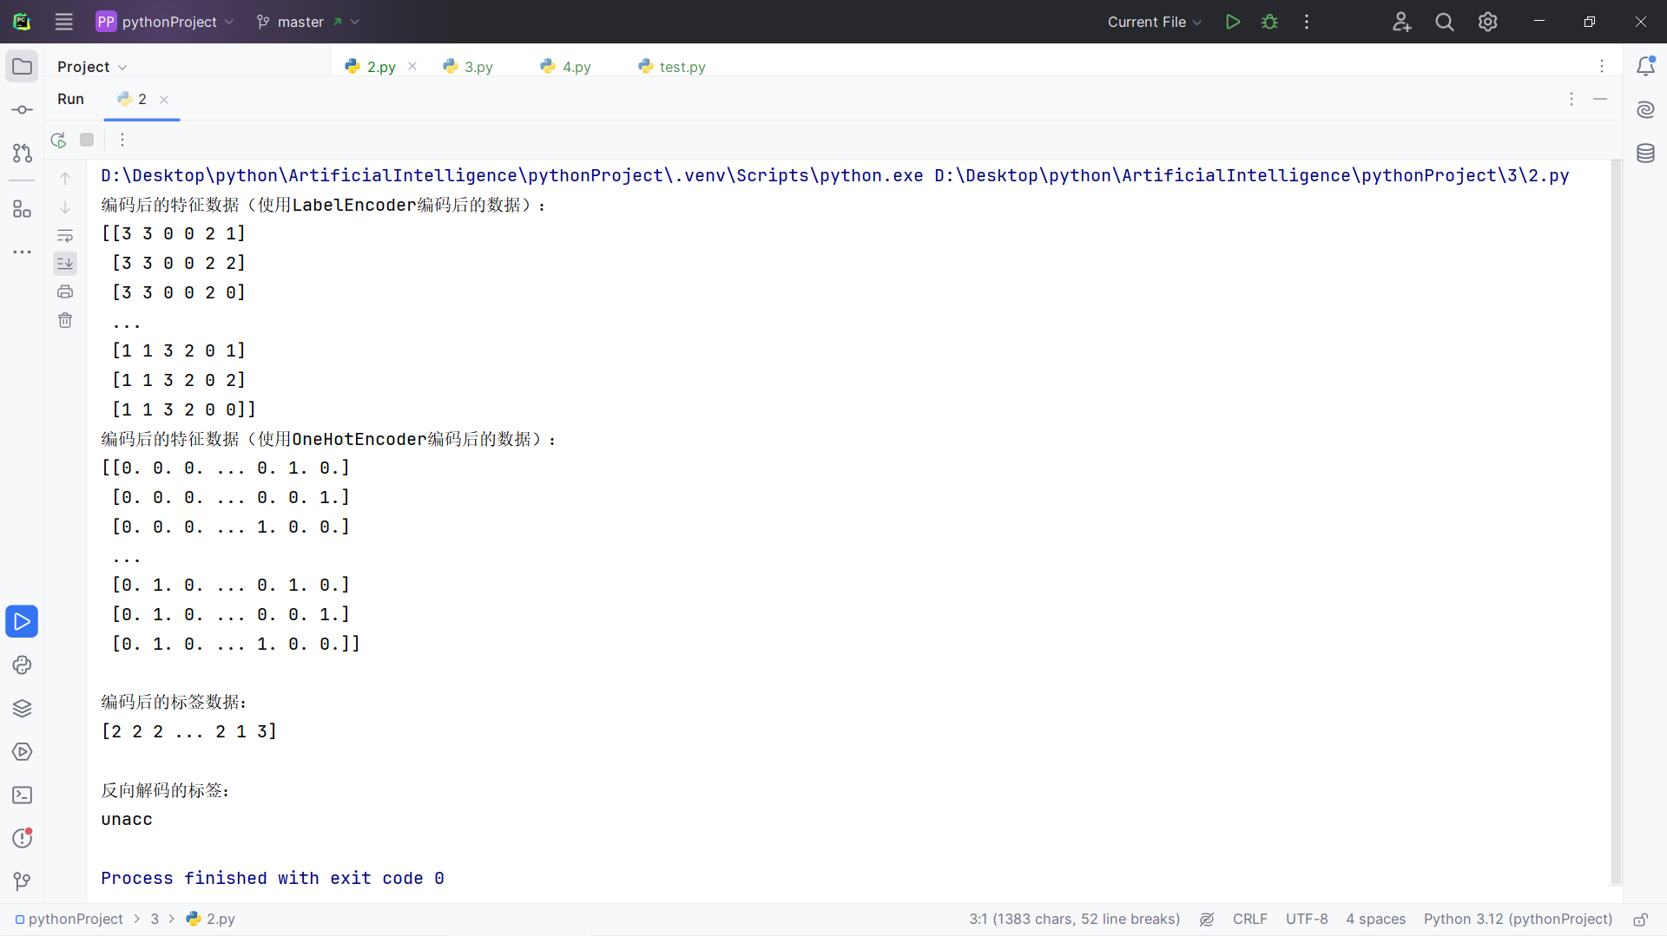

3、读取data_multivar.txt,先对数据进行训练集和测试集拆分（0.2比例），使用线性回归模型对训练集进行训练，输出训练集的预测结果，并输出训练集的均方差MSE，平均绝对误差MAE，R方得分，解释方差

from sklearn.model_selection import train_test_split  
from sklearn.linear_model import LinearRegression  
from sklearn.metrics import mean_squared_error, mean_absolute_error, r2_score, explained_variance_score  
import numpy as np  
  
# 读取数据  
data = np.loadtxt('data_multivar.txt', delimiter=',')  
  
# 划分特征和标签  
X = data[:, :-1]  
y = data[:, -1]  
  
# 划分训练集和测试集  
X_train, X_test, y_train, y_test = train_test_split(X, y, test_size=0.2, random_state=42)  
  
# 创建线性回归模型  
model = LinearRegression()  
  
# 训练模型  
model.fit(X_train, y_train)  
  
# 预测训练集结果  
y_train_pred = model.predict(X_train)  
  
# 计算训练集的均方差MSE  
mse = mean_squared_error(y_train, y_train_pred)  
  
# 计算训练集的平均绝对误差MAE  
mae = mean_absolute_error(y_train, y_train_pred)  
  
# 计算R方得分  
r2 = r2_score(y_train, y_train_pred)  
  
# 计算解释方差  
explained_variance = explained_variance_score(y_train, y_train_pred)  
  
# 输出训练集的预测结果  
print("训练集的预测结果：")  
print(y_train_pred)  
  
# 输出训练集的均方差MSE  
print("训练集的均方差MSE：", mse)  
  
# 输出训练集的平均绝对误差MAE  
print("训练集的平均绝对误差MAE：", mae)  
  
# 输出R方得分  
print("R方得分：", r2)  
  
# 输出解释方差  
print("解释方差：", explained_variance)

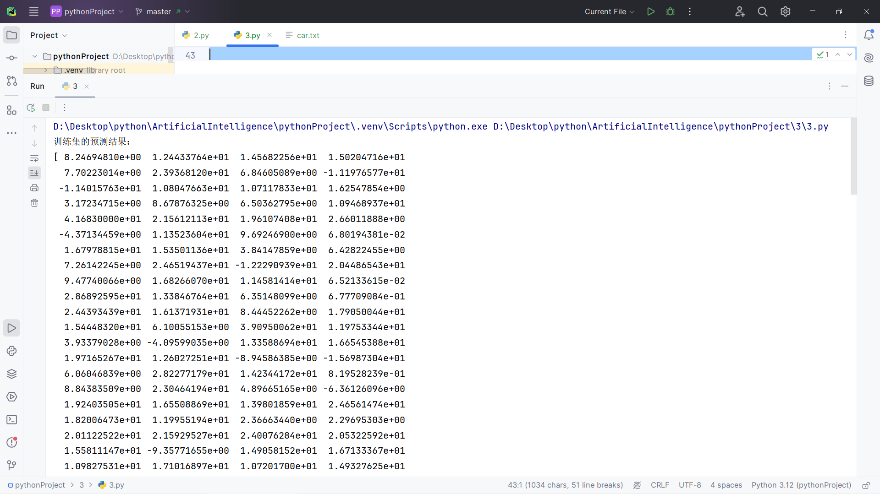

### 中间的预测数据太多了，我直接略过了不截屏了

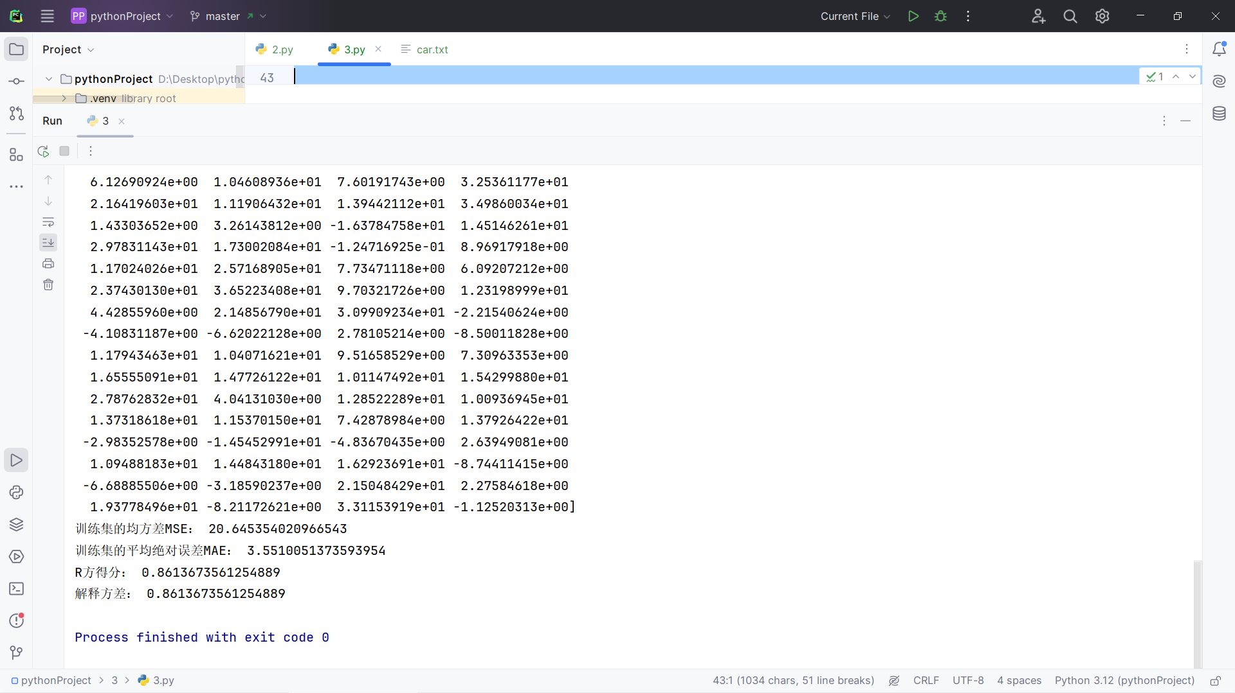

1. 使用训练过的模型预测测试集的结果，输出均方差MSE和平均绝对误差MAE

from sklearn.model_selection import train_test_split  
from sklearn.linear_model import LinearRegression  
from sklearn.metrics import mean_squared_error, mean_absolute_error, r2_score, explained_variance_score  
import numpy as np  
  
# 读取数据  
data = np.loadtxt('data_multivar.txt', delimiter=',')  
  
# 划分特征和标签  
X = data[:, :-1]  
y = data[:, -1]  
  
# 划分训练集和测试集  
X_train, X_test, y_train, y_test = train_test_split(X, y, test_size=0.2, random_state=42)  
  
# 创建线性回归模型  
model = LinearRegression()  
  
# 训练模型  
model.fit(X_train, y_train)  
  
# 预测测试集结果  
y_test_pred = model.predict(X_test)  
# 计算测试集的均方差MSE  
mse_test = mean_squared_error(y_test, y_test_pred)  
  
# 计算测试集的平均绝对误差MAE  
mae_test = mean_absolute_error(y_test, y_test_pred)  
# 输出测试集的均方差MSE  
print("测试集的均方差MSE：", mse_test)  
  
# 输出测试集的平均绝对误差MAE  
print("测试集的平均绝对误差MAE：", mae_test)

