1、读取data_multivar.txt数据

（1）划分训练集和测试集

（2）使用线性模型、岭回归和随机梯度下降模型训练数据，分别输出训练集在三种模型下的mse 和mae，三种模型对测试集的测试结果mse，mae,r2

   (3) 选择三种模型中的一种使用十折交叉验证输出交叉验证后的mse，mae,r2

import numpy as np  
import pandas as pd  
from sklearn.model_selection import train_test_split, cross_val_score  
from sklearn.linear_model import LinearRegression, Ridge  
from sklearn.linear_model import SGDRegressor  
from sklearn.metrics import mean_squared_error, mean_absolute_error, r2_score  
  
# 读取数据  
data = np.loadtxt('../3/data_multivar.txt',delimiter=',')  
# print(data)  
X=data[:,:-1]  
y=data[:,-1]  
# print(X)  
# print(y)  
  
  
# 划分训练集和测试集  
X_train, X_test, y_train, y_test = train_test_split(X, y, test_size=0.2, random_state=42)  
  
# 定义模型  
models = {  
 "Linear Regression": LinearRegression(),  
 "Ridge Regression": Ridge(),  
 "SGD Regression": SGDRegressor()  
}  
  
# 训练模型并输出结果  
results = {}  
for name, model in models.items():  
 model.fit(X_train, y_train)  
 train_pred = model.predict(X_train)  
 test_pred = model.predict(X_test)  
 train_mse = mean_squared_error(y_train, train_pred)  
 train_mae = mean_absolute_error(y_train, train_pred)  
 test_mse = mean_squared_error(y_test, test_pred)  
 test_mae = mean_absolute_error(y_test, test_pred)  
 test_r2 = r2_score(y_test, test_pred)  
 results[name] = {  
 "Train MSE": train_mse,  
 "Train MAE": train_mae,  
 "Test MSE": test_mse,  
 "Test MAE": test_mae,  
 "Test R2": test_r2  
 }  
  
# 输出结果  
for name, metrics in results.items():  
 print(name)  
 for metric, value in metrics.items():  
 print(f"{metric}: {value}")  
 print()  
  
# 选择一种模型进行十折交叉验证  
selected_model = SGDRegressor()  
cv_scores_mse = cross_val_score(selected_model, X, y, cv=10, scoring='neg_mean_squared_error')  
cv_scores_mae = cross_val_score(selected_model, X, y, cv=10, scoring='neg_mean_absolute_error')  
cv_scores_r2 = cross_val_score(selected_model, X, y, cv=10, scoring='r2')  
  
print("Cross-validation results:")  
print(f"CV MSE: {-cv_scores_mse.mean()}")  
print(f"CV MAE: {-cv_scores_mae.mean()}")  
print(f"CV R2: {cv_scores_r2.mean()}")

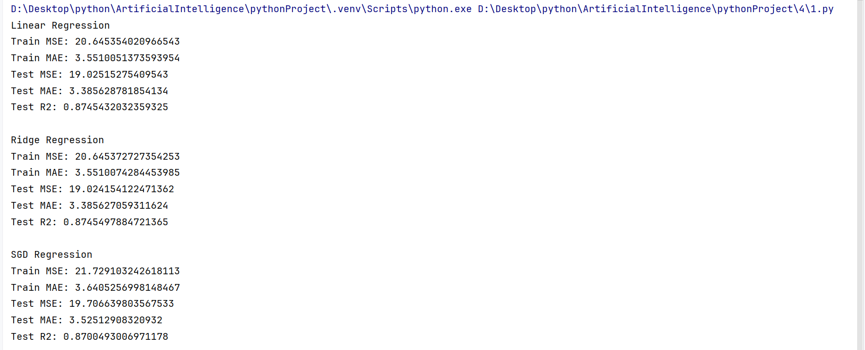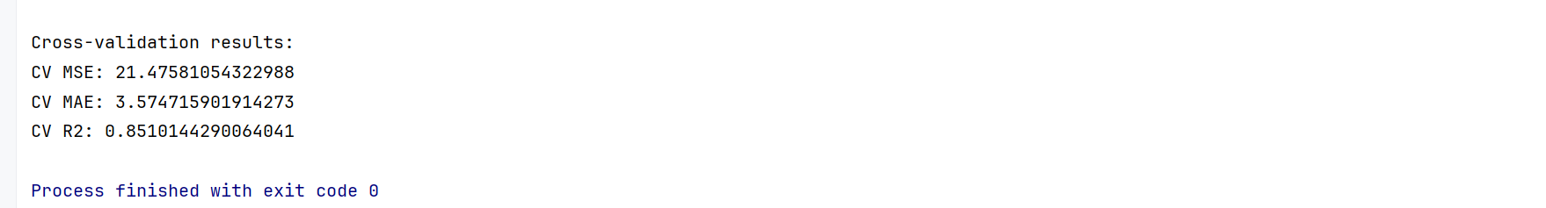

2、获取加州(california)住房数据集

from sklearn.datasets import fetch_california_housing

housing = fetch_california_housing()

艾姆斯住房数据集

# from sklearn.datasets import fetch_openml

# housing = fetch_openml(name="house_prices", as_frame=True)

（1）划分训练集和测试集

（2）岭回归（测试不同的alpha参数）和随机梯度下降模型（测试不同的参数）训练数据，分别输出训练集在两种模型下的mse 和mae，两种模型对测试集的测试结果mse，mae,r2

   (3) 选择一种调试最优的模型使用十折交叉验证输出交叉验证后的mse，mae,r2

(4)保存模型

from sklearn.datasets import fetch_california_housing  
from sklearn.model_selection import train_test_split, cross_val_score  
from sklearn.linear_model import LinearRegression, Ridge  
from sklearn.metrics import mean_squared_error, mean_absolute_error, r2_score  
import joblib  
import numpy as np  
  
# 获取加州住房数据集  
housing = fetch_california_housing()  
  
# 划分训练集和测试集  
X_train, X_test, y_train, y_test = train_test_split(housing.data, housing.target, test_size=0.2, random_state=42)  
  
# 线性模型  
linear_model = LinearRegression()  
linear_model.fit(X_train, y_train)  
train_pred_linear = linear_model.predict(X_train)  
test_pred_linear = linear_model.predict(X_test)  
train_mse_linear = mean_squared_error(y_train, train_pred_linear)  
train_mae_linear = mean_absolute_error(y_train, train_pred_linear)  
test_mse_linear = mean_squared_error(y_test, test_pred_linear)  
test_mae_linear = mean_absolute_error(y_test, test_pred_linear)  
test_r2_linear = r2_score(y_test, test_pred_linear)  
  
print("Linear Model Results:")  
print(f"Train MSE: {train_mse_linear}")  
print(f"Train MAE: {train_mae_linear}")  
print(f"Test MSE: {test_mse_linear}")  
print(f"Test MAE: {test_mae_linear}")  
print(f"Test R2: {test_r2_linear}")  
  
# 岭回归  
alpha_values = [0.1, 1, 10] # 测试不同的alpha参数  
ridge_results = {}  
for alpha in alpha_values:  
 ridge = Ridge(alpha=alpha)  
 ridge.fit(X_train, y_train)  
 train_pred = ridge.predict(X_train)  
 test_pred = ridge.predict(X_test)  
 train_mse = mean_squared_error(y_train, train_pred)  
 train_mae = mean_absolute_error(y_train, train_pred)  
 test_mse = mean_squared_error(y_test, test_pred)  
 test_mae = mean_absolute_error(y_test, test_pred)  
 test_r2 = r2_score(y_test, test_pred)  
 ridge_results[alpha] = {  
 "Train MSE": train_mse,  
 "Train MAE": train_mae,  
 "Test MSE": test_mse,  
 "Test MAE": test_mae,  
 "Test R2": test_r2  
 }  
  
print("\nRidge Regression Results:")  
for alpha, metrics in ridge_results.items():  
 print(f"Alpha: {alpha}")  
 for metric, value in metrics.items():  
 print(f"{metric}: {value}")  
 print()  
  
# 选择模型  
selected_model = linear_model  
  
# 十折交叉验证  
cv_scores_mse = cross_val_score(selected_model, housing.data, housing.target, cv=10, scoring='neg_mean_squared_error')  
cv_scores_mae = cross_val_score(selected_model, housing.data, housing.target, cv=10, scoring='neg_mean_absolute_error')  
cv_scores_r2 = cross_val_score(selected_model, housing.data, housing.target, cv=10, scoring='r2')  
  
print("\nCross-validation results:")  
print(f"CV MSE: {-cv_scores_mse.mean()}")  
print(f"CV MAE: {-cv_scores_mae.mean()}")  
print(f"CV R2: {cv_scores_r2.mean()}")  
print()  
# 保存模型  
joblib.dump(selected_model, 'california_housing_model.pkl')  
  
# 从文件中加载模型  
model = joblib.load('california_housing_model.pkl')  
  
sample = X_train[1]  
  
# 使用加载的模型进行预测  
prediction = model.predict(sample.reshape(1, -1))  
# print(y_train[1])  
# 打印预测结果  
print("Predicted housing price:", prediction)

