1、读取iris.txt数据，划分训练集和测试集，

（1）使用逻辑回归模型训练数据，画出训练集的混淆矩阵图。

（2）分别输出测试集在average='macro'和average='weighted'时的精确率、召回率和F1分数，

（3）输出测试集预测的性能报告

（4）分别画正则参数C=100 和C=1时的分类器模型图（数据选用前两维或后两维都可以）

import numpy as np  
import pandas as pd  
import matplotlib.pyplot as plt  
from sklearn.model_selection import train_test_split  
from sklearn.linear_model import LogisticRegression  
from sklearn.metrics import confusion_matrix, classification_report  
from sklearn.preprocessing import StandardScaler, LabelEncoder  
  
# 1. 读取iris数据  
iris_df = pd.read_csv('../iris.csv')  
  
# 划分特征和标签  
X = iris_df.iloc[:, :-1].values  
y = iris_df.iloc[:, -1].values  
scaler=StandardScaler()  
X=scaler.fit_transform(X)  
label_encoder = LabelEncoder()  
y_encoded = label_encoder.fit_transform(y)  
# 划分训练集和测试集  
X_train, X_test, y_train, y_test = train_test_split(X, y_encoded, test_size=0.2, random_state=42)  
  
# (1) 使用逻辑回归模型训练数据，画出训练集的混淆矩阵图  
log_reg = LogisticRegression()  
log_reg.fit(X_train, y_train)  
y_pred_train = log_reg.predict(X_train)  
conf_matrix_train = confusion_matrix(y_train, y_pred_train)  
  
plt.imshow(conf_matrix_train, cmap='Blues', interpolation='nearest')  
plt.colorbar()  
plt.xlabel('Predicted labels')  
plt.ylabel('True labels')  
plt.xticks(np.arange(len(iris_df['Species'].unique())), iris_df['Species'].unique())  
plt.yticks(np.arange(len(iris_df['Species'].unique())), iris_df['Species'].unique())  
plt.title('Confusion Matrix - Training Set')  
plt.show()  
  
# (2) 分别输出测试集在average='macro'和average='weighted'时的精确率、召回率和F1分数  
from sklearn.metrics import precision_recall_fscore_support  
  
def print_metrics(y_true, y_pred, average):  
 precision, recall, f1, _ = precision_recall_fscore_support(y_true, y_pred, average=average)  
 print(f'Precision ({average}): {precision}')  
 print(f'Recall ({average}): {recall}')  
 print(f'F1-score ({average}): {f1}')  
  
print_metrics(y_test, log_reg.predict(X_test), average='macro')  
print_metrics(y_test, log_reg.predict(X_test), average='weighted')  
  
# (3) 输出测试集预测的性能报告  
print(classification_report(y_test, log_reg.predict(X_test)))  
  
# # (4) 分别画正则参数C=100 和C=1时的分类器模型图  
def plot_decision_boundary(classifier, X, y, title):  
 x_min, x_max = X[:, 0].min() - 1.0, X[:, 0].max() + 1.0  
 y_min, y_max = X[:, 1].min() - 1.0, X[:, 1].max() + 1.0  
  
 step_size = 0.01  
 x_values, y_values = np.meshgrid(np.arange(x_min, x_max, step_size), np.arange(y_min, y_max, step_size))  
 mesh_output = classifier.predict(np.c_[x_values.ravel(), y_values.ravel()])  
 mesh_output = mesh_output.reshape(x_values.shape)  
 # print(x_values)  
 plt.figure()  
 plt.pcolormesh(x_values, y_values, mesh_output, cmap=plt.cm.gray)  
 plt.scatter(X[:, 0], X[:, 1], c=y, s=80, edgecolors='black', linewidth=1, cmap=plt.cm.Paired)  
 plt.xlim(x_values.min(), x_values.max())  
 plt.ylim(y_values.min(), y_values.max())  
 # specify the ticks on the X and Y axes  
 plt.xticks((np.arange(int(min(X[:, 0]) - 1), int(max(X[:, 0]) + 1), 1.0)))  
 plt.yticks((np.arange(int(min(X[:, 1]) - 1), int(max(X[:, 1]) + 1), 1.0)))  
 plt.title(title)  
 plt.show()  
  
  
C_values = [100, 1]  
for C in C_values:  
 log_reg = LogisticRegression(C=C)  
 log_reg.fit(X_train[:, :2], y_train) # 使用前两维特征  
 plot_decision_boundary(log_reg,X_train[:, :2],y_train , f'Logistic Regression (C={C})')

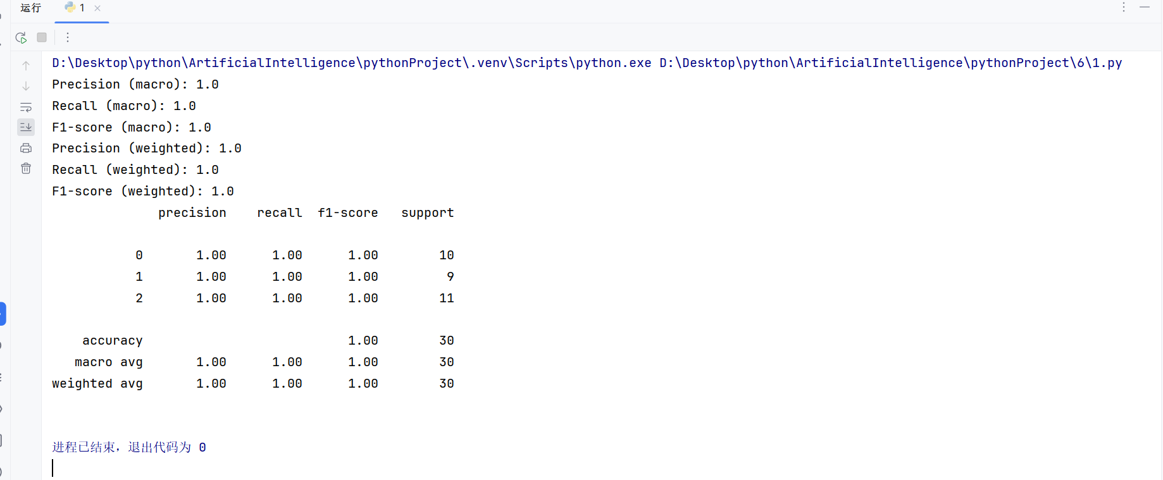

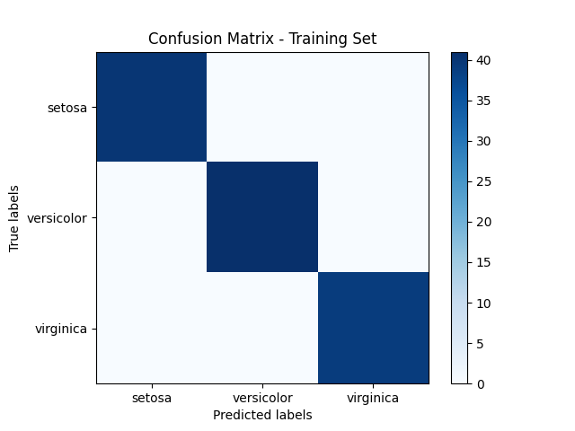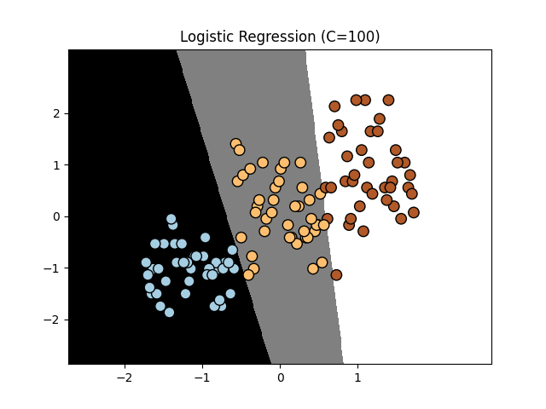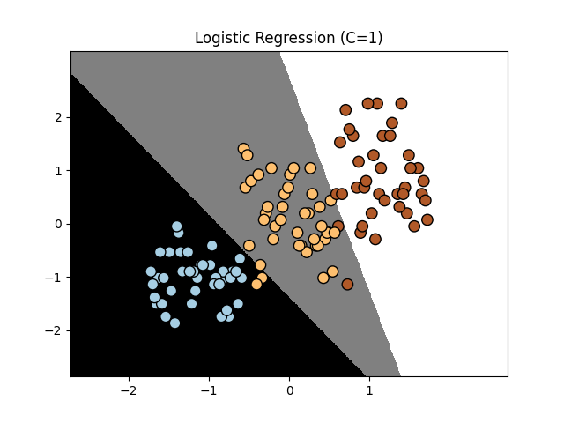

2、读取car.txt数据，对样本特征和标签数据进行编码（OneHot/LabelEncoder)，

（1）统计不同类别样本的个数并输出，

（2）选择一种average评价指标，使用逻辑回归模型训练数据，并输出五折交叉验证的正确率，精确率、召回率和F1分数

（3）输出五折交叉验证的性能报告

（4）生成一个测试样本，使用模型进行预测，并输出预测值。

import numpy as np  
import pandas as pd  
import sklearn.metrics as ms  
from sklearn.preprocessing import OneHotEncoder, LabelEncoder  
from sklearn.model_selection import cross_val_score, cross_validate, train_test_split, cross_val_predict  
from sklearn.linear_model import LogisticRegression  
from sklearn.metrics import accuracy_score, precision_score, recall_score, f1_score, classification_report,make_scorer  
  
# 读取数据  
car_df = pd.read_csv('../3/car.txt', header=None)  
  
# 对特征数据进行OneHot编码  
X = pd.get_dummies(car_df.iloc[:, :-1])  
X1=X  
X=np.array(X)  
y_original = car_df.iloc[:, -1]  
  
# 统计编码前每个类别的个数  
unique_labels, counts = np.unique(y_original, return_counts=True)  
  
print("不同类别样本的个数：")  
for label, count in zip(unique_labels, counts):  
 print(f"Class {label}: {count} samples")  
# 对标签数据进行LabelEncoder编码  
label_encoder = LabelEncoder()  
y = label_encoder.fit_transform(car_df.iloc[:, -1])  
  
# (2) 选择一种average评价指标，使用逻辑回归模型训练数据，并输出五折交叉验证的正确率、精确率、召回率和F1分数  
# scoring = ['accuracy', 'precision_macro', 'recall_macro', 'f1_macro']  
scoring = {  
 'accuracy': make_scorer(accuracy_score),  
 'precision': make_scorer(precision_score, zero_division=0,average='weighted'),  
 'recall': make_scorer(recall_score, zero_division=0,average='weighted'),  
 'f1': make_scorer(f1_score, zero_division=0,average='weighted'),  
}  
log_reg = LogisticRegression()  
  
# cv_results = cross_validate(log_reg, X, y, cv=5, scoring=scoring,error_score=0)  
for key,value in scoring.items():  
 scores = cross_val_score(log_reg, X, y, cv=5, scoring=value)  
 scoring[key]=scores  
 # print(scores)  
accuracy_avg = np.mean(scoring['accuracy'])  
precision_avg = np.mean(scoring['precision'])  
recall_avg = np.mean(scoring['recall'])  
f1_avg = np.mean(scoring['f1'])  
  
print("\n五折交叉验证结果：")  
print(f"平均正确率：{accuracy_avg}")  
print(f"平均精确率：{precision_avg}")  
print(f"平均召回率：{recall_avg}")  
print(f"平均F1分数：{f1_avg}")  
  
# (3) 输出五折交叉验证的性能报告  
print("\n五折交叉验证性能报告：")  
log_reg.fit(X, y) # 使用全部数据进行训练  
# print(X)  
y_pred = cross_val_predict(log_reg, X, y, cv=5) # 预测  
print(classification_report(y, y_pred))  
  
# (4) 生成一个测试样本，使用模型进行预测，并输出预测值  
# 假设新的测试样本为第一行数据  
test_sample = X1.iloc[0, :].values.reshape(1, -1)  
predicted_class = log_reg.predict(test_sample)  
predicted_class_label = label_encoder.inverse_transform(predicted_class)  
print(f"\n测试样本的预测类别为：{predicted_class_label}")

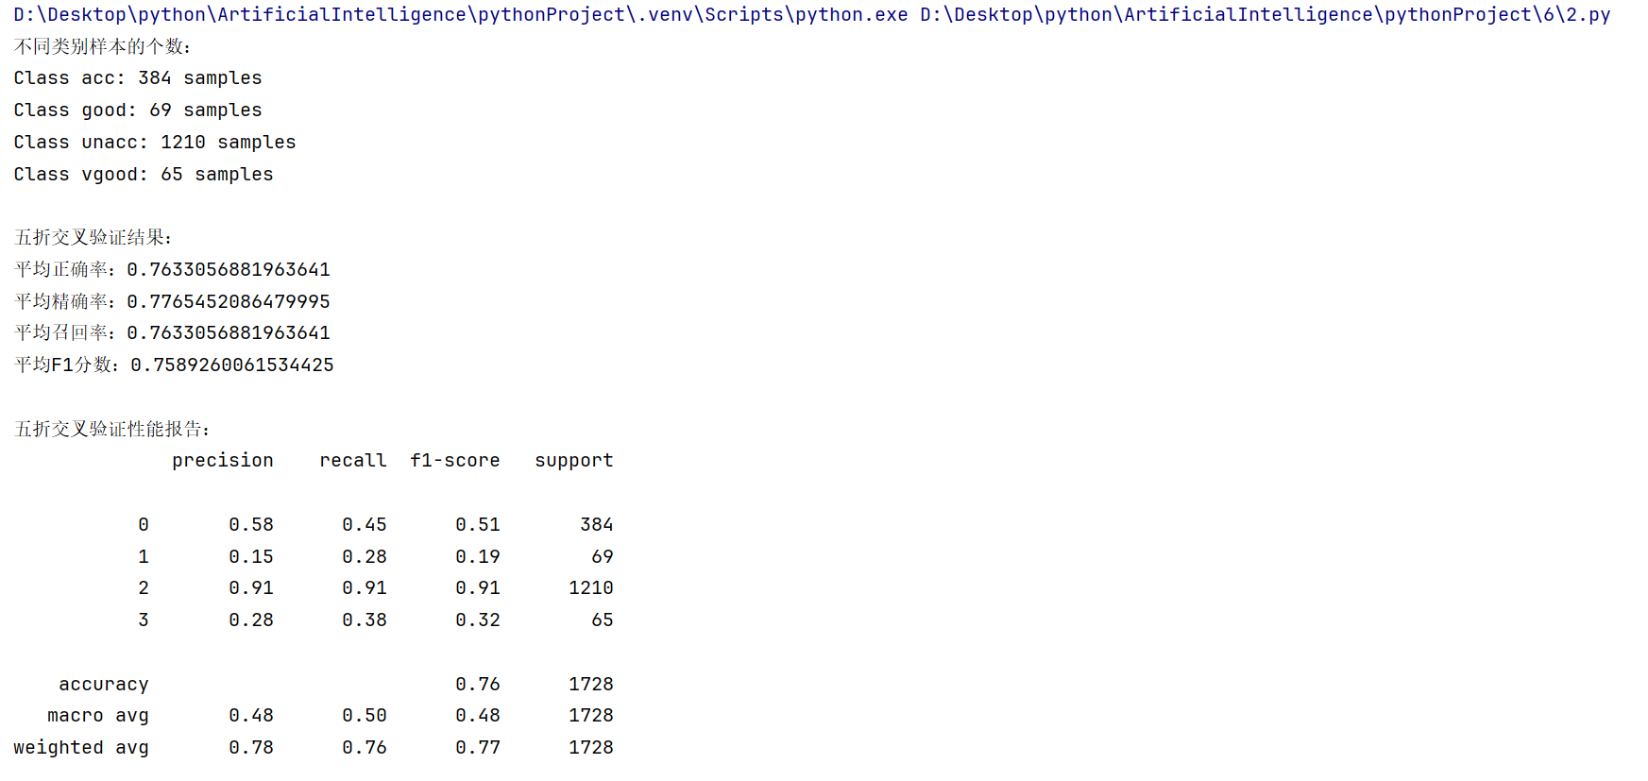

3、读取data_nn_classifier.txt数据

（1）使用KNN分类模型训练数据，分别输出数据集在average='macro'和average='weighted'时的精确率、召回率和F1分数

（2）画出测试集的混淆矩阵图，及测试集的性能报告

（3）画KNN分类模型图（包含分类边界）

（4）输入新测试样本，输出新样本的预测值，并对画出KNN分类结果图（包含新样本，新样本的标签及K个邻近点）

import numpy as np  
import pandas as pd  
import matplotlib.pyplot as plt  
from sklearn.model_selection import train_test_split  
from sklearn.neighbors import KNeighborsClassifier  
from sklearn.metrics import confusion_matrix, classification_report, precision_score, recall_score, f1_score  
from mlxtend.plotting import plot_decision_regions  
import seaborn as sns  
  
# 读取数据  
data = pd.read_csv("data_nn_classifier.txt")  
  
# 提取特征和标签  
X = data.iloc[:, :-1].values  
y = data.iloc[:, -1].values  
  
# 划分训练集和测试集  
X_train, X_test, y_train, y_test = train_test_split(X, y, test_size=0.2, random_state=42)  
  
# 训练KNN分类器  
knn = KNeighborsClassifier()  
knn.fit(X, y)  
  
# 任务(1): 输出精确率、召回率和F1分数  
for average in ['macro', 'weighted']:  
 y_pred = knn.predict(X)  
 precision = precision_score(y, y_pred, average=average)  
 recall = recall_score(y, y_pred, average=average)  
 f1 = f1_score(y, y_pred, average=average)  
 print(f"Average: {average}")  
 print(f"Precision: {precision}")  
 print(f"Recall: {recall}")  
 print(f"F1 Score: {f1}")  
  
# 任务(2): 绘制混淆矩阵图和性能报告  
y_pred = knn.predict(X_test)  
conf_matrix = confusion_matrix(y_test, y_pred)  
plt.figure(figsize=(8, 6))  
sns.heatmap(conf_matrix, annot=True, fmt='d', cmap='Blues')  
plt.xlabel('Predicted labels')  
plt.ylabel('True labels')  
plt.title('Confusion Matrix')  
plt.show()  
  
# print("Confusion Matrix:")  
# print(conf_matrix)  
print("Classification Report:")  
print(classification_report(y_test, y_pred))  
  
# 任务(3): 绘制KNN分类模型图  
plt.figure(figsize=(10, 6))  
plot_decision_regions(X_train, y_train, clf=knn, legend=2)  
plt.xlabel('Feature 1')  
plt.ylabel('Feature 2')  
plt.title('KNN Classifier Decision Regions')  
plt.show()  
  
# 任务(4): 输入新测试样本，输出预测值，并绘制KNN分类结果图  
# 假设新测试样本为X_new  
X_new = np.array([[1.5, 2.5]]) # 请根据实际情况修改新测试样本的值  
y_new_pred = knn.predict(X_new)  
print("Predicted Class for New Sample:", y_new_pred)  
  
from sklearn.neighbors import NearestNeighbors  
  
# 找到新样本的K个最近邻点  
k = 5 # 假设K值为5  
neigh = NearestNeighbors(n_neighbors=k)  
neigh.fit(X)  
distances, indices = neigh.kneighbors(X_new)  
label = 'New Sample (Predicted to be' + str(y_new_pred) + ')'  
# print(indices)  
# 绘制KNN分类结果图  
plt.figure(figsize=(10, 6))  
# plot_decision_regions(X, y, clf=knn, legend=0, scatter_kwargs={'alpha': 0, 'label': None})  
plot_decision_regions(X, y, clf=knn, legend=2)  
l1 = plt.scatter(X_new[:, 0], X_new[:, 1], c='r', marker='x', label=label)  
l2 = plt.scatter(X[indices[0], 0], X[indices[0], 1], c='g', marker='o', label='Nearest Neighbors')  
plt.xlabel('Feature 1')  
plt.ylabel('Feature 2')  
plt.title('KNN Classifier Decision Regions with New Sample and Nearest Neighbors')  
# plt.get_legend().remove()  
# plt.legend([l1, l2], [label, 'Nearest Neighbors'])  
plt.legend()  
plt.show()

