1、读取data_multivar_imbalance.txt数据，

（1）根据labels对样本前两列特征进行数据可视化

（2） 划分训练集和测试集，使用SVC模型训练数据，

      手动调参，核函数分别为linear, poly，sigmoid, rbf时，设置参数

      输出不同参数下的测试集的性能报告

（3）使用网格调参，输出网格调参下的模型得分，最佳参数取值组合，最佳预测精度值，学习模型

（4）使用非网格调参，基于最高分数的参数集模型输出测试集的性能报告

（5）使用嵌套交叉验证机制下的网格参数寻优搜索，输出测试集的性能报告

import pandas as pd  
import numpy as np  
import matplotlib.pyplot as plt  
from sklearn.model_selection import train_test_split, GridSearchCV, cross_val_score, cross_val_predict  
from sklearn.svm import SVC  
from sklearn.metrics import classification_report  
import warnings  
warnings.filterwarnings("ignore")  
  
# 1. 读取data_multivar_imbalance.txt数据  
data = pd.read_csv("data_multivar_imbalance.txt", header=None)  
  
# print(data)  
# 添加列名  
data.columns = ['feature1', 'feature2', 'labels']  
  
# 2. 根据labels对样本前两列特征进行数据可视化  
plt.figure(figsize=(10, 6))  
for label in data['labels'].unique():  
 subset = data[data['labels'] == label]  
 plt.scatter(subset['feature1'], subset['feature2'], label=label)  
plt.xlabel('Feature 1')  
plt.ylabel('Feature 2')  
plt.legend()  
plt.title('Feature 1 vs Feature 2 by Label')  
plt.show()  
  
# 3. 划分训练集和测试集  
X = data[['feature1', 'feature2']]  
y = data['labels']  
X_train, X_test, y_train, y_test = train_test_split(X, y, test_size=0.2, random_state=42)  
  
# 设置SVC模型参数和核函数  
params = [  
 {'kernel':'linear','C':1.0,'tol':0.001},  
 {'kernel':'poly','C':1.0,'degree':3,'gamma':'auto','tol':0.001},  
 {'kernel':'sigmoid','C':1.0,'gamma':'auto','tol':0.001},  
 {'kernel': 'rbf', 'C': 1.0, 'gamma': 'auto', 'tol': 0.001}  
]  
  
# 4. 手动调参，输出不同参数下的测试集的性能报告  
for param in params:  
 svc = SVC(**param)  
 svc.fit(X_train, y_train)  
 y_pred = svc.predict(X_test)  
 print("Parameters:", param)  
 print(classification_report(y_test, y_pred))  
  
# 5. 使用网格调参  
param_grid = {  
 'C': [0.1, 1, 10],  
 'gamma': [0.1, 1, 'scale', 'auto']  
}  
  
grid_search = GridSearchCV(SVC(), param_grid, cv=5)  
grid_search.fit(X_train, y_train)  
  
# 输出网格调参下的模型得分，最佳参数取值组合，最佳预测精度值，学习模型  
print("Grid Search Best Score:", grid_search.best_score_)  
print("Grid Search Best Parameters:", grid_search.best_params_)  
print("Grid Search Best Estimator:", grid_search.best_estimator_)  
print("Grid Search Test Score:", grid_search.score(X_test, y_test))  
print('\n')  
# 6. 使用非网格调参，基于最高分数的参数集模型输出测试集的性能报告  
param_grid2=[{'kernel':['linear'],'C':[1,10,50,600]},  
 {'kernel':['poly'],'degree':[2,3],'C':[1,10,50,600]},  
 {'kernel':['sigmoid'],'C':[1,10,50,600]},  
 {'kernel':['rbf'],'gamma':[0.1,1,10],'C':[1,10,50]}]  
grid_search2 = GridSearchCV(SVC(), param_grid2, cv=5)  
grid_search2.fit(X_train, y_train)  
best_params = grid_search2.best_params_  
best_svc = SVC(**best_params)  
best_svc.fit(X_train, y_train)  
y_pred = best_svc.predict(X_test)  
print("Best Parameters:", best_params)  
print(classification_report(y_test, y_pred))  
  
# 7. 使用嵌套交叉验证机制下的网格参数寻优搜索  
nested_predict = cross_val_predict(grid_search, X_test, y_test, cv=5)  
# print(nested_predict.mean())  
print(classification_report(y_test,nested_predict))  
# print("Nested Cross-Validation Score:", nested_score.mean())

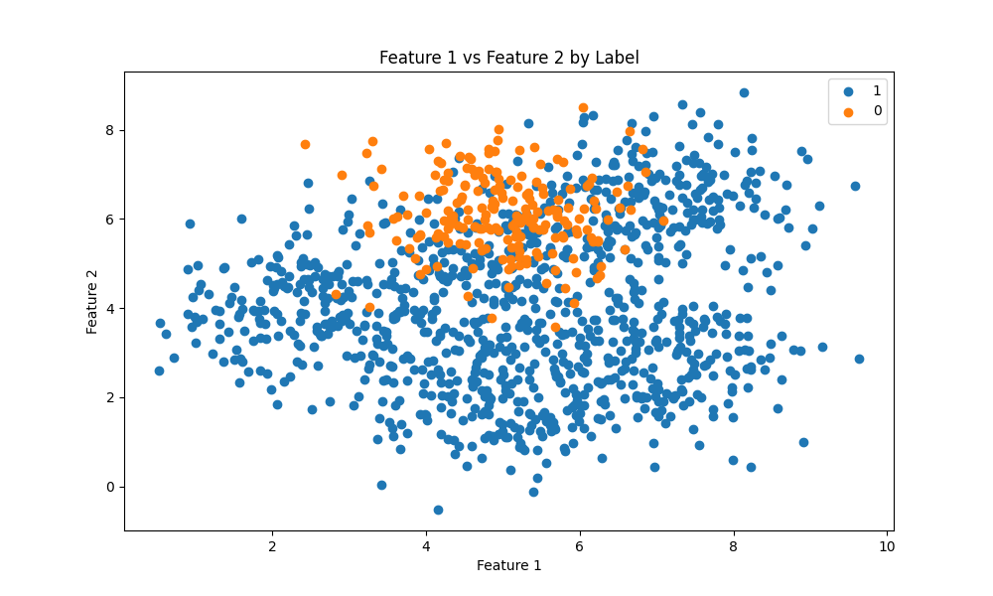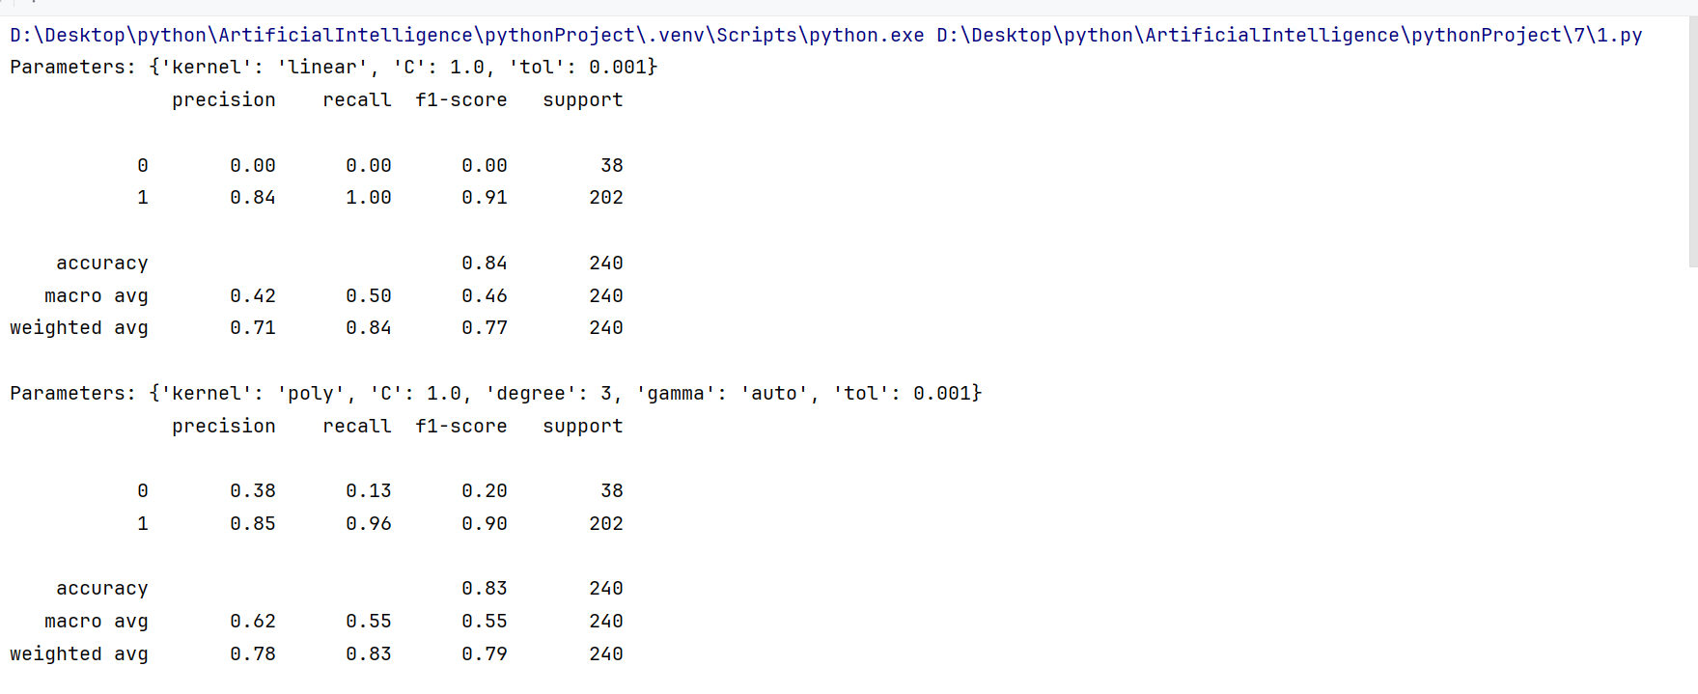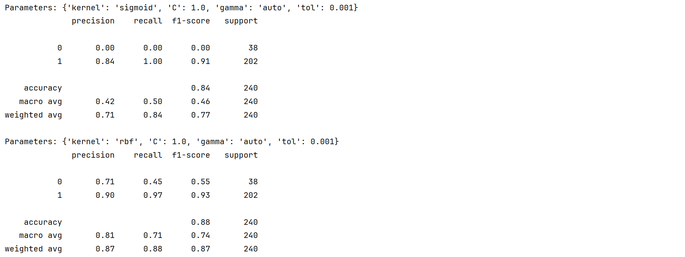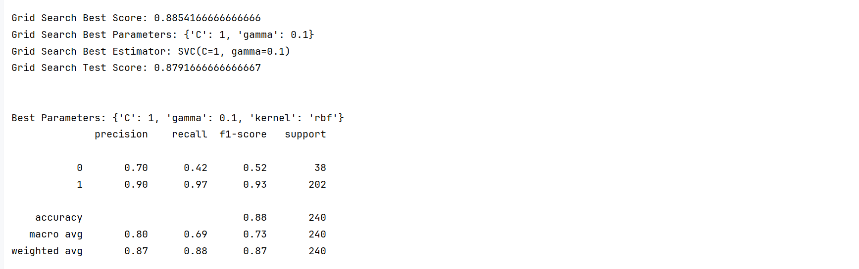

嵌套交叉验证机制下的网格参数寻优搜索，输出测试集的性能报告：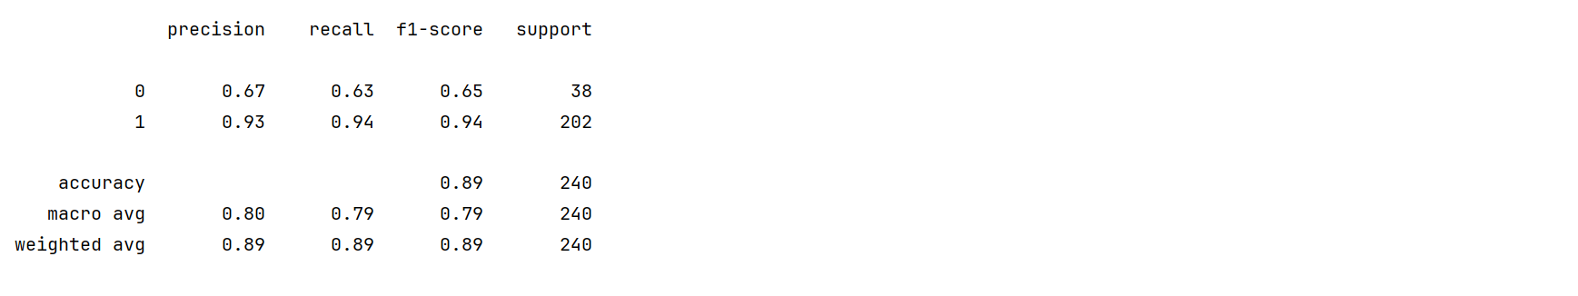

2、读取heart.csv数据

      （1） 划分训练集和测试集，使用SVM模型训练数据

          任选一种网格调参方式，输出调参下的模型得分，最佳参数取值组合，最佳预测精度值，学习模型

        （2）基于调参后的最优学习模型，输出测试集的性能报告

import pandas as pd  
from sklearn.model_selection import train_test_split, GridSearchCV  
from sklearn.svm import SVC  
from sklearn.metrics import classification_report  
  
# 1. 读取 heart.csv 数据集  
heart_data = pd.read_csv("../5/heart.csv")  
  
# 2. 划分训练集和测试集  
X = heart_data.drop('target', axis=1)  
y = heart_data['target']  
X_train, X_test, y_train, y_test = train_test_split(X, y, test_size=0.2, random_state=42)  
  
# 3. 定义网格调参的参数范围  
param_grid = {  
 'C': [0.1, 1, 10, 100],  
 'gamma': [0.1, 1, 10],  
 # 'kernel': ['linear', 'poly', 'rbf', 'sigmoid']  
}  
  
# 4. 使用网格调参  
grid_search = GridSearchCV(SVC(), param_grid, cv=5)  
grid_search.fit(X_train, y_train)  
  
# 输出网格调参下的模型得分，最佳参数取值组合，最佳预测精度值，学习模型  
print("Grid Search Best Score:", grid_search.best_score_)  
print("Grid Search Best Parameters:", grid_search.best_params_)  
print("Grid Search Best Estimator:", grid_search.best_estimator_)  
print("Grid Search Test Score:", grid_search.score(X_test, y_test))  
  
# 5. 输出测试集的性能报告  
y_pred = grid_search.predict(X_test)  
print("Test Set Performance Report:")  
print(classification_report(y_test, y_pred))

