1、基于生成数据、多项式特征生成，数据归一化和SVM构建机器学习流水线

（1）使用make_classification 或者 make_moons()生成二维二元分类数据集，根据标签进行样本数据可视化

（2）参数：多项式特征生成PolynomialFeatures()， 归一化方式StandardScaler()，

SVM的选择：线性 LinearSVC()和SVC()

多项式 SVC()和SVC()

构建机器学习流水线模型Pipeline()，基于流水线模型训练输出各种参数下，流水线模型对应的性能报告

（3）将网格调参GridSearchCV与Pipeline进行结合使用构建基于流水线的网格寻参模型，进行训练数据，输出最优参数集合和最优模型，使用最优模型测试模型的测试集输出测试集的性能报告

import numpy as np  
import matplotlib.pyplot as plt  
from sklearn.datasets import make_classification  
from sklearn.pipeline import Pipeline  
from sklearn.preprocessing import PolynomialFeatures, StandardScaler  
from sklearn.svm import LinearSVC, SVC  
from sklearn.model_selection import train_test_split, GridSearchCV  
from sklearn.metrics import classification_report  
  
# 生成三维二元分类数据集并可视化  
X, y = make_classification(n_samples=500, n_features=2, n_classes=2, n_clusters_per_class=1,  
 n_informative=2, n_redundant=0, n_repeated=0, random_state=42)  
plt.scatter(X[:, 0], X[:, 1], c=y, cmap=plt.cm.Paired)  
plt.xlabel('Feature 1')  
plt.ylabel('Feature 2')  
plt.title('Generated Classification Data')  
plt.show()  
  
# 划分训练集和测试集  
X_train, X_test, y_train, y_test = train_test_split(X, y, test_size=0.2, random_state=42)  
  
# 构建机器学习流水线  
pipelines = {  
 'LinearSVC': Pipeline([('poly', PolynomialFeatures()), ('scaler', StandardScaler()), ('clf', LinearSVC(dual='auto'))]),  
 'SVC_linear': Pipeline([('poly', PolynomialFeatures()), ('scaler', StandardScaler()), ('clf', SVC(kernel='linear'))]),  
 'SVC_poly': Pipeline([('poly', PolynomialFeatures()), ('scaler', StandardScaler()), ('clf', SVC(kernel='poly'))]),  
 'SVC_rbf': Pipeline([('poly', PolynomialFeatures()), ('scaler', StandardScaler()), ('clf', SVC(kernel='rbf'))])  
}  
  
# 训练模型并输出性能报告  
for name, pipeline in pipelines.items():  
 pipeline.fit(X_train, y_train)  
 y_pred = pipeline.predict(X_test)  
 print(f"=== {name} ===")  
 print(classification_report(y_test, y_pred))  
  
# 结合网格调参寻找最优参数组合  
parameters = {  
 'poly__degree': [2, 3],  
 'clf__C': [0.1, 1, 10],  
 'clf__gamma': [0.1, 1, 10]  
}  
  
grid_search = GridSearchCV(pipelines['SVC_rbf'], parameters, cv=5, n_jobs=-1)  
grid_search.fit(X_train, y_train)  
  
# 输出最优参数组合和最优模型的性能报告  
best_params = grid_search.best_params_  
best_model = grid_search.best_estimator_  
print("Best Parameters:", best_params)  
y_pred = best_model.predict(X_test)  
print("Best Model Performance:")  
print(classification_report(y_test, y_pred))

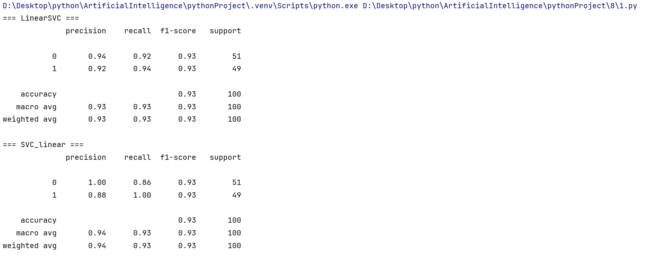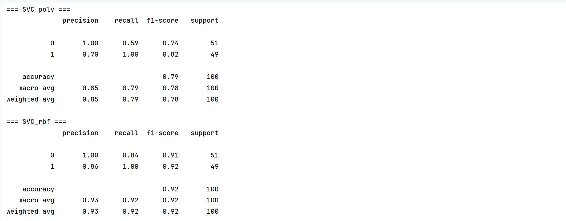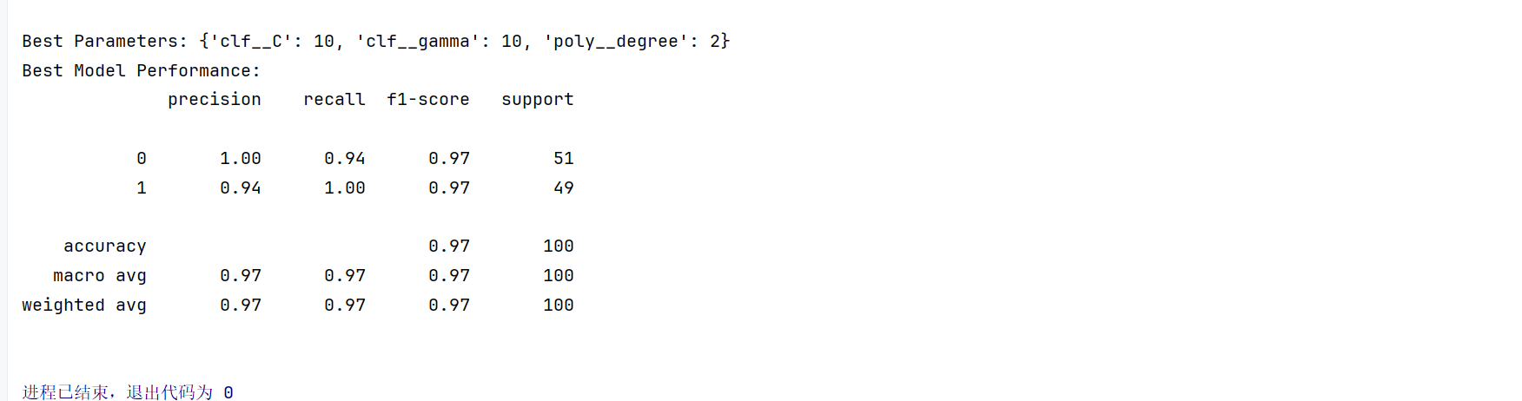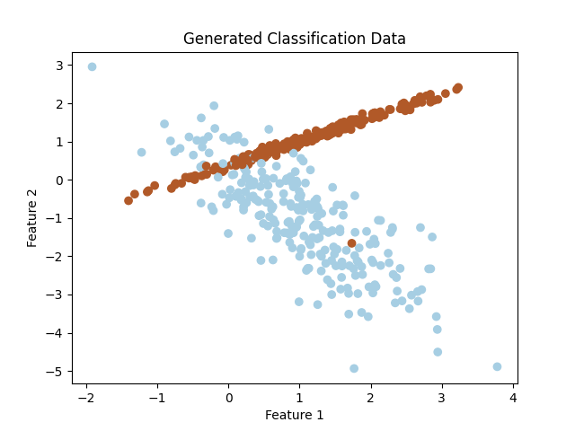

2、多特征分类中的特征选择

（1）导入datasets.load_digit()数据，使用 SelectKBest(chi2, k>=20)选择最优特征

（2）输出各个特征的的得分和返回特征过滤后保留下的特征列索引

（3）基于特征过滤后保留下的特征数据集和SVC（参数自己定）构建机器学习流水线

Pipeline([('selector', ),

('svm', )])，使用该模型训练数据，输出性能报告

from sklearn.datasets import load_digits  
from sklearn.feature_selection import SelectKBest, chi2  
from sklearn.pipeline import Pipeline  
from sklearn.svm import SVC  
from sklearn.model_selection import train_test_split  
from sklearn.metrics import classification_report  
  
# 导入数据集  
digits = load_digits()  
X, y = digits.data, digits.target  
  
# 特征选择  
selector = SelectKBest(chi2, k=20) # 选择得分最高的20个特征  
# X_selected = selector.fit_transform(X, y)  
selector.fit(X, y)  
selected_feature_indices = selector.get_support(indices=True)  
feature_scores = selector.scores_  
  
# 输出特征得分和选择后的特征列索引  
print("Feature Scores:")  
for i, score in enumerate(feature_scores):  
 print(f"Feature {i}: {score}")  
print("\nSelected Feature Indices:", selected_feature_indices)  
  
# 划分训练集和测试集  
# X_train, X_test, y_train, y_test = train_test_split(X_selected, y, test_size=0.2, random_state=42)  
X_train, X_test, y_train, y_test = train_test_split(X, y, test_size=0.2, random_state=42)  
# 构建机器学习流水线  
pipeline = Pipeline([  
 ("selector",SelectKBest(chi2, k=20)),  
 ('svm', SVC(kernel='rbf', C=1.0, gamma='scale')) # 参数可以自行调整  
])  
  
# 训练模型并输出性能报告  
pipeline.fit(X_train, y_train)  
y_pred = pipeline.predict(X_test)  
print("\nClassification Report:")  
print(classification_report(y_test, y_pred))

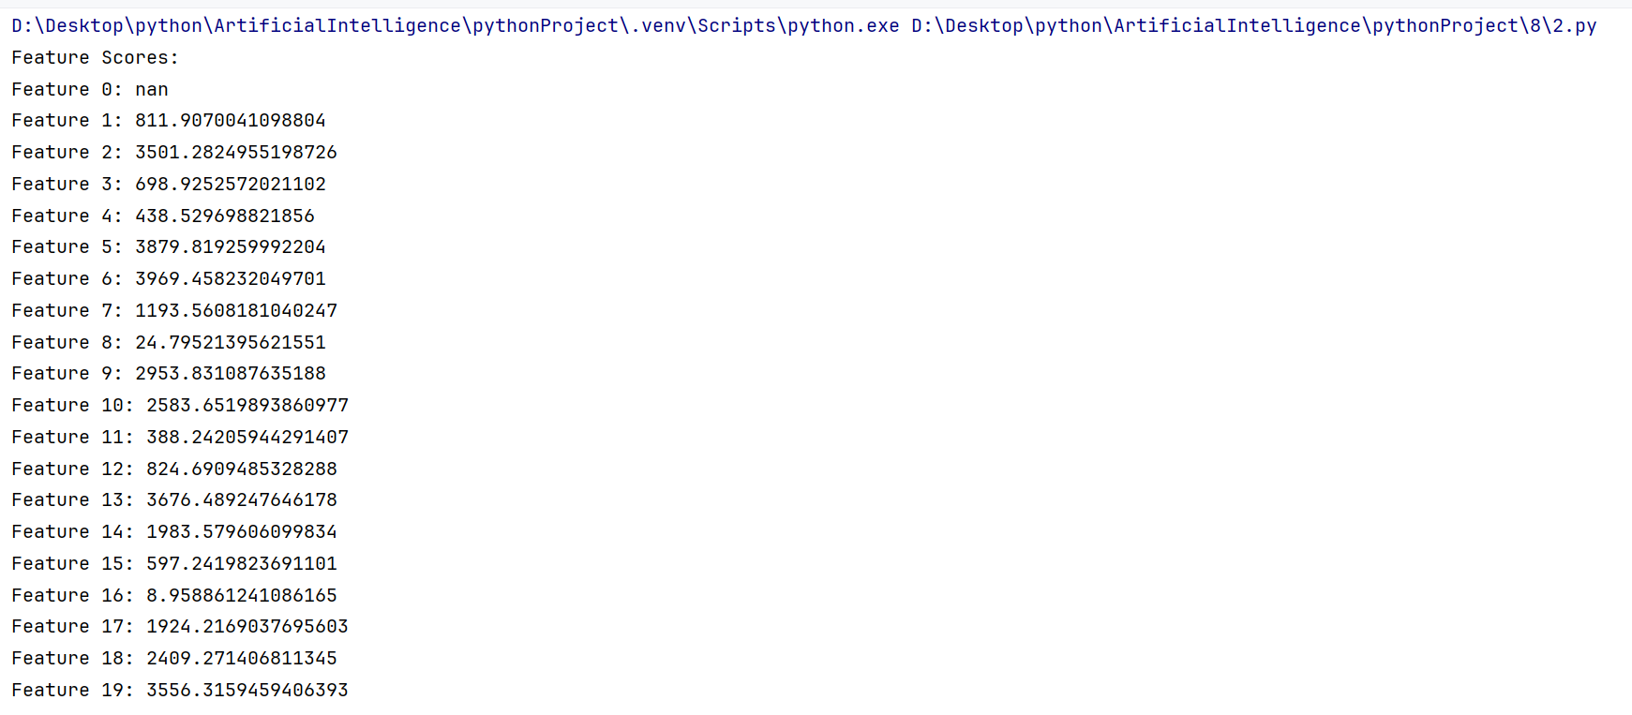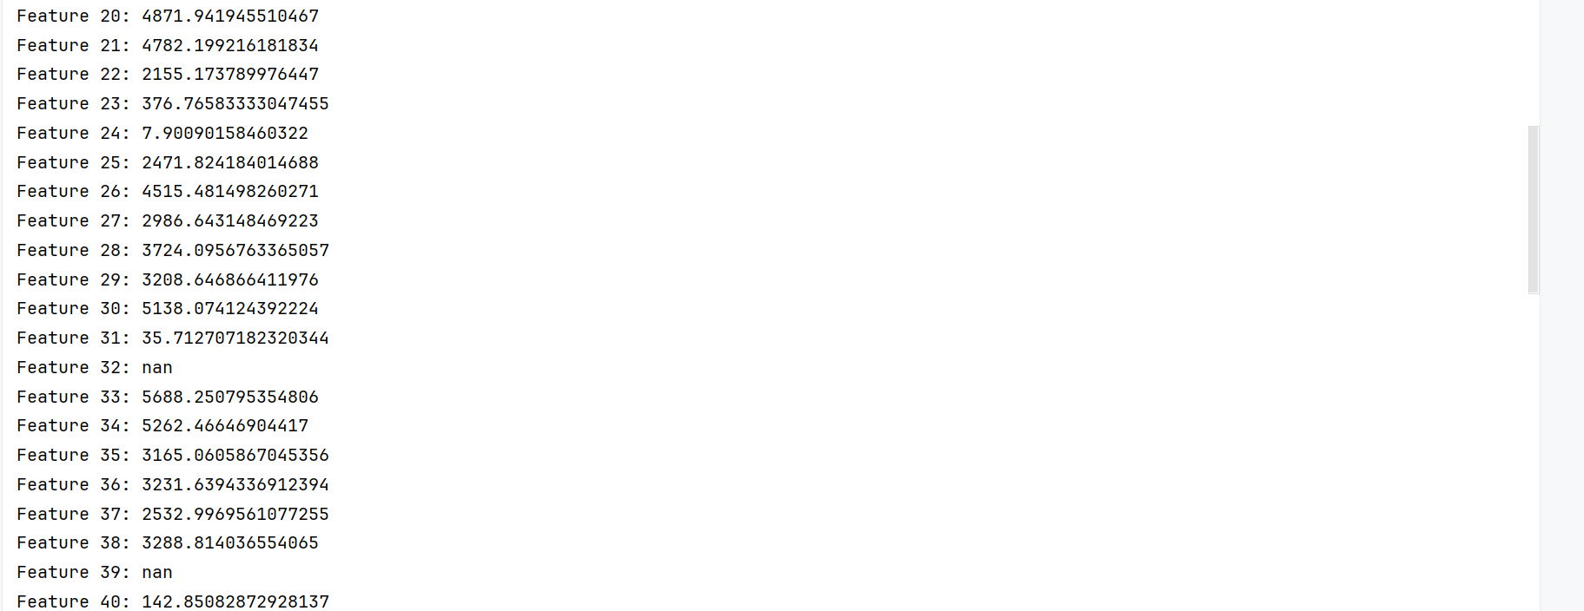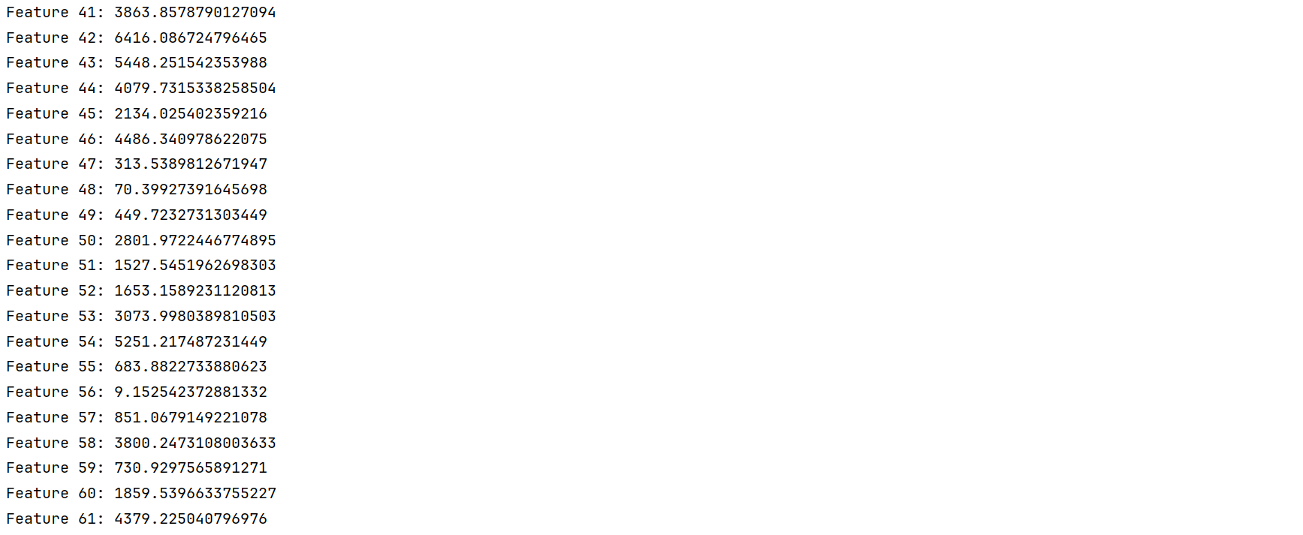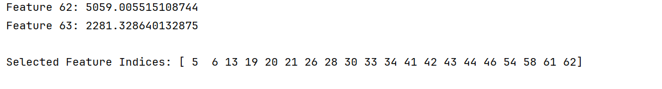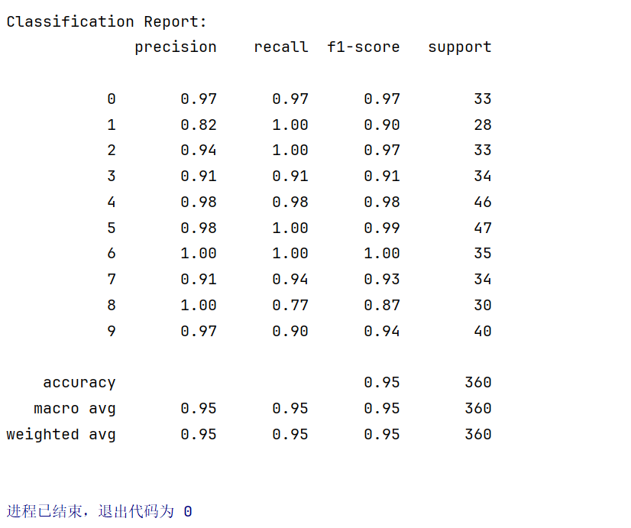

3、多特征选择和SVM回归SVR的结合

（1）导入datasets.fetch_california_housing()数据，使用SelectKBest(f_regression, k=4)选择最优特征

（2）输出各个特征的的得分和返回特征过滤后保留下的特征列索引,4个特征的名称

（3）基于特征过滤后保留下的特征数据集和回归SVR(参数自己定)

构建机器学习流水线Pipeline([('selector', ), ('svm', )])，使用该模型训练数据，输出MSE和MAE

from sklearn.datasets import fetch_california_housing  
from sklearn.feature_selection import SelectKBest, f_regression  
from sklearn.pipeline import Pipeline  
from sklearn.svm import SVR  
from sklearn.model_selection import train_test_split  
from sklearn.metrics import mean_squared_error, mean_absolute_error  
  
# 导入数据集  
housing = fetch_california_housing()  
X, y = housing.data, housing.target  
# print(X.shape)  
# 特征选择  
selector = SelectKBest(f_regression, k=4) # 选择与目标变量最相关的 10 个特征  
selector.fit(X, y)  
selected_feature_indices = selector.get_support(indices=True)  
feature_scores = selector.scores_  
  
# 输出特征得分和选择后的特征列索引  
print("Feature Scores:")  
for i, score in enumerate(feature_scores):  
 print(f"Feature {i}: {score}")  
print("\nSelected Feature Indices:", selected_feature_indices)  
  
# 获取特征名称  
selected_feature_names = [housing.feature_names[i] for i in selected_feature_indices]  
print("\nSelected Feature Names:", selected_feature_names)  
  
  
# 划分训练集和测试集  
X_train, X_test, y_train, y_test = train_test_split(X, y, test_size=0.2, random_state=42)  
  
# 构建机器学习流水线  
pipeline = Pipeline([  
 ("selector",SelectKBest(f_regression, k=4)),  
 ('svm', SVR(kernel='rbf', C=1.0, gamma='scale')) # 参数可以自行调整  
])  
  
# 训练模型并预测  
pipeline.fit(X_train, y_train)  
y_pred = pipeline.predict(X_test)  
  
# 计算 MSE 和 MAE  
mse = mean_squared_error(y_test, y_pred)  
mae = mean_absolute_error(y_test, y_pred)  
print("\nMean Squared Error (MSE):", mse)  
print("Mean Absolute Error (MAE):", mae)

