1、决策树模型

（1）使用make_classification生成分类数据集（要求样本个数1000，特征个数为10），划分训练集和测试集，使用决策树分类模型训练数据，输出测试集的性能指标

（2）使用make_regression()生成回归数据集（要求样本个数1000，特征个数为10）或者导入from sklearn.datasets 房价回归数据集，划分训练集和测试集，使用决策树回归模型训练数据，输出测试集的性能指标

from sklearn.datasets import make_classification, make_regression  
from sklearn.model_selection import train_test_split  
from sklearn.tree import DecisionTreeClassifier, DecisionTreeRegressor  
from sklearn.metrics import accuracy_score, mean_squared_error  
  
# 生成分类数据集  
X_classification, y_classification = make_classification(n_samples=1000, n_features=10, random_state=42)  
X_train_clf, X_test_clf, y_train_clf, y_test_clf = train_test_split(X_classification, y_classification, test_size=0.2, random_state=42)  
  
# 训练决策树分类模型  
clf = DecisionTreeClassifier(random_state=42)  
clf.fit(X_train_clf, y_train_clf)  
  
# 输出测试集的性能指标  
y_pred_clf = clf.predict(X_test_clf)  
accuracy = accuracy_score(y_test_clf, y_pred_clf)  
print("Classification Accuracy:", accuracy)  
  
# 生成回归数据集  
X_regression, y_regression = make_regression(n_samples=1000, n_features=10, random_state=42)  
X_train_reg, X_test_reg, y_train_reg, y_test_reg = train_test_split(X_regression, y_regression, test_size=0.2, random_state=42)  
  
# 训练决策树回归模型  
reg = DecisionTreeRegressor(random_state=42)  
reg.fit(X_train_reg, y_train_reg)  
  
# 输出测试集的性能指标  
y_pred_reg = reg.predict(X_test_reg)  
mse = mean_squared_error(y_test_reg, y_pred_reg)  
print("Regression Mean Squared Error:", mse)

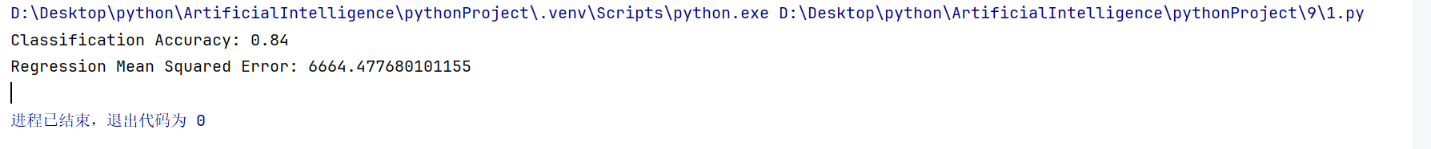

2、贝叶斯模型

对sklearn中的肿瘤数据集进行分类，该数据集包含569个样本数据，30个特征值。

from sklearn.datasets import load_breast_cancer，输出数据样本特征信息

(1)划分训练集和测试集，

(2)分别使用BernoulliNB、MultinomialNB和GaussianNB三种朴素贝叶斯模型进行训练，并输出分类性能指标，特征重要性，

(3)随机测试其中一个样本，输出其预测值，及每个类别的概率。

import pandas as pd  
from sklearn.datasets import load_breast_cancer  
from sklearn.model_selection import train_test_split  
from sklearn.naive_bayes import BernoulliNB, MultinomialNB, GaussianNB  
from sklearn.metrics import accuracy_score, classification_report  
import numpy as np  
  
# Load breast cancer dataset  
data = load_breast_cancer()  
# print(type(data))  
X = data.data  
y = data.target  
# print(type(X))  
df = pd.DataFrame(data.data, columns=data.feature_names)  
# Output sample feature information  
print("Sample Features Information:")  
print(df.info)  
  
# Split the dataset into training and testing sets  
X_train, X_test, y_train, y_test = train_test_split(X, y, test_size=0.2, random_state=42)  
  
# Train and evaluate three types of Naive Bayes models  
models = {  
 "BernoulliNB": BernoulliNB(),  
 "MultinomialNB": MultinomialNB(),  
 "GaussianNB": GaussianNB()  
}  
  
for name, model in models.items():  
 print(f"\n{name}:")  
 model.fit(X_train, y_train)  
 y_pred = model.predict(X_test)  
 accuracy = accuracy_score(y_test, y_pred)  
 print("Accuracy:", accuracy)  
 print("Classification Report:")  
 print(classification_report(y_test, y_pred, zero_division=1))  
  
 # Output feature importance for GaussianNB  
 if name == "GaussianNB":  
 print("Feature Means:")  
 print(model.theta_)  
  
 # For BernoulliNB and MultinomialNB, as they are not probability-based,  
 # we can't directly get feature importance in the same way as GaussianNB.  
 # However, we can output the learned parameters for inspection.  
 elif name == "BernoulliNB":  
 print("Feature Log Probability (BernoulliNB):")  
 print(model.feature_log_prob_)  
  
 elif name == "MultinomialNB":  
 print("Feature Log Probability (MultinomialNB):")  
 print(model.feature_log_prob_)  
  
# Randomly test one sample  
random_index = np.random.randint(0, len(X_test))  
sample = X_test[random_index]  
true_label = y_test[random_index]  
  
print("\nRandom Sample:")  
print("True Label:", true_label)  
  
# Output predicted probabilities for each class for each model  
for name, model in models.items():  
 prob = model.predict_proba([sample])[0]  
 print(f"{name} Predicted Value:")  
 print(model.predict([sample]))  
 print(f"{name} Predicted Probabilities:")  
 for i, p in enumerate(prob):  
 print(f"Class {i}: {p}")

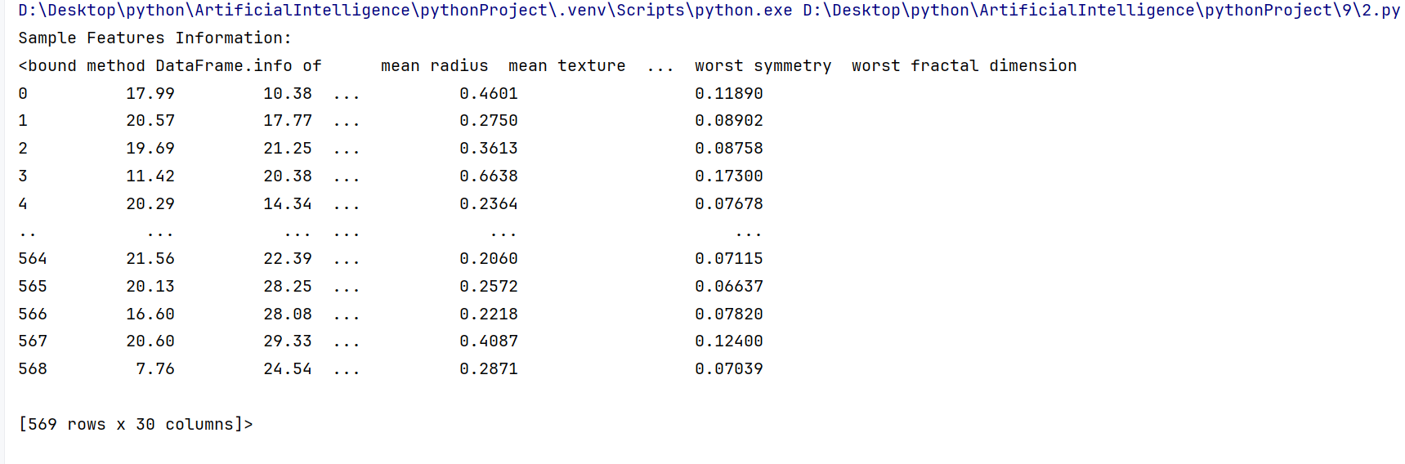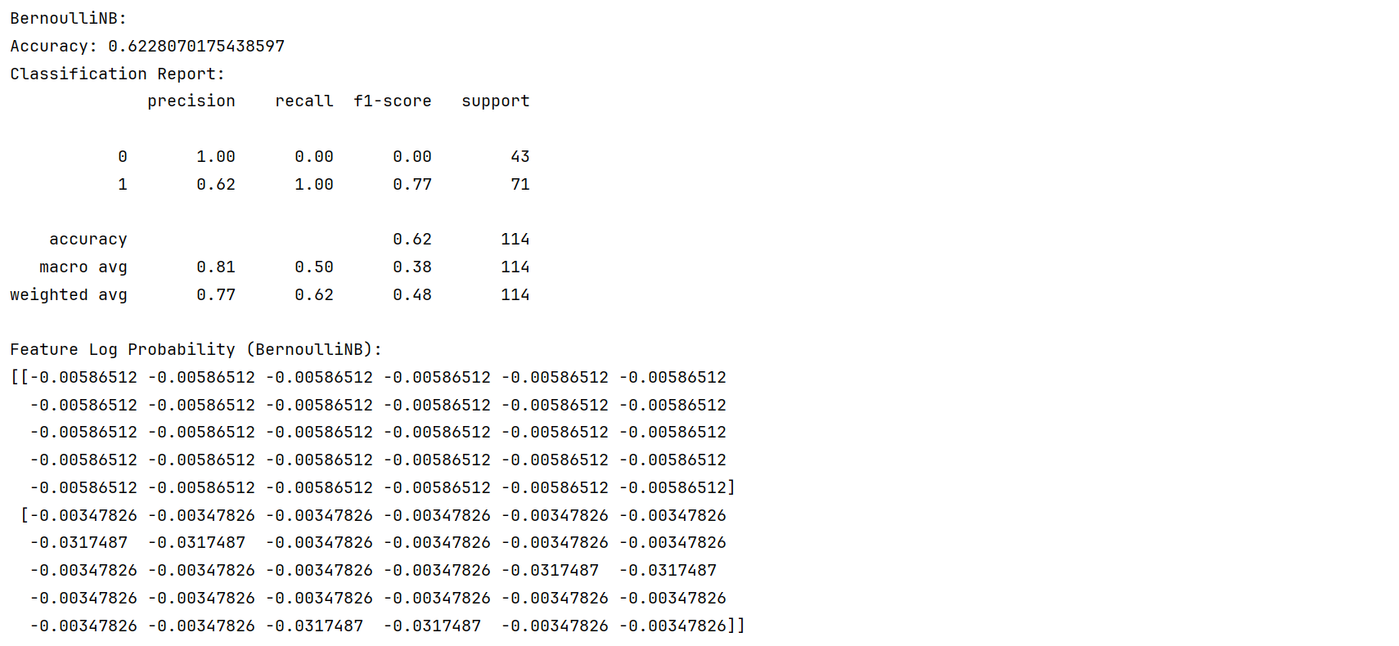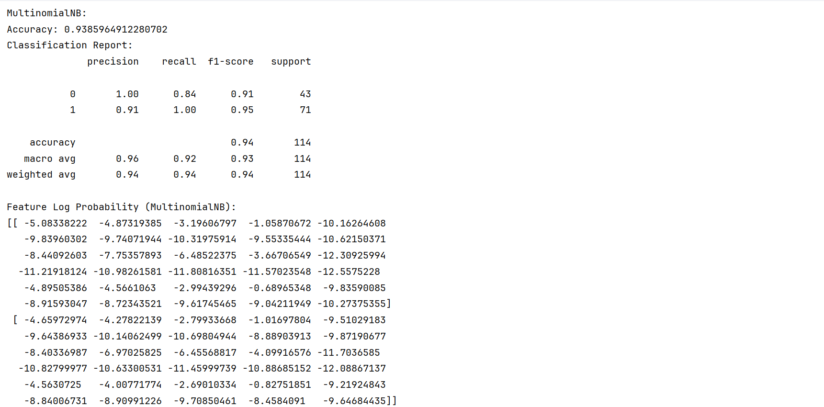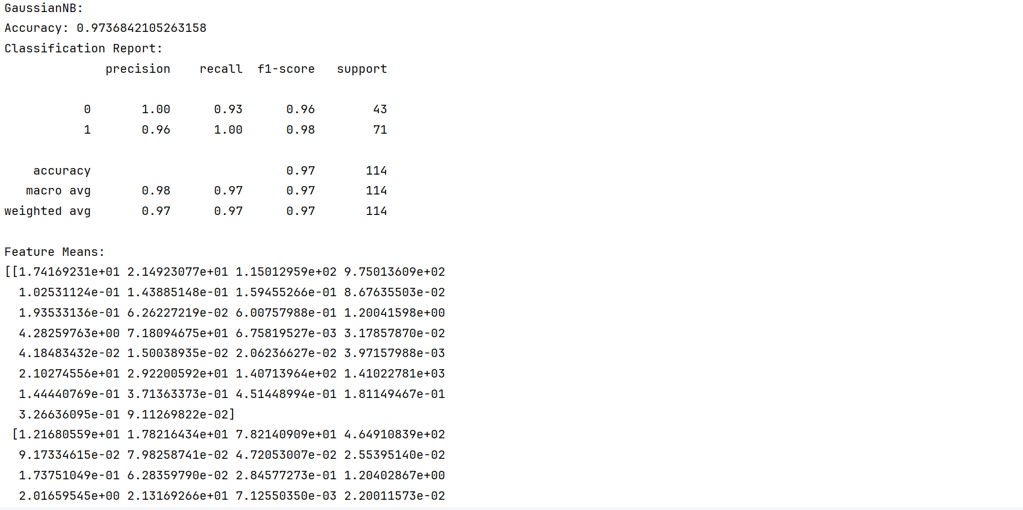

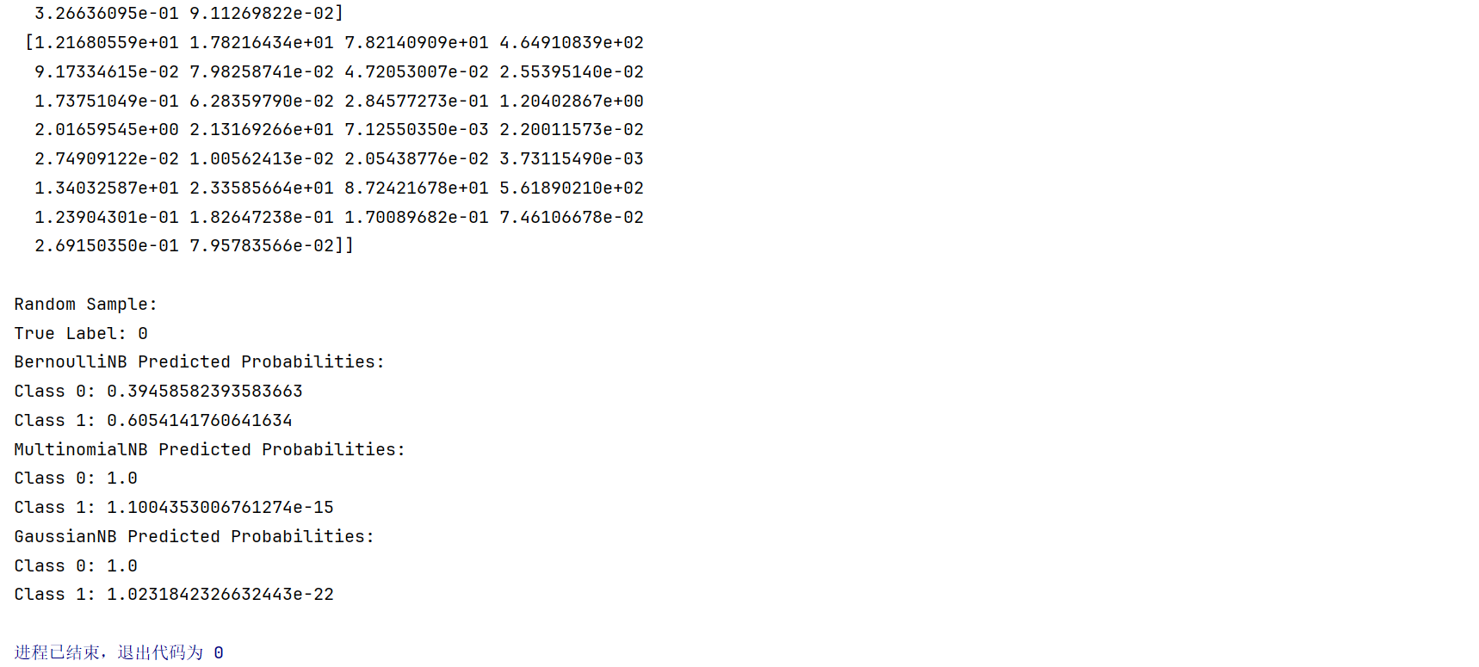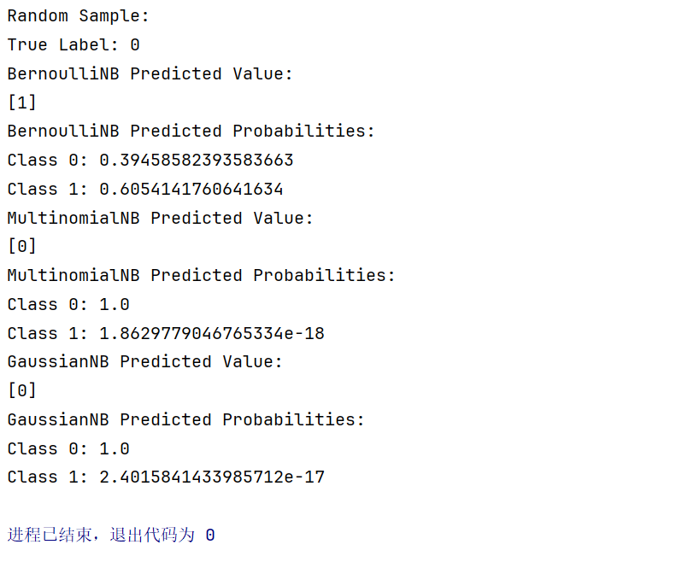

3、集成模型

（1）使用make_moons生成分类数据，

（2）自定义三个基学习器

（3）分别使用voting集成模型、bagging集成模型、随机森林和Boosting模型训练数据，输出用于评估模型的性能指标。

from sklearn.datasets import make_moons  
from sklearn.model_selection import train_test_split  
from sklearn.ensemble import VotingClassifier, BaggingClassifier, RandomForestClassifier, AdaBoostClassifier  
from sklearn.tree import DecisionTreeClassifier  
from sklearn.linear_model import LogisticRegression  
from sklearn.svm import SVC  
from sklearn.metrics import accuracy_score, classification_report  
  
# 生成分类数据  
X, y = make_moons(n_samples=1000, noise=0.3, random_state=42)  
  
# 划分训练集和测试集  
X_train, X_test, y_train, y_test = train_test_split(X, y, test_size=0.2, random_state=42)  
  
# 定义基学习器  
log_clf = LogisticRegression(solver="liblinear", random_state=42)  
rnd_clf = RandomForestClassifier(n_estimators=10, random_state=42)  
svm_clf = SVC(gamma="auto", random_state=42, probability=True)  
  
# Hard Voting Classifier  
voting_clf = VotingClassifier(  
 estimators=[('lr', log_clf), ('rf', rnd_clf), ('svc', svm_clf)],  
 voting='hard'  
)  
voting_clf.fit(X_train, y_train)  
y_pred_voting = voting_clf.predict(X_test)  
print("Hard Voting Classifier Accuracy:", accuracy_score(y_test, y_pred_voting))  
print("Hard Voting Classifier Classification Report:")  
print(classification_report(y_test, y_pred_voting))  
  
# Soft Voting Classifier  
voting_clf_soft = VotingClassifier(  
 estimators=[('lr', log_clf), ('rf', rnd_clf), ('svc', svm_clf)],  
 voting='soft'  
)  
voting_clf_soft.fit(X_train, y_train)  
y_pred_voting_soft = voting_clf_soft.predict(X_test)  
print("Soft Voting Classifier Accuracy:", accuracy_score(y_test, y_pred_voting_soft))  
print("Soft Voting Classifier Classification Report:")  
print(classification_report(y_test, y_pred_voting_soft))  
  
# Bagging Classifier  
bag_clf = BaggingClassifier(  
 DecisionTreeClassifier(random_state=42), n_estimators=500,  
 max_samples=100, bootstrap=True, n_jobs=-1, random_state=42  
)  
bag_clf.fit(X_train, y_train)  
y_pred_bagging = bag_clf.predict(X_test)  
print("Bagging Classifier Accuracy:", accuracy_score(y_test, y_pred_bagging))  
print("Bagging Classifier Classification Report:")  
print(classification_report(y_test, y_pred_bagging))  
  
# Random Forest Classifier  
rnd_clf = RandomForestClassifier(n_estimators=500, max_leaf_nodes=16, n_jobs=-1, random_state=42)  
rnd_clf.fit(X_train, y_train)  
y_pred_rf = rnd_clf.predict(X_test)  
print("Random Forest Classifier Accuracy:", accuracy_score(y_test, y_pred_rf))  
print("Random Forest Classifier Classification Report:")  
print(classification_report(y_test, y_pred_rf))  
  
# AdaBoost Classifier  
ada_clf = AdaBoostClassifier(  
 DecisionTreeClassifier(max_depth=1), n_estimators=200,  
 algorithm="SAMME", learning_rate=0.5, random_state=42  
)  
ada_clf.fit(X_train, y_train)  
y_pred_ada = ada_clf.predict(X_test)  
print("AdaBoost Classifier Accuracy:", accuracy_score(y_test, y_pred_ada))  
print("AdaBoost Classifier Classification Report:")  
print(classification_report(y_test, y_pred_ada))

