SkyJet Flight Recovery
A Self-Service Flight Disruption Recovery Platform
Instant rebooking and refund answers for disrupted passengers — and a clean hand-off to a human agent the moment the rules aren't confident.
Hackathon Submission — Technical & Product Documentation
Stack: React 19 · TypeScript · Vite · Node.js · Express · MongoDB · Mistral AI
Built with the assistance of Claude Code (Anthropic)

Table of Contents
1. Project Overview & Development Disclosure
2. Problem Statement & Value Proposition
3. Customer Journey
4. System Architecture
5. System Design Diagrams (Use Case, Activity, Class)
6. API Design
7. Key Assumptions & Scope
8. Demo Script
9. Technology Stack & Credentials
10. Future Roadmap
11. Screenshots & Live Link

1. Project Overview
SkyJet Flight Recovery is a full-stack, self-service web application built for passengers whose flights are disrupted. Instead of calling a contact center and waiting on hold, a passenger can look up their trip with just their booking reference and last name, see real-time flight status, and — where the rules are confident — get an instant outcome: rebook onto the next available flight, or get a refund eligibility determination. Where the rules aren't confident (international itineraries, special fares, no available alternates), the system escalates immediately and transparently to a human agent, with full context already attached.
Core capabilities:
- Instant trip lookup by PNR + last name — no account required
- Real-time flight status and disruption details
- Automatic rebooking onto the next eligible alternate flight
- Instant refund eligibility determination for qualifying cancellations
- AI-powered chat agent (Mistral LLM) for support conversations
- A dedicated staff/admin dashboard to manage passengers, bookings, recovery requests, and support tickets
Development Disclosure
This project was built with the assistance of Claude Code, Anthropic's AI coding agent, which was used throughout development for implementation, debugging, and documentation — including this submission document.

2. Problem Statement & Value Proposition
During weather and operational disruptions, a large share of an airline's passengers call the contact center to ask one of three questions: is my flight cancelled, can I move to another flight, and am I owed a refund. Long hold times generate poor passenger experience and unnecessary agent load for questions that have clear, rule-based answers most of the time.
SkyJet Flight Recovery automates the clear-cut cases — domestic, standard-fare bookings with a matching alternate — and gets out of the way for everything else. International fares, special fares, and cases with no available alternate are escalated immediately, before the passenger invests time in a flow that can't resolve automatically. The result: faster answers for most passengers, and better-informed hand-offs for the rest.
3. Customer Journey
A passenger whose flight may be disrupted looks up their trip and, if it's cancelled, is walked through rebooking or a refund check — with a clear exit to a human agent at every point where the rules don't give a confident answer.
Narrative Flow
- Lookup. The passenger enters their booking reference (PNR) and last name — no account or password needed. This mirrors what they'd read off a ticket or confirmation email.
- Trip status. They immediately see their flight status. If it's on-time or delayed, that's the whole interaction — informational only, no action needed.
- Disruption actions. If the flight is cancelled, they see up to three choices: Find another flight, Check refund eligibility, and Talk to an agent (always available, regardless of the other two).
- Rebooking. The system checks whether an alternate flight on the same route, same cabin, with available seats exists — and whether the fare allows automatic rebooking at all (domestic + standard fare only). If so, the passenger picks a flight and is confirmed immediately. If not, they see why upfront (no guessing, no dead-end button) and can hand off to an agent with one click.
- Refund check. Same idea: cancelled + standard fare + no accepted rebooking resolves instantly to an eligibility determination. International or special-fare cases are flagged for agent review instead of guessing.
- Escalation confirmation. Any hand-off — from rebooking, from refund check, or the passenger clicking “Talk to an agent” directly — lands on the same confirmation screen with a reference number and expected turnaround, so the passenger always knows what happens next.
Decision Logic
The recovery decision follows a simple, auditable branching structure so the passenger is never guessing what will happen next:
Flight / Booking State | Condition | Outcome
On-time / Delayed | — | Show status only — no action needed
Cancelled | Domestic + standard fare + matching alternate available | Auto-rebook: passenger picks alternate, confirmed instantly
Cancelled | International, special fare, or no matching alternate | Escalate: rebooking needs agent review
Cancelled (refund path) | Domestic + standard fare + no accepted rebooking | Auto-determine: eligible / not eligible
Cancelled (refund path) | International or special fare | Escalate: refund needs agent review
Any status | Passenger clicks “Talk to an agent” | Escalate directly

Every escalation path — whether automatic or passenger-initiated — resolves to the same confirmation screen: a reference number and a 24-hour turnaround commitment.
4. System Architecture
A single Express application hosts two route namespaces on top of one MongoDB database: a simulated airline data service, and the app's own orchestration API. The simulated service is the explicit swap point for a real airline integration later.
Component Overview
Layer | Responsibility
Client (React + TypeScript, Vite) | Pages: Lookup, Trip Status, Rebooking, Refund Status, Escalation. Communicates with the app API over JSON via fetch.
App API (/api/*) | Orchestration routes for trips, bookings, and flights — called directly by the client.
Service layer | rebookingEngine and refundEngine — the business rules that decide auto-confirm vs. escalate.
Airline adapter (airlineClient.js) | The single seam between the app's business logic and flight/passenger/booking data. This is the only file that changes when a real airline integration replaces the mock.
Mock airline API (/api/mock/*) | Simulated airline data service — flights, passengers, bookings — backed by Mongoose models.
MongoDB | Stores Passengers, Flights, and Bookings collections.

Design Rationale
Swap point: when a real airline integration becomes available, only `airlineClient.js` changes — it currently calls `/api/mock/*` (backed by Mongoose models), but the app-level routes and decision engines never touch the mock routes or the database directly, so they don't need to change.
Why one process instead of two services: for a 48-hour MVP, running the mock airline API and the app backend as separate deployments would add operational overhead (two processes, two ports, two configs) without proving anything the route-namespace separation doesn't already prove. The seam is in the code, not the infrastructure.

5. System Design Diagrams
The following UML diagrams model the system from three complementary angles: who does what (use case), how a passenger's request flows through the decision rules (activity), and how the domain data is structured (class).
5.1 Use Case Diagram
Guest passengers can look up a trip and act on it without an account. Registered passengers additionally get persistent booking history. Staff manage the operational data. The AI chat agent is a supporting system invoked from the chat use case. Rebooking and refund checks each conditionally include an escalation to a human agent when the recovery rules aren't confident.
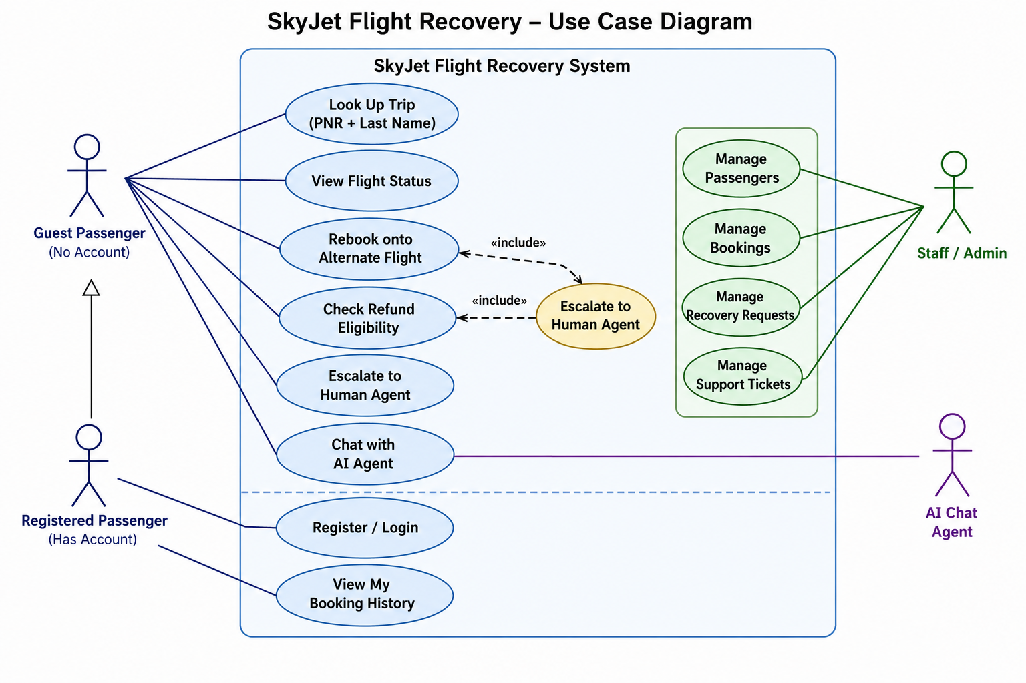
Figure 1 — Use Case Diagram: actors and system capabilities
5.2 Activity Diagram
This traces a single passenger session end to end — from entering a PNR through to either an instant resolution (status shown, rebooked, refund determined) or an escalation confirmation — mirroring the decision-logic table in Section 3.
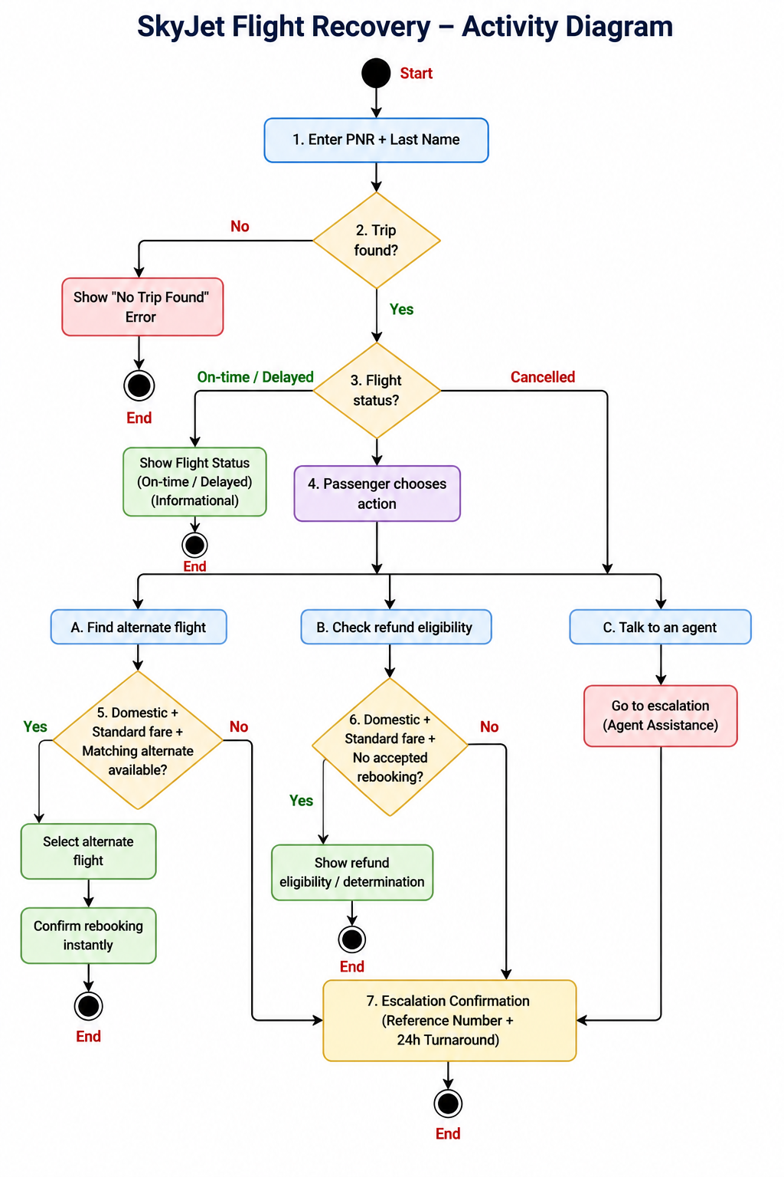

Figure 2 — Activity Diagram: passenger disruption recovery flow
5.3 Class Diagram
The domain model centers on `Booking`, which composes three embedded sub-documents (`Rebooking`, `Refund`, `Escalation`) and is referenced by `RecoveryRequest`, `SupportTicket`, and `ChatMessage`. `User` (auth/login) is intentionally decoupled from `Passenger` (trip data) — they're matched by email at the application layer, not a foreign key, since guest lookups never require an account.
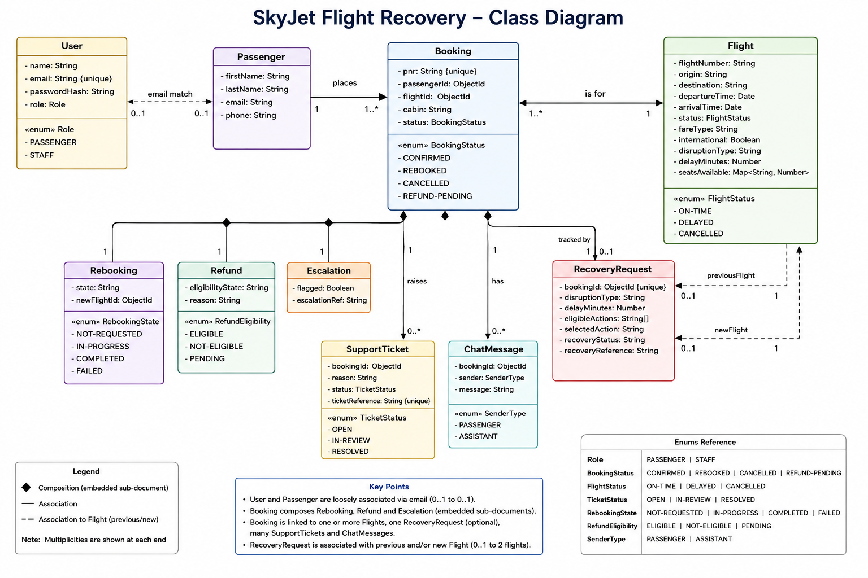

Figure 3 — Class Diagram: core Mongoose domain models and relationships

6. API Design
Base URL: `http://localhost:4000`. All responses are JSON. Errors use `{ "error": "message" }` with an appropriate HTTP status (400, 404, 500).
Simulated Airline Data Service (`/api/mock/*`)
Stands in for a real airline system. Not called by the client directly — only by the app backend, through `services/airlineClient.js`.
Method | Path | Description
GET | /api/mock/flights/:id | Flight detail
GET | /api/mock/flights/:id/alternatives | Raw candidate flights on the same route within a 48h window
GET | /api/mock/passengers/:id | Passenger detail
GET | /api/mock/bookings/pnr/:pnr | Booking lookup by PNR

App Backend (`/api/*`)
Called directly by the client.
POST /api/trips/lookup
Look up a trip by PNR + last name (case-insensitive).
Request body:
{ "pnr": "SJRBK1", "lastName": "Mehta" }
Response 200:
{
"bookingId": "...", "pnr": "SJRBK1", "passengerName": "Chirag Mehta",
"flight": { "...": "Flight document" },
"bookingStatus": "confirmed",
"rebooking": { "state": "none", "newFlightId": null, "rebookedAt": null },
"refund": { "eligibilityState": "not-applicable", "determinedAt": null, "reason": "" },
"escalation": { "flagged": false, "reason": "", "queuedAt": null, "queueStatus": "pending", "escalationRef": null }
}
Response 404: no matching trip.
GET /api/bookings/:id
Full booking + flight detail, used to refresh state on any page. Response 200: `{ "booking": {...}, "flight": {...} }`
GET /api/flights/:id/alternatives?bookingId=<id>
Candidate alternate flights for a cancelled flight. When `bookingId` is provided, the response also reports whether the rebooking engine would auto-confirm a selection — so the UI can show an escalation notice upfront instead of after the passenger picks a flight.
Response 200:
{
"alternatives": [{ "flightId": "...", "flightNumber": "SJ201", "departureTime": "...",
"arrivalTime": "...", "cabinClasses": ["economy"], "seatsAvailable": { "economy": 12 } }],
"canAutoRebook": true,
"escalationReason": null
}
POST /api/bookings/:id/rebook
Confirm rebooking onto a chosen alternate. The server re-validates against the same rules used to compute `canAutoRebook` — a `newFlightId` from a stale alternatives list can still be escalated instead of confirmed.
Request body: `{ "newFlightId": "..." }` (omit if the booking cannot auto-rebook — the server will escalate immediately)
Response 200:
{ "result": "confirmed", "booking": { "...": "updated Booking document" } }
or
{ "result": "escalated", "booking": { "...": "updated Booking document" } }
GET /api/bookings/:id/refund-eligibility
Computes and persists a refund eligibility determination. Status/determination only — never issues a payment.
Response 200:
{ "eligibilityState": "eligible", "reason": "Flight cancelled, no accepted rebooking — full refund eligible", "determinedAt": "..." }
`eligibilityState` is one of: `not-applicable | eligible | not-eligible | escalated`.
POST /api/bookings/:id/escalate
Flags the booking for agent follow-up. Used both as the target of automatic escalation and the “Talk to an agent” button.
Request body: `{ "reason": "optional override" }`
Response 200:
{ "escalationRef": "ESC-8E62C537", "queuedAt": "...", "queueStatus": "pending" }
7. Key Assumptions & Scope
The following assumptions and scope boundaries were deliberately chosen to keep the MVP focused within the hackathon timeframe, while keeping the architecture honest about what would need to change for production use.
- No payment integration. Refund eligibility is a status determination only (eligible / not-eligible / escalated) — no payment is ever issued by this system, per the challenge constraints.
- No real airline API. Flight/passenger/booking data is served by a small mock Express + MongoDB service (/api/mock/*) rather than a real airline system. It's designed to be swappable: the app backend only ever talks to it through one adapter (services/airlineClient.js), so a real integration later only touches that file.
- PNR + last name is sufficient “authentication” for this MVP. No password, OTP, or account system — matching what a passenger could read off a boarding pass or confirmation email. The booking's MongoDB ObjectId, returned after a successful lookup, is held client-side (React context + sessionStorage) and used to scope every subsequent request. This is not a secure session mechanism and would need real auth before production use.
- Escalation queue is simulated. “Talk to an agent” and auto-escalation both just set a flag/reference/timestamp on the Booking document and show a confirmation screen. There's no real ticketing system, live queue, or agent notification — no messages are actually sent.
- Alternate-flight matching is simplified. Alternates are found by same origin/destination, non-cancelled status, and departure within a 48-hour window of the original flight — not a full fare-rules or connections engine. Real rebooking logic (codeshares, multi-city itineraries, fare bucket rules) would need airline-specific business rules.
- Auto vs. escalate split is rule-based, not ML-based. A cancelled flight auto-rebooks/auto-determines refund eligibility only if it's domestic and standard-fare, and (for rebooking) a matching same-cabin alternate with seats exists. International, special, or multi-leg fares always escalate, as does any case with no matching alternate. These thresholds are a starting point for the MVP, not validated against real fare-rule data.
- Single currency/timezone, no notifications. All demo data uses one implied currency and the server's local timezone; no emails, SMS, or push notifications are actually sent when a booking is rebooked or escalated.
- Delayed flights are informational only. No rebooking or refund flow is offered for delays in this MVP, since the brief's three scenarios (is it cancelled / can I move / am I eligible) are framed around cancellation.
8. Demo Script (5 Minutes)
Setup beforehand: server and client both running (`npm run dev` in each), database freshly seeded (`npm run seed` in server). Have `http://localhost:5173` open in the browser.
1. Frame the problem (30s)
“During weather disruptions, 40% of SkyJet passengers call in just to ask: is my flight cancelled, can I move to another flight, or am I owed a refund. Average wait is 25 minutes. This MVP answers all three without an agent — and knows when not to guess.”
2. On-time flight — the non-event (30s)
Enter PNR SJONT1, last name Shah, submit. Point out: status badge, no action buttons — because there's nothing to self-serve when the flight is fine. Don't show disruption UI for non-disrupted passengers.
3. Cancelled + auto-rebook (90s)
Go back, enter PNR SJRBK1, last name Mehta. Point out the “Cancelled” badge and the three action buttons. Click Find another flight — two same-route, same-cabin alternates appear immediately, pulled live from the mock airline API. Click Select on the first one — confirmed instantly, no agent needed, no hold time.
4. Cancelled + escalation (90s)
Go back, enter PNR SJINT1, last name Rodrigues (an international itinerary). Click Find another flight — instead of a flight list, the passenger sees upfront that this itinerary needs agent review, before they pick anything and get surprised. Click Get agent help with rebooking. Land on the escalation confirmation screen: reference number, 24-hour turnaround, no phone call required — the same screen the Talk to an agent button reaches from anywhere.
5. Refund eligibility (60s)
Go back, enter PNR SJRFD1, last name Khan. Click Check refund eligibility. Instant determination: “Eligible for refund” with the reasoning shown — cancelled flight, standard fare, no accepted rebooking. No payment is issued here; this is a status check the passenger can act on (or that feeds a downstream refund process).
6. Close (30s)
One line on architecture: “the mock airline API is a deliberate seam — one adapter file is the only thing that changes when this plugs into SkyJet's real systems.” One line on scope: “we automate the clear-cut cases and get out of the way for the rest — international fares, missing alternates, anything the rules aren't confident about goes straight to an agent with full context already attached, instead of a passenger repeating themselves on hold.”
Demo PNR Reference Table
PNR | Last Name | Scenario
SJONT1 | Shah | On-time flight
SJDLY1 | Fernandes | Delayed flight
SJRBK1 | Mehta | Cancelled — auto-rebook eligible
SJESC1 | Nair | Cancelled — no alternate, escalated to agent
SJINT1 | Rodrigues | Cancelled — international/special fare, escalated
SJRFD1 | Khan | Cancelled — refund eligible

9. Technology Stack
Backend (/server)
Technology | Purpose
Node.js | Runtime
Express.js | REST API server
Mongoose | MongoDB ODM
MongoDB / mongodb-memory-server | Database (persistent or in-memory)
bcryptjs | Password hashing
jsonwebtoken | JWT-based auth (httpOnly cookies)
svg-captcha | CAPTCHA for login
Mistral AI API | AI chatbot (“Talk to an agent”)

Frontend (/client)
Technology | Purpose
React 19 | UI framework
TypeScript | Type safety
Vite | Build tool & dev server
Tailwind CSS v4 | Utility-first styling
shadcn/ui | Accessible UI component library
framer-motion | Page transition animations
react-type-animation | Typing animation on hero
lucide-react | Icon set
react-router-dom v7 | Client-side routing

10. Future Roadmap
Enhancements identified beyond the current MVP scope:
- Email notifications — confirm rebooking/refunds via email (Nodemailer / SendGrid)
- Real-time flight status — integrate a live flight data API (e.g. AviationStack, FlightAware)
- Mobile app — React Native client reusing the same REST API
- Refund processing — connect to a real payment gateway (Stripe) for automated refunds
- Multi-language support — i18n for international passengers
- Seat selection — allow passengers to choose a seat when rebooking
- Push notifications — browser/PWA push alerts for flight status changes
- Admin analytics — dashboard charts for disruption trends, recovery rates
- OAuth login — sign in with Google / Apple
- Rate limiting & WAF — production-grade security hardening

SkyJet Flight Recovery — Hackathon Submission

11. Screenshots & Live Link
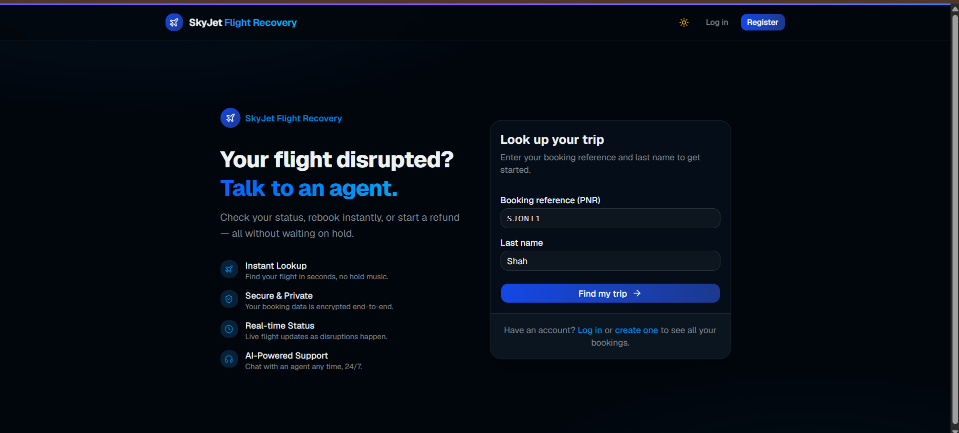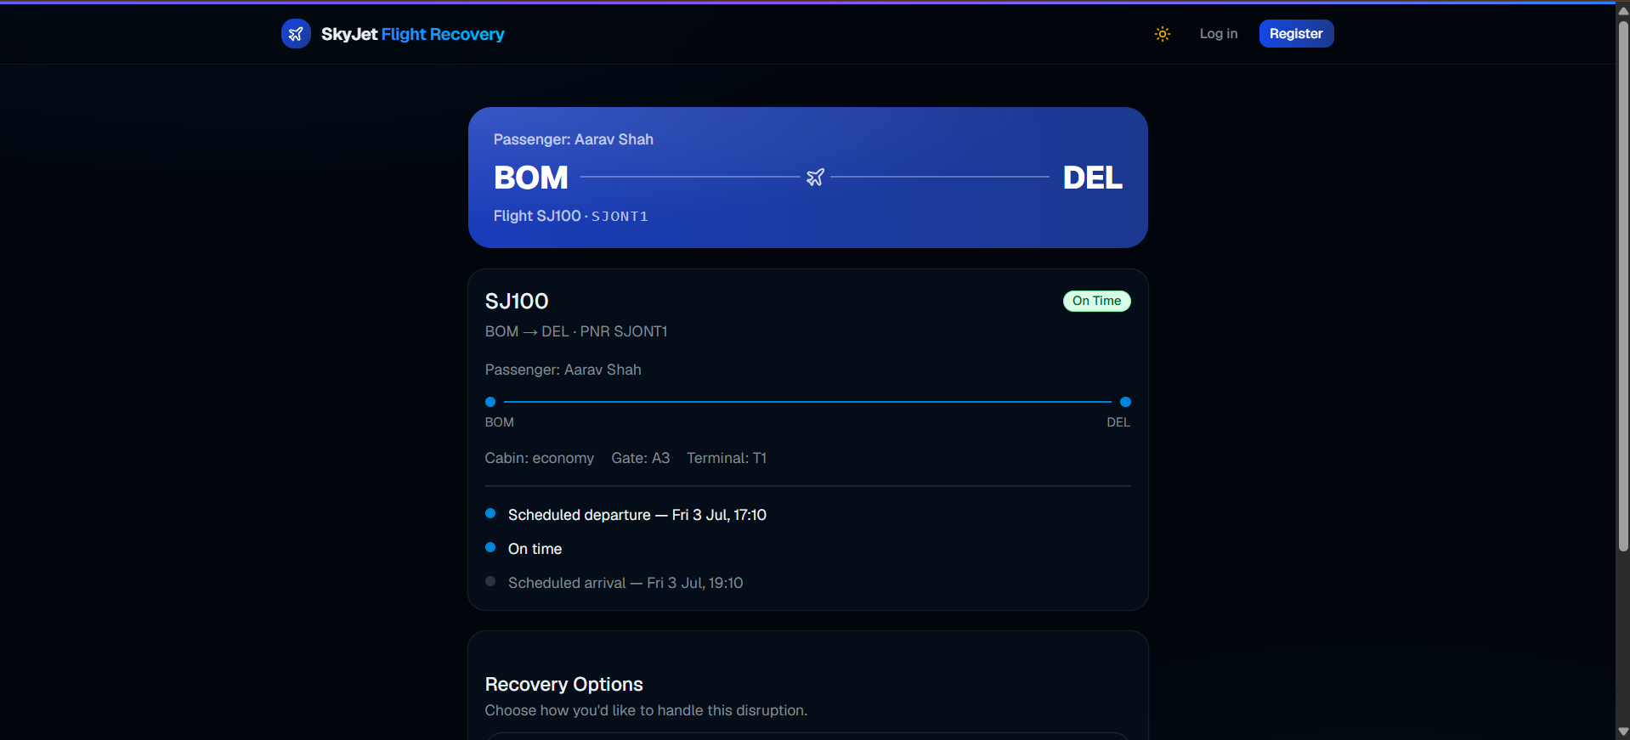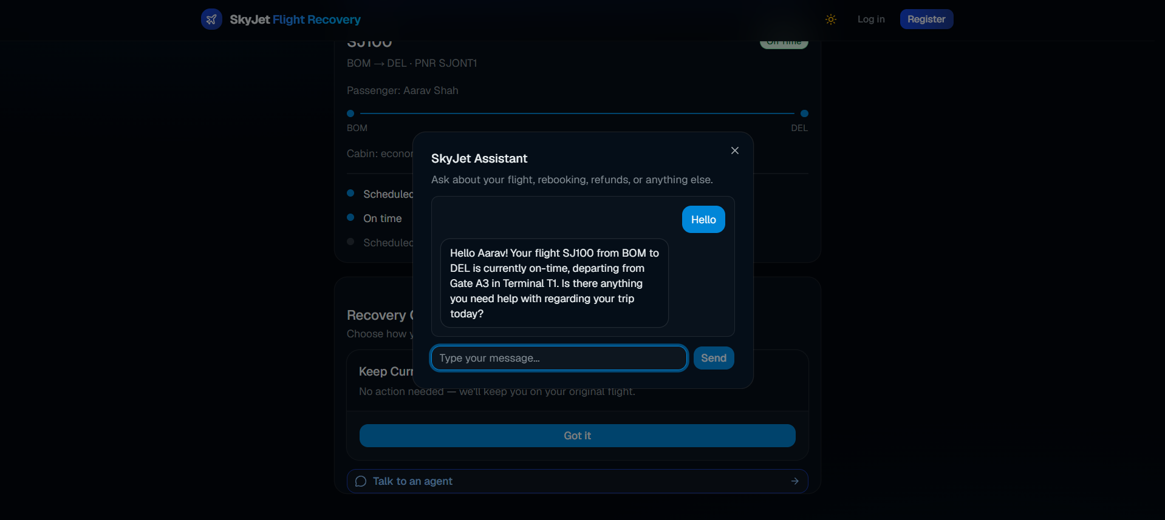
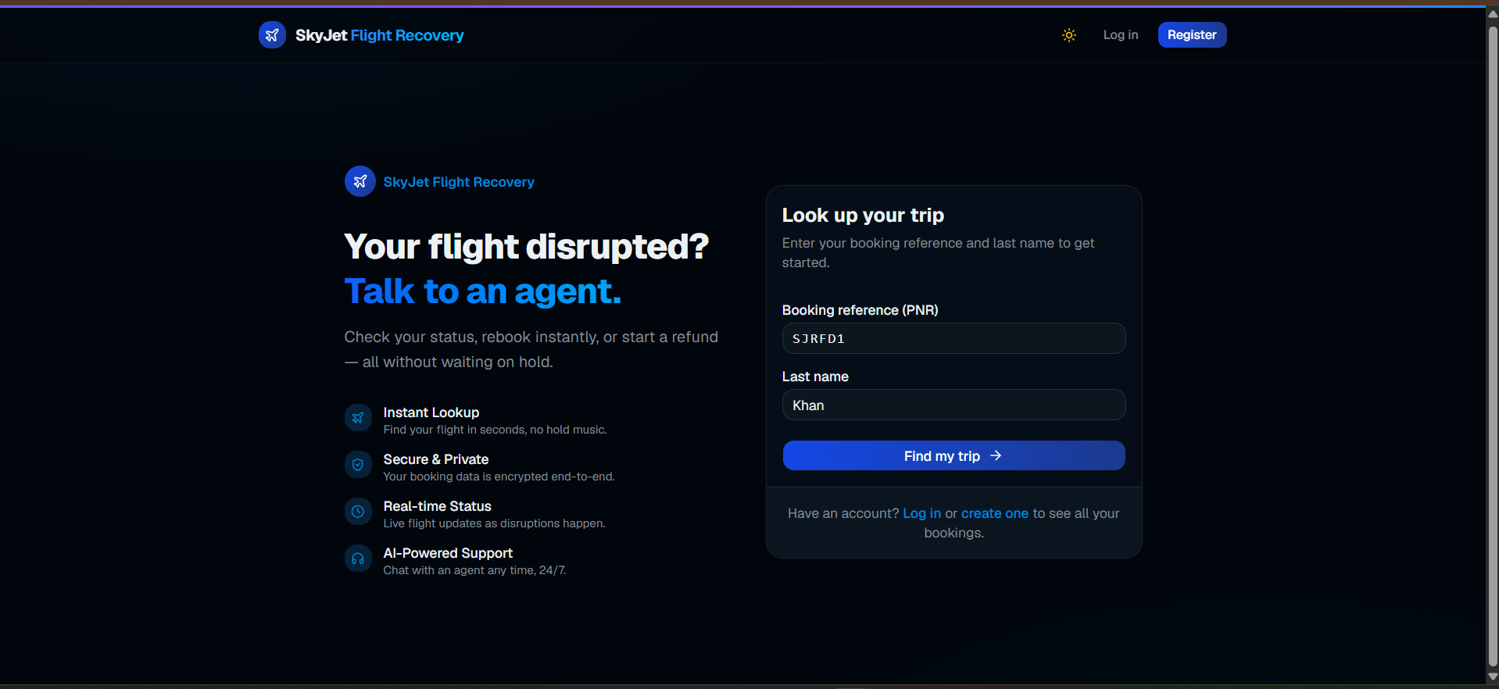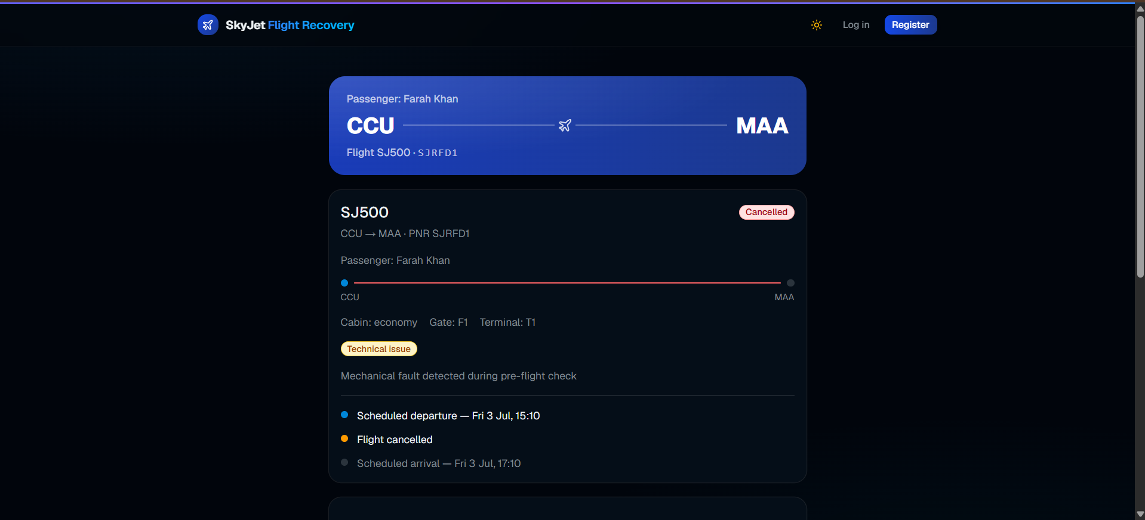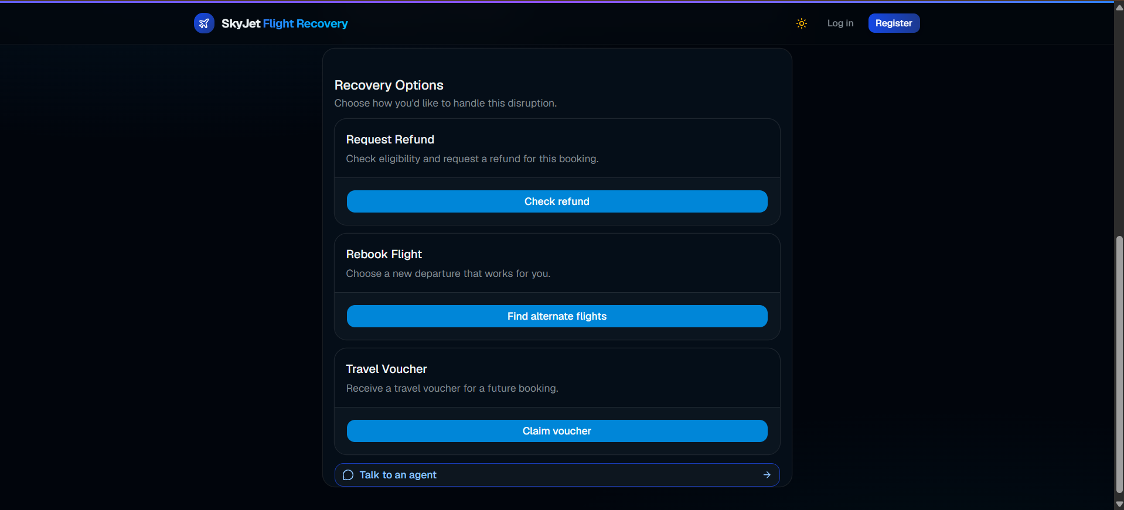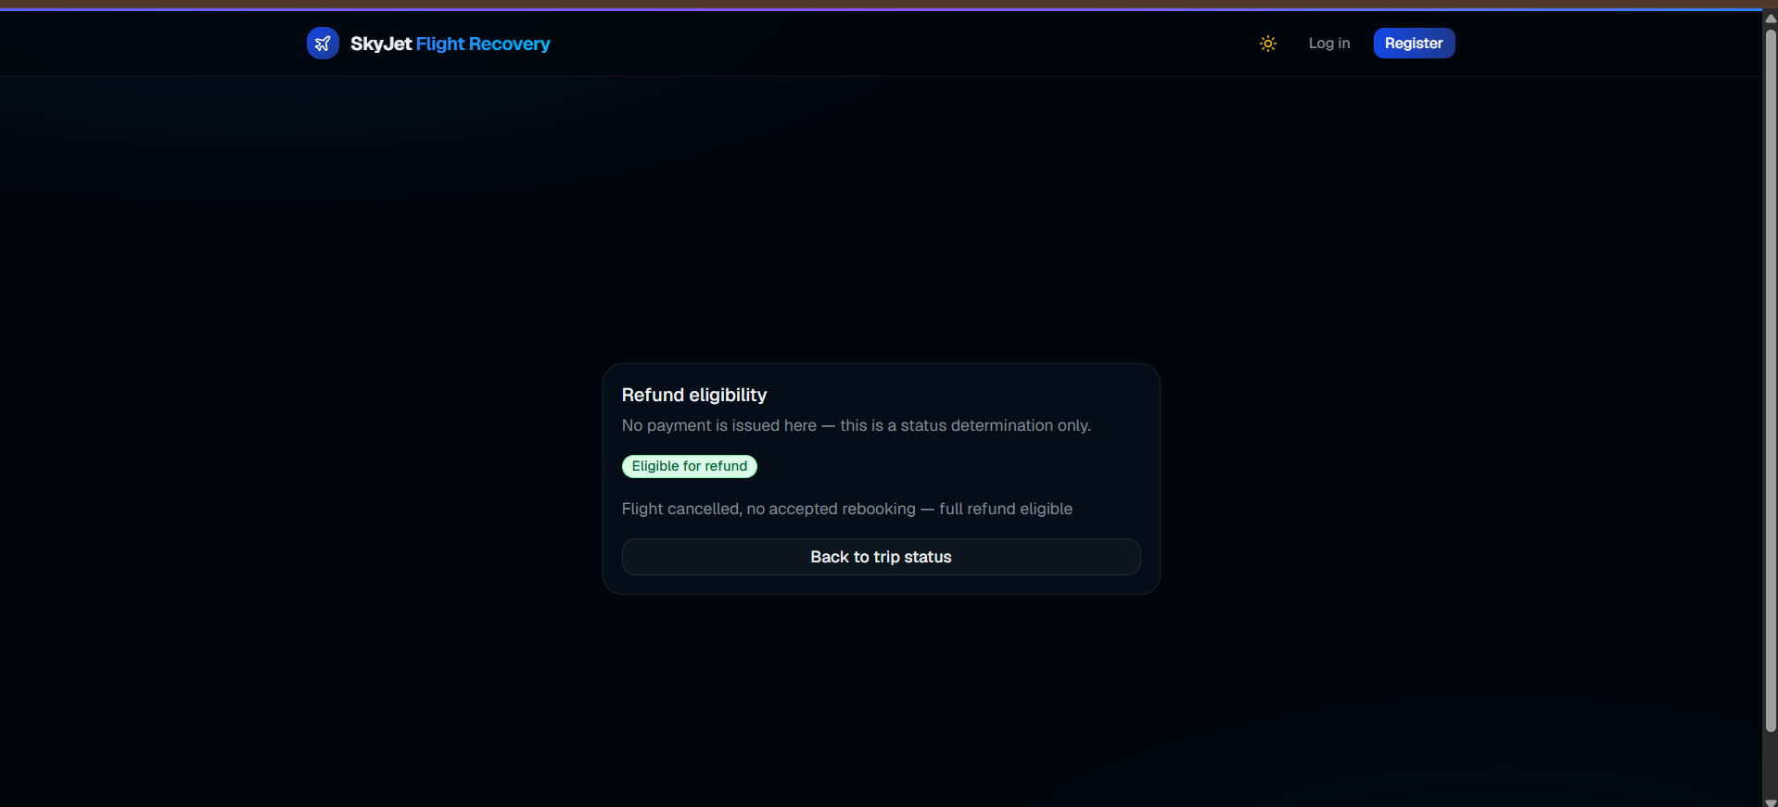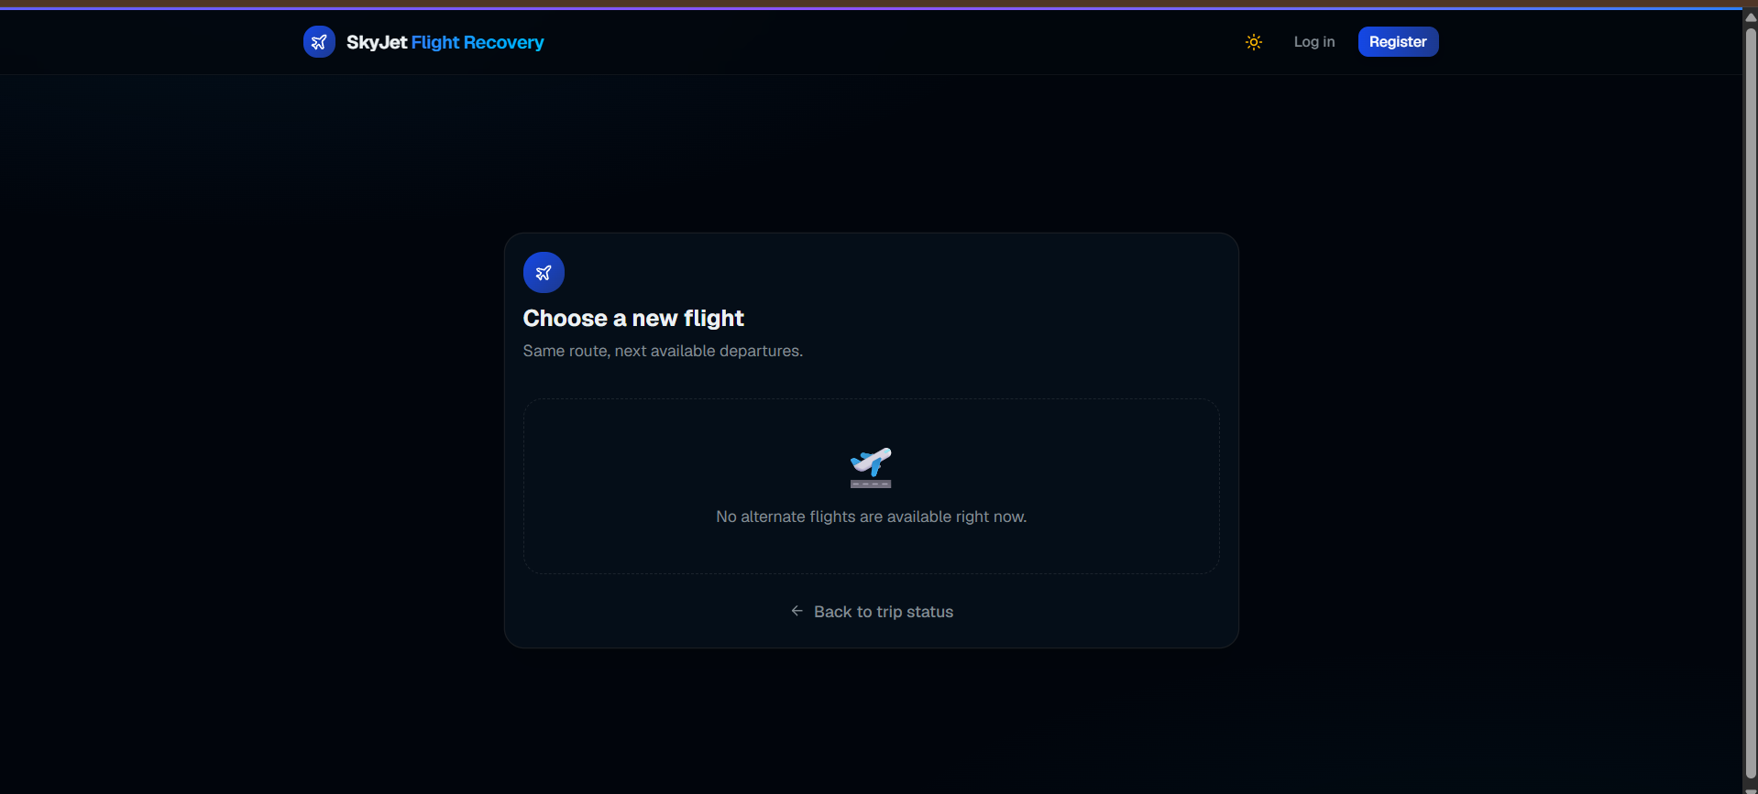
Passenger Login & Register:-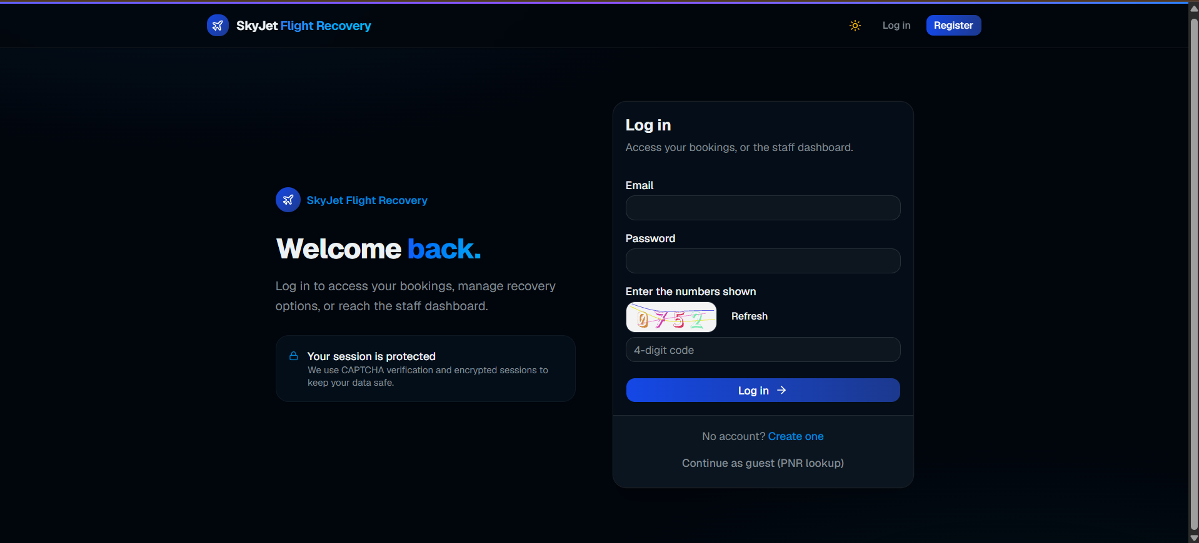
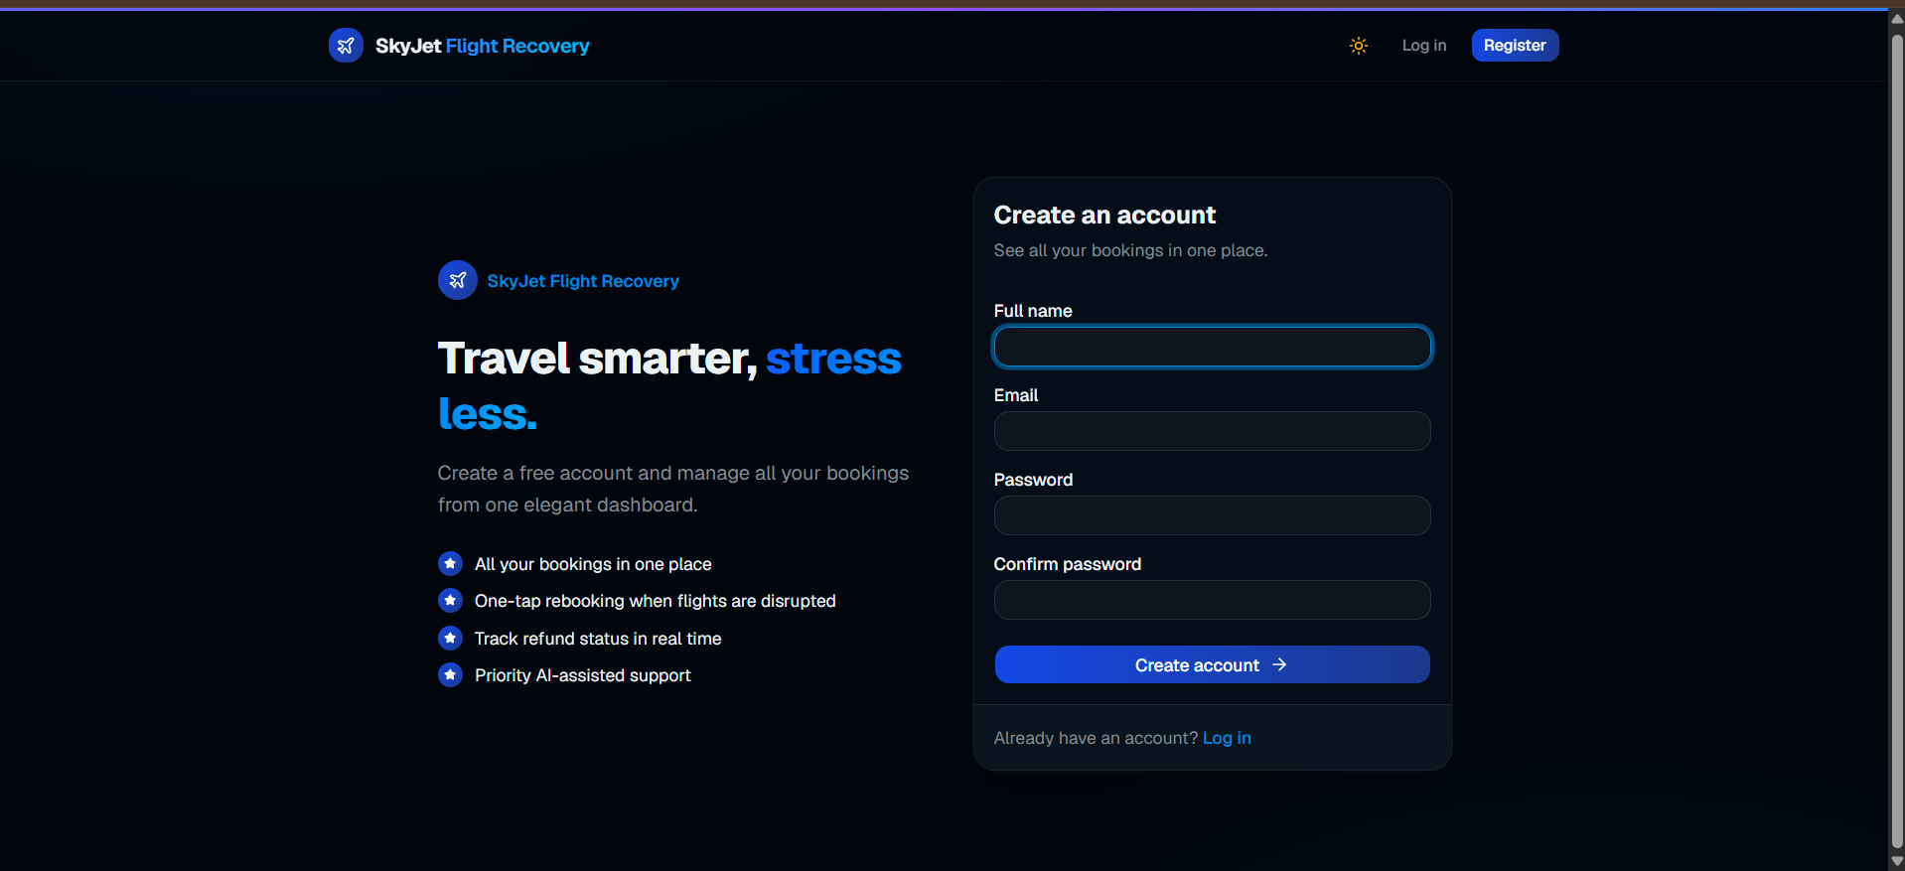

Live Link:
https://skyjet-flight-recovery-1.vercel.app/

