Codebook for tidy

Autogenerated data summary from dataMaid

2018-10-31 09:56:09

# Data report overview

The dataset examined has the following dimensions:

|  |  |
| --- | --- |
| Feature | Result |
| Number of observations | 180 |
| Number of variables | 68 |

# Codebook summary table

|  |  |  |  |  |  |
| --- | --- | --- | --- | --- | --- |
| Label | Variable | Class | # unique values | Missing | Description |
|  | **subject** | factor | 30 | 0.00 % |  |
|  | **activity_label** | factor | 6 | 0.00 % |  |
|  | **tBodyAcc-mean()-X** | numeric | 180 | 0.00 % |  |
|  | **tBodyAcc-mean()-Y** | numeric | 180 | 0.00 % |  |
|  | **tBodyAcc-mean()-Z** | numeric | 180 | 0.00 % |  |
|  | **tBodyAcc-std()-X** | numeric | 180 | 0.00 % |  |
|  | **tBodyAcc-std()-Y** | numeric | 180 | 0.00 % |  |
|  | **tBodyAcc-std()-Z** | numeric | 180 | 0.00 % |  |
|  | **tGravityAcc-mean()-X** | numeric | 180 | 0.00 % |  |
|  | **tGravityAcc-mean()-Y** | numeric | 180 | 0.00 % |  |
|  | **tGravityAcc-mean()-Z** | numeric | 180 | 0.00 % |  |
|  | **tGravityAcc-std()-X** | numeric | 180 | 0.00 % |  |
|  | **tGravityAcc-std()-Y** | numeric | 180 | 0.00 % |  |
|  | **tGravityAcc-std()-Z** | numeric | 180 | 0.00 % |  |
|  | **tBodyAccJerk-mean()-X** | numeric | 180 | 0.00 % |  |
|  | **tBodyAccJerk-mean()-Y** | numeric | 180 | 0.00 % |  |
|  | **tBodyAccJerk-mean()-Z** | numeric | 180 | 0.00 % |  |
|  | **tBodyAccJerk-std()-X** | numeric | 180 | 0.00 % |  |
|  | **tBodyAccJerk-std()-Y** | numeric | 180 | 0.00 % |  |
|  | **tBodyAccJerk-std()-Z** | numeric | 180 | 0.00 % |  |
|  | **tBodyGyro-mean()-X** | numeric | 180 | 0.00 % |  |
|  | **tBodyGyro-mean()-Y** | numeric | 180 | 0.00 % |  |
|  | **tBodyGyro-mean()-Z** | numeric | 180 | 0.00 % |  |
|  | **tBodyGyro-std()-X** | numeric | 180 | 0.00 % |  |
|  | **tBodyGyro-std()-Y** | numeric | 180 | 0.00 % |  |
|  | **tBodyGyro-std()-Z** | numeric | 180 | 0.00 % |  |
|  | **tBodyGyroJerk-mean()-X** | numeric | 180 | 0.00 % |  |
|  | **tBodyGyroJerk-mean()-Y** | numeric | 180 | 0.00 % |  |
|  | **tBodyGyroJerk-mean()-Z** | numeric | 180 | 0.00 % |  |
|  | **tBodyGyroJerk-std()-X** | numeric | 180 | 0.00 % |  |
|  | **tBodyGyroJerk-std()-Y** | numeric | 180 | 0.00 % |  |
|  | **tBodyGyroJerk-std()-Z** | numeric | 180 | 0.00 % |  |
|  | **tBodyAccMag-mean()** | numeric | 180 | 0.00 % |  |
|  | **tBodyAccMag-std()** | numeric | 180 | 0.00 % |  |
|  | **tGravityAccMag-mean()** | numeric | 180 | 0.00 % |  |
|  | **tGravityAccMag-std()** | numeric | 180 | 0.00 % |  |
|  | **tBodyAccJerkMag-mean()** | numeric | 180 | 0.00 % |  |
|  | **tBodyAccJerkMag-std()** | numeric | 180 | 0.00 % |  |
|  | **tBodyGyroMag-mean()** | numeric | 180 | 0.00 % |  |
|  | **tBodyGyroMag-std()** | numeric | 180 | 0.00 % |  |
|  | **tBodyGyroJerkMag-mean()** | numeric | 180 | 0.00 % |  |
|  | **tBodyGyroJerkMag-std()** | numeric | 180 | 0.00 % |  |
|  | **fBodyAcc-mean()-X** | numeric | 180 | 0.00 % |  |
|  | **fBodyAcc-mean()-Y** | numeric | 180 | 0.00 % |  |
|  | **fBodyAcc-mean()-Z** | numeric | 180 | 0.00 % |  |
|  | **fBodyAcc-std()-X** | numeric | 180 | 0.00 % |  |
|  | **fBodyAcc-std()-Y** | numeric | 180 | 0.00 % |  |
|  | **fBodyAcc-std()-Z** | numeric | 180 | 0.00 % |  |
|  | **fBodyAccJerk-mean()-X** | numeric | 180 | 0.00 % |  |
|  | **fBodyAccJerk-mean()-Y** | numeric | 180 | 0.00 % |  |
|  | **fBodyAccJerk-mean()-Z** | numeric | 180 | 0.00 % |  |
|  | **fBodyAccJerk-std()-X** | numeric | 180 | 0.00 % |  |
|  | **fBodyAccJerk-std()-Y** | numeric | 180 | 0.00 % |  |
|  | **fBodyAccJerk-std()-Z** | numeric | 180 | 0.00 % |  |
|  | **fBodyGyro-mean()-X** | numeric | 180 | 0.00 % |  |
|  | **fBodyGyro-mean()-Y** | numeric | 180 | 0.00 % |  |
|  | **fBodyGyro-mean()-Z** | numeric | 180 | 0.00 % |  |
|  | **fBodyGyro-std()-X** | numeric | 180 | 0.00 % |  |
|  | **fBodyGyro-std()-Y** | numeric | 180 | 0.00 % |  |
|  | **fBodyGyro-std()-Z** | numeric | 180 | 0.00 % |  |
|  | **fBodyAccMag-mean()** | numeric | 180 | 0.00 % |  |
|  | **fBodyAccMag-std()** | numeric | 180 | 0.00 % |  |
|  | **fBodyBodyAccJerkMag-mean()** | numeric | 180 | 0.00 % |  |
|  | **fBodyBodyAccJerkMag-std()** | numeric | 180 | 0.00 % |  |
|  | **fBodyBodyGyroMag-mean()** | numeric | 180 | 0.00 % |  |
|  | **fBodyBodyGyroMag-std()** | numeric | 180 | 0.00 % |  |
|  | **fBodyBodyGyroJerkMag-mean()** | numeric | 180 | 0.00 % |  |
|  | **fBodyBodyGyroJerkMag-std()** | numeric | 180 | 0.00 % |  |

# Variable list

## subject

|  |  |
| --- | --- |
| Feature | Result |
| Variable type | factor |
| Number of missing obs. | 0 (0 %) |
| Number of unique values | 30 |
| Mode | “1” |
| Reference category | 1 |

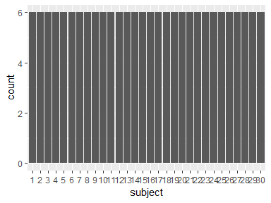

* Observed factor levels: "1", "10", "11", "12", "13", "14", "15", "16", "17", "18", "19", "2", "20", "21", "22", "23", "24", "25", "26", "27", "28", "29", "3", "30", "4", "5", "6", "7", "8", "9".

## activity_label

|  |  |
| --- | --- |
| Feature | Result |
| Variable type | factor |
| Number of missing obs. | 0 (0 %) |
| Number of unique values | 6 |
| Mode | “LAYING” |
| Reference category | LAYING |

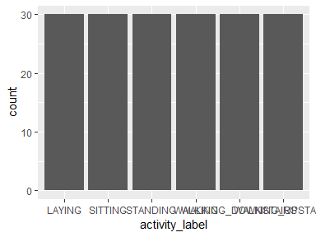

* Observed factor levels: "LAYING", "SITTING", "STANDING", "WALKING", "WALKING_DOWNSTAIRS", "WALKING_UPSTAIRS".

## tBodyAcc-mean()-X

|  |  |
| --- | --- |
| Feature | Result |
| Variable type | numeric |
| Number of missing obs. | 0 (0 %) |
| Number of unique values | 180 |
| Median | 0.28 |
| 1st and 3rd quartiles | 0.27; 0.28 |
| Min. and max. | 0.22; 0.3 |

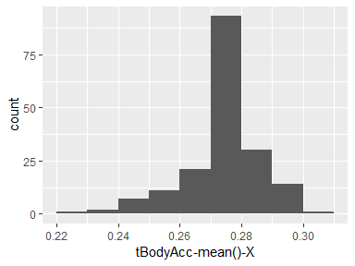

## tBodyAcc-mean()-Y

|  |  |
| --- | --- |
| Feature | Result |
| Variable type | numeric |
| Number of missing obs. | 0 (0 %) |
| Number of unique values | 180 |
| Median | -0.02 |
| 1st and 3rd quartiles | -0.02; -0.01 |
| Min. and max. | -0.04; 0 |

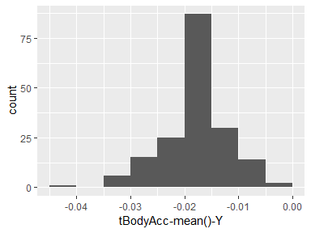

## tBodyAcc-mean()-Z

|  |  |
| --- | --- |
| Feature | Result |
| Variable type | numeric |
| Number of missing obs. | 0 (0 %) |
| Number of unique values | 180 |
| Median | -0.11 |
| 1st and 3rd quartiles | -0.11; -0.1 |
| Min. and max. | -0.15; -0.08 |

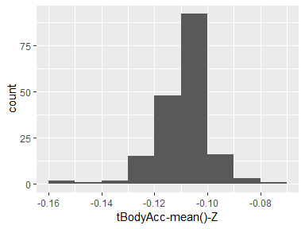

## tBodyAcc-std()-X

|  |  |
| --- | --- |
| Feature | Result |
| Variable type | numeric |
| Number of missing obs. | 0 (0 %) |
| Number of unique values | 180 |
| Median | -0.75 |
| 1st and 3rd quartiles | -0.98; -0.2 |
| Min. and max. | -1; 0.63 |

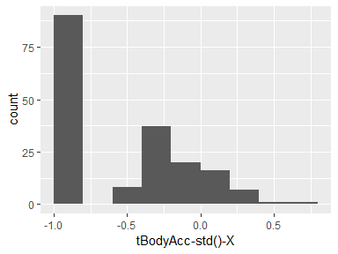

## tBodyAcc-std()-Y

|  |  |
| --- | --- |
| Feature | Result |
| Variable type | numeric |
| Number of missing obs. | 0 (0 %) |
| Number of unique values | 180 |
| Median | -0.51 |
| 1st and 3rd quartiles | -0.94; -0.03 |
| Min. and max. | -0.99; 0.62 |

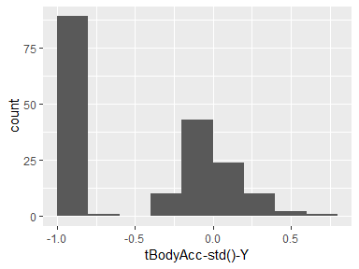

## tBodyAcc-std()-Z

|  |  |
| --- | --- |
| Feature | Result |
| Variable type | numeric |
| Number of missing obs. | 0 (0 %) |
| Number of unique values | 180 |
| Median | -0.65 |
| 1st and 3rd quartiles | -0.95; -0.23 |
| Min. and max. | -0.99; 0.61 |

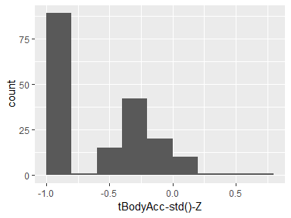

## tGravityAcc-mean()-X

|  |  |
| --- | --- |
| Feature | Result |
| Variable type | numeric |
| Number of missing obs. | 0 (0 %) |
| Number of unique values | 180 |
| Median | 0.92 |
| 1st and 3rd quartiles | 0.84; 0.94 |
| Min. and max. | -0.68; 0.97 |

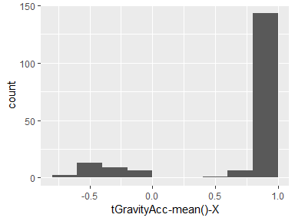

## tGravityAcc-mean()-Y

|  |  |
| --- | --- |
| Feature | Result |
| Variable type | numeric |
| Number of missing obs. | 0 (0 %) |
| Number of unique values | 180 |
| Median | -0.13 |
| 1st and 3rd quartiles | -0.23; 0.09 |
| Min. and max. | -0.48; 0.96 |

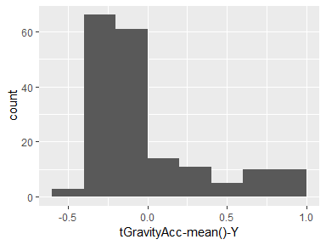

## tGravityAcc-mean()-Z

|  |  |
| --- | --- |
| Feature | Result |
| Variable type | numeric |
| Number of missing obs. | 0 (0 %) |
| Number of unique values | 180 |
| Median | 0.02 |
| 1st and 3rd quartiles | -0.12; 0.15 |
| Min. and max. | -0.5; 0.96 |

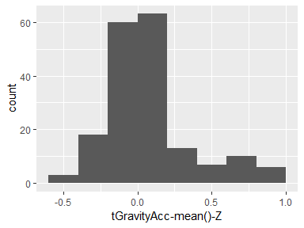

## tGravityAcc-std()-X

|  |  |
| --- | --- |
| Feature | Result |
| Variable type | numeric |
| Number of missing obs. | 0 (0 %) |
| Number of unique values | 180 |
| Median | -0.97 |
| 1st and 3rd quartiles | -0.98; -0.95 |
| Min. and max. | -1; -0.83 |

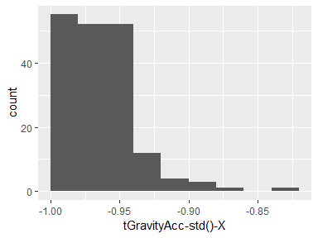

## tGravityAcc-std()-Y

|  |  |
| --- | --- |
| Feature | Result |
| Variable type | numeric |
| Number of missing obs. | 0 (0 %) |
| Number of unique values | 180 |
| Median | -0.96 |
| 1st and 3rd quartiles | -0.97; -0.94 |
| Min. and max. | -0.99; -0.64 |

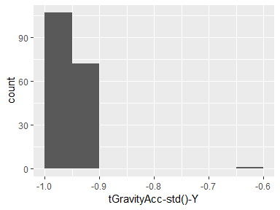

## tGravityAcc-std()-Z

|  |  |
| --- | --- |
| Feature | Result |
| Variable type | numeric |
| Number of missing obs. | 0 (0 %) |
| Number of unique values | 180 |
| Median | -0.95 |
| 1st and 3rd quartiles | -0.96; -0.92 |
| Min. and max. | -0.99; -0.61 |

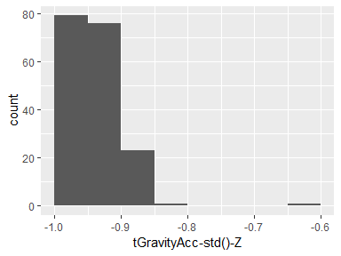

## tBodyAccJerk-mean()-X

|  |  |
| --- | --- |
| Feature | Result |
| Variable type | numeric |
| Number of missing obs. | 0 (0 %) |
| Number of unique values | 180 |
| Median | 0.08 |
| 1st and 3rd quartiles | 0.07; 0.08 |
| Min. and max. | 0.04; 0.13 |

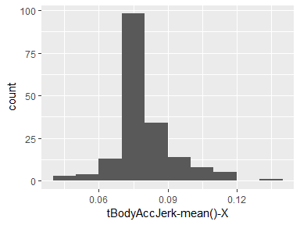

## tBodyAccJerk-mean()-Y

|  |  |
| --- | --- |
| Feature | Result |
| Variable type | numeric |
| Number of missing obs. | 0 (0 %) |
| Number of unique values | 180 |
| Median | 0.01 |
| 1st and 3rd quartiles | 0; 0.01 |
| Min. and max. | -0.04; 0.06 |

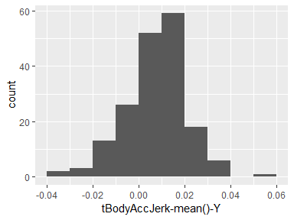

## tBodyAccJerk-mean()-Z

|  |  |
| --- | --- |
| Feature | Result |
| Variable type | numeric |
| Number of missing obs. | 0 (0 %) |
| Number of unique values | 180 |
| Median | 0 |
| 1st and 3rd quartiles | -0.01; 0 |
| Min. and max. | -0.07; 0.04 |

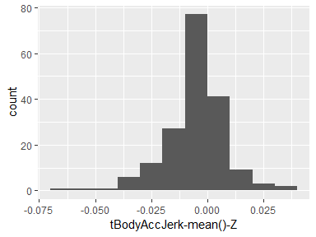

## tBodyAccJerk-std()-X

|  |  |
| --- | --- |
| Feature | Result |
| Variable type | numeric |
| Number of missing obs. | 0 (0 %) |
| Number of unique values | 180 |
| Median | -0.81 |
| 1st and 3rd quartiles | -0.98; -0.22 |
| Min. and max. | -0.99; 0.54 |

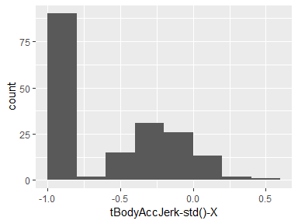

## tBodyAccJerk-std()-Y

|  |  |
| --- | --- |
| Feature | Result |
| Variable type | numeric |
| Number of missing obs. | 0 (0 %) |
| Number of unique values | 180 |
| Median | -0.78 |
| 1st and 3rd quartiles | -0.97; -0.15 |
| Min. and max. | -0.99; 0.36 |

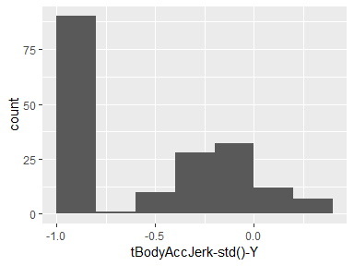

## tBodyAccJerk-std()-Z

|  |  |
| --- | --- |
| Feature | Result |
| Variable type | numeric |
| Number of missing obs. | 0 (0 %) |
| Number of unique values | 180 |
| Median | -0.88 |
| 1st and 3rd quartiles | -0.98; -0.51 |
| Min. and max. | -0.99; 0.03 |

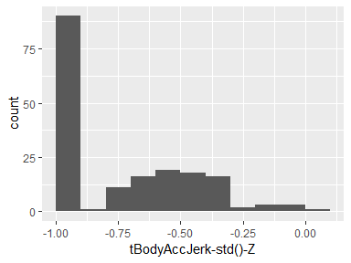

## tBodyGyro-mean()-X

|  |  |
| --- | --- |
| Feature | Result |
| Variable type | numeric |
| Number of missing obs. | 0 (0 %) |
| Number of unique values | 180 |
| Median | -0.03 |
| 1st and 3rd quartiles | -0.05; -0.02 |
| Min. and max. | -0.21; 0.19 |

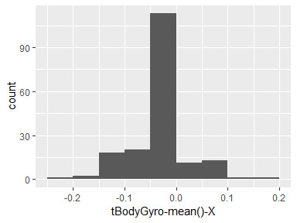

## tBodyGyro-mean()-Y

|  |  |
| --- | --- |
| Feature | Result |
| Variable type | numeric |
| Number of missing obs. | 0 (0 %) |
| Number of unique values | 180 |
| Median | -0.07 |
| 1st and 3rd quartiles | -0.09; -0.06 |
| Min. and max. | -0.2; 0.03 |

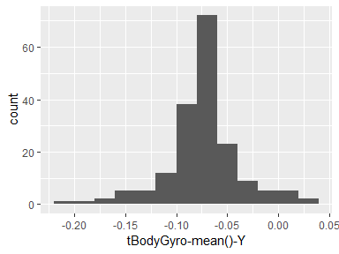

## tBodyGyro-mean()-Z

|  |  |
| --- | --- |
| Feature | Result |
| Variable type | numeric |
| Number of missing obs. | 0 (0 %) |
| Number of unique values | 180 |
| Median | 0.09 |
| 1st and 3rd quartiles | 0.07; 0.1 |
| Min. and max. | -0.07; 0.18 |

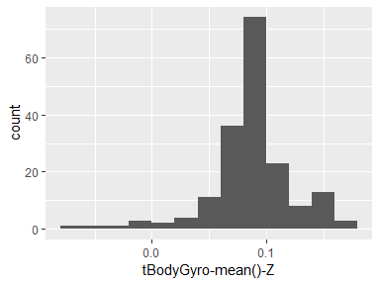

## tBodyGyro-std()-X

|  |  |
| --- | --- |
| Feature | Result |
| Variable type | numeric |
| Number of missing obs. | 0 (0 %) |
| Number of unique values | 180 |
| Median | -0.79 |
| 1st and 3rd quartiles | -0.97; -0.44 |
| Min. and max. | -0.99; 0.27 |

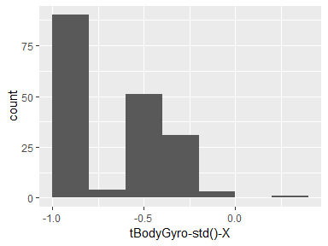

## tBodyGyro-std()-Y

|  |  |
| --- | --- |
| Feature | Result |
| Variable type | numeric |
| Number of missing obs. | 0 (0 %) |
| Number of unique values | 180 |
| Median | -0.8 |
| 1st and 3rd quartiles | -0.96; -0.42 |
| Min. and max. | -0.99; 0.48 |

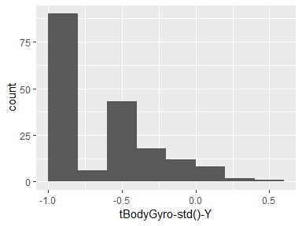

## tBodyGyro-std()-Z

|  |  |
| --- | --- |
| Feature | Result |
| Variable type | numeric |
| Number of missing obs. | 0 (0 %) |
| Number of unique values | 180 |
| Median | -0.8 |
| 1st and 3rd quartiles | -0.96; -0.31 |
| Min. and max. | -0.99; 0.56 |

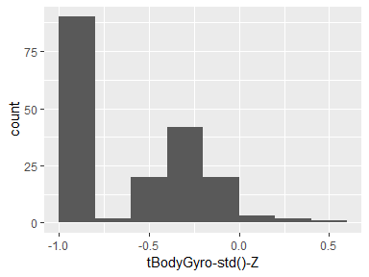

## tBodyGyroJerk-mean()-X

|  |  |
| --- | --- |
| Feature | Result |
| Variable type | numeric |
| Number of missing obs. | 0 (0 %) |
| Number of unique values | 180 |
| Median | -0.1 |
| 1st and 3rd quartiles | -0.1; -0.09 |
| Min. and max. | -0.16; -0.02 |

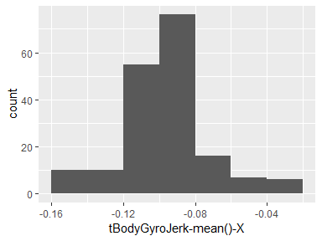

## tBodyGyroJerk-mean()-Y

|  |  |
| --- | --- |
| Feature | Result |
| Variable type | numeric |
| Number of missing obs. | 0 (0 %) |
| Number of unique values | 180 |
| Median | -0.04 |
| 1st and 3rd quartiles | -0.05; -0.04 |
| Min. and max. | -0.08; -0.01 |

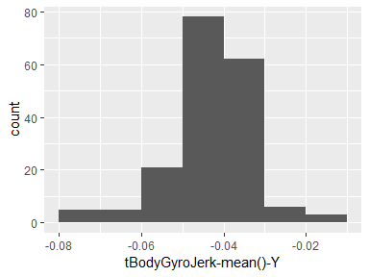

## tBodyGyroJerk-mean()-Z

|  |  |
| --- | --- |
| Feature | Result |
| Variable type | numeric |
| Number of missing obs. | 0 (0 %) |
| Number of unique values | 180 |
| Median | -0.05 |
| 1st and 3rd quartiles | -0.06; -0.05 |
| Min. and max. | -0.09; -0.01 |

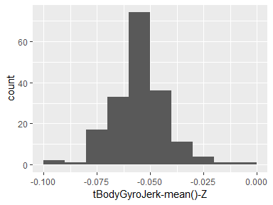

## tBodyGyroJerk-std()-X

|  |  |
| --- | --- |
| Feature | Result |
| Variable type | numeric |
| Number of missing obs. | 0 (0 %) |
| Number of unique values | 180 |
| Median | -0.84 |
| 1st and 3rd quartiles | -0.98; -0.46 |
| Min. and max. | -1; 0.18 |

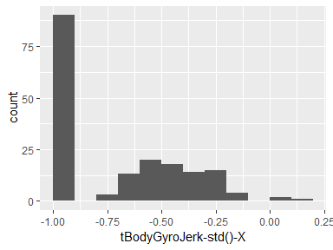

## tBodyGyroJerk-std()-Y

|  |  |
| --- | --- |
| Feature | Result |
| Variable type | numeric |
| Number of missing obs. | 0 (0 %) |
| Number of unique values | 180 |
| Median | -0.89 |
| 1st and 3rd quartiles | -0.98; -0.59 |
| Min. and max. | -1; 0.3 |

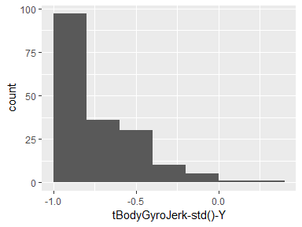

## tBodyGyroJerk-std()-Z

|  |  |
| --- | --- |
| Feature | Result |
| Variable type | numeric |
| Number of missing obs. | 0 (0 %) |
| Number of unique values | 180 |
| Median | -0.86 |
| 1st and 3rd quartiles | -0.98; -0.47 |
| Min. and max. | -1; 0.19 |

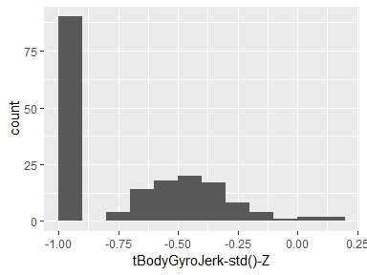

## tBodyAccMag-mean()

|  |  |
| --- | --- |
| Feature | Result |
| Variable type | numeric |
| Number of missing obs. | 0 (0 %) |
| Number of unique values | 180 |
| Median | -0.48 |
| 1st and 3rd quartiles | -0.96; -0.09 |
| Min. and max. | -0.99; 0.64 |

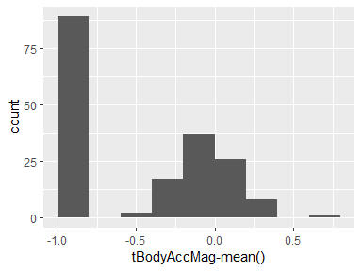

## tBodyAccMag-std()

|  |  |
| --- | --- |
| Feature | Result |
| Variable type | numeric |
| Number of missing obs. | 0 (0 %) |
| Number of unique values | 180 |
| Median | -0.61 |
| 1st and 3rd quartiles | -0.94; -0.21 |
| Min. and max. | -0.99; 0.43 |

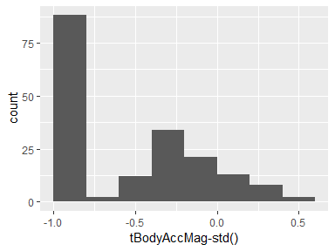

## tGravityAccMag-mean()

|  |  |
| --- | --- |
| Feature | Result |
| Variable type | numeric |
| Number of missing obs. | 0 (0 %) |
| Number of unique values | 180 |
| Median | -0.48 |
| 1st and 3rd quartiles | -0.96; -0.09 |
| Min. and max. | -0.99; 0.64 |

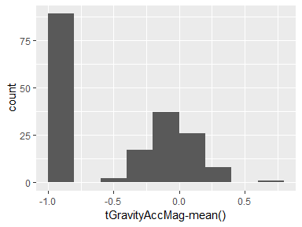

## tGravityAccMag-std()

|  |  |
| --- | --- |
| Feature | Result |
| Variable type | numeric |
| Number of missing obs. | 0 (0 %) |
| Number of unique values | 180 |
| Median | -0.61 |
| 1st and 3rd quartiles | -0.94; -0.21 |
| Min. and max. | -0.99; 0.43 |

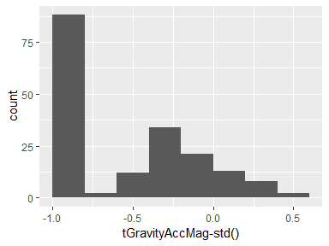

## tBodyAccJerkMag-mean()

|  |  |
| --- | --- |
| Feature | Result |
| Variable type | numeric |
| Number of missing obs. | 0 (0 %) |
| Number of unique values | 180 |
| Median | -0.82 |
| 1st and 3rd quartiles | -0.98; -0.25 |
| Min. and max. | -0.99; 0.43 |

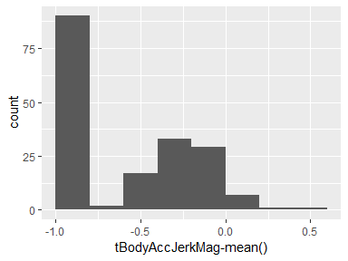

## tBodyAccJerkMag-std()

|  |  |
| --- | --- |
| Feature | Result |
| Variable type | numeric |
| Number of missing obs. | 0 (0 %) |
| Number of unique values | 180 |
| Median | -0.8 |
| 1st and 3rd quartiles | -0.98; -0.22 |
| Min. and max. | -0.99; 0.45 |

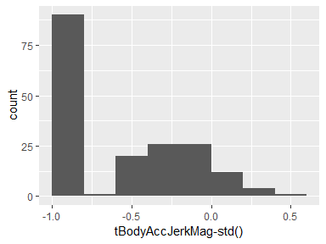

## tBodyGyroMag-mean()

|  |  |
| --- | --- |
| Feature | Result |
| Variable type | numeric |
| Number of missing obs. | 0 (0 %) |
| Number of unique values | 180 |
| Median | -0.66 |
| 1st and 3rd quartiles | -0.95; -0.22 |
| Min. and max. | -0.98; 0.42 |

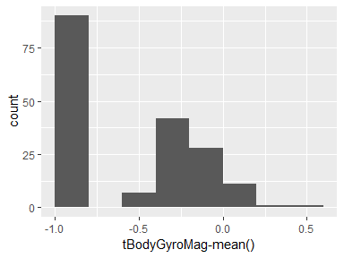

## tBodyGyroMag-std()

|  |  |
| --- | --- |
| Feature | Result |
| Variable type | numeric |
| Number of missing obs. | 0 (0 %) |
| Number of unique values | 180 |
| Median | -0.74 |
| 1st and 3rd quartiles | -0.95; -0.36 |
| Min. and max. | -0.98; 0.3 |

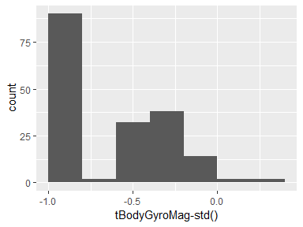

## tBodyGyroJerkMag-mean()

|  |  |
| --- | --- |
| Feature | Result |
| Variable type | numeric |
| Number of missing obs. | 0 (0 %) |
| Number of unique values | 180 |
| Median | -0.86 |
| 1st and 3rd quartiles | -0.99; -0.51 |
| Min. and max. | -1; 0.09 |

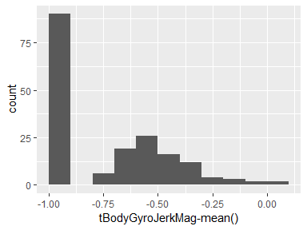

## tBodyGyroJerkMag-std()

|  |  |
| --- | --- |
| Feature | Result |
| Variable type | numeric |
| Number of missing obs. | 0 (0 %) |
| Number of unique values | 180 |
| Median | -0.88 |
| 1st and 3rd quartiles | -0.98; -0.58 |
| Min. and max. | -1; 0.25 |

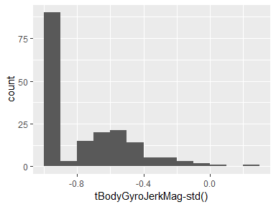

## fBodyAcc-mean()-X

|  |  |
| --- | --- |
| Feature | Result |
| Variable type | numeric |
| Number of missing obs. | 0 (0 %) |
| Number of unique values | 180 |
| Median | -0.77 |
| 1st and 3rd quartiles | -0.98; -0.22 |
| Min. and max. | -1; 0.54 |

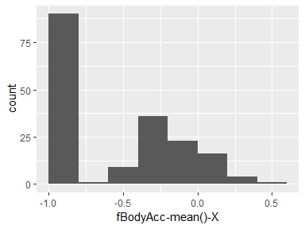

## fBodyAcc-mean()-Y

|  |  |
| --- | --- |
| Feature | Result |
| Variable type | numeric |
| Number of missing obs. | 0 (0 %) |
| Number of unique values | 180 |
| Median | -0.59 |
| 1st and 3rd quartiles | -0.95; -0.06 |
| Min. and max. | -0.99; 0.52 |

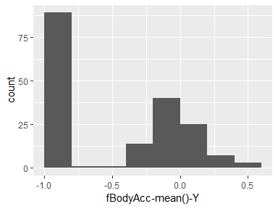

## fBodyAcc-mean()-Z

|  |  |
| --- | --- |
| Feature | Result |
| Variable type | numeric |
| Number of missing obs. | 0 (0 %) |
| Number of unique values | 180 |
| Median | -0.72 |
| 1st and 3rd quartiles | -0.96; -0.32 |
| Min. and max. | -0.99; 0.28 |

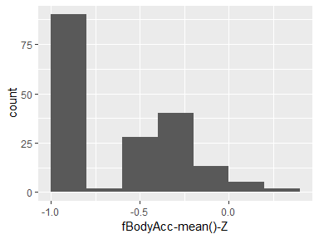

## fBodyAcc-std()-X

|  |  |
| --- | --- |
| Feature | Result |
| Variable type | numeric |
| Number of missing obs. | 0 (0 %) |
| Number of unique values | 180 |
| Median | -0.75 |
| 1st and 3rd quartiles | -0.98; -0.2 |
| Min. and max. | -1; 0.66 |

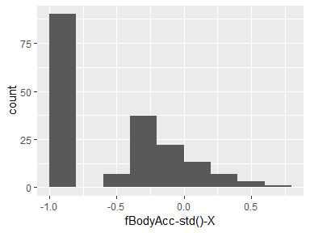

## fBodyAcc-std()-Y

|  |  |
| --- | --- |
| Feature | Result |
| Variable type | numeric |
| Number of missing obs. | 0 (0 %) |
| Number of unique values | 180 |
| Median | -0.51 |
| 1st and 3rd quartiles | -0.94; -0.08 |
| Min. and max. | -0.99; 0.56 |

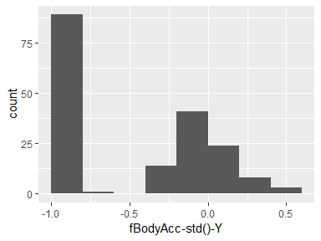

## fBodyAcc-std()-Z

|  |  |
| --- | --- |
| Feature | Result |
| Variable type | numeric |
| Number of missing obs. | 0 (0 %) |
| Number of unique values | 180 |
| Median | -0.64 |
| 1st and 3rd quartiles | -0.95; -0.27 |
| Min. and max. | -0.99; 0.69 |

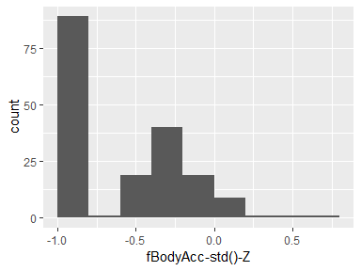

## fBodyAccJerk-mean()-X

|  |  |
| --- | --- |
| Feature | Result |
| Variable type | numeric |
| Number of missing obs. | 0 (0 %) |
| Number of unique values | 180 |
| Median | -0.81 |
| 1st and 3rd quartiles | -0.98; -0.28 |
| Min. and max. | -0.99; 0.47 |

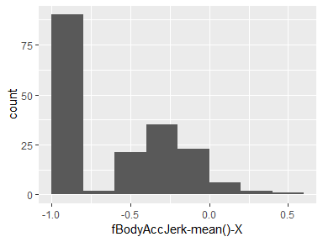

## fBodyAccJerk-mean()-Y

|  |  |
| --- | --- |
| Feature | Result |
| Variable type | numeric |
| Number of missing obs. | 0 (0 %) |
| Number of unique values | 180 |
| Median | -0.78 |
| 1st and 3rd quartiles | -0.97; -0.2 |
| Min. and max. | -0.99; 0.28 |

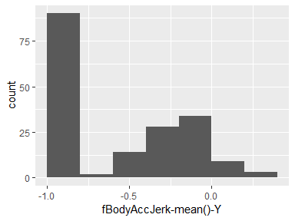

## fBodyAccJerk-mean()-Z

|  |  |
| --- | --- |
| Feature | Result |
| Variable type | numeric |
| Number of missing obs. | 0 (0 %) |
| Number of unique values | 180 |
| Median | -0.87 |
| 1st and 3rd quartiles | -0.98; -0.47 |
| Min. and max. | -0.99; 0.16 |

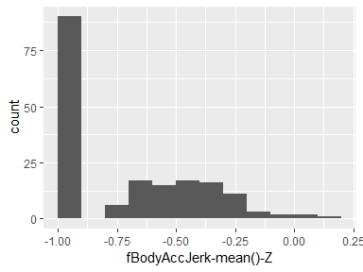

## fBodyAccJerk-std()-X

|  |  |
| --- | --- |
| Feature | Result |
| Variable type | numeric |
| Number of missing obs. | 0 (0 %) |
| Number of unique values | 180 |
| Median | -0.83 |
| 1st and 3rd quartiles | -0.98; -0.25 |
| Min. and max. | -1; 0.48 |

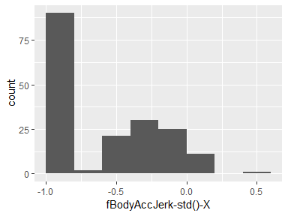

## fBodyAccJerk-std()-Y

|  |  |
| --- | --- |
| Feature | Result |
| Variable type | numeric |
| Number of missing obs. | 0 (0 %) |
| Number of unique values | 180 |
| Median | -0.79 |
| 1st and 3rd quartiles | -0.97; -0.17 |
| Min. and max. | -0.99; 0.35 |

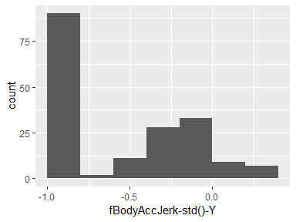

## fBodyAccJerk-std()-Z

|  |  |
| --- | --- |
| Feature | Result |
| Variable type | numeric |
| Number of missing obs. | 0 (0 %) |
| Number of unique values | 180 |
| Median | -0.9 |
| 1st and 3rd quartiles | -0.98; -0.54 |
| Min. and max. | -0.99; -0.01 |

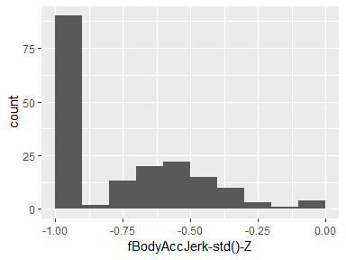

## fBodyGyro-mean()-X

|  |  |
| --- | --- |
| Feature | Result |
| Variable type | numeric |
| Number of missing obs. | 0 (0 %) |
| Number of unique values | 180 |
| Median | -0.73 |
| 1st and 3rd quartiles | -0.97; -0.34 |
| Min. and max. | -0.99; 0.47 |

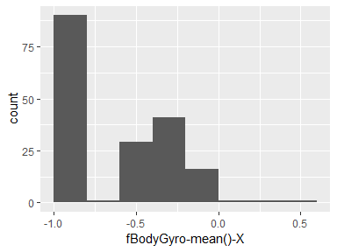

## fBodyGyro-mean()-Y

|  |  |
| --- | --- |
| Feature | Result |
| Variable type | numeric |
| Number of missing obs. | 0 (0 %) |
| Number of unique values | 180 |
| Median | -0.81 |
| 1st and 3rd quartiles | -0.97; -0.45 |
| Min. and max. | -0.99; 0.33 |

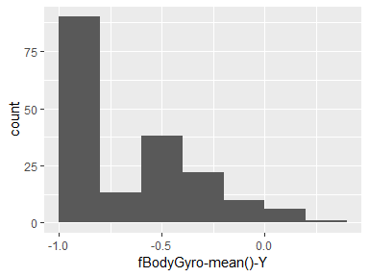

## fBodyGyro-mean()-Z

|  |  |
| --- | --- |
| Feature | Result |
| Variable type | numeric |
| Number of missing obs. | 0 (0 %) |
| Number of unique values | 180 |
| Median | -0.79 |
| 1st and 3rd quartiles | -0.96; -0.26 |
| Min. and max. | -0.99; 0.49 |

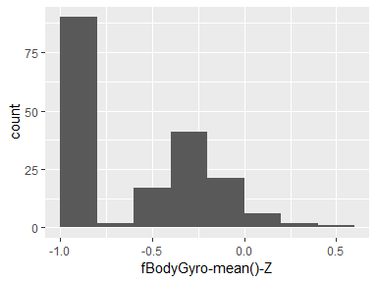

## fBodyGyro-std()-X

|  |  |
| --- | --- |
| Feature | Result |
| Variable type | numeric |
| Number of missing obs. | 0 (0 %) |
| Number of unique values | 180 |
| Median | -0.81 |
| 1st and 3rd quartiles | -0.98; -0.48 |
| Min. and max. | -0.99; 0.2 |

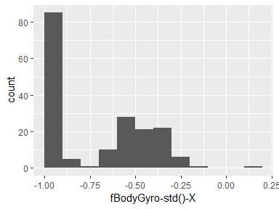

## fBodyGyro-std()-Y

|  |  |
| --- | --- |
| Feature | Result |
| Variable type | numeric |
| Number of missing obs. | 0 (0 %) |
| Number of unique values | 180 |
| Median | -0.8 |
| 1st and 3rd quartiles | -0.96; -0.42 |
| Min. and max. | -0.99; 0.65 |

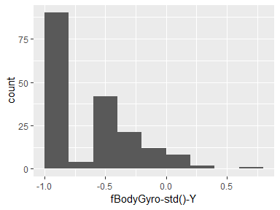

## fBodyGyro-std()-Z

|  |  |
| --- | --- |
| Feature | Result |
| Variable type | numeric |
| Number of missing obs. | 0 (0 %) |
| Number of unique values | 180 |
| Median | -0.82 |
| 1st and 3rd quartiles | -0.96; -0.39 |
| Min. and max. | -0.99; 0.52 |

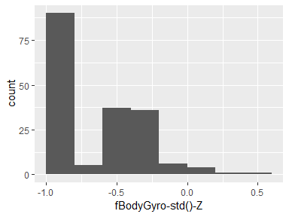

## fBodyAccMag-mean()

|  |  |
| --- | --- |
| Feature | Result |
| Variable type | numeric |
| Number of missing obs. | 0 (0 %) |
| Number of unique values | 180 |
| Median | -0.67 |
| 1st and 3rd quartiles | -0.96; -0.16 |
| Min. and max. | -0.99; 0.59 |

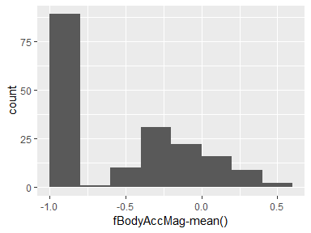

## fBodyAccMag-std()

|  |  |
| --- | --- |
| Feature | Result |
| Variable type | numeric |
| Number of missing obs. | 0 (0 %) |
| Number of unique values | 180 |
| Median | -0.65 |
| 1st and 3rd quartiles | -0.95; -0.37 |
| Min. and max. | -0.99; 0.18 |

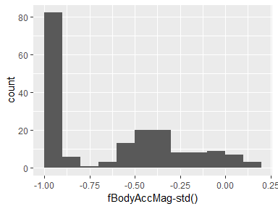

## fBodyBodyAccJerkMag-mean()

|  |  |
| --- | --- |
| Feature | Result |
| Variable type | numeric |
| Number of missing obs. | 0 (0 %) |
| Number of unique values | 180 |
| Median | -0.79 |
| 1st and 3rd quartiles | -0.98; -0.19 |
| Min. and max. | -0.99; 0.54 |

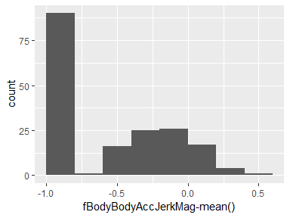

## fBodyBodyAccJerkMag-std()

|  |  |
| --- | --- |
| Feature | Result |
| Variable type | numeric |
| Number of missing obs. | 0 (0 %) |
| Number of unique values | 180 |
| Median | -0.81 |
| 1st and 3rd quartiles | -0.98; -0.27 |
| Min. and max. | -0.99; 0.32 |

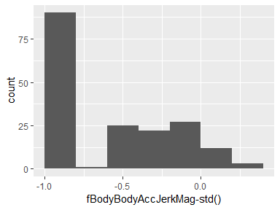

## fBodyBodyGyroMag-mean()

|  |  |
| --- | --- |
| Feature | Result |
| Variable type | numeric |
| Number of missing obs. | 0 (0 %) |
| Number of unique values | 180 |
| Median | -0.77 |
| 1st and 3rd quartiles | -0.96; -0.41 |
| Min. and max. | -0.99; 0.2 |

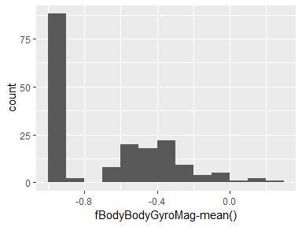

## fBodyBodyGyroMag-std()

|  |  |
| --- | --- |
| Feature | Result |
| Variable type | numeric |
| Number of missing obs. | 0 (0 %) |
| Number of unique values | 180 |
| Median | -0.77 |
| 1st and 3rd quartiles | -0.95; -0.43 |
| Min. and max. | -0.98; 0.24 |

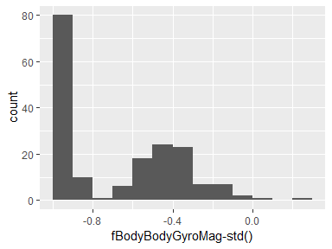

## fBodyBodyGyroJerkMag-mean()

|  |  |
| --- | --- |
| Feature | Result |
| Variable type | numeric |
| Number of missing obs. | 0 (0 %) |
| Number of unique values | 180 |
| Median | -0.88 |
| 1st and 3rd quartiles | -0.98; -0.58 |
| Min. and max. | -1; 0.15 |

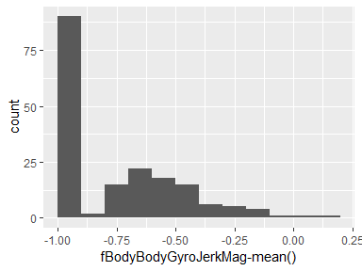

## fBodyBodyGyroJerkMag-std()

|  |  |
| --- | --- |
| Feature | Result |
| Variable type | numeric |
| Number of missing obs. | 0 (0 %) |
| Number of unique values | 180 |
| Median | -0.89 |
| 1st and 3rd quartiles | -0.98; -0.61 |
| Min. and max. | -1; 0.29 |

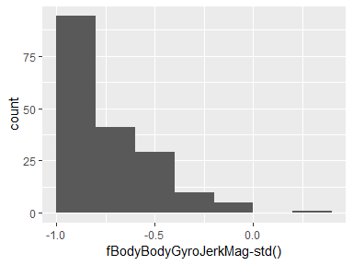

Report generation information:

* Created by MeetaC (username: mn080632).
* Report creation time: Wed Oct 31 2018 09:56:10
* Report was run from directory: C:/Meeta Skill Enhancement/Data Science Specialization/Course 3- Getting and Cleaning Data/Project
* dataMaid v1.2.0 [Pkg: 2018-10-03 from CRAN (R 3.5.1)]
* R version 3.5.1 (2018-07-02).
* Platform: x86_64-w64-mingw32/x64 (64-bit)(Windows >= 8 x64 (build 9200)).
* Function call: makeDataReport(data = tidy, mode = c("summarize", "visualize", "check"), smartNum = FALSE, file = "codebook_tidy.Rmd", checks = list( character = "showAllFactorLevels", factor = "showAllFactorLevels", labelled = "showAllFactorLevels", haven_labelled = "showAllFactorLevels", numeric = NULL, integer = NULL, logical = NULL, Date = NULL), listChecks = FALSE, maxProbVals = Inf, codebook = TRUE, reportTitle = "Codebook for tidy")