Experiment-1

Design a Program to find 2’s complement of a given binary number.

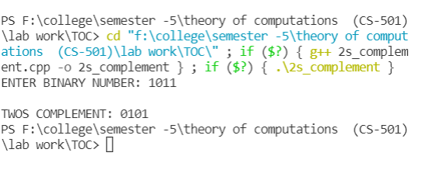

Experiment-2

 Design a Program which will increment the given binary number by 1.

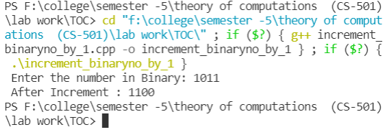

Experiment-3

 Design a program to perform string operations.

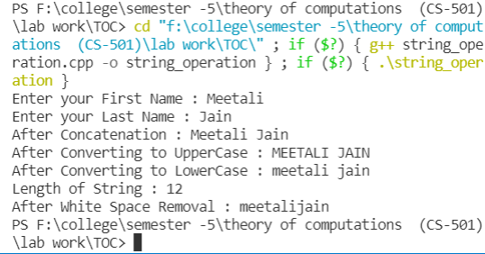

Experiment-4

Design a program to take strings from user and compute its length.

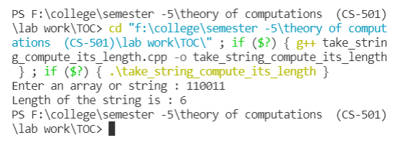

Experiment-5

Design a Program for creating machine that accept three consecutive one.

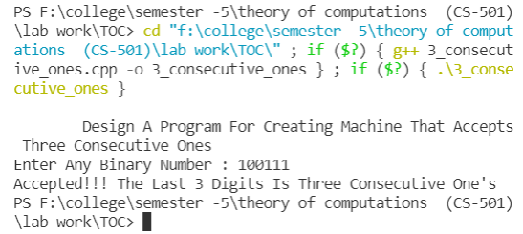

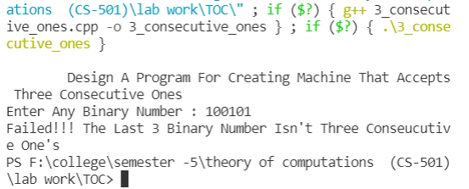

Experiment-6

Design a Program for creating a machine that accepts the string always ending with 101.

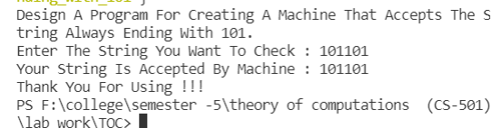

Experiment-7

Design a program for accepting decimal number divisible by 2.

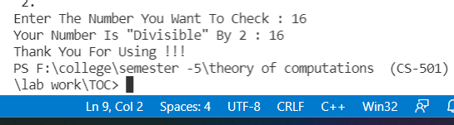

Experiment-8

 Design a program for creating a machine which accepts string having equal no. of 1’s and 0’s.

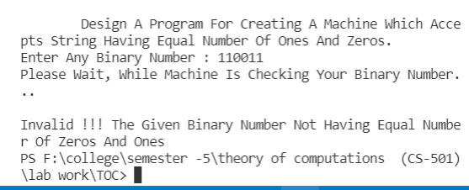

Experiment-9

Design a program for creating a machine which count number of 1’s and 0’s in a given string.

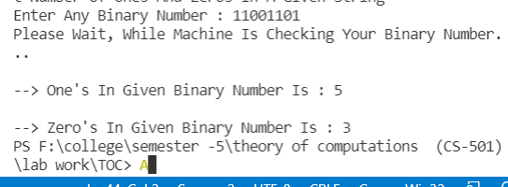

Experiment-10

Program For PDA Which Accepts Strings Of (a^n)(b^2n) n>=1.

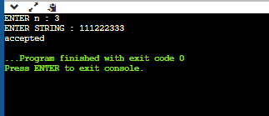

Experiment-11

Create Design a Program to PDA accepting string 0^n1^n n>=1.

