Course: Robotics and Spatial Intelligence, Fall 2024

Homework 2

Name: Mu-Ruei Tseng (UIN: 133007868)

*For this assignment, you'll use the last two digits of your Texas A&M UIN to select a task and environment for a hypothetical robot to complete.*

You are a roboticist that wants to design a robot that can complete the task of autonomously **playing chess** in the environment **Victoria Crater, Mars**.

Consider the basic hardware design of your robot and answer the questions below.

1. Choose a mode of locomotion for your robot. Explain, in one English sentence, why this mode of locomotion is a good choice for this problem.
   * **Locomotion Mode: Terrestrial.** This is because Mars has gravity, allowing the robot to move efficiently on the ground while navigating the terrain to pick up chess pieces.
2. Identify what type of actuators your robot will use to achieve this mode of locomotion.
   * I think using **stepper motors** can better achieve this mode of locomotion, as they provide the precise navigation and accurate positioning needed for the robot to move to specific chess positions and pick up the pieces.
3. Use your favorite search engine to locate actuators of this type manufactured by at least two different companies. Provide links to the product listings.
   * **Leadshine 110HS28 High Performance 2-Phase NEMA 42 Hybrid Stepper Motor** produced by Leadshine Technology, Inc. (link: <http://www.americanmotiontech.com/products/productdetail.aspx?model=leadshine-110hs28-3965-oz-in-nema-42-stepper-motor>)
   * **AMT HS440 NEMA 42 2-Phase 2** produced by American Motion Technology, LLC. (link: <http://www.americanmotiontech.com/products/productdetail.aspx?model=hs4220-2832-oz-in-nema-42-stepper-motor>)
4. Compare and contrast the specifications for those actuators, as listed in the product descriptions or data sheets.
   * Specifications comparison: Leadshine 110HS28 vs AMT HS440

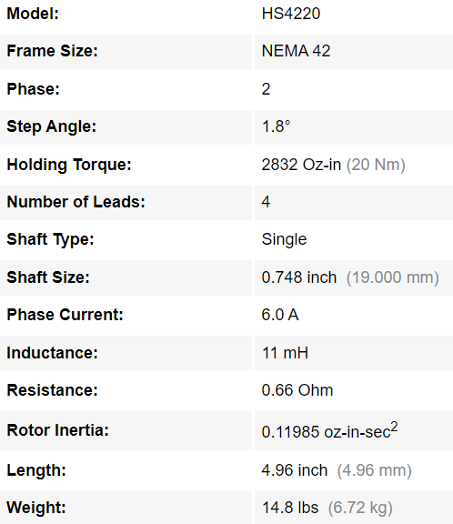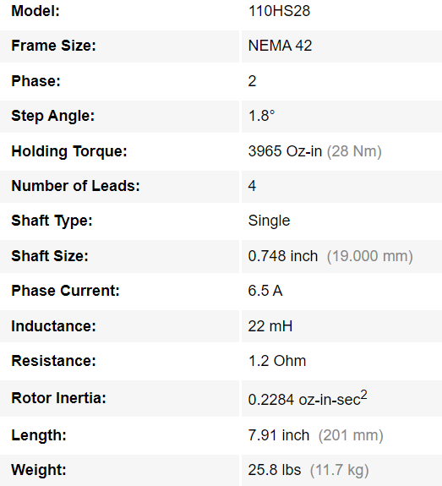

* + The two actuators share similar specifications in most categories, with the key differences being in holding torque, size, weight, and other electrical characteristics such as inductance, resistance, and rotor inertia.
    - Holding Torque: The 110HS28 offers a higher holding torque compared to the HS4220, making it more suitable for tasks involving heavier loads.
    - Size and Weight: The 110HS28 is larger and heavier than the HS4220
  + Since we are building a chess-playing robot that navigates on Mars, the size and weight of the robot wouldn’t be significant constraints. Besides, without knowing the weight of the chess pieces, choosing for the motor with higher holding torque, the 110HS28, would be a better to ensure the robot can handle the task effectively.

1. Choose at least two types of sensors for your robot. Explain how the information from these sensors can help the robot complete its task.
   * Cameras: Camera sensors are important for the robot to observe the current distribution of chess pieces on the board. It allows the robot to analyze the game’s state and determine which piece to move.
   * Infrared (IR) sensors: IR sensors can be used to estimate the distance between the robot and the chess pieces. This distance information is essential for the robot to know the position of itself accurately and ensure the robotic arm is close enough to grab the chess pieces.
2. For one of those two sensors, your favorite search engine to locate sensors of this type manufactured by at least two different companies. Provide links to the product listings.
   * **C2590, 1" Color, Dalsa Genie Nano GigE PoE Camera** produced by Teledyne DALSA (link: <https://www.edmundoptics.com/p/c2590-1-color-dalsa-genie-nano-poe-camera/4061/>)
   * **Allied Vision Mako G-234C 1/1.2" Color CMOS Camera** produced by Allied Vision (link: <https://www.edmundoptics.com/p/allied-vision-mako-g-234c-112-color-cmos-camera/3609/>)
3. Compare and contrast the specifications for those sensors, as listed in the product descriptions or data sheets.
   * 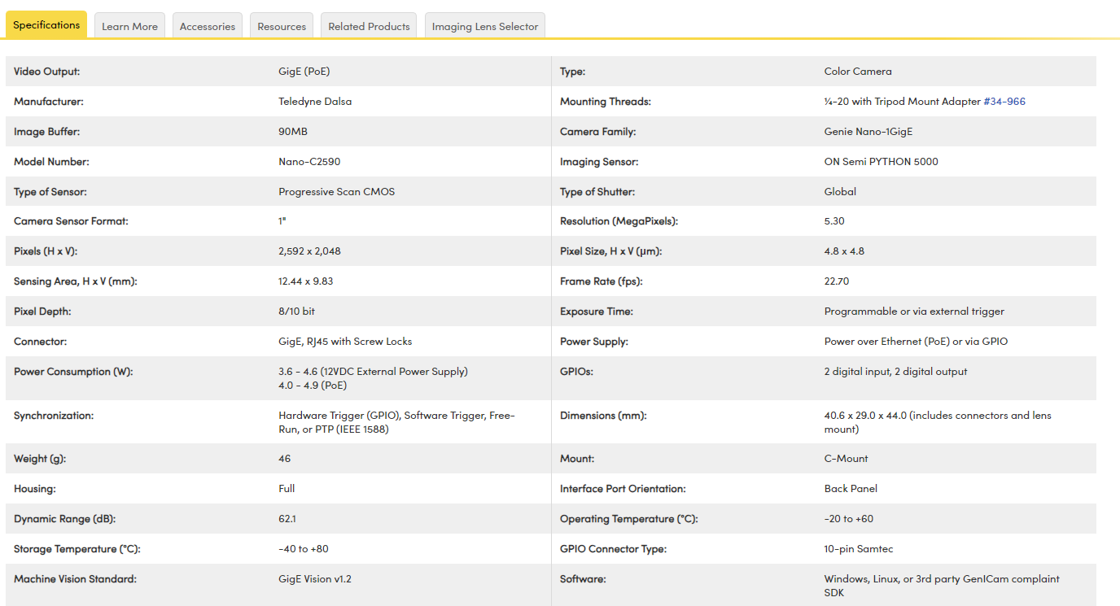Specification for **Teledyne Dalsa Genie Nano GigE PoE Camera**
   * A screenshot of a computer

     Description automatically generatedSpecification for **Allied Vision Mako G-234C 1/1.2" Color CMOS Camera**
   * Teledyne Dalsa Nano-C2590 offers a higher resolution (5.3 MP) compared to the Allied Vision G-234C (2.35 MP), but it has a lower frame rate (22.7 fps versus 40 fps). However, since the robot's task does not involve fast-moving objects, a high frame rate is not required.
   * Notably, the Teledyne Dalsa Nano-C2590 camera operates within a broader temperature range, making it more suitable for our task, given the extreme temperatures on Mars. While the Teledyne Dalsa Nano-C2590 consumes more power (3.6W to 4.6W) and is more expensive, its advantages in resolution and environmental resilience make it the better choice over the Allied Vision G-234C.