**Name: Shubh Gangar**

**Roll No: 1911013**

**Batch: A1**

**Lab: 19/1/21**

**Question 1:**

Code:

n = int(input("Enter a number : "))

if n == 0:

print("Zero")

elif n == 1:

print("One")

elif n == 2:

print("Two")

elif n == 3:

print("Three")

elif n == 4:

print("Four")

elif n == 5:

print("Five")

elif n == 6:

print("Six")

elif n == 7:

print("Seven")

elif n == 8:

print("Eight")

elif n == 9:

print("Nine")

else:

print("Enter a single digit number")

Output:

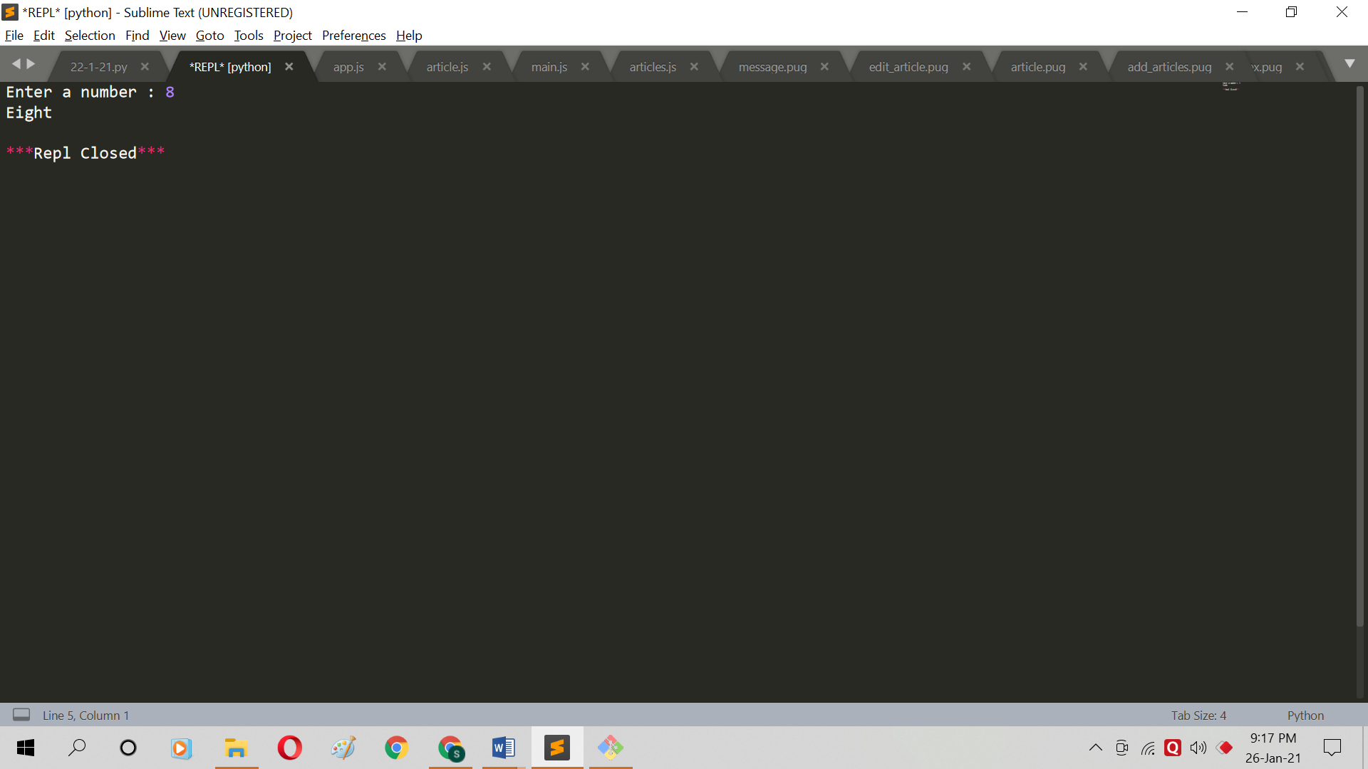

**Question 2:**

Code:

n = int(input("Enter lower limit: "));

i= n;

m = int(input("Enter upper limit: "));

while i>=n and i<=m :

if(i % 3 == 0):

print(i," ");

i=i+1;

Output: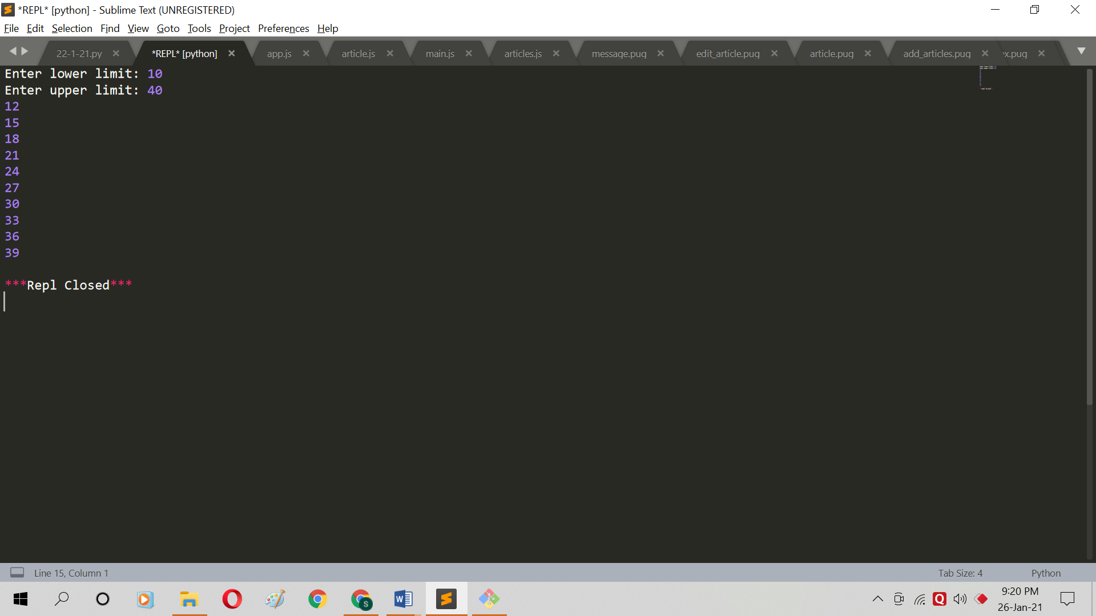

**Question 3:**

Code:

n = int(input("Enter number of rows and columns: "));

for i in range (0,n):

for j in range(0,i+1):

print("*",end=" ");

print("\r");

Output:

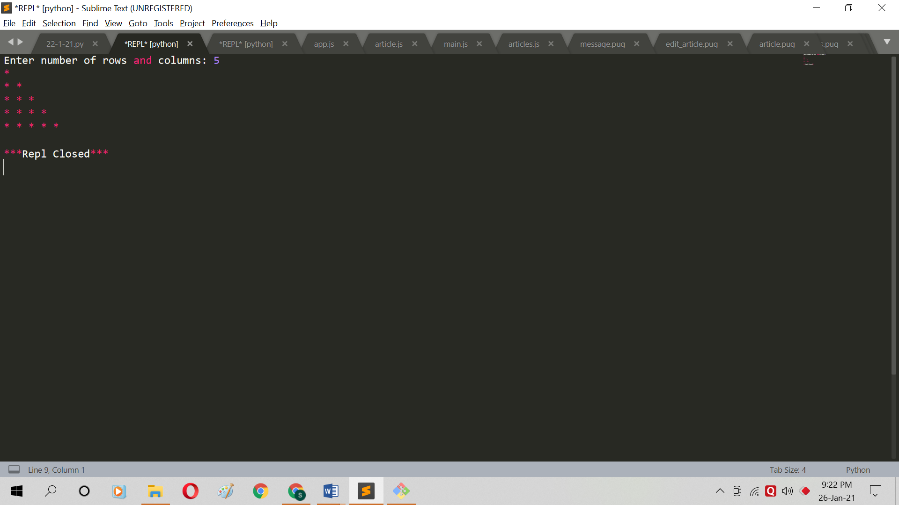

**Question 4:**

Code:

days = int(input("Enter number of days : "))

fine = 0

if days > 0 and days <= 5 :

fine = days * 0.50

print("Fine is Rs: ",fine)

elif days > 5 and days <= 10 :

fine = 2.50 + (days-5)

print("Fine is ",fine)

elif days > 10 and days <= 30 :

fine = 2.50 + 5 + (days-10)

print("Fine is ",fine)

else:

print("Membership cancelled")

Output: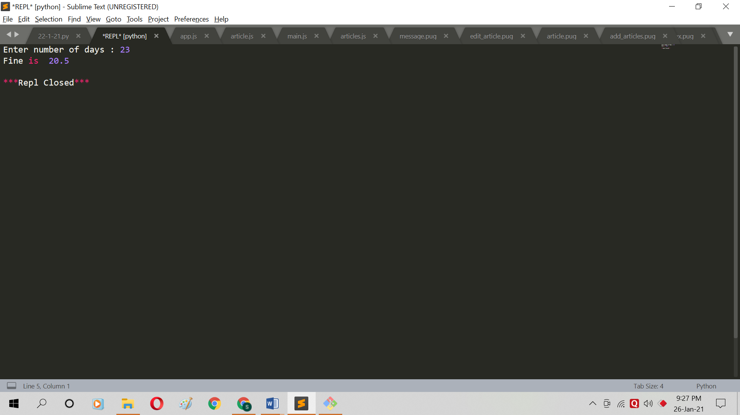

**Addition Problems:**

**Question 1:**

Code:

n = int(input("Enter a number : "))

if n%2 == 0:

print("Even number")

else:

print("Odd number")

Output:

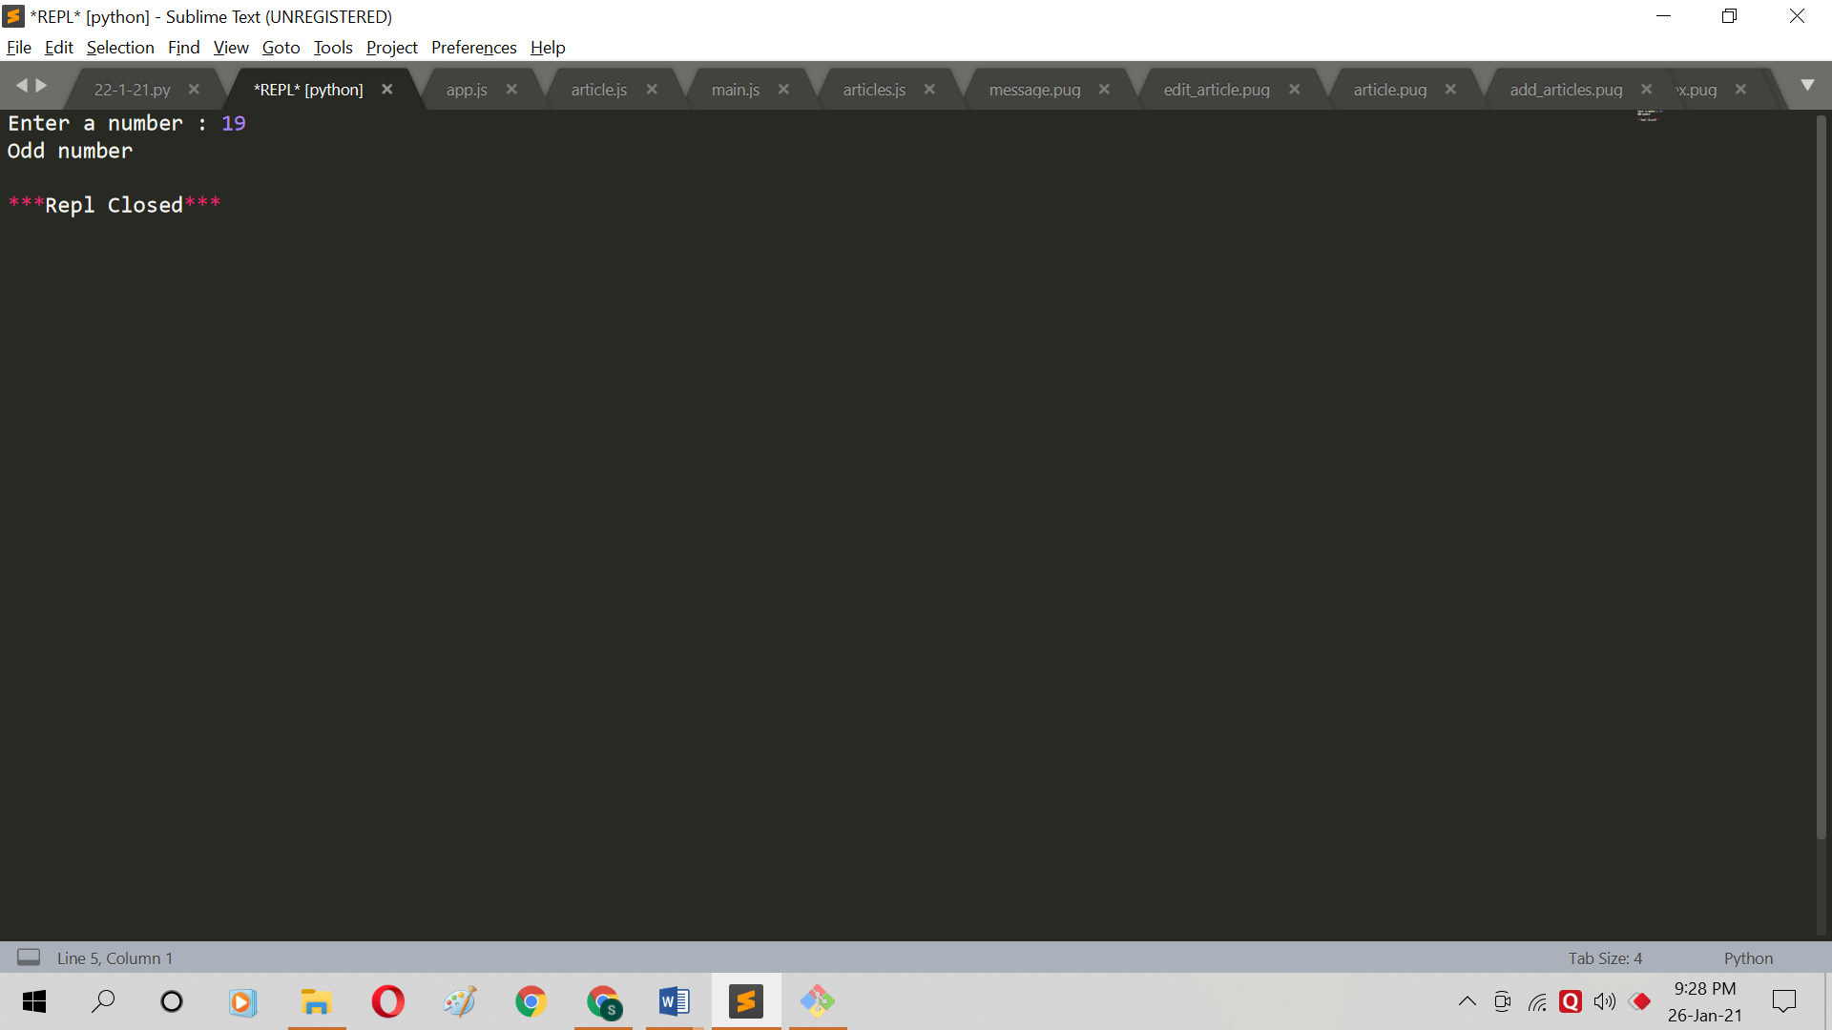

**Question 2:**

Code:

ch = input("Enter a Character : ")

if(ch == 'a' or ch == 'e' or ch == 'i' or ch == 'o' or ch == 'u' or ch == 'A' or ch == 'E' or ch == 'I' or ch == 'O' or ch == 'U'):

print("Vowel")

else:

print("Consonant")

Output:

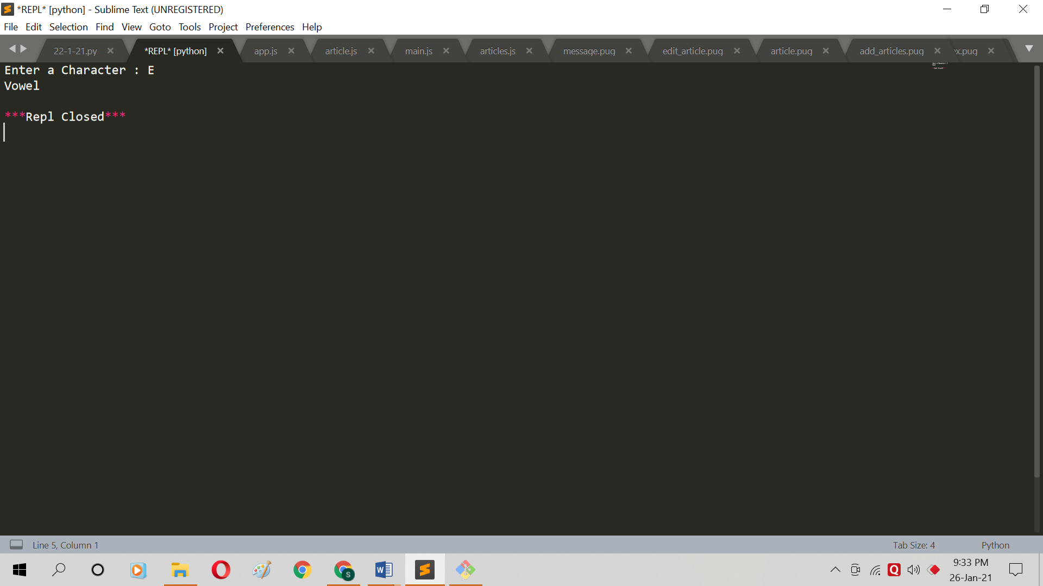

**Question 3:**

Code:

BS = int(input("Enter basic salary : "))

if BS < 15000:

hra = (10/100)*BS

da = (90/100)*BS

else :

da = (98/100)*BS

hra = 1700

gross = BS+hra+da

print("Gross salary is ",gross)

Output: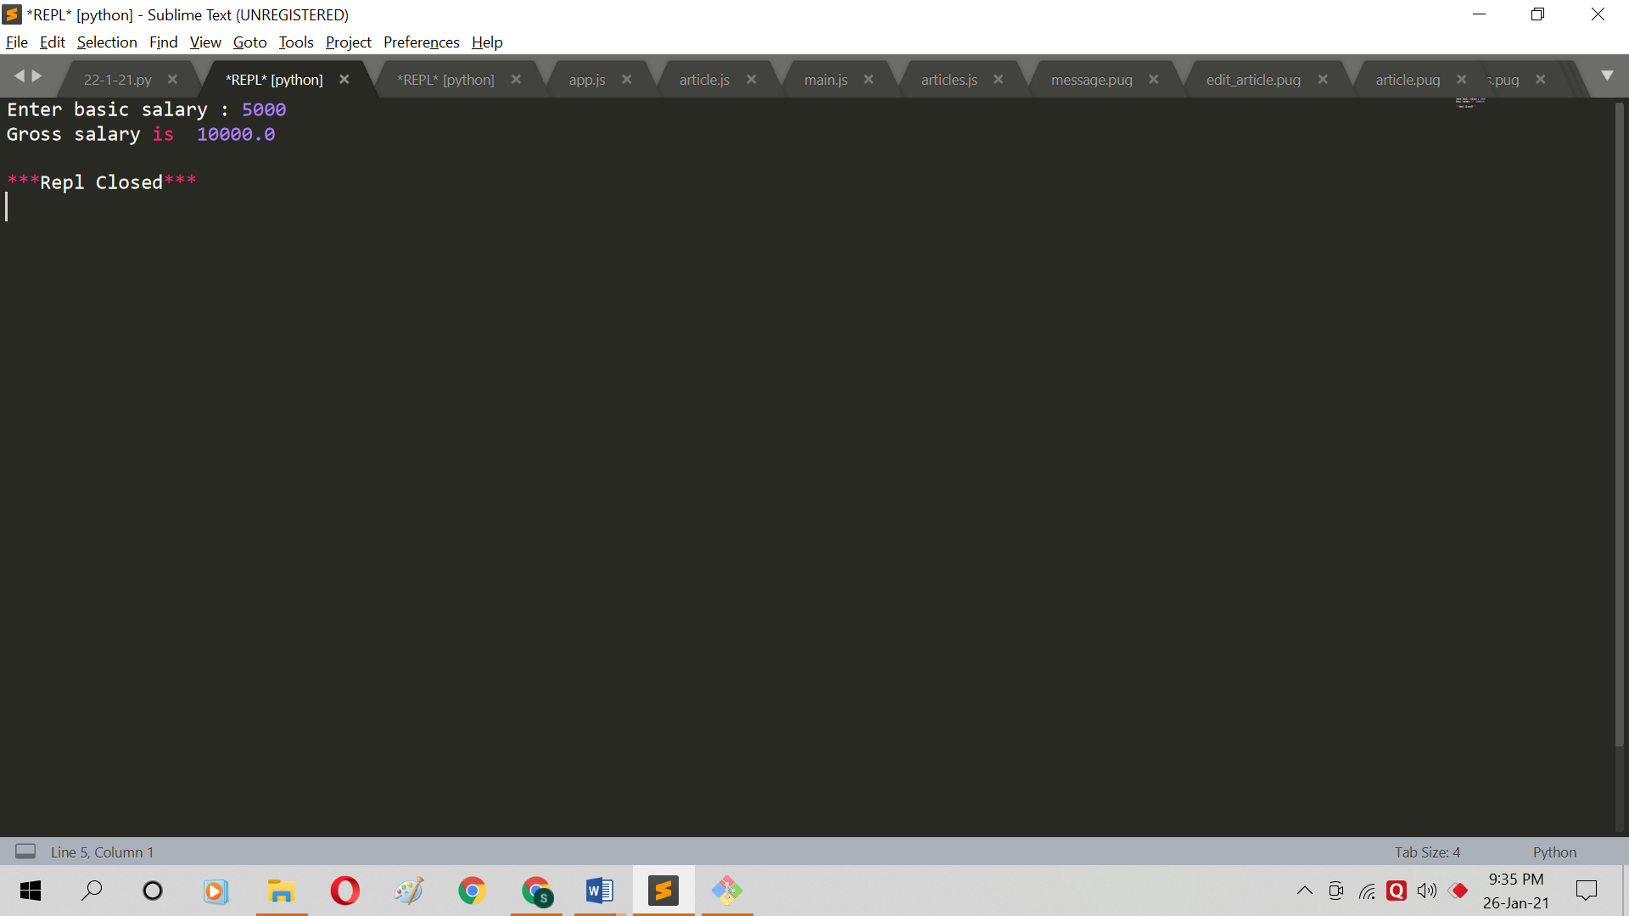

**Question 4:**

Code:

qty = int(input("Enter Quantity: "));

rate = int(input("Enter Rate: "));

dis=0;

if (qty>1000) :

dis = 10;

expense = (qty*rate)*(1- dis / 100);

print("Total Expenses = Rs. ", expense);

Output: 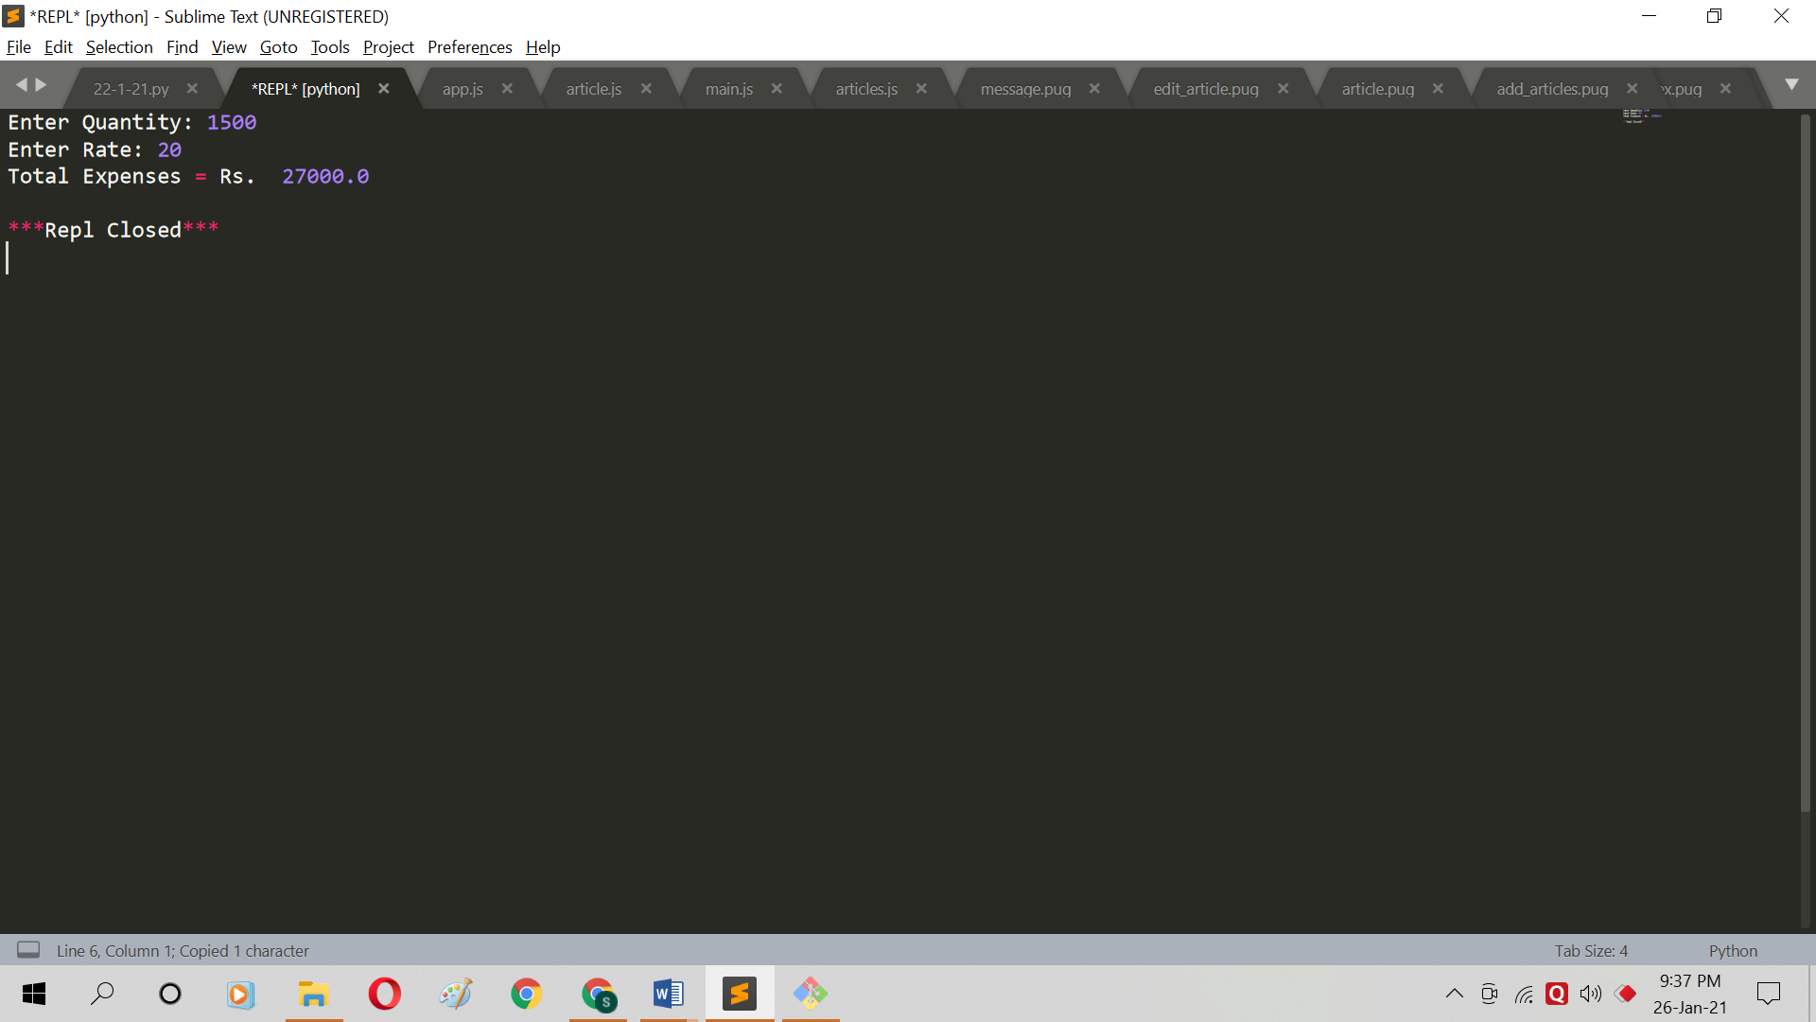

**Question 5:**

Code:

x = int(input("Enter x coordinate : "))

y = int(input("Enter y coordinate : "))

if x==0 and y==0:

print("Point is on origin")

elif x==0:

print("Point is on Y axis")

elif y==0:

print("Point is on X axis")

else:

print("Point neither lies on x-axis nor on y-axis")

Output: 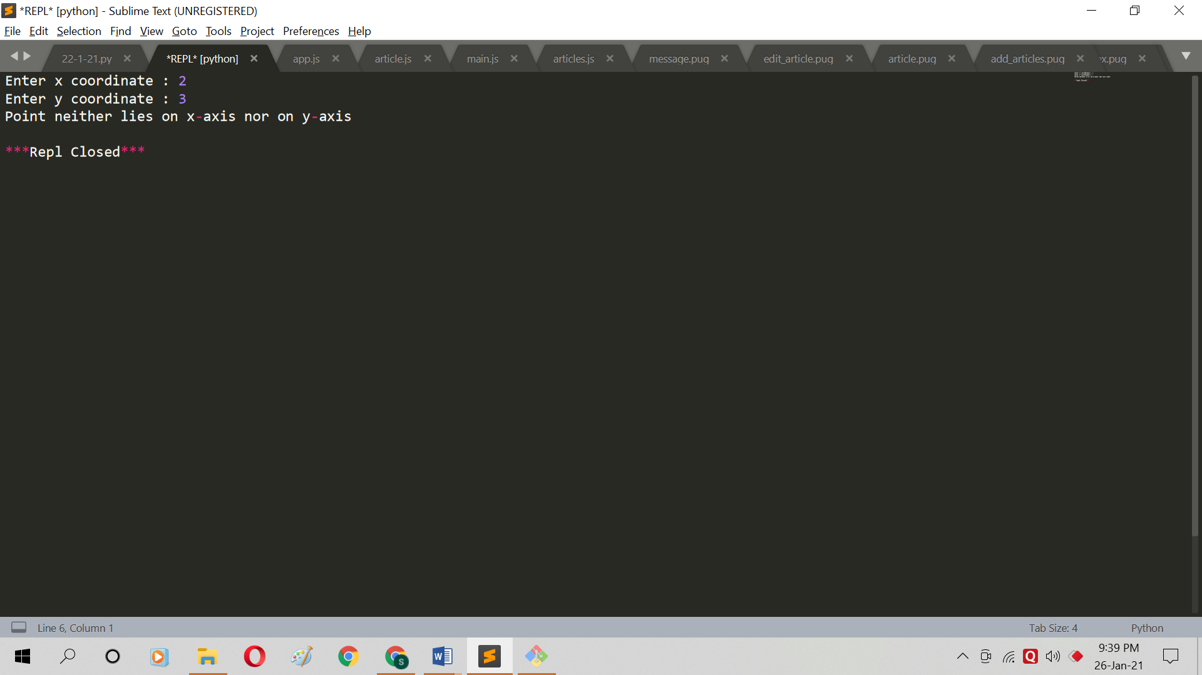

**Question 6:**

Code:

x1 = int(input("Enter x coordinate for Point 1 : "));

y1 = int(input("Enter y coordinate for Point 1 : "));

x2 = int(input("Enter x coordinate for Point 2 : "));

y2 = int(input("Enter y coordinate for Point 2 : "));

x3 = int(input("Enter x coordinate for Point 3 : "));

y3 = int(input("Enter y coordinate for Point 3 : "));

a = x1 * (y2 - y3) + x2 * (y3 - y1) + x3 * (y1 - y2)

if a == 0:

print("Collinear points")

else:

print("Not Collinear points")

Output: 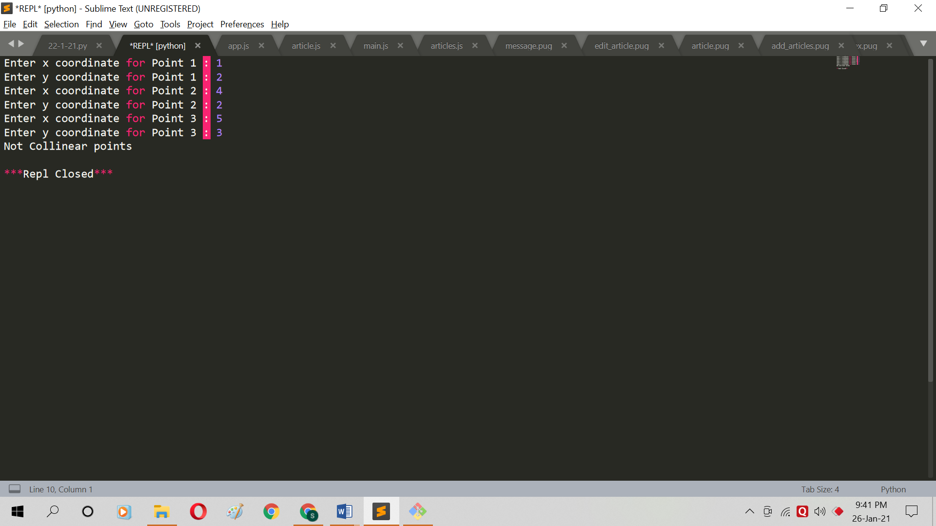

**Question 7:**

Code:

print("Enter lengths of three triangle sides: ")

x = int(input("side 1: "));

y = int(input("side 2: "));

z = int(input("side 3: "));

if x == y == z:

print("Equilateral triangle")

elif x==y or y==z or z==x:

print("isosceles triangle")

else:

print("Scalene triangle")

Output: 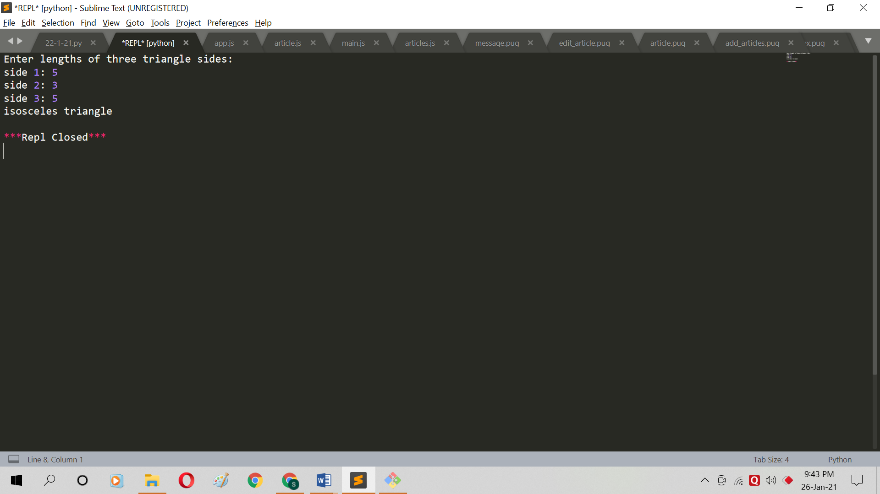

**Question 8:**

Code:

n=int(input("Enter the number of terms:"))

x=int(input("Enter the value of x:"))

s=1

for i in range(2,n+1):

s=s+((x**i)/i)

print("The sum of series is",round(s,2))

Output: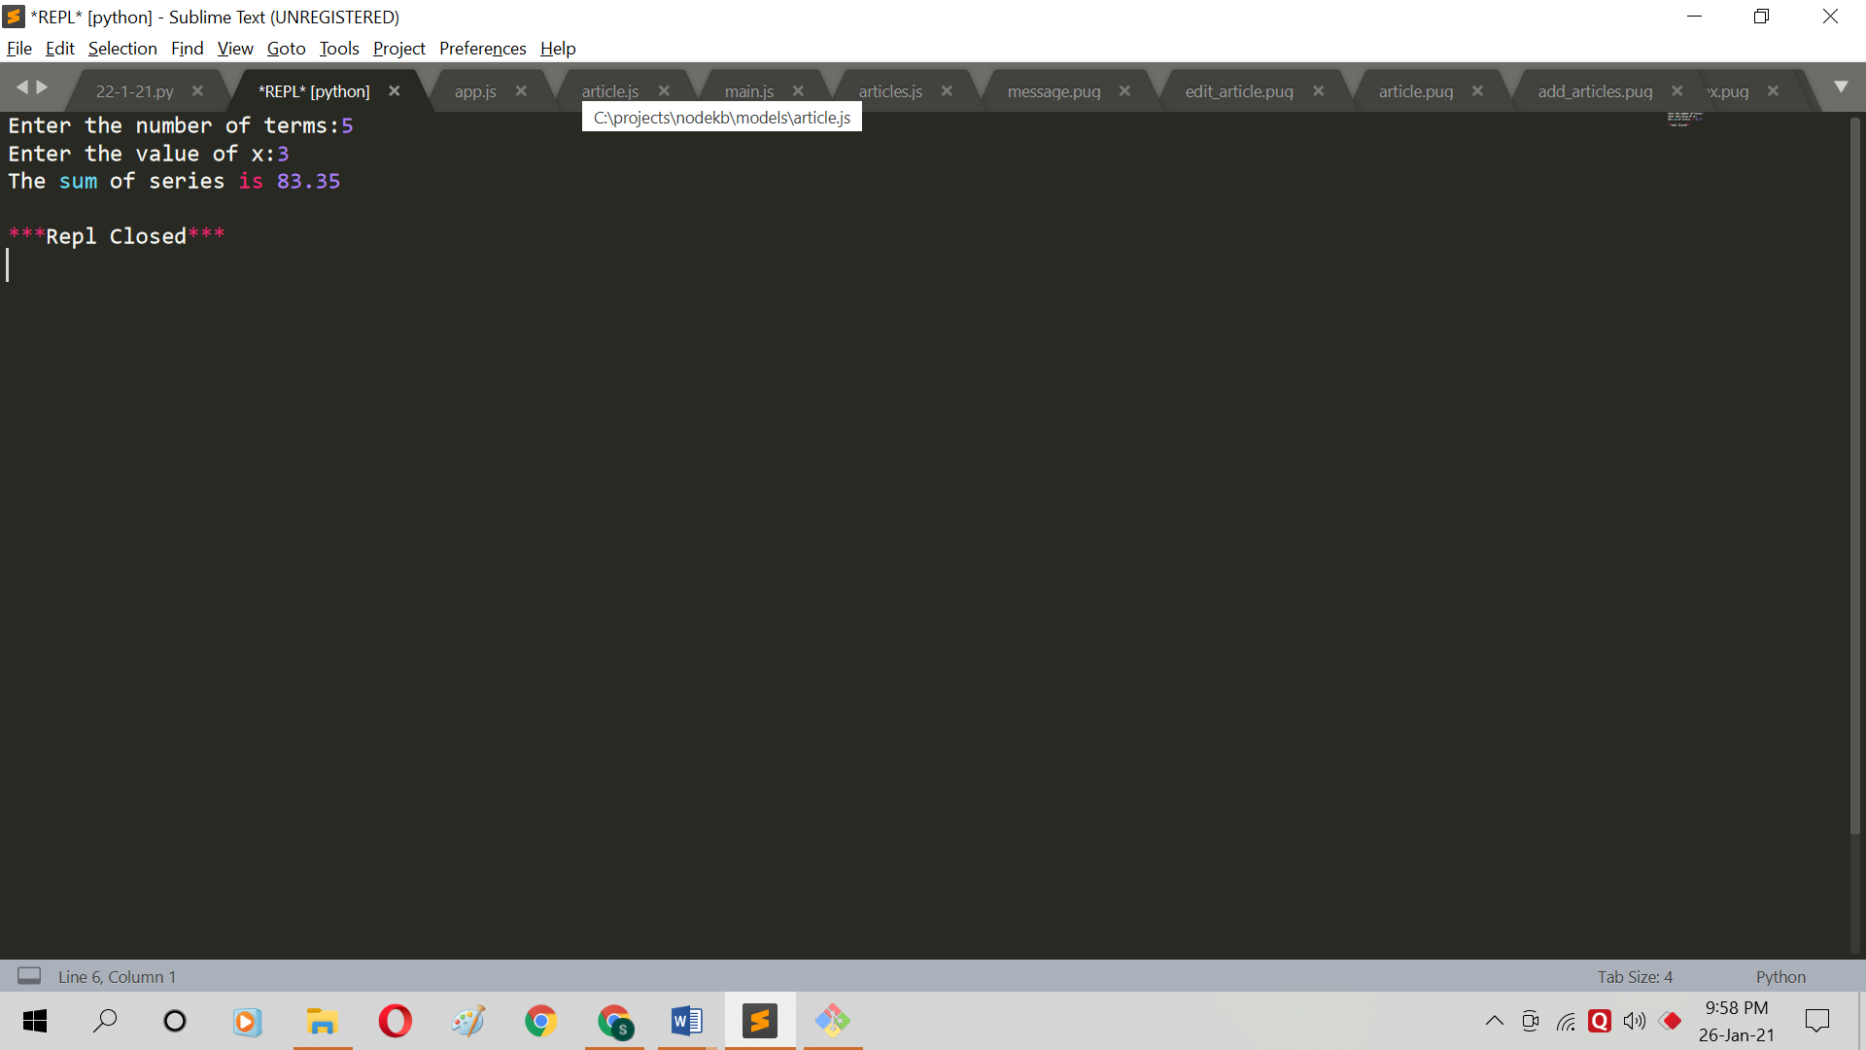

**Question 9:**

Code:

r=int(input("Enter upper limit: "))

for a in range(2,r+1):

k=0

for i in range(2,int(a/2)+1):

if(a%i==0):

k=k+1

if(k<=0):

print(a)

Output: 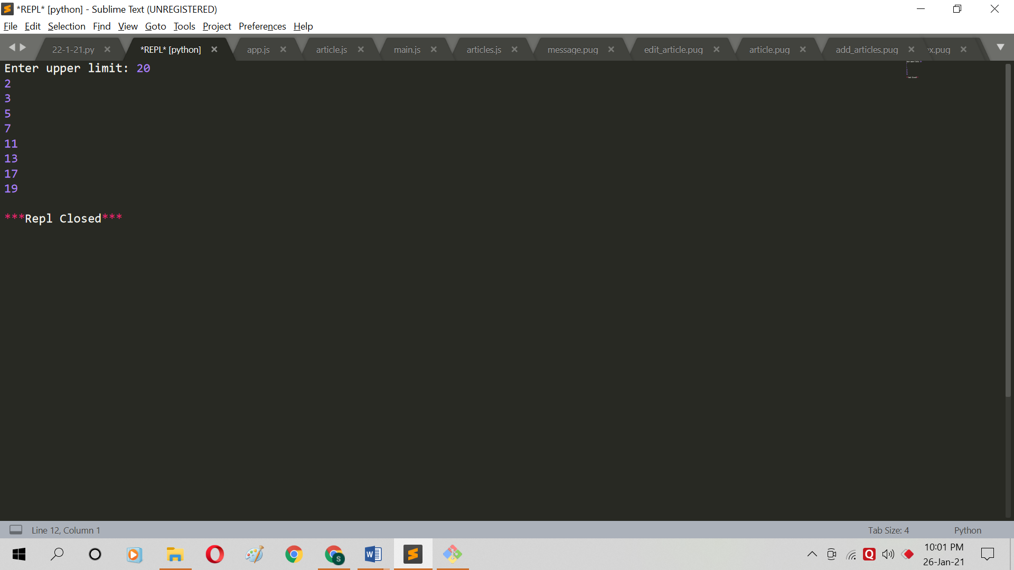

**Question 10:**

Code:

h = float(input("Enter hardness: "))

cc = float(input("Enter carbon content: "))

t = float(input("Enter tensile strength: "))

if h>50 and cc<0.7 and t>5600:

print('Grade 10')

elif h>50 and cc<0.7 and t<=5600:

print('Grade 9')

elif h>=50 and cc<0.7 and t>5600:

print("Grade 8")

elif h>50 and cc>=0.7 and t>5600:

print("Grade 7")

elif (h>50 and cc>=0.7 and t<=5600) or (h<=50 and cc<0.7 and t<=5600) or(h<=50 and cc>=0.7 and t>5600):

print("Grade 6")

else:

print("Grade 5")

Output:

