**Name : Shubh Gangar**

**Roll No: 1911013**

**Batch A1**

**Question 1:**

p=0;

r=0;

n=0;

s=0;

p=int(input("Enter the prinicipal amount: "))

r=int(input("Enter the Rate of interest per month (in %age ): "))

n=int(input("Enter the number of years: "))

s=p*n*r*0.12;

print("The Simple interest is Rs "+ str(s));

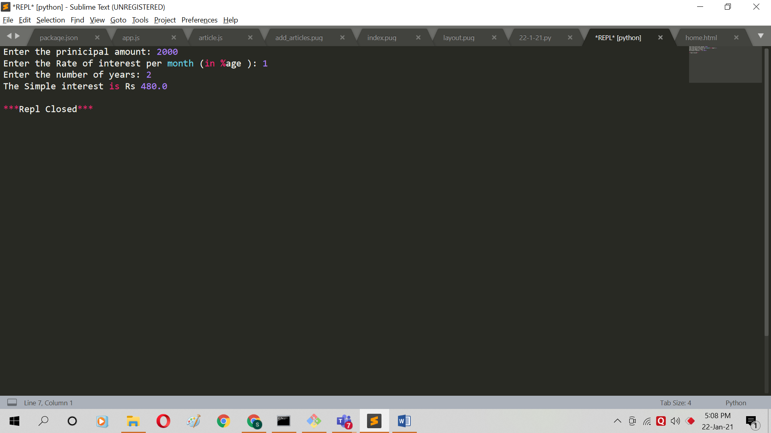

**Question 2:**

TC=0;TF=0;

TC=int(input("Enter the temperature in degree celsius: "));

TF=(TC*1.8)+32.0;

print("The temperature in fahrenheit is " + str(TF));

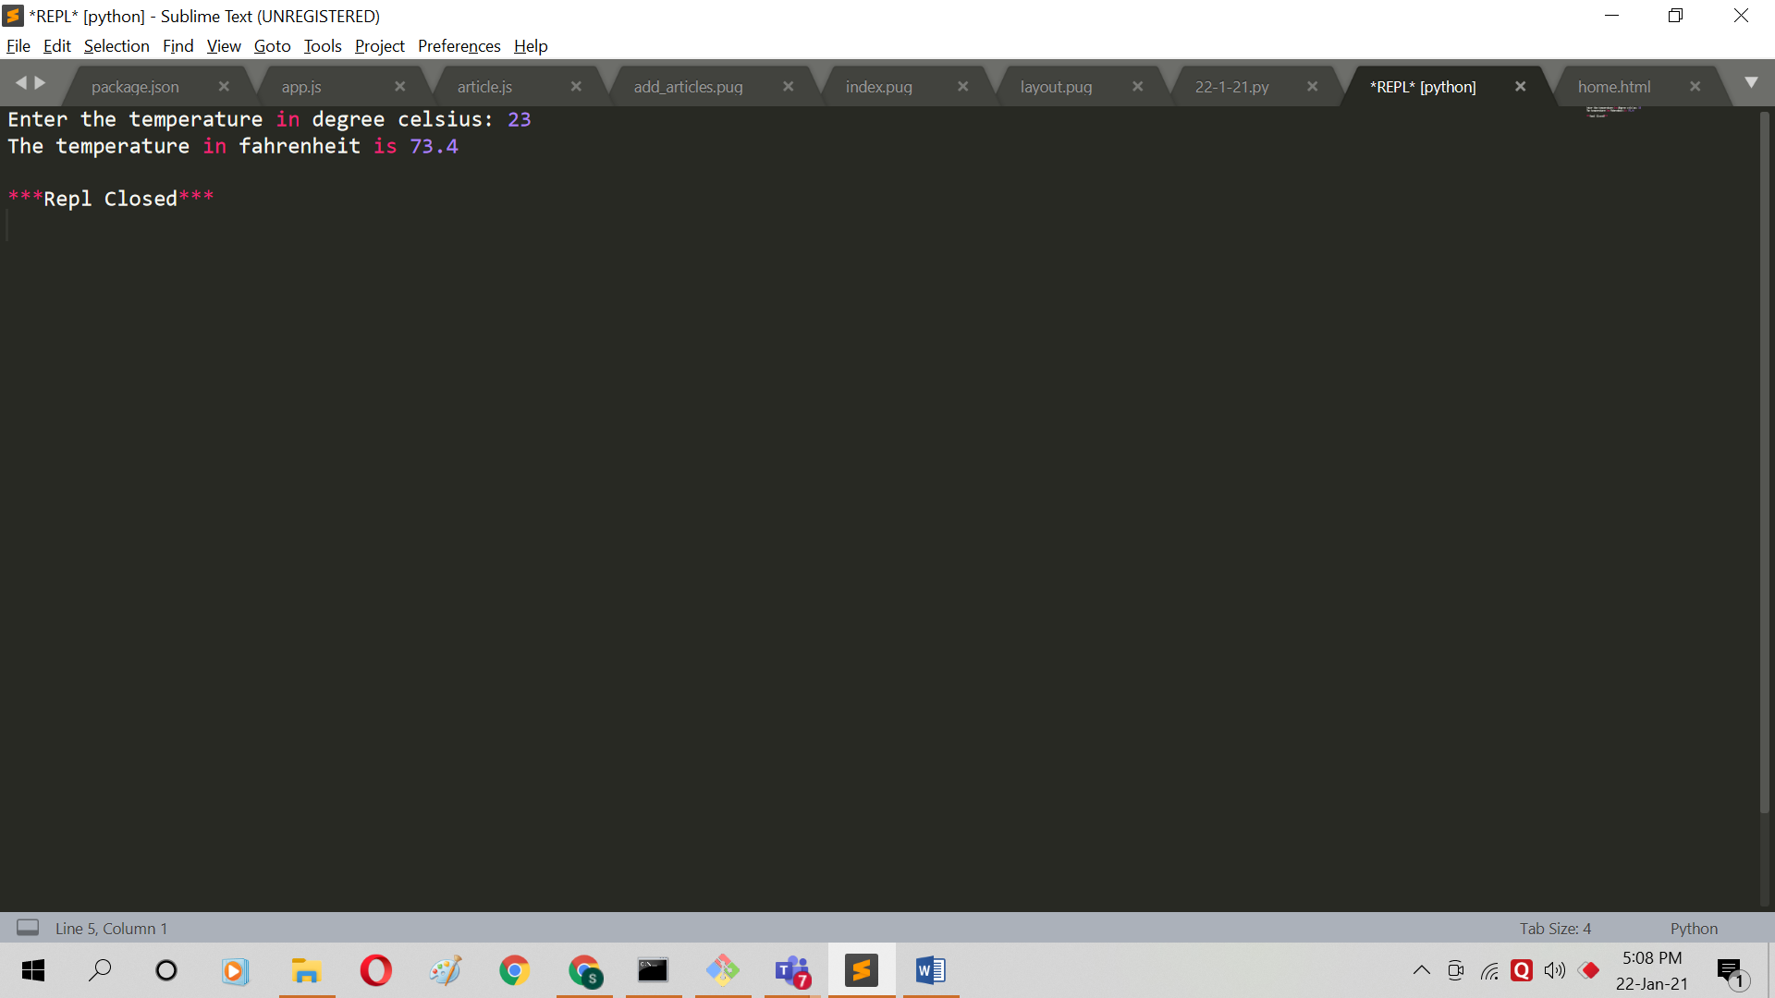

**Question 3:**

x=0;

x = int(input("Enter the side of the triangle"))

print ("The area of triangle is " + str(x*x*0.433) );

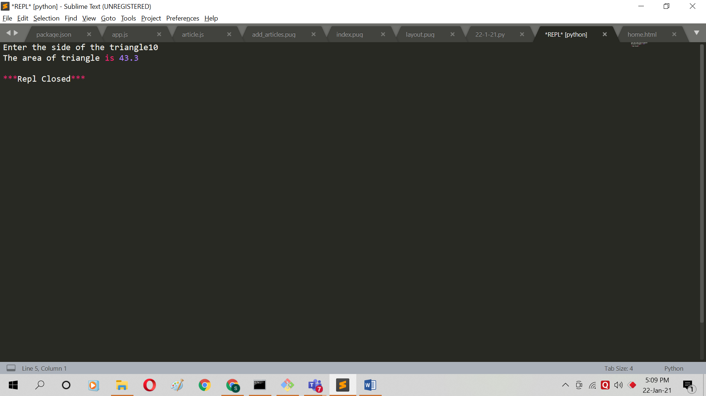

**Question 4:**

days=0

days=int(input("Enter the number of days : "));

years= days // 365;

weekleft=(days%365)//7;

daysleft=(days%365)%7;

print("Years: "+str(years)+", Weeks: "+ str(weekleft)+", Days: "+str(daysleft));

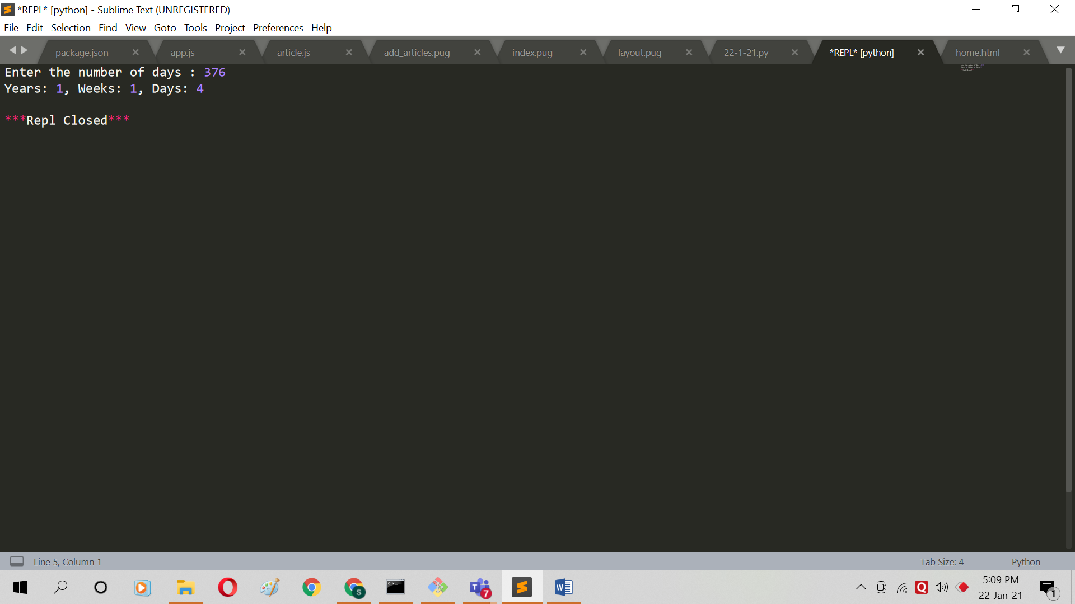

**Question 5:**

a=0;b=0;temp=0;

a=int(input("Enter the value of a: "));

b=int(input("Enter the value of b: "));

print("Values of a and b before swapping are: "+ str(a)+" , "+str(b));

temp=a;

a=b;

b=temp;

print("Values of a and b after swapping are: "+ str(a)+" , "+str(b));

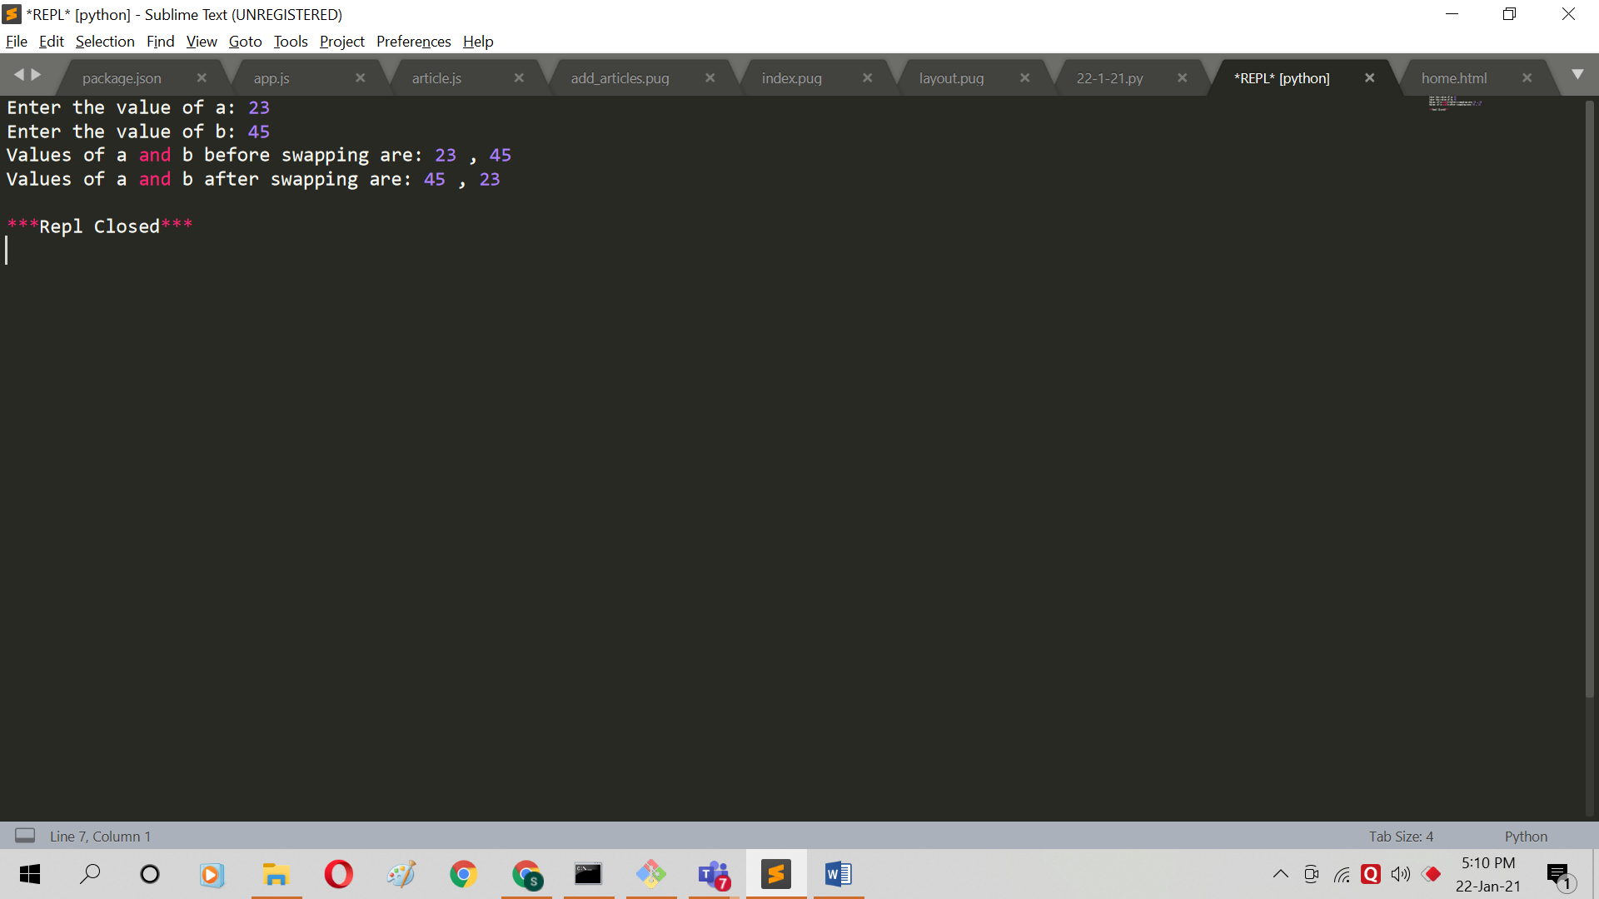

**Question 6:**

marks=[];

sums=0;

for i in range(0,5):

a=0;

a=int(input(" Enter the marks of subject "+ str(i+1)+" : "));

sums=sums+a;

marks.append(a);

print("The sum of marks are "+str(sums));

print("The average of marks are "+str(sums/5));

print("The percentage of marks are "+str(sums/5));

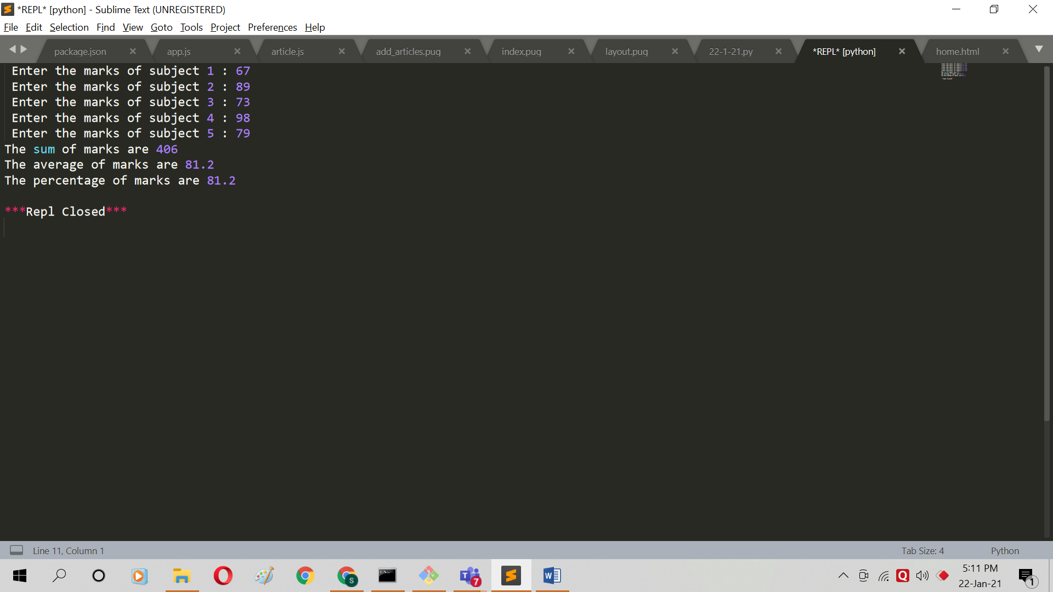

**Question 7:**

KG=0;P=0;

KG=int(input("Enter the weight in Kilograms: "));

P=(KG*2.205);

print("The weight in pound is " + str(P));

**Question 8:**

sal=0;

sal=int(input("Enter the salary : "));

gross_sal=100-40-20-10;

print("Gross salary is : "+ str(sal*gross_sal/100));

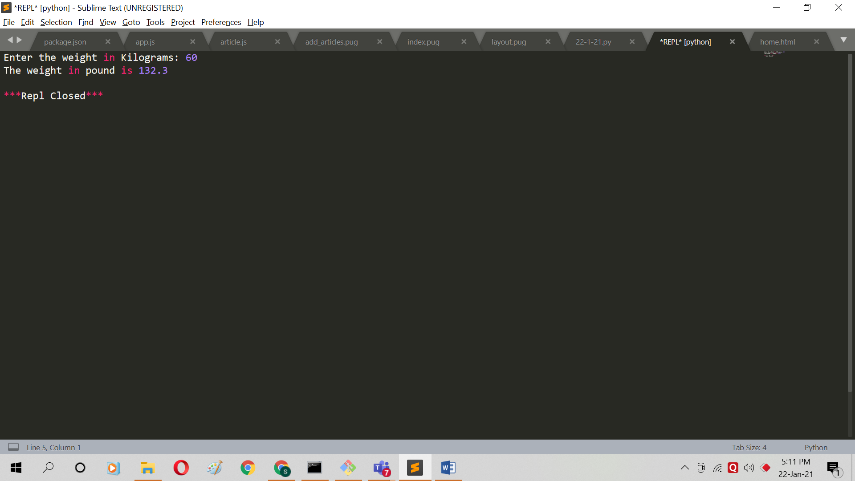

**Question 9:**

PM=52;

PW=48;

PTL=48;

PTIL=52;

PML=35;

PWML=13;

total=80000;

total_men=0.52*80000;

total_women=0.48*80000;

total_literate=0.48*80000;

men_liter=0.35*80000;

women_liter=0.13*80000;

men_illter=total_men - men_liter;

women_illter = total_women - women_liter;

print("The number of illiterate men and women are : "+ str(men_illter)+" and "+str(women_illter));

