**Name: Shubh Gangar**

**Roll No: 1911013**

**Batch: A1**

**Question 1:**

**Code:**

sentence=input("Enter the sentence: ");

sentence=sentence.lower();

d={}

for ch in "abcdefghijklmnopqrstuvwxyz ":

d[ch]=0;

for ch in sentence:

d[ch]+=1;

chk=0;

for keys in d:

if(d[keys]==0):

chk=1;

if(chk==0):

print("Panagram");

else:

print("Not a Panagram")

**Output:**

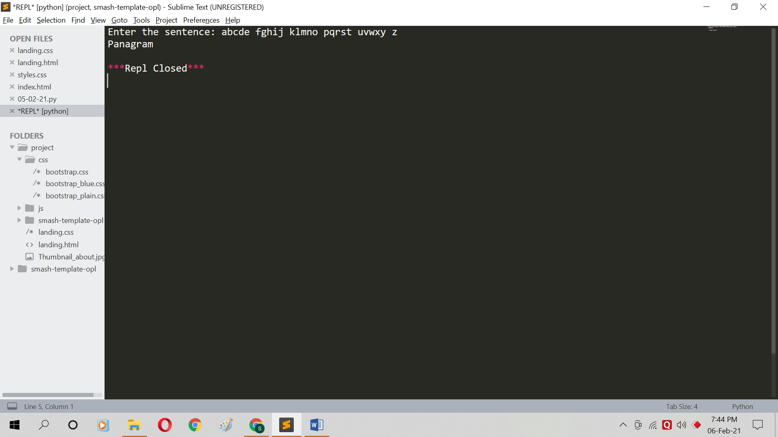

**Question 2:**

**Code:**

d={"Lower Case":0,"Upper Case":0};

sentence=input("Enter the sentence: ");

for ch in sentence:

if(ch.islower()):

d["Lower Case"]+=1;

if(ch.isupper()):

d["Upper Case"]+=1;

print(d);

**Output:**

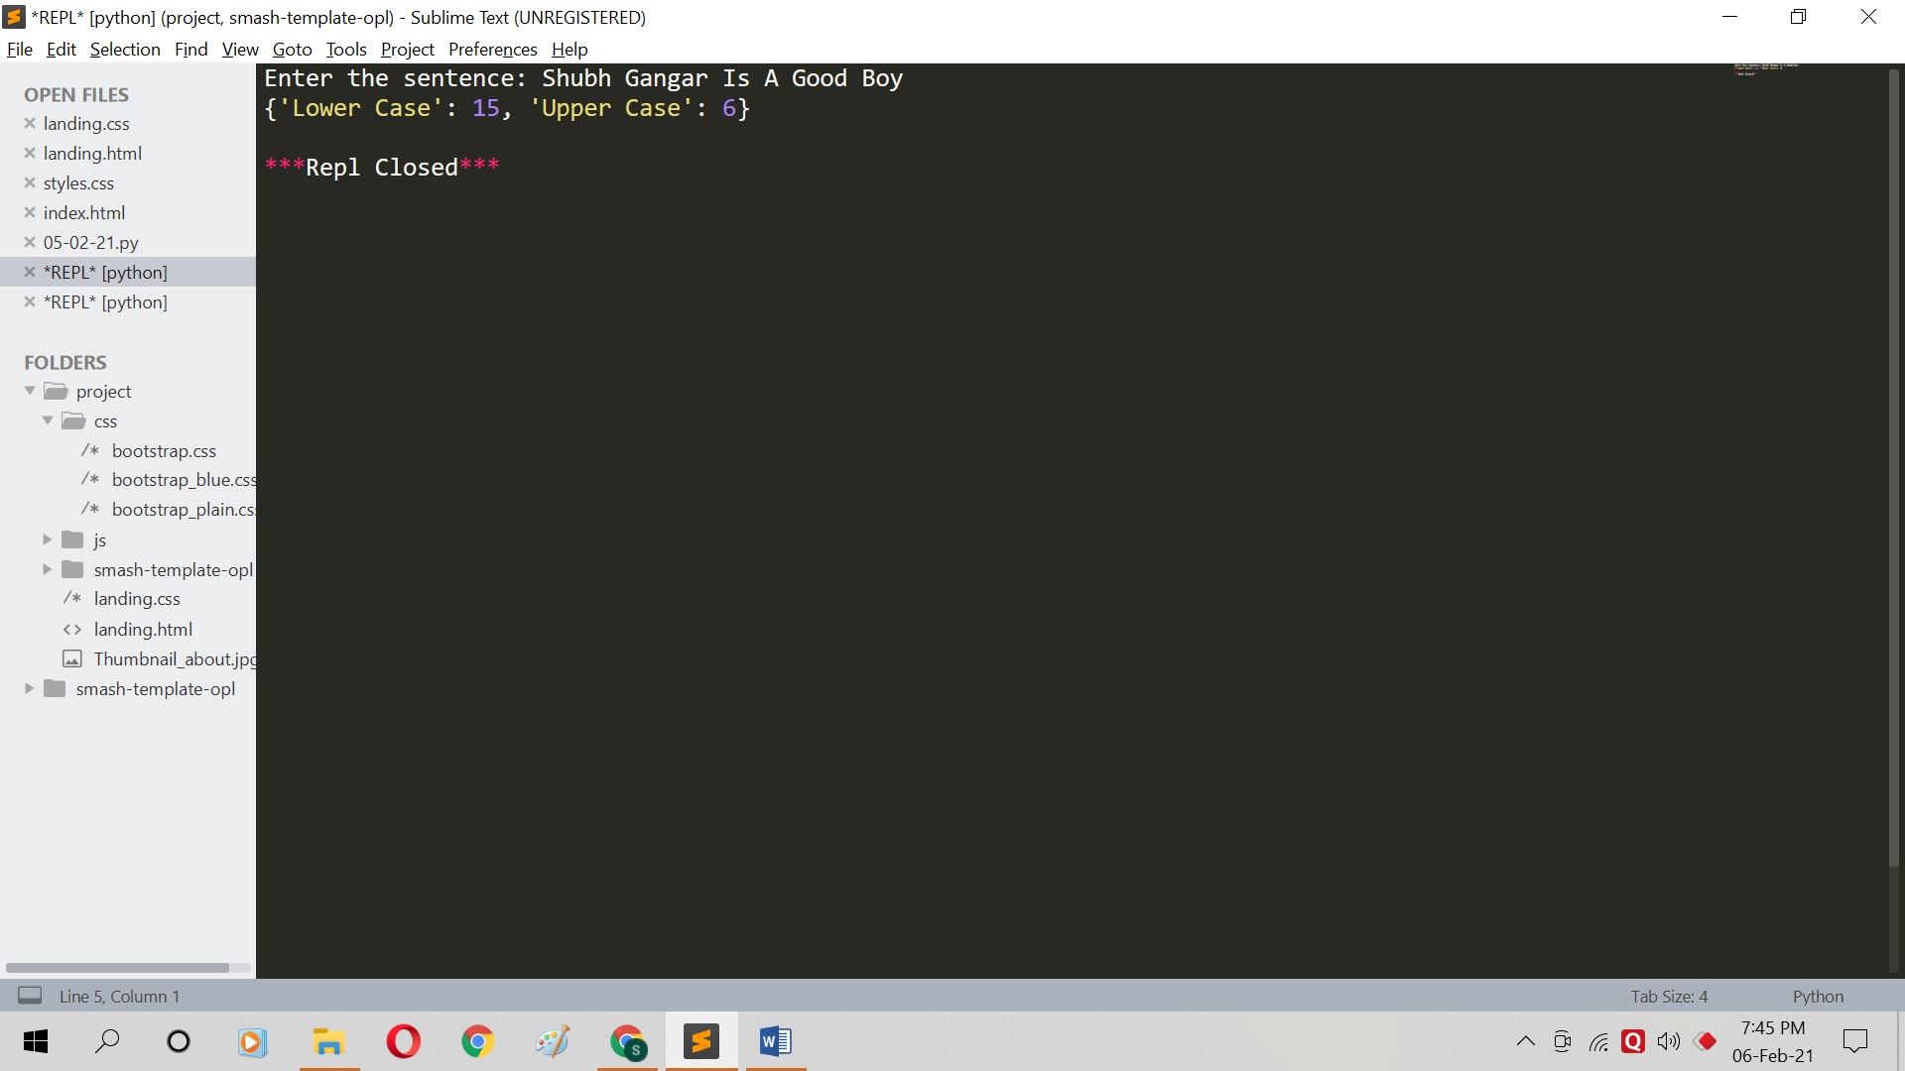

**Question 3:**

**Code:**

set1=set(input("Enter first sentence: ").lower().split());

set2=set(input("Enter second sentence: ").lower().split());

print(set1.intersection(set2));

**Output:**