**Batch: A1 Roll No.: 1911011, 1911015**

**Experiment / assignment / tutorial No.**

**Grade: AA / AB / BB / BC / CC / CD /DD**

**Signature of the Staff In-charge with date**

|  |
| --- |
| **Title: Python Application Development** |

**AIM :** To develop a python application for a real world problem

**______________________________________________________________________**

**Expected OUTCOME of Experiment:**

**CO :**

**________________________________________________________________**

**Books/ Journals/ Websites referred:**

1.<https://stackoverflow.com/questions>

2. <https://www.geeksforgeeks.org/python-regex/>

3. <https://www.javatpoint.com/python-tkinter>

4.<https://www.w3schools.com/python/python_mysql_getstarted.asp>

**Github Link of Project files :**

https://github.com/shubhgosalia/Hotel-Management-System

**Problem definition:**

* To manage a huge property like a hotel is no easy task right from managing your staff, your rooms to handling customer needs and records.
* Manual work is never an option in such scenarios and it requires a proper management system to carry out daily operations.
* Thus, a hotel management system is an apt solution to this problem.

**Scope:**

* User can book/reserve a room given the room is available/unreserved
* Unbook/Unreserve a room
* Generate bill once booking is done
* User can filter out rooms as per his/her requirements i.e room type and availability of AC.
* Information regarding the rooms such as its type, pricing and availability status can be checked in a separate section. If room is booked, the record of the person who booked it is visible
* Rooms can be added via database connectivity
* Hotel status such as the no. of staff, available rooms, total customers is displayed and dynamically updated
* A section to reach out to the hotel in-charges is added

**Component diagram:**

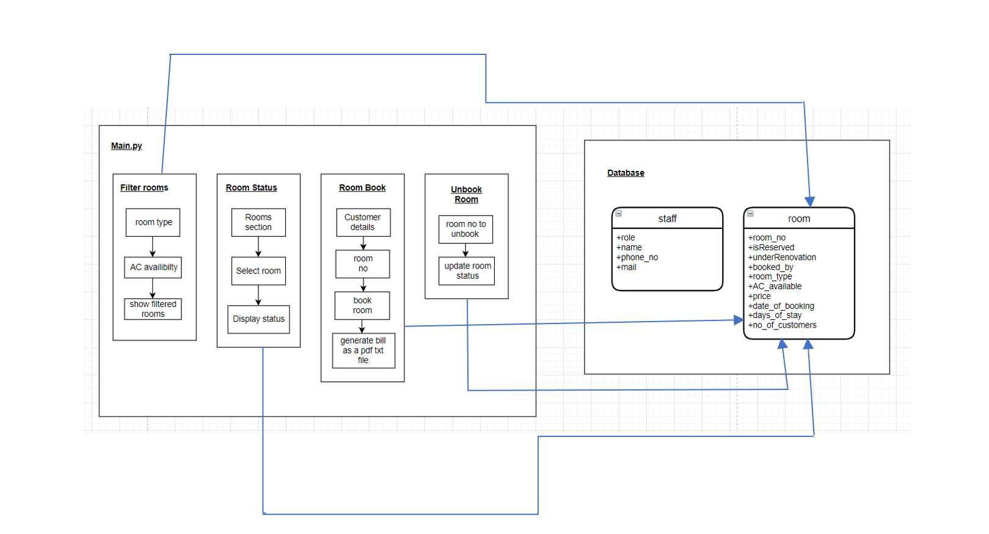

**API or package used**

* Tkinter Module:

1.) Message Box

2.) TTK with tkinter

3.) Combobox

* re module
* Regular expressions for checking phone number and email
* MySQLdb module
* Database Connectivity and Query Handling
* datetime module
* To show the room booking date by a customer, also printed on bill
* PIL module
* To display images
* os module
* To create path for a directory that stores txt files for bills

**Difficulties faced and measures taken to resolve:**

1. **Printing bills**

We had added a feature of generating a bill on booking a room and then storing the bill in a bills folder in the project directory as a txt file. The bill was getting stored in my project’s bills folder however the bill was not getting stored on my teammate’s bills folder . So we found out that the problem was because I was storing the txt file on a path which was different from my teammates path. So instead of hard-coding the path, we used os.getcwd() method of os library and obtained a path for current directory and to it we appended the bills folder which solved the problem.

1. **Query Handling**

When the user entered his details in the input boxes for booking a room, we had to query the database using those inputs. We accessed the values of the input boxes using .get() method and then inserted them as arguments in our SQL query. However we kept getting the error (TypeError: %d format: a number is required, not str). So later we found out that this was happening because the .get() method was returning the values in the input boxes as strings.

1. **Creating buttons using loop**

In the room status page, we had to create as many number of buttons as there were rooms. Initially we just typed individually the code for all the buttons which created a lot of code repetition. So we implemented a loop which ran that number of times as there were rooms and created a button for each room.

|  |  |
| --- | --- |
| **Implementation** | **By** |
| UI Design | Shubh Gosalia |
| Front-End | Meet Gajra, Shubh Gosalia |
| Database Design and Connectivity | Meet Gajra |
| Query Handling | Meet Gajra, Shubh Gosalia |
| Filter Rooms | Shubh Gosalia |
| Hotel status and rooms status | Meet Gajra |
| Room Booking | Meet Gajra, Shubh Gosalia |
| Add Rooms | Shubh Gosalia |
| Bill Generation | Meet Gajra |

**Team work (Contribution of each member)**