A satellite map image contains huge amount of data/ information in it. With every passing day, new objects get added into or removed from these satellite map images. It is very important to identify this information and sort it for an accurate navigation system. Companies like Google, Microsoft etc. rely on crowdsourcing to categorize objects present in these images. It is a time consuming and error-prone process. Our objective is to reduce this labor work and automate this task.

With this project our main motive is to train a neural network to learn about a particular object present in the map image and detect its location in the image. We are starting off with water bodies.

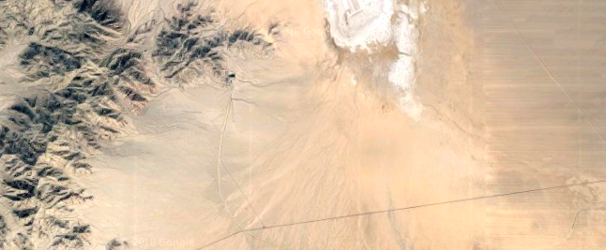 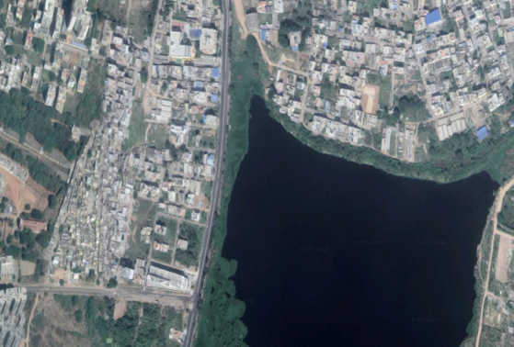

a. Without waterbody b. With waterbody

Fig.1 – Classification

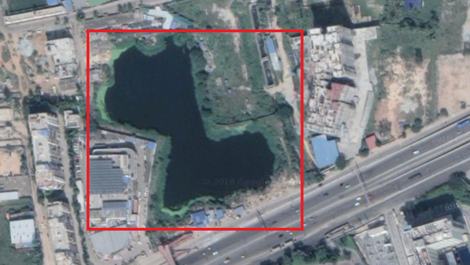 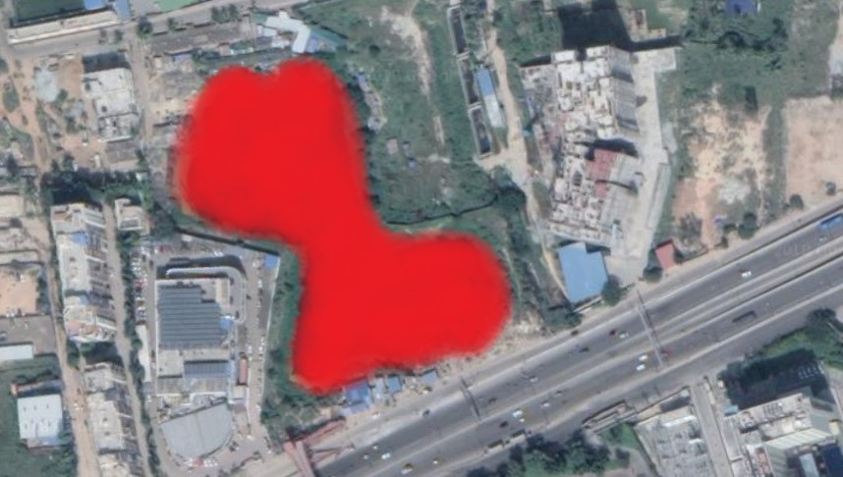

a. Detection b. Segmentation

Fig.2 – Segmentation

Our project is divided into two parts, classification and segmentation. In the first part (fig.1), we are going to train our neural network to detect and segregate images based on the presence of water bodies. In the second phase of the project (fig.2), neural network will learn to mark the location surrounding the waterbody present in the image.