SentinelShield: Advanced Intrusion Detection & Web Protection System
[KALI LINUX]
↓ (attacks)
[METASPLOITABLE (WEB SERVER)]
↓ (logs)
[LOG ANALYSIS IN KALI]
- Kali = attacker + monitoring tools
- Metasploitable = vulnerable server (Apache already installed)
STEP 1: Start Services (Metasploitable)
sudo service apache2 start

Kali browser:
http://192.168.188.129
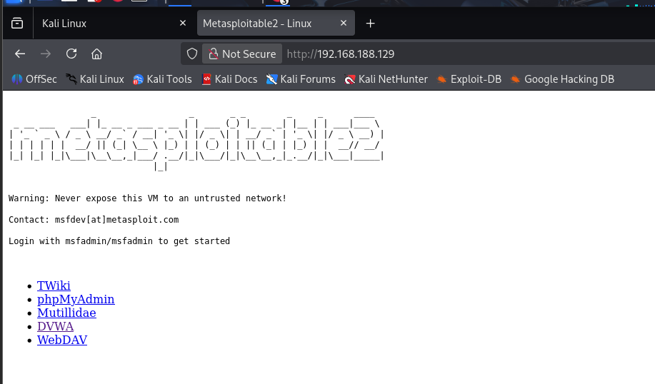

STEP 2: Use DVWA
http://192.168.56.102/dvwa
Login: admin/password

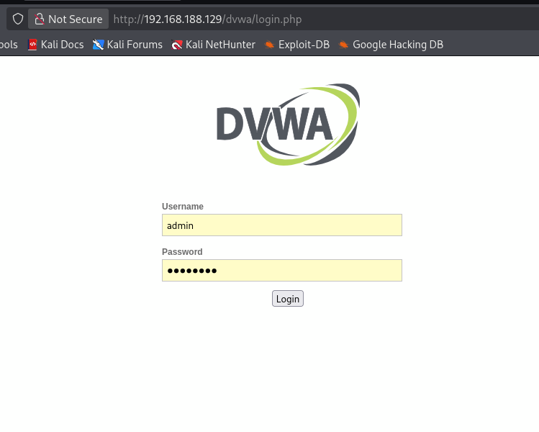
STEP 3: Perform Attacks
- SQL Injection: http://192.168.56.102/dvwa/vulnerabilities/sqli/

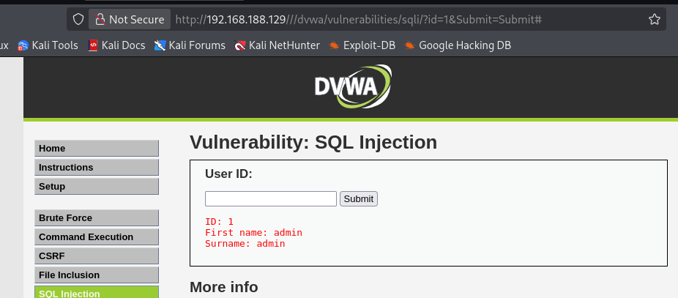
- XSS Attack : /dvwa/vulnerabilities/xss_r/
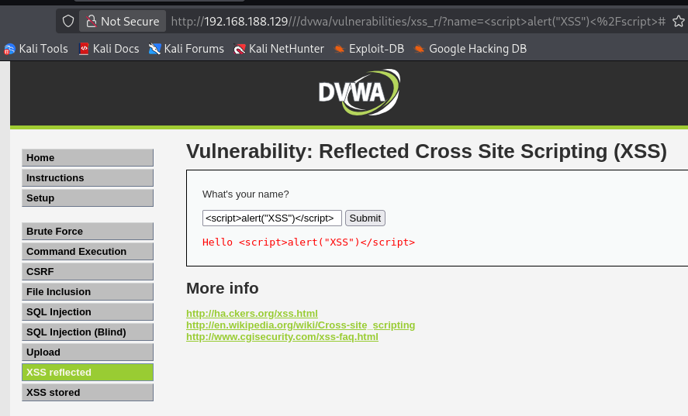
- Command Injection: /dvwa/vulnerabilities/exec/
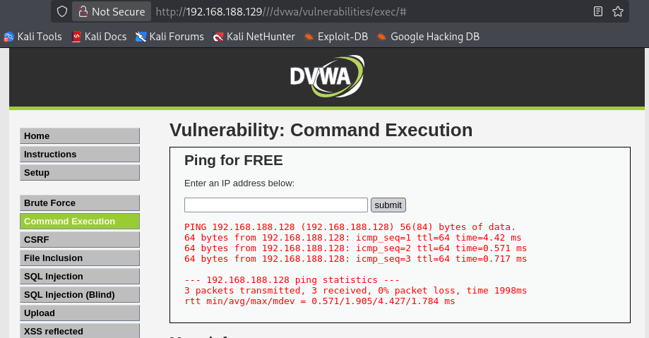
- Brute Force : /dvwa/vulnerabilities/brute/
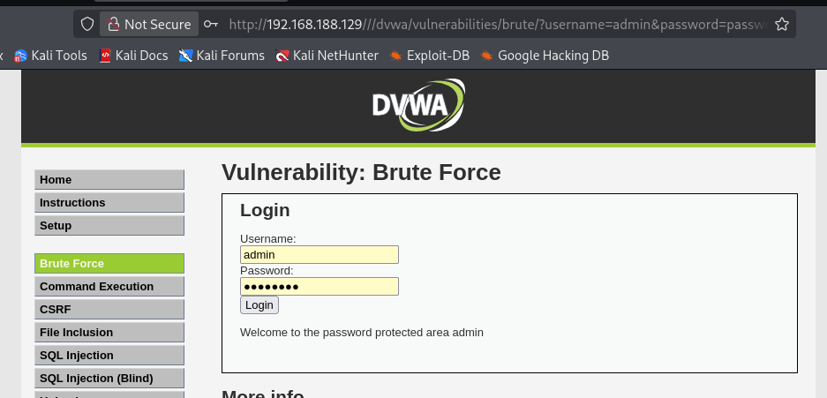
STEP 4: Monitor Logs
Now switch to Metasploitable terminal
- View logs:: tail -f /var/log/apache2/access.log
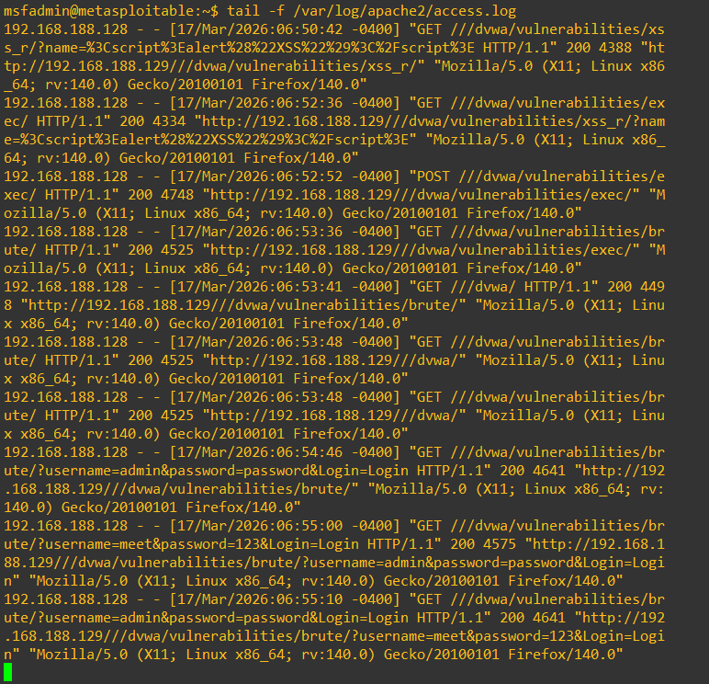
STEP 5: Analyze Logs
nano /var/log/apache2/access.log
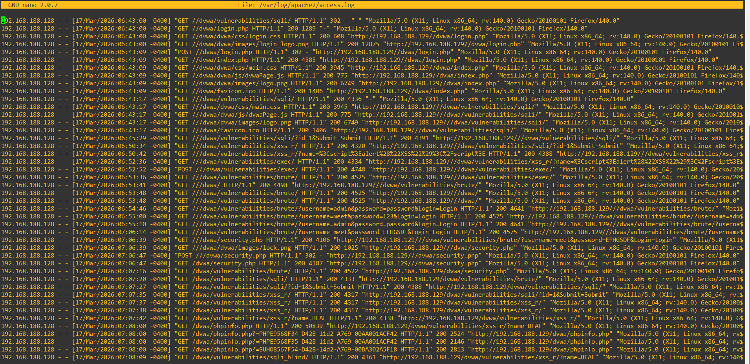
STEP 6: Use Kali Tools
- Nmap Scan:
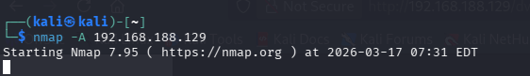
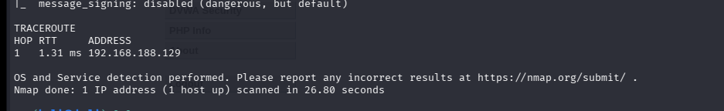
- Nikto:
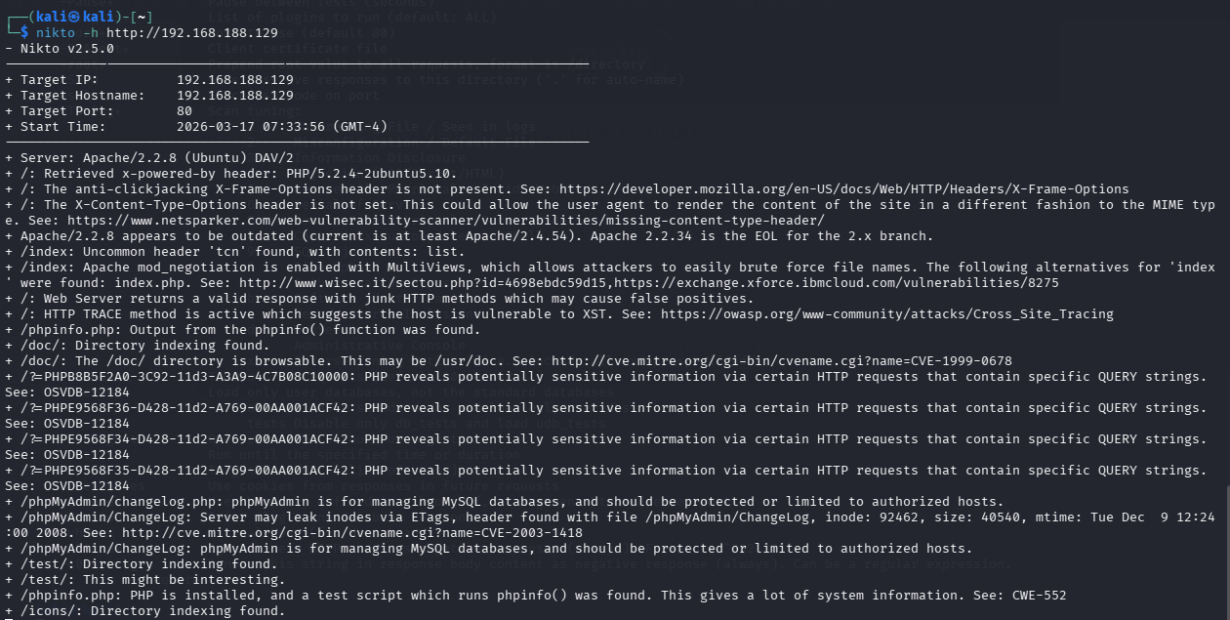
- Metasploit:
