**ITE-5201 – Fall 2022**

**Humber College IGS**

**Final Project Report**

**Introduction to Data Analytics**

**Project Title:**

**Visualization / Analysis of**

**E-Commerce Shipping Data using shipping dataset**

**Prepared By:**

**Meet Trivedi (N01520331)**

**Raghavender Chakilam (N01533573)**

1. Problem statement:
   * Visualization / Analysis of Shipping data using E-Commerce shipping data set.
2. Dataset description:
   * The E-commerce shipping dataset contains daily shipping logs of good which was delivered from different warehouse to customers.
   * Dependent variables such as warehouse_block, mode_of_shipment, gender and weight_of_goods, which we have used to analysis of is goods received by customer on time.
3. Dataset analysis and observation:

* For dataset analysis, we have used heatmap and subplot for finding correlation coefficient rank and for observation using above columns.

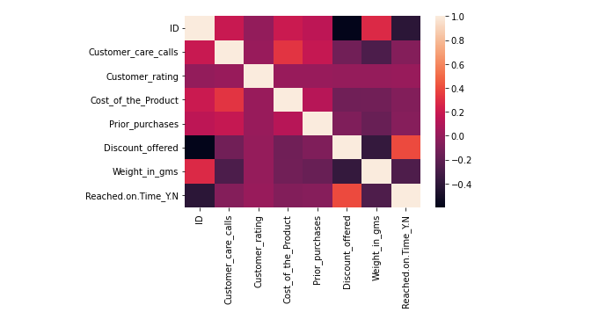

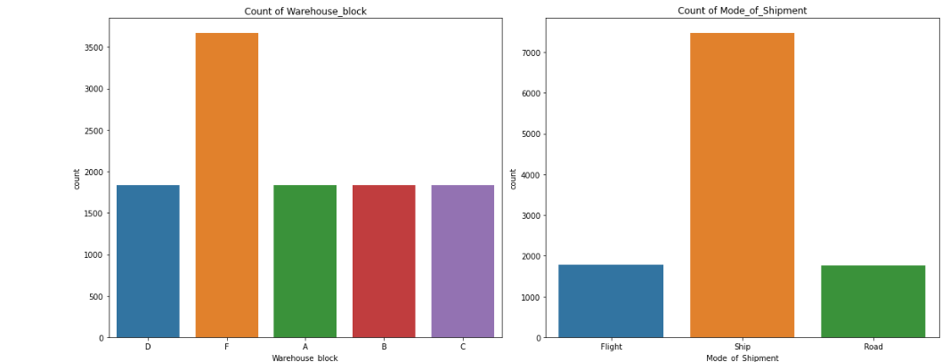

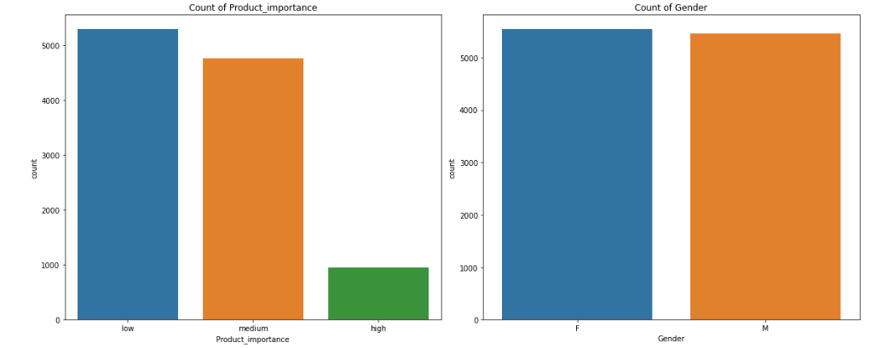

1. Proposed Analytical Model:

* As above analysis, the dataset has dependent variable for analysis of package were delivered on time or not.
* We have used Logistic regression with random state of 15.

1. Result and Discussion:

* In result we got 64% of accuracy

