L.J. SCHOOL OF COMPUTER APPLICATION



SMARTSUMMARIZER AI

Developed By:

Tushar Chauhan

22004501210011

Bhoomi Chavada

22004501210012

L.J. SCHOOL OF COMPUTER APPLICATIONS
L.J. SCHOOL OF COMPUTER APPLICATIONS

LJ Campus, LJ University Road, Off S.G. Road, Ahmedabad-382210



CERTIFICATE

Enrolment No: 22004501210011
This is to certify that Mr. Tushar Chauhan of Integrated Master of Computer Applications Semester 8 has satisfactorily completed his project titled Pocket-Buddy under the supervision of Prof. Anurag Jobanputra

Internal Guide Name Head of Department

Prof. Parth Joshi Dr.Monica Gahalawat
Signature
Date of Submission:
Director
Prof. Alok Manke

L.J. SCHOOL OF COMPUTER APPLICATIONS
L.J. SCHOOL OF COMPUTER APPLICATIONS

LJ Campus, LJ University Road, Off S.G. Road, Ahmedabad-382210



CERTIFICATE

Enrolment No: 22004501210012
This is to certify that Ms. Bhoomi Chavada of Integrated Master of Computer Applications Semester 6 has satisfactorily completed his project titled Pocket-Buddy under the supervision of Prof. Anurag Jobanputra

Internal Guide Name Head of Department

Prof. Parth Joshi Dr.Monica Gahalawat
Signature
Date of Submission:
Director
Prof. Alok Manke

L.J. SCHOOL OF COMPUTER APPLICATIONS
1. Introduction
1.1. Existing System 3
1.2. Need for the New System 3
1.3. Objective of the New System 3
1.4. Problem Definition 3
1.5. Core Components 3
1.6. Project Profile 3
1.7. Assumptions and Constraints 4
1.8. Advantages and Limitations of the Proposed System 4
2. Requirement Determination & Analysis 6
2.1. Requirement Determination 6
2.2. Targeted Users 6
3. System Design 7
3.1. Use Case Diagram 7
3.2. Class Diagram 8
3.3. Interaction Diagram 9
3.4. Activity Diagram 11
3.5. Data Dictionary 15
4. Development 18
4.1. Coding Standards 18
4.2. Screenshots ..………………………………………………………………………………………………………….21
5. Agile Documentation 28
5.1. Agile Project Charter 28
5.2. Agile Project Charter 29
5.3. Agile Project Plan 30
5.4. Agile User Story ( Minimum 3 Tasks) 31
5.5. Agile Release Plan 31
5.6. Agile Sprint Backlog 33
5.7. Agile Test Plan 34
6. Proposed Enhancements 36
7. Conclusion 37
8. Bibliography 38

Introduction
SmartSummarizer AI is a full-stack AI-powered web application designed to process multiple file formats including text documents, PDFs, Word files, audio files, and video files, then generate structured intelligent summaries automatically. The system uses advanced AI models for summarization and transcription, helping users consume large amounts of content quickly and efficiently.
The application combines a modern React frontend with a FastAPI backend, MongoDB database storage, and Groq AI models including Llama and Whisper to provide fast and accurate summarization services.

Existing System
Currently, users rely on separate tools for different content processing tasks. Traditional summarization tools usually only support text-based documents and often fail when handling audio or video content. Many available tools also lack persistent history, structured summary formatting, and efficient handling of large files.
For audio transcription, users typically need dedicated transcription software, while video summarization requires multiple manual steps including audio extraction and summarization. This fragmented workflow reduces efficiency and increases complexity.

Need for the New System
There is a growing need for a centralized intelligent platform capable of handling multiple file formats and producing concise structured summaries automatically.
SmartSummarizer AI addresses this by providing:
- Unified support for documents, audio, and video
- AI-powered transcription and summarization
- Persistent summary history
- Fast processing using modern AI infrastructure
- User-friendly interface for seamless interaction

Objective of the New System
Objectives of SmartSummarizer AI include:
- Generate structured summaries from uploaded content
- Support multiple file formats in a single platform
- Reduce manual reading and listening effort
- Store summaries for future access
- Provide fast AI-driven summarization
- Deliver an intuitive modern web interface

Problem Definition
Modern users frequently deal with large volumes of information in different formats. Reading lengthy documents, listening to long recordings, or reviewing full videos consumes significant time.
Existing tools are fragmented and often specialized for only one format. Users need a unified solution that intelligently extracts, transcribes, summarizes, and stores important information efficiently.
SmartSummarizer AI solves this problem through automated multi-format AI summarization.

Core Components
- React Frontend Interface
- FastAPI Backend Services
- MongoDB Database Storage
- Groq Llama AI Summarization Engine
- Groq Whisper Speech Transcription Engine
- FFmpeg Media Processing Pipeline
- File Extraction Services
- Summary History Management Module

Project Profile
Project Title | SmartSummarizer AI
Duration | 3 months
Front End | ReactJS (with Vite)
Backend | FastAPI
Database | MongoDB
AI Provider | Groq API
Media Processing | FFmpeg
Operating System | Windows 11
Users | Students, Researchers, Professionals, Content Consumers

Assumptions and Constraints

Assumptions:
- Users have internet access
- AI API services remain available
- Uploaded files are in supported formats
- Browser environment supports file uploads
Constraints:
- API dependency may affect performance
- Large files require longer processing times
- Internet connectivity is mandatory
- Processing limitations based on model constraints

Advantages and Limitations of the Proposed System
Advantages
- Multi-format file support
- Fast AI-powered summarization
- Persistent history storage
- Modern responsive UI
- Structured summary output
- Audio/video transcription support
- Scalable modular architecture
Limitations
- Requires internet connection
- Dependent on third-party AI APIs
- Large media files may increase processing time
- OCR for scanned documents not currently implemented

Requirement Determination & Analysis

Requirement Determination

Functional requirements:
- File upload functionality
- PDF text extraction
- DOCX text extraction
- TXT file reading
- Audio transcription
- Video audio extraction
- AI summarization generation
- Summary history storage
- Summary retrieval by ID

Targeted Users

SmartSummarizer AI is designed for:
Students
To summarize study materials, lecture notes, and academic documents.
Researchers
To quickly process research papers and reference materials.
Professionals
To summarize reports, meetings, recordings, and presentations.
Content Consumers
To consume long-form content quickly through concise summaries.

System Design

Use Case Diagram

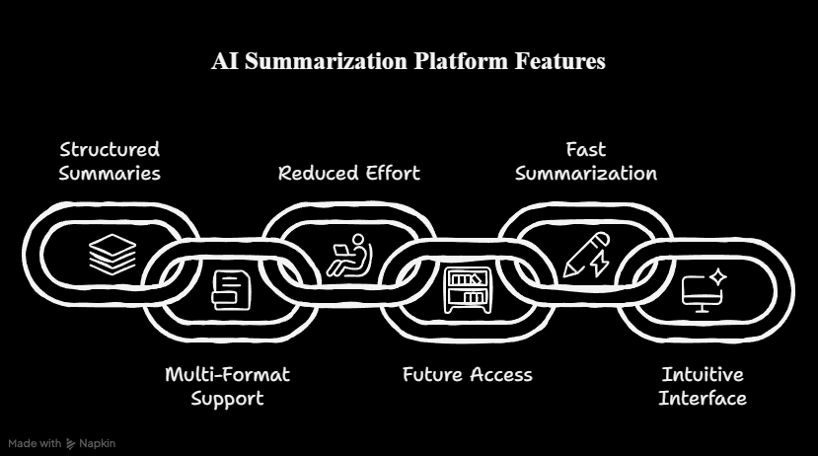

The use case diagram represents interactions between users and the SmartSummarizer AI system.
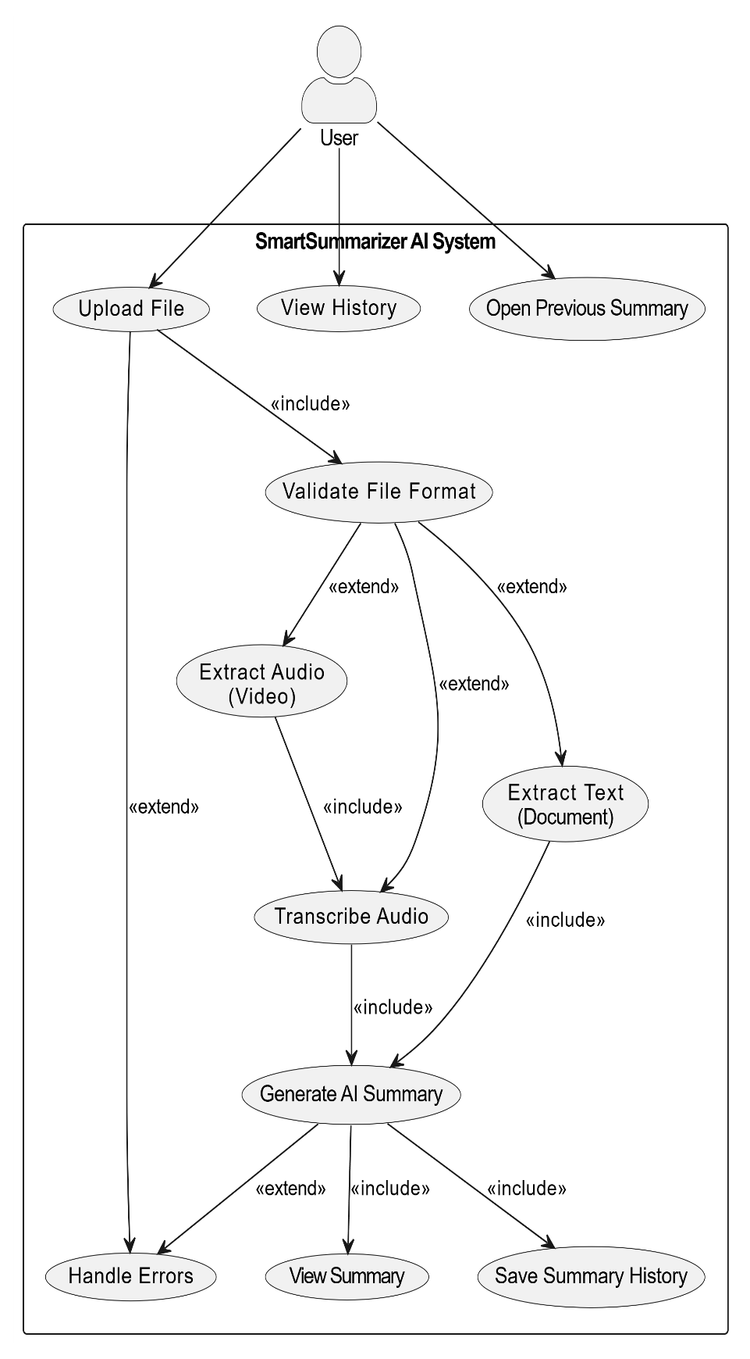

Class Diagram
NOTE: This class diagram and database schema are included to fulfill academic documentation requirements. However, the actual project is built using the MERN stack (MongoDB, Express.js, React, Node.js), which follows a schema-less, document-based structure in MongoDB. Therefore, these diagrams are conceptual representations and may not fully reflect the dynamic and flexible nature of the implemented system.
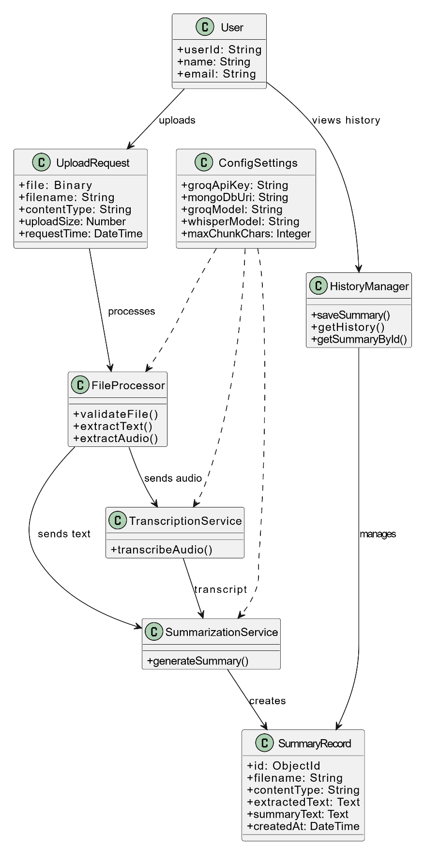

Interaction Diagram
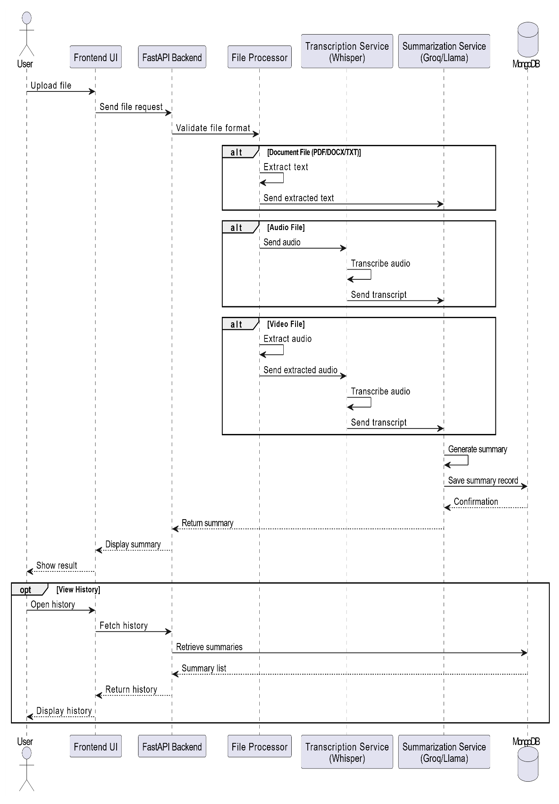

Activity Diagram
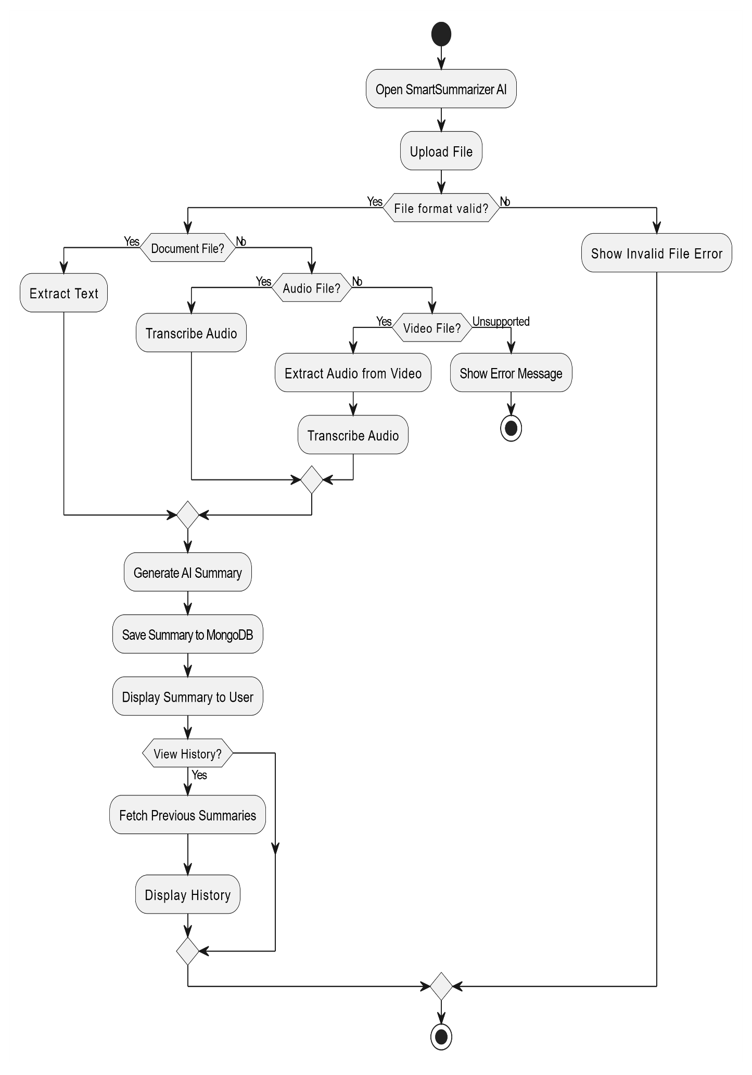

Data Dictionary

1. Table Name: SummaryRecord
Table Description: Stores uploaded file information, extracted content, and generated AI summaries.

Table Name | Field Name | Data Type | Constraint | Description | Sample Data
SummaryRecord | _id | ObjectID | Primary Key | Unique summary identifier | 507f1f77bcf86cd799439011
SummaryRecord | filename | String | Required | Name of uploaded file | project_report.pdf
SummaryRecord | content_type | String | Required | File MIME type | application/pdf
SummaryRecord | extracted_text | Text | Required | Extracted or transcribed raw content | Long extracted text content
SummaryRecord | summary_text | Text | Required | AI-generated structured summary | Key Points, Details, Summary
SummaryRecord | created_at | DateTime | Auto-generated | Date and time summary was created | 2026-05-15T14:30:00Z

2. Table Name: UploadRequest
Table Description: Stores incoming file upload request details.
Table Name | Field Name | Data Type | Constraint | Description | Sample Data
UploadRequest | file | Binary | Required | Uploaded file object | sample_audio.mp3
UploadRequest | filename | String | Required | Original uploaded filename | lecture_recording.mp3
UploadRequest | file_extension | String | Derived | File extension for processing logic | .mp3
UploadRequest | upload_size | Number | Required | Size of uploaded file in bytes | 10485760
UploadRequest | request_time | DateTime | Auto-generated | Upload request timestamp | 2026-05-15T15:00:00Z

- Table: ConfigSettings
Table Description: Stores application runtime configuration values.
Table Name | Field Name | Data Type | Constraint | Description | Sample Data
ConfigSettings | GROQ_API_KEY | String | Required | API key for Groq AI access | sk_xxxxxxxx
ConfigSettings | DATABASE_NAME | String | Required | MongoDB database name | smart_summarizer
ConfigSettings | MONGODB_URI | String | Required | MongoDB connection URI | mongodb://localhost:27017
ConfigSettings | GROQ_MODEL | String | Required | LLM model used for summarization | llama-3.3-70b-versatile
ConfigSettings | WHISPER_MODEL | String | Required | Model used for transcription | whisper-large-v3
ConfigSettings | MAX_CHUNK_CHARS | Integer | Required | Maximum characters per chunk | 6000
ConfigSettings | CHUNK_OVERLAP | Integer | Required | Overlap between text chunks | 500
ConfigSettings | MAX_HISTORY_ITEMS | Integer | Required | Maximum stored summary history items | 50

4. Development
SmartSummarizer AI was developed using a modular full-stack architecture combining React frontend technologies with Python FastAPI backend services. The development approach focused on scalability, maintainability, and efficient AI integration.
The frontend handles user interaction, uploads, summary display, and history navigation. The backend manages extraction, transcription, summarization, database storage, and API responses.

Coding Standards
Following coding standards were maintained during development:
- Frontend Components: PascalCase naming (Example: UploadBox.jsx)
- Variables & Functions: camelCase naming
- Python Files & Functions: snake_case naming
- Proper indentation and readable code structure
- Reusable modular components
- API routing separation
- Inline comments for better understanding
- Git version control for project management

4.2 SCREENSHOTS

Home Page
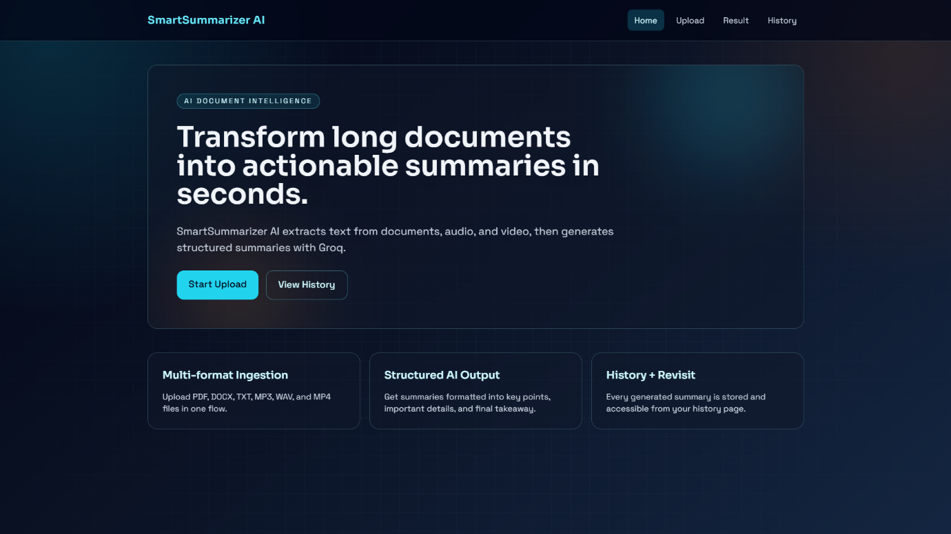

Upload Page
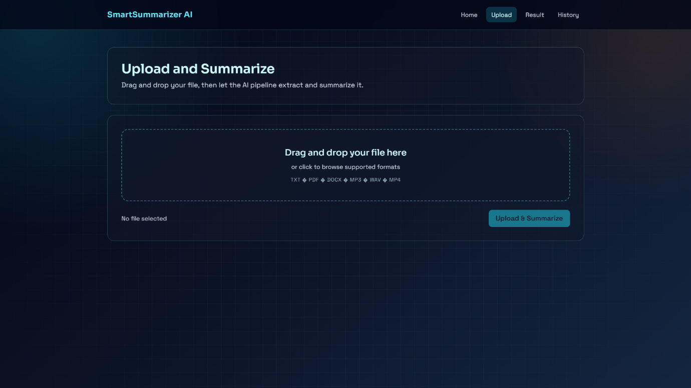

Result Page
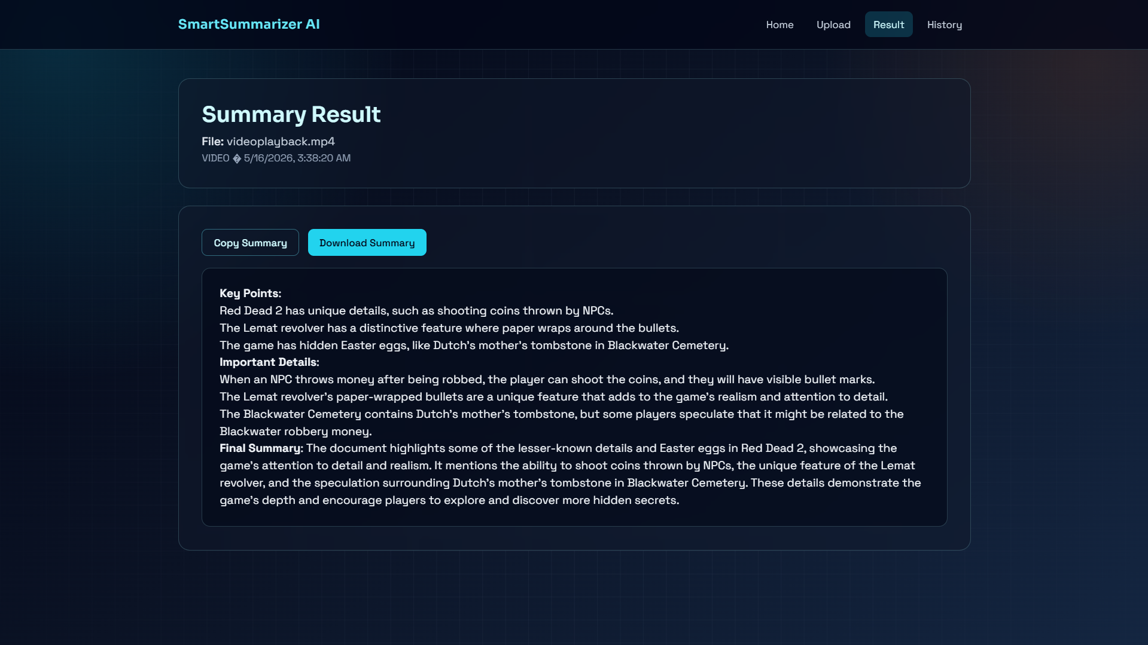

History Page
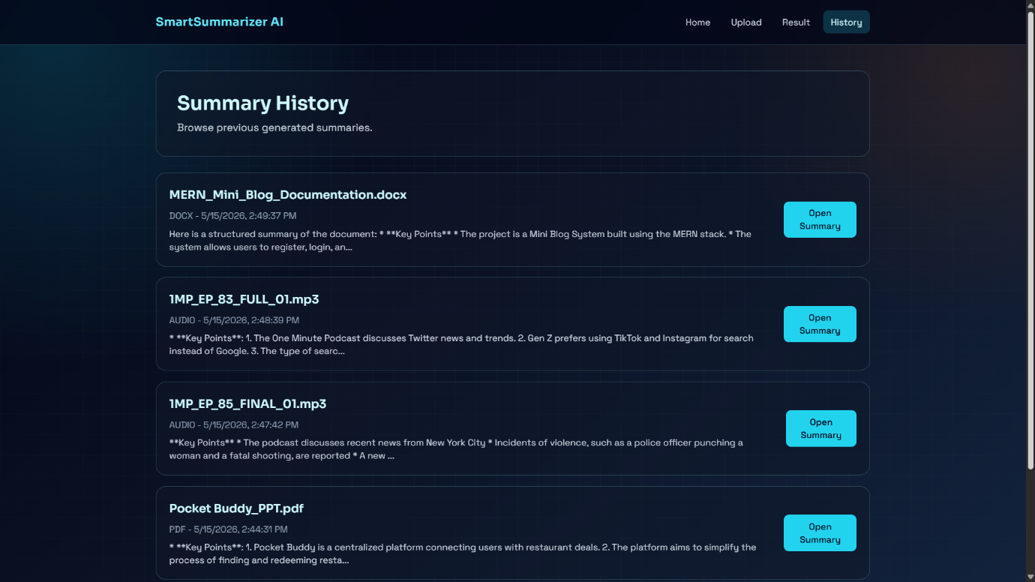

Error Handling Screen
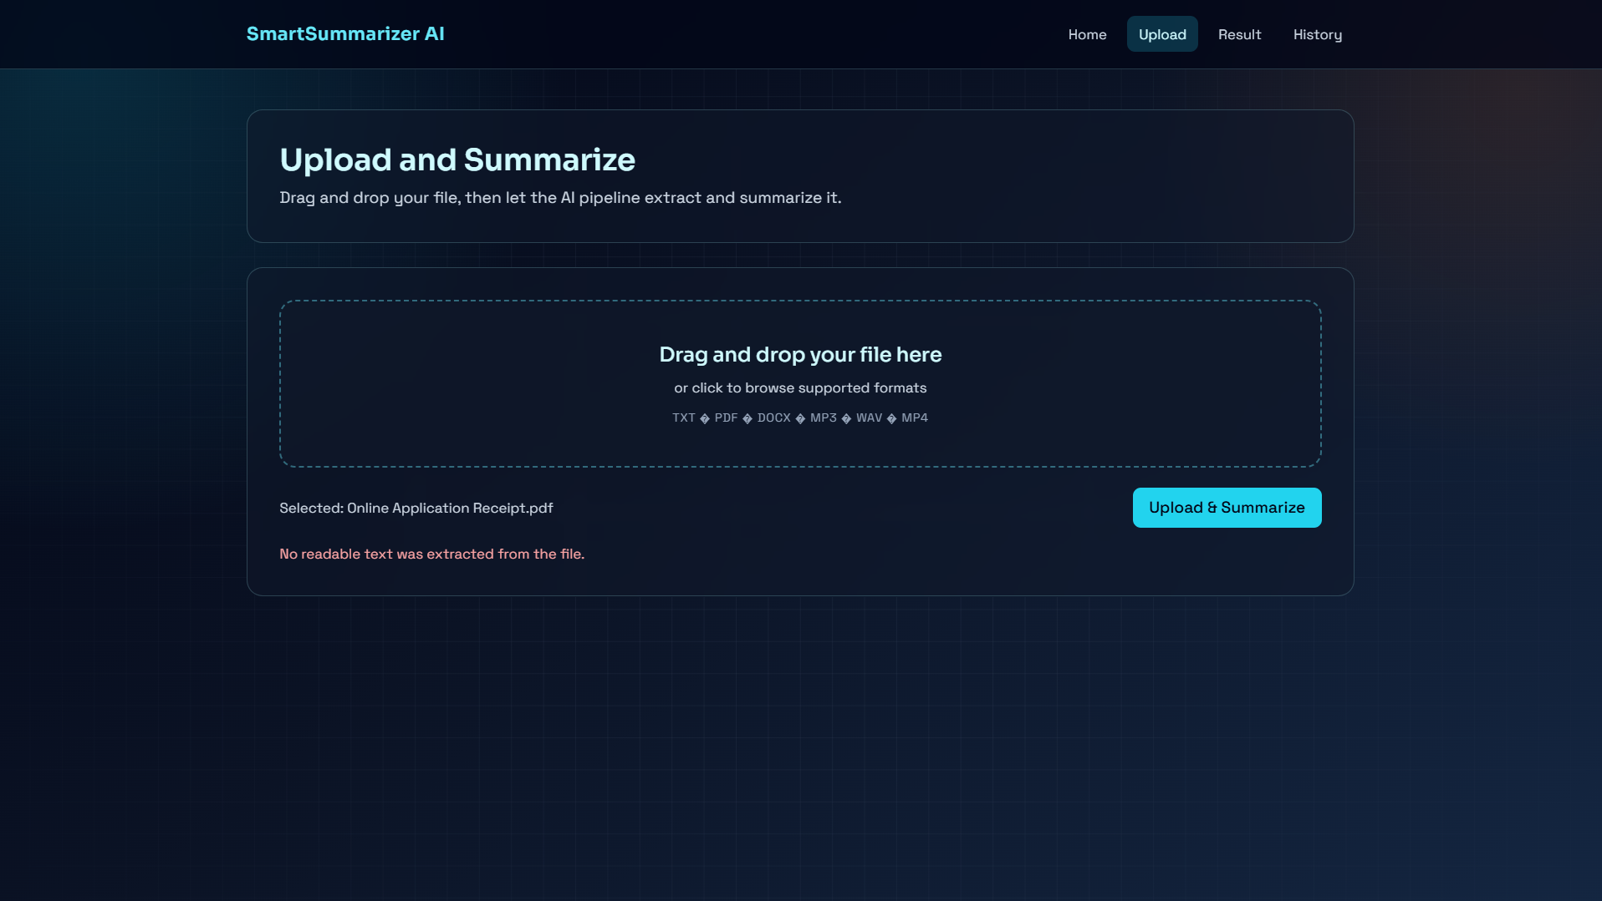

Agile Documentation

Agile Project Charter

General Project Information
Project Name | Pocket Buddy
Project Champion | Tushar Chauhan - Bhoomi Chavada
Project Sponsor | Tushar Chauhan - Bhoomi Chavada
Project Manager | Parth joshi
Stakeholders | Tushar Chauhan - Bhoomi Chavada
Expected Start Date | January 1, 2026
Expected Completion Date | April 15, 2026
Project Details
Mission | To provide an intelligent AI-powered summarization platform that helps users quickly process and understand documents, audio, and video content through automated summarization and transcription.
Vision | SmartSummarizer AI aims to simplify information consumption by offering a single platform where users can upload various file formats and receive accurate, structured summaries instantly using advanced AI technologies.
Scope | SmartSummarizer AI is designed to provide a centralized platform for processing multiple file formats including documents, audio, and video. The system extracts content, performs AI-based transcription and summarization, stores generated summaries for future access, and provides a simple user-friendly interface with proper error handling for unsupported files.

Agile Road Map
Agile Roadmap – SmartSummarizer AI Project
The SmartSummarizer AI project follows an agile roadmap divided into five iterative sprints, focusing on gradual development and testing of core features.
- Sprint 1: Project Setup & UI Design (Week 1–2)
Set up the project structure, development environment, frontend UI design, and basic file upload interface.

- Sprint 2: File Processing Module (Week 3–4)
Implement document upload handling, PDF/DOCX/TXT text extraction, and backend API integration.

- Sprint 3: AI Integration (Week 5–6)
Integrate Groq AI models for summarization and Whisper for audio transcription, including video audio extraction support.

- Sprint 4: History Management & Testing (Week 7–8)
Develop summary history storage, retrieval features, error handling, debugging, and performance testing.

- Sprint 5: Final Optimization & Documentation (Week 9–10)
Perform UI improvements, final testing, code optimization, project documentation, and deployment preparation.

Agile Project Plan

Sprint | Task Name | Duration | Start | Finish | Status
Sprint #1 | Project Setup & UI Design | 14 days | 01-02-2026 | 14-02-2026 | Completed
Sprint #1 | Sprint Planning | 2 days | 01-02-2026 | 02-02-2026 | Completed
Sprint #1 | Project Environment Setup | 4 days | 03-02-2026 | 06-02-2026 | Completed
Sprint #1 | Frontend UI Design | 5 days | 07-02-2026 | 11-02-2026 | Completed
Sprint #1 | File Upload Interface | 3 days | 12-02-2026 | 14-02-2026 | Completed
Sprint #2 | File Processing Module | 14 days | 15-02-2026 | 28-02-2026 | Completed
Sprint #2 | PDF Text Extraction | 4 days | 15-02-2026 | 18-02-2026 | Completed
Sprint #2 | DOCX/TXT Processing | 4 days | 19-02-2026 | 22-02-2026 | Completed
Sprint #2 | Backend API Development | 6 days | 23-02-2026 | 28-02-2026 | Completed
Sprint #3 | AI Integration | 14 days | 01-03-2026 | 14-03-2026 | Completed
Sprint #3 | Groq AI Summarization Integration | 5 days | 01-03-2026 | 05-03-2026 | Completed
Sprint #3 | Whisper Audio Transcription | 5 days | 06-03-2026 | 10-03-2026 | Completed
Sprint #3 | Video Audio Extraction | 4 days | 11-03-2026 | 14-03-2026 | Completed
Sprint #4 | History & Testing | 14 days | 15-03-2026 | 28-03-2026 | Completed
Sprint #4 | Summary History Storage | 5 days | 15-03-2026 | 19-03-2026 | Completed
Sprint #4 | History Retrieval Module | 4 days | 20-03-2026 | 23-03-2026 | Completed
Sprint #4 | Error Handling & Debugging | 5 days | 24-03-2026 | 28-03-2026 | Completed
Sprint #5 | Final Optimization & Documentation | 14 days | 29-03-2026 | 11-04-2026 | Completed
Sprint #5 | UI Improvements | 4 days | 29-03-2026 | 01-04-2026 | Completed
Sprint #5 | Final Testing | 4 days | 02-04-2026 | 05-04-2026 | Completed
Sprint #5 | Documentation | 3 days | 06-04-2026 | 08-04-2026 | Completed
Sprint #5 | Deployment Preparation | 3 days | 09-04-2026 | 11-04-2026 | Completed

Agile User Story
User Story ID | As a (type of user) | I want to (perform some task) | So that I can (achieve some goal)
1 | User | Upload documents, audio, or video files | Generate summaries from different content formats
2 | User | View AI-generated summaries | Quickly understand large content without full reading or listening
3 | User | Upload audio files for transcription | Convert spoken content into readable text summaries
4 | User | Upload video files | Extract important information from video content
5 | User | Access previously generated summaries | Review old summaries anytime without re-uploading files
6 | User | Receive error messages for invalid files | Understand upload issues and correct them easily
7 | Admin/System Manager | Configure AI models and system settings | Maintain system performance and functionality

Agile Release Plan
Release | Features Included | Planned Delivery | Status
Release 1.0 | Project setup, frontend UI, file upload interface | 14-02-2026 | Completed
Release 2.0 | Document processing (PDF, DOCX, TXT extraction) and backend APIs | 28-02-2026 | Completed
Release 3.0 | AI summarization, audio transcription, video audio extraction | 14-03-2026 | Completed
Release 4.0 | Summary history management, error handling, testing | 28-03-2026 | Completed
Release 5.0 | UI optimization, final testing, documentation, deployment preparation | 11-04-2026 | Completed

Agile Sprint Backlog
Task Name | Story Ready | Sprint Ready | Priority | Status | Story Point
Project Setup & Environment Configuration | Yes | Yes | High | Completed | 8
Frontend UI Design | Yes | Yes | High | Completed | 6
File Upload Module Development | Yes | Yes | High | Completed | 5
PDF/DOCX/TXT Text Extraction | Yes | Yes | High | Completed | 8
Backend API Development | Yes | Yes | High | Completed | 7
Groq AI Summarization Integration | Yes | Yes | High | Completed | 10
Whisper Audio Transcription Integration | Yes | Yes | High | Completed | 8
Video Audio Extraction Processing | Yes | Yes | Medium | Completed | 6
Summary History Storage Module | Yes | Yes | Medium | Completed | 5
History Retrieval Feature | Yes | Yes | Medium | Completed | 4
Error Handling & Debugging | Yes | Yes | High | Completed | 6
Final UI Improvements | Yes | Yes | Medium | Completed | 4
Testing & Quality Assurance | Yes | Yes | High | Completed | 7
Documentation & Final Deployment Preparation | Yes | Yes | Medium | Completed | 5

Agile Test Plan

5.7 Agile Test Plan
Project Name: SmartSummarizer AI
Technology Stack: ReactJS, FastAPI, MongoDB, Groq AI, FFmpeg
Testing Device: HP Laptop / Modern Browsers (Chrome, Edge)

Test Case 1: File Upload & Validation
Module: File Upload System
Priority: High
Tested By: Tushar Chauhan, Bhoomi Chavada
Test Step | Action | Expected Result | Actual Result | Pass/Fail
1 | Upload valid PDF file | File uploads successfully | File uploaded successfully | ✅ Pass
2 | Upload unsupported file format | Show error message | Error displayed correctly | ✅ Pass
3 | Upload empty file | Show validation error | Validation worked correctly | ✅ Pass
4 | Upload DOCX/TXT file | File processed successfully | Processing successful | ✅ Pass

Test Case 2: AI Summarization
Module: Summary Generation
Priority: High
Tested By: Tushar Chauhan, Bhoomi Chavada
Test Step | Action | Expected Result | Actual Result | Pass/Fail
1 | Upload text document | AI generates summary | Summary generated successfully | ✅ Pass
2 | Upload large document | Summary generated after processing | Completed successfully | ✅ Pass
3 | API connection failure simulation | Show processing error | Error handled correctly | ✅ Pass

Test Case 3: Audio/Video Processing
Module: Transcription & Media Processing
Priority: Medium
Tested By: Tushar Chauhan, Bhoomi Chavada
Test Step | Action | Expected Result | Actual Result | Pass/Fail
1 | Upload audio file | Audio transcription starts | Transcription successful | ✅ Pass
2 | Upload video file | Audio extracted and summarized | Processing successful | ✅ Pass
3 | Upload corrupted media file | Show error message | Error displayed correctly | ✅ Pass

Test Case 4: Summary History
Module: History Management
Priority: Medium
Tested By: Tushar Chauhan, Bhoomi Chavada
Test Step | Action | Expected Result | Actual Result | Pass/Fail
1 | Generate summary | Save in history | Saved successfully | ✅ Pass
2 | Open history page | Previous summaries displayed | Displayed correctly | ✅ Pass
3 | Open specific summary | Full summary shown | Loaded successfully | ✅ Pass

Proposed Enhancements

The current SmartSummarizer AI system provides core summarization features, but several enhancements can improve functionality and user experience in the future:
- OCR Support: Enable processing of scanned PDFs and image-based documents.
- Multi-language Support: Generate summaries in different languages.
- User Authentication: Add login and user account management.
- Export Feature: Allow users to download summaries in PDF or DOCX format.
- Cloud Deployment: Deploy the system for public online access.
- Advanced AI Models: Improve summary quality using newer AI models.
- Speaker Identification: Differentiate speakers in audio transcription.

Conclusion

SmartSummarizer AI is an intelligent web-based application developed to simplify the process of understanding large amounts of information from different content formats. The system successfully supports document, audio, and video file processing by combining text extraction, audio transcription, and AI-powered summarization into a single platform. This eliminates the need for multiple separate tools and provides users with a faster and more efficient way to consume content.

The project was developed using modern technologies such as ReactJS for the frontend, FastAPI for backend services, MongoDB for data storage, and Groq AI models for summarization and transcription. The application provides accurate summary generation, maintains summary history for future reference, and offers a user-friendly interface for smooth interaction.

Overall, SmartSummarizer AI demonstrates the practical use of artificial intelligence in solving real-world information overload problems. With future enhancements such as OCR support, multi-language summarization, and cloud deployment, the system can become an even more powerful and scalable solution.

Bibliography

- Groq API Documentation – https://groq.com
- FastAPI Official Documentation – https://fastapi.tiangolo.com
- ReactJS Official Documentation – https://react.dev
- MongoDB Documentation – https://www.mongodb.com/docs
- Tailwind CSS Documentation – https://tailwindcss.com
- FFmpeg Documentation – https://ffmpeg.org
- Python Official Documentation – https://docs.python.org
- pdfplumber Documentation – https://github.com/jsvine/pdfplumber
- python-docx Documentation – https://python-docx.readthedocs.io
- Software Engineering Concepts – Ian Sommerville, Software Engineering

