**Expenses sharing app:**

1. **Task Description**

Create an app that allows users to split and track shared expenses among a group.

1. **Task Output Screenshot**

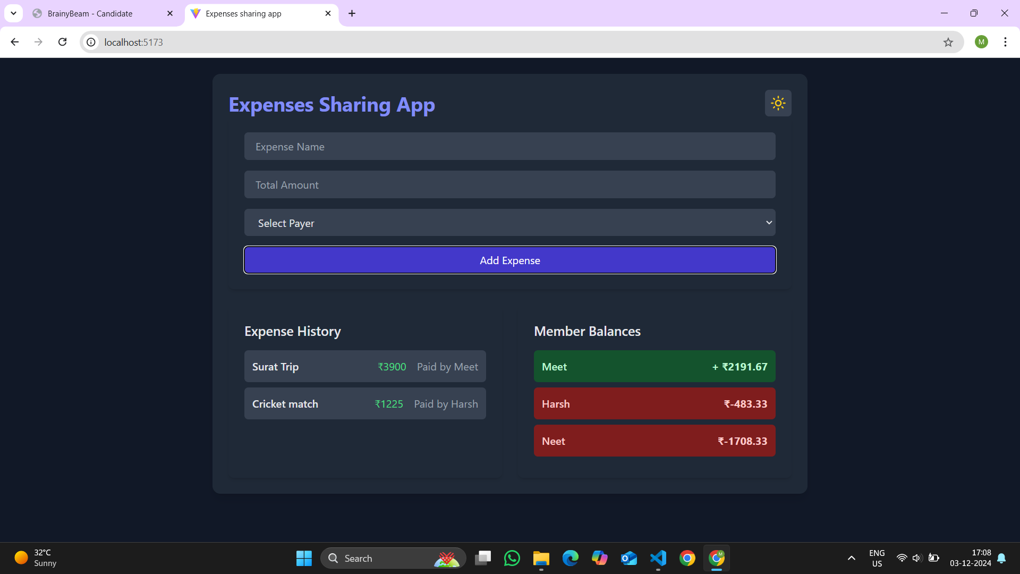

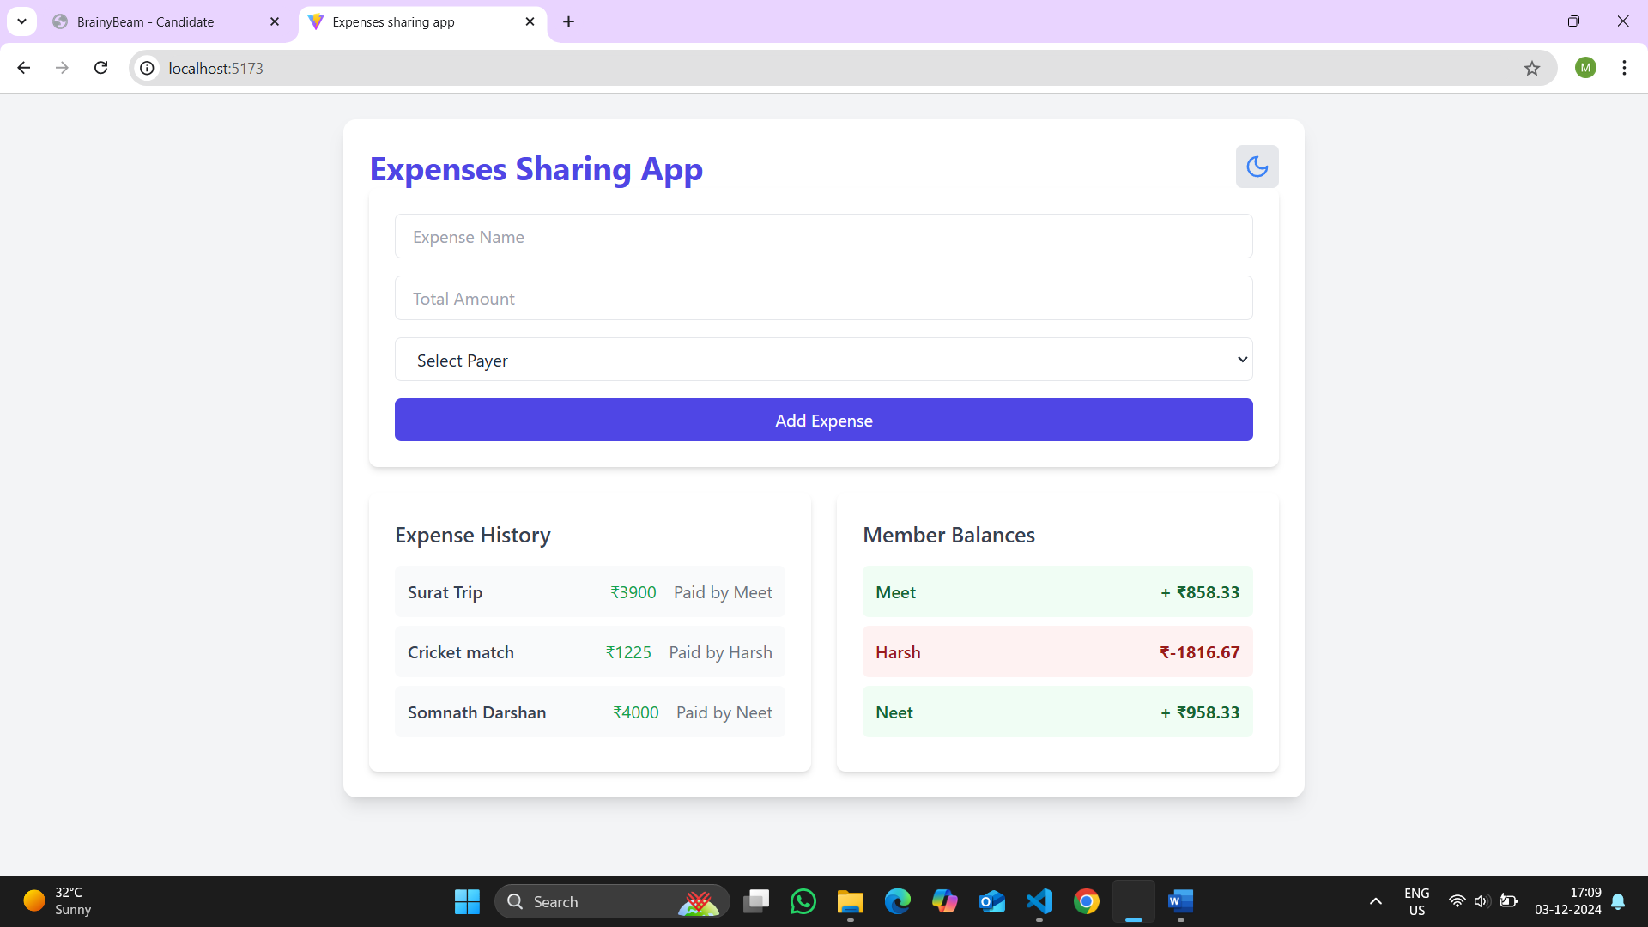

1. **Widget/Algorithm Used In Task**

• **Input Fields:**

* Used in the ExpenseForm component to allow users to input expense details such as the name, total amount, and payer.
* Includes styling for light and dark mode to enhance user experience.

**• Button Components:**

* Add Expense and Add Member buttons are used for performing key actions.
* The buttons are styled with Tailwind classes to transition smoothly between light and dark modes.

**• List Components:**

* The ExpenseList component displays a dynamically updated list of expense history, showing expense name, amount, and payer details.
* The BalanceSummary component lists members along with their calculated balances in visually distinct styles (positive, negative, or neutral balance).

**• Toggle Button (Lucide-react):**

* The theme toggle button uses sun and moon icons to represent light and dark modes, with smooth transition animations applied via Tailwind CSS.

**• Card Components:**

* Sections such as BalanceSummary and ExpenseList use card-like UI elements to neatly organize and display data.

**• Responsive Grid Layouts:**

* The application layout employs a responsive grid structure for adaptive display across devices.

**• Animations and Transitions:**

* Smooth animations and transitions are applied globally with Tailwind's utilities, including a 200ms default transition duration for theme toggling and user interaction feedback.