**Social Media Dashboard Report:**

1. **Task Description**

Design a dashboard that displays social media analytics and statistics.

1. **Task Output Screenshot**

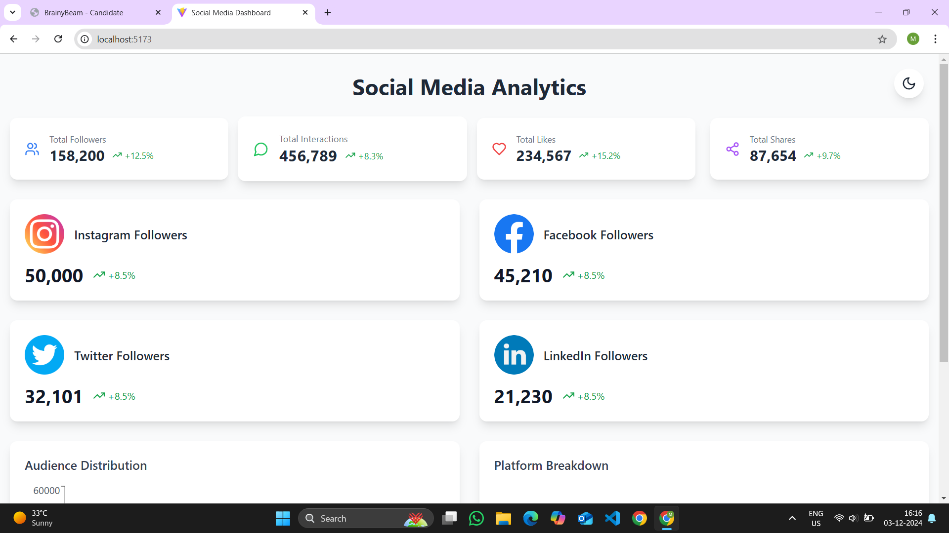

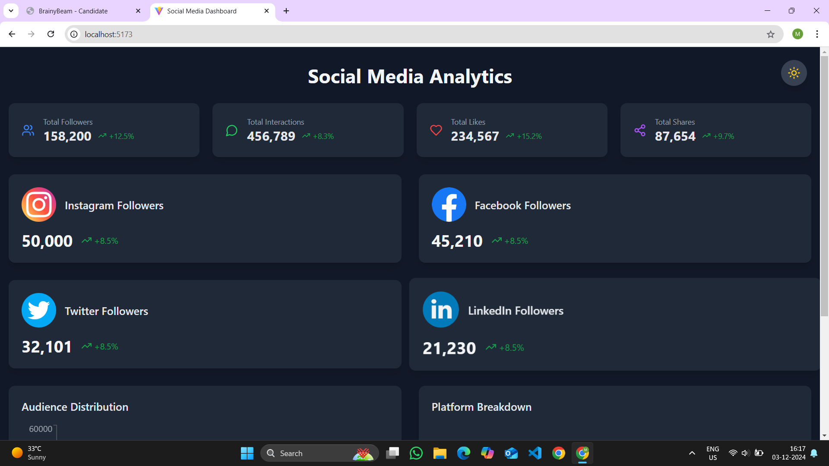

1. **Widget/Algorithm Used In Task**

**Reusable Metrics Components**

* **MetricCard Component**
  + Displays total followers, interactions, likes, and shares
  + Implements dynamic growth percentage visualization
  + Uses Lucide icons for visual representation
  + Supports light/dark mode theming

### Reusable Metrics Components

* **MetricCard Component**
  + Displays total followers, interactions, likes, and shares
  + Implements dynamic growth percentage visualization
  + Uses Lucide icons for visual representation
  + Supports light/dark mode theming

### Platform Contribution Visualization

* **Pie Chart Implementation**
  + Utilizes Recharts PieChart component
  + Displays percentage contribution of each platform
  + Custom color mapping
  + Centered design with inner/outer radius

### Technical Highlights

* Modular React component architecture
* Context-based theme management
* Responsive and adaptive UI design
* Performance-optimized data rendering

### Data Sources

* Predefined audience and engagement datasets
* Platform-specific follower and interaction metrics

### Conclusion

Comprehensive, interactive social media analytics dashboard with modular, reusable components and advanced visualization techniques.