**Theme Changer:**

1. **Task Description**

Implement a global app theme switcher using context and local storage.

1. **Task Output Screenshot**

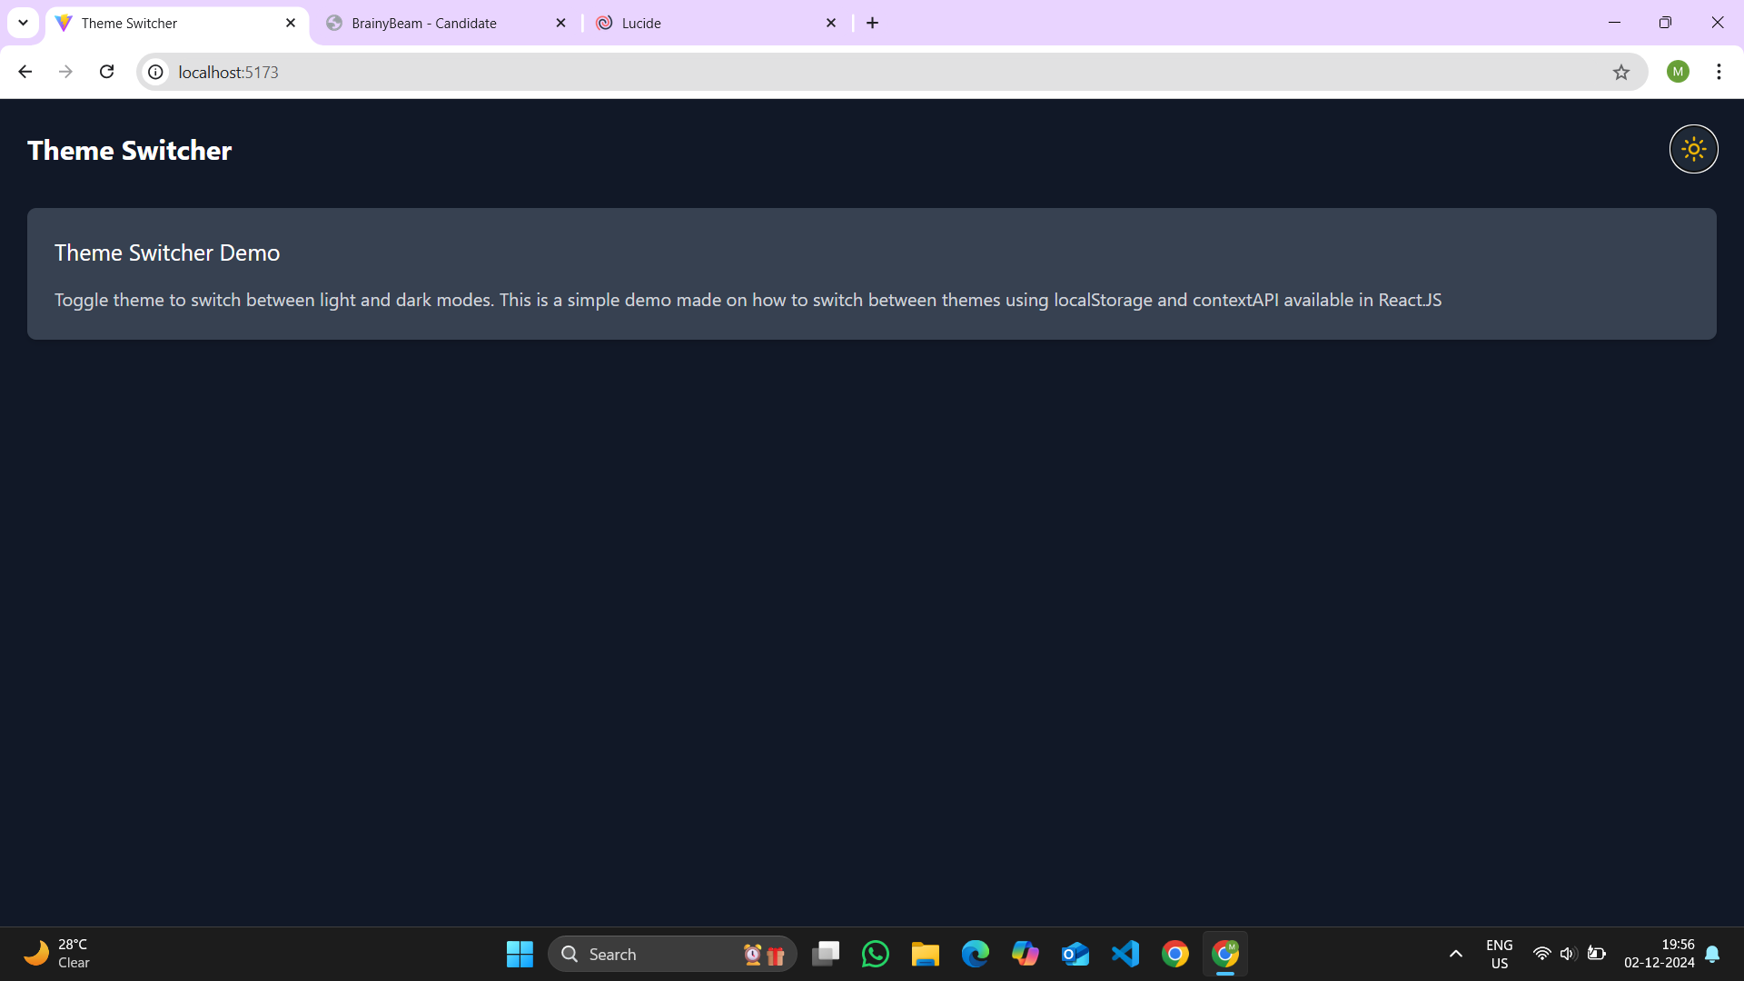

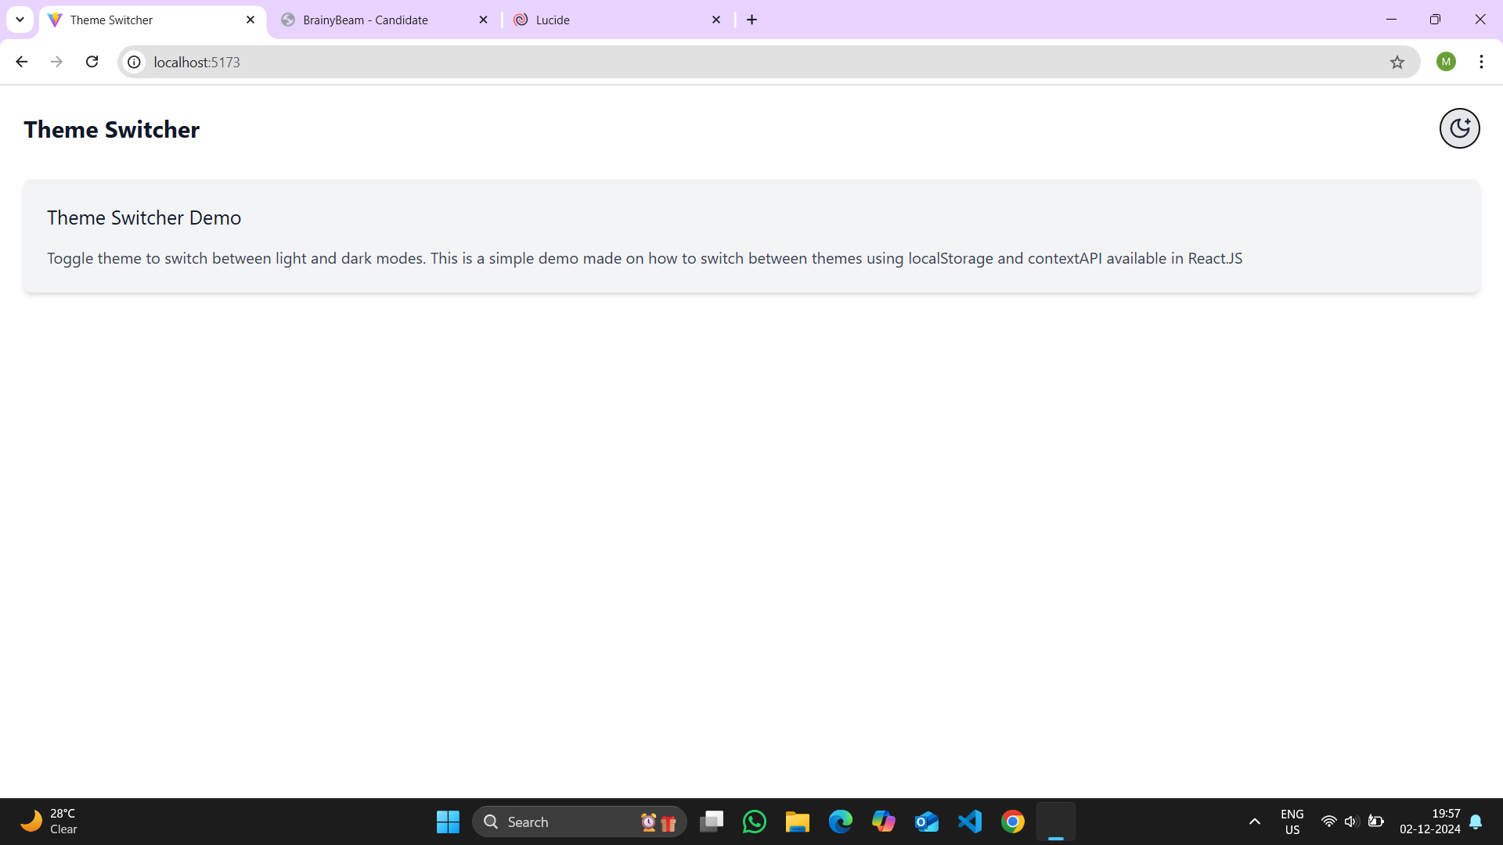

**3.Widgets/Components Used in Theme Switcher Project**

* Context API for Global Theme Management
* ThemeProvider Component for Theme State and Logic
* ThemeToggle Button for Switching Themes
* useTheme Custom Hook for Accessing Theme State
* Tailwind CSS Classes for Dynamic Styling
* LocalStorage for Theme Persistence
* Lucide React Icons for Theme Toggle Visuals