A2Z Argon to Zero Organizational Password Manager

Advanced Cryptography Mini Project Report

Group Members:
Mohammed Ibrahim al Balushi - 16j21212
Nasser Saleh Al-Alawi - 16j19203
Saud Sultan Al Mughairi - 16a2236489
Course coordinator:
Dr. Amur Hamed Mohammed Al Manji

Course: CSSY4102 Advanced Cryptography
Date: 4 May 2026

- Introduction

The A2Z Organizational Password Manager is a highly secure, zero-knowledge platform designed to safely store and share credentials across an organization. This report details the cryptographic principles, zero-trust architecture, and implementation specifics of the system. The project strictly adheres to modern cryptographic standards by utilizing a combination of robust symmetric encryption, asymmetric key wrapping, and memory-hard key derivation functions to ensure data confidentiality and integrity. Furthermore, the application provides an intuitive, standardized organizational interface including a securely designed admin dashboard and a landing page that visually reflects the underlying zero-trust architecture to ensure a seamless yet secure user experience (Rose et al., 2020).
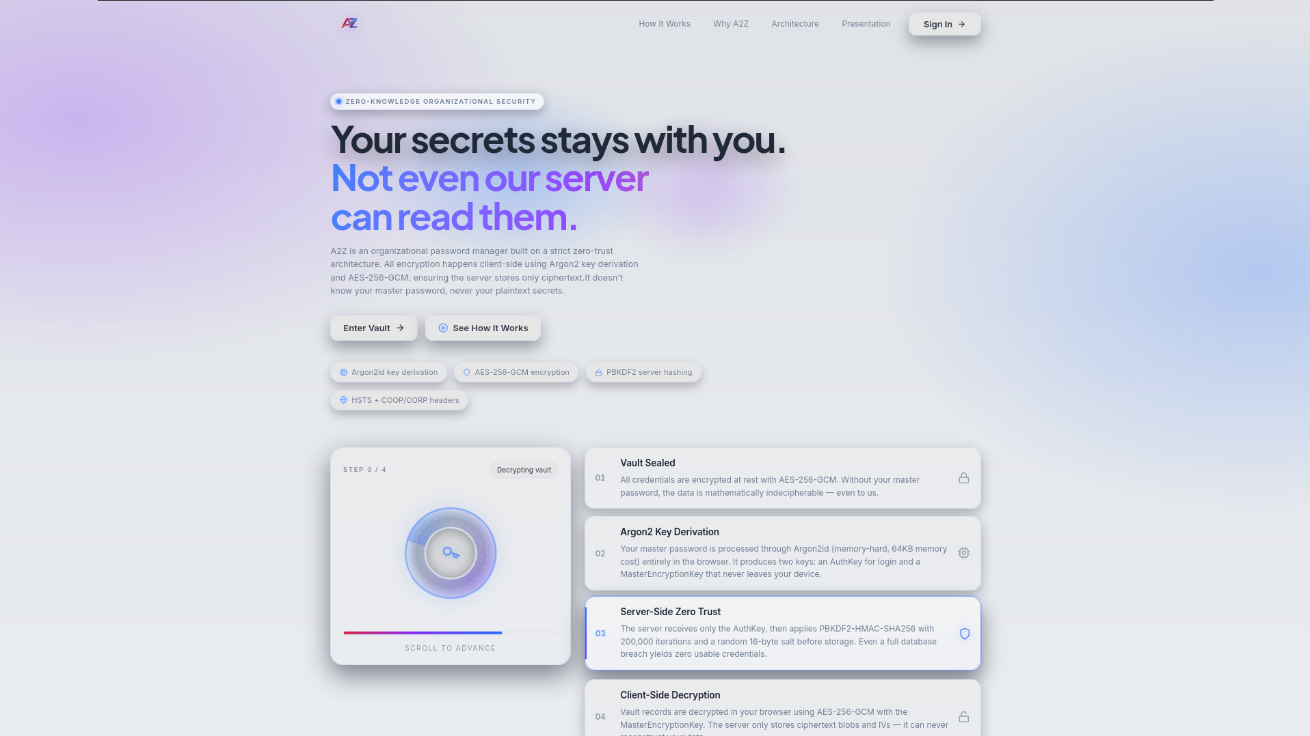
Figure 1:landing Page

2. Methodology

The methodology of this system is built entirely around a Zero Trust Architecture. The core principle of assuming compromise so that the server must never have access to the user’s master password, nor the plain text data stored within their vault. To achieve this, the system relies on a multi-layered cryptographic approach. First, key derivation is performed entirely on the client side using the memory-hard Argon2 algorithm. Second, the server employs PBKDF2 hashing to protect authentication credentials against database leaks. Third, all sensitive vault data is encrypted within the browser using AES-256-GCM before transmission, while RSA-OAEP handles secure organizational sharing. Finally, all network communications are protected by strict Nginx transport configurations. Together, these methods ensure that data remains confidential and secure, even if the central server is completely compromised (Grassi et al., 2017).

2.1 Key Derivation
To achieve zero trust, all key derivation occurs on the client side (in the browser). When a user enters their Master Password, the system uses the Argon2 hashing algorithm to derive a 64-byte combined key (Biryukov et al., 2022). This combined key is split into two components:
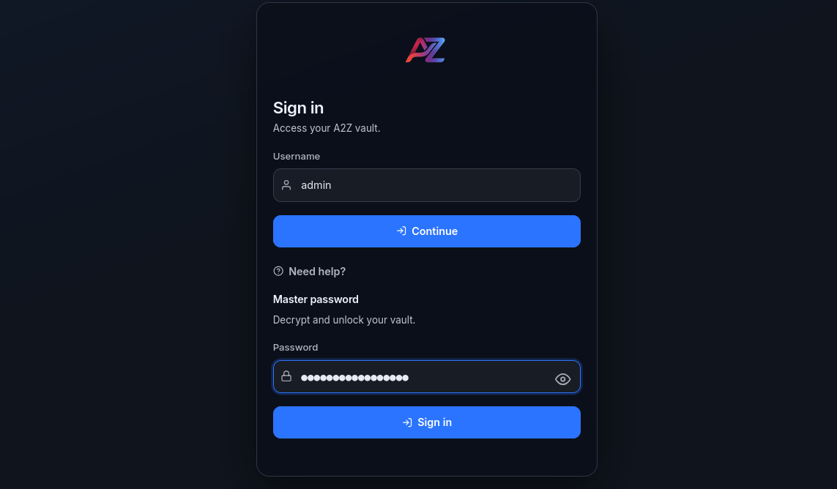
Figure 2: Login Page
- AuthKey (32 bytes): Sent to the server for authentication.
- MasterEncryptionKey (32 bytes): Kept securely in the browser's memory and used to encrypt and decrypt the user's personal vault key or RSA private key.
The browser does not save the “MasterEncryptionKey” on the hard drive or in any permanent storage. Instead, it is kept safe by holding it temporarily in a secure variable within the browser's working memory (RAM), which other websites cannot access. The key is automatically cleared and erased from memory when the user logs out or closes the browser tab. Because the key is never saved permanently, an attacker who steals the computer cannot find the key.
However, it is important to note that if an attacker compromises the device with malware or gains deep system-level access, they could theoretically read the computer's live memory and extract the key while the user is actively logged in.
A2Z runs entirely within the web browser, it relies on the browser's security sandbox and cannot execute native memory-locking defenses against advanced memory scraping attacks. This remains a fundamental risk for any web application running on a compromised operating system. To reduce the impact of such attacks, Multi-Factor Authentication (MFA) is crucial. Even if an attacker steals the Master Password or extracted keys, they cannot log into the server from another device without the user's physical MFA token like a mobile authenticator app. This extra layer of defense severely limits the attacker's ability to access the vault remotely.
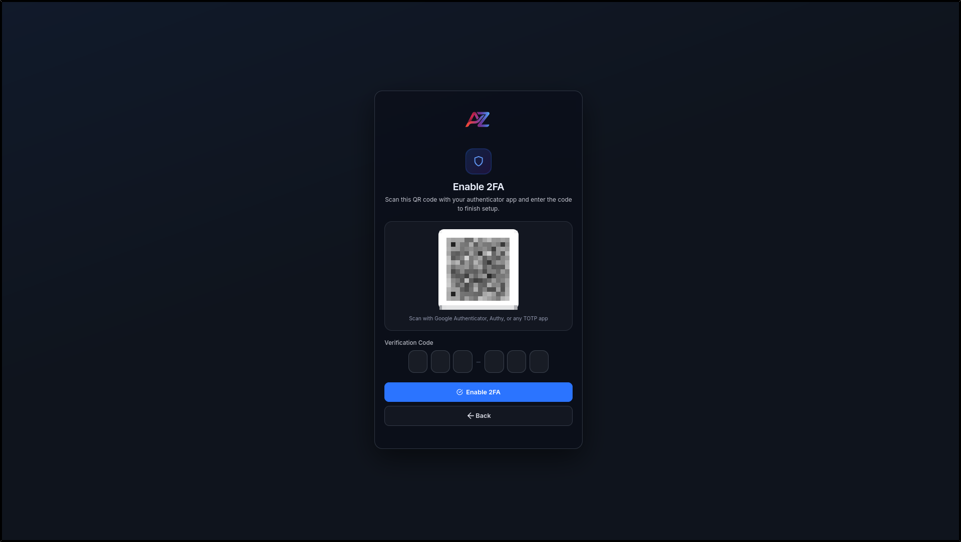
Figure 3: MFA TOTP

2.2 Server-Side Zero Trust & Hashing
When the server receives the “AuthKey” during login or registration, it does not store it directly. Instead, the server applies to a second layer of hashing using the PBKDF2-HMAC-SHA256 algorithm, combined with a randomly generated 16-byte salt and 200,000 rounds of mixing. The result is saved in the database in a “salt$hash” format.
This two-step process stops a common threat known as a "Pass-the-Hash" attack. If hackers break into the server's database, they only get the PBKDF2 hash, not the original “AuthKey”. To log in, the hacker would still need to provide the actual “AuthKey”, which the server then checks against the database. As a result, the stolen hash is useless for logging in, providing strong, layered security.

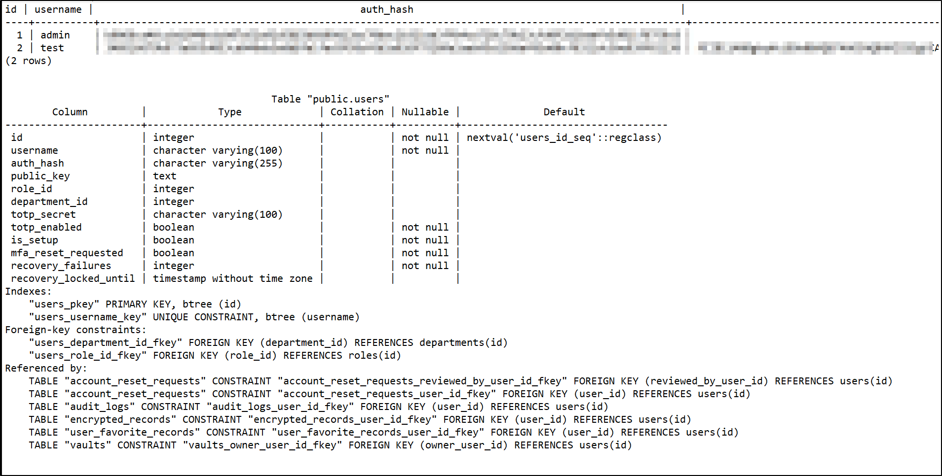
Figure 4:database overview

2.3 Encryption and Decryption
Data confidentiality is maintained using AES-256-GCM (Advanced Encryption Standard with Galois/Counter Mode). AES-GCM is an authenticated encryption algorithm that ensures both the secrecy of the data and its integrity. When a user saves a password, it is encrypted in the browser using their Vault Key. Only the resulting “ciphertext_blob” and “iv_blob” (Initialization Vector) are transmitted to the server.
For organizational sharing, including structured department-level password sharing, the system utilizes RSA-OAEP (4096-bit) (Moriarty et al., 2016). A shared vault or department credential is protected by a symmetric Vault Key, which is then encrypted by the RSA Public Keys of the specific users or department members who are authorized to access that vault.
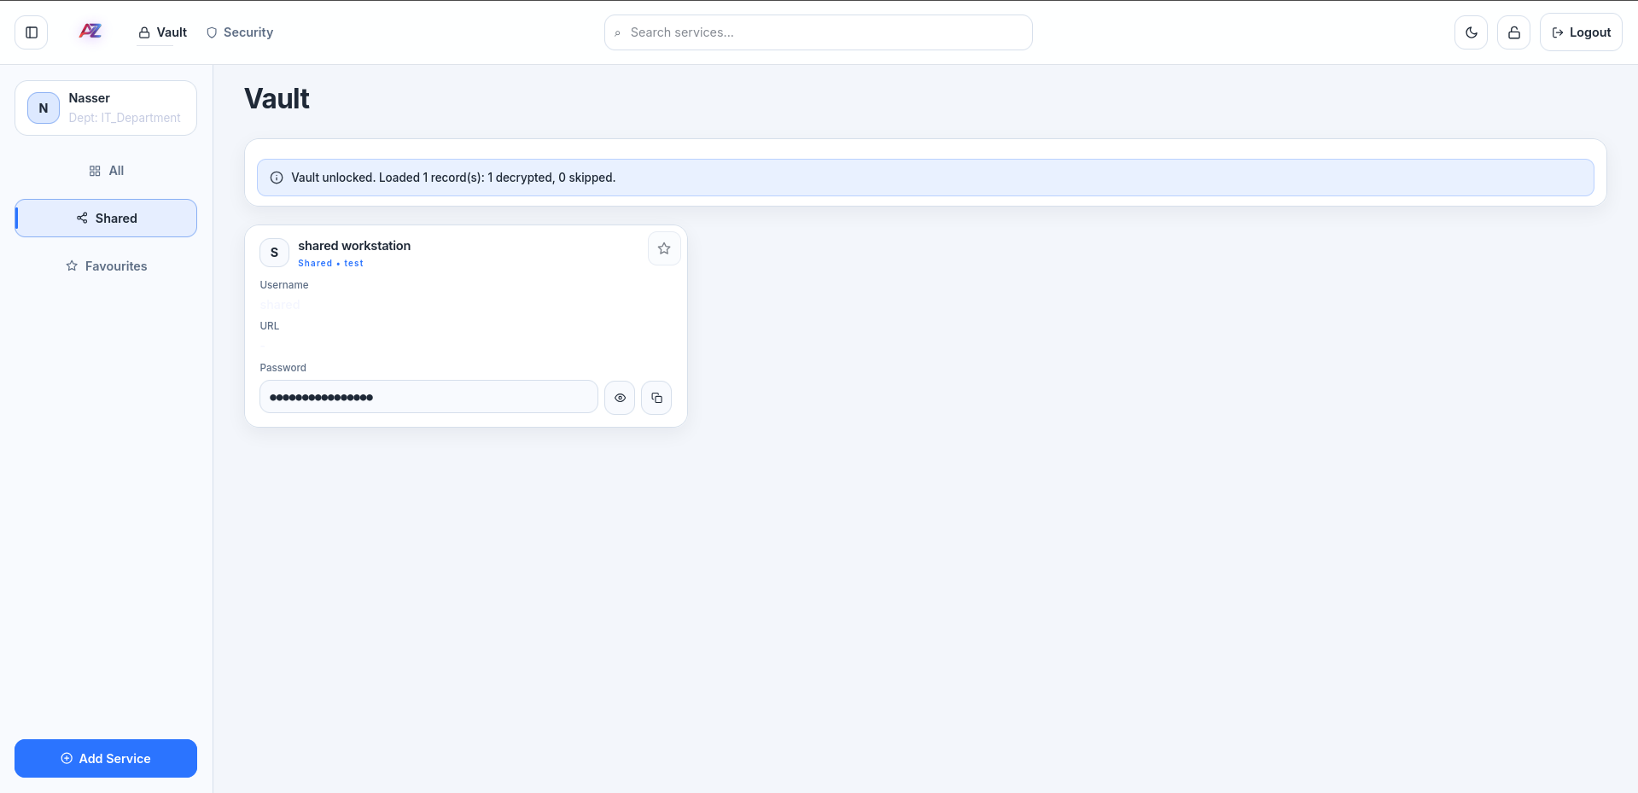
Figure 5: User shared Vault

2.2 Transport Layer Security (Nginx)
While the Web Crypto API protects the data itself, securing the communication channel is equally vital. The application is deployed behind an Nginx reverse proxy configured with strict security measures. It mandates HTTPS by permanently redirecting all HTTP traffic to HTTPS. The proxy enforces modern encryption standards by strictly allowing only TLSv1.2 and TLSv1.3 protocols alongside high-security ciphers (McKay & Cooper, 2019). Furthermore, the Nginx configuration injects several critical HTTP security headers:
Response header:
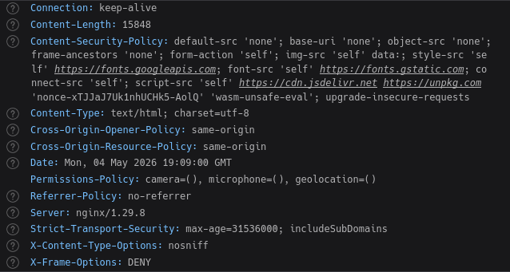
- Strict-Transport-Security (HSTS): Ensures browsers only interact with the application over a secure HTTPS connection.
- X-Frame-Options (DENY): Prevents the site from being embedded in iframes, neutralizing Clickjacking attacks.
- Cross-Origin Opener/Resource Policies (COOP/CORP): Isolates the browsing context to protect the ephemeral MasterEncryptionKey from advanced cross-site leaks.

2.3 Administrative and Organizational Security
Administrative functions, such as service creation and department assignment within the admin dashboard, are secured through rigorous backend validation and session management. This prevents unauthorized privilege escalation and ensures that structural changes such as adding new services or managing department-level sharing policies are securely authenticated and authorized before any organizational state changes occur.
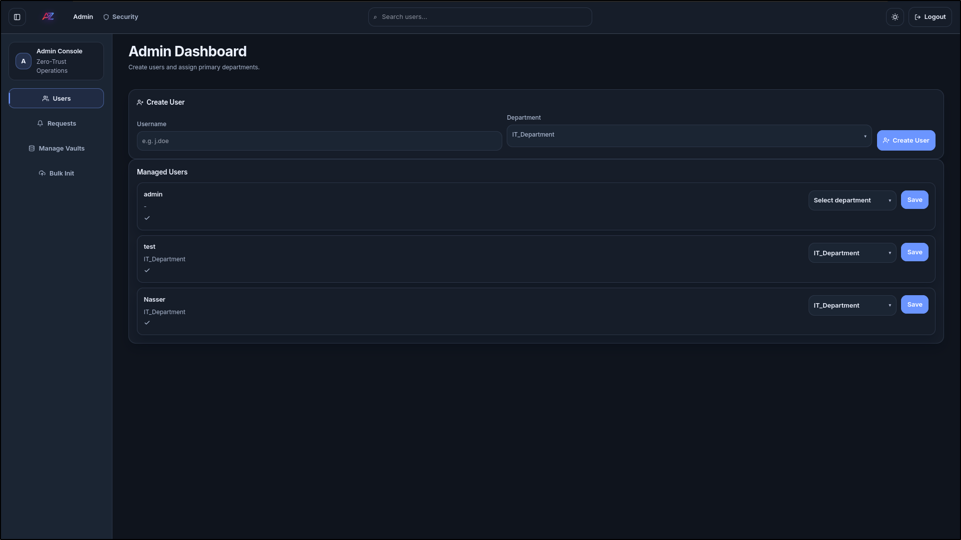
Figure 6:Admin dashboard for assigning users to department.
.
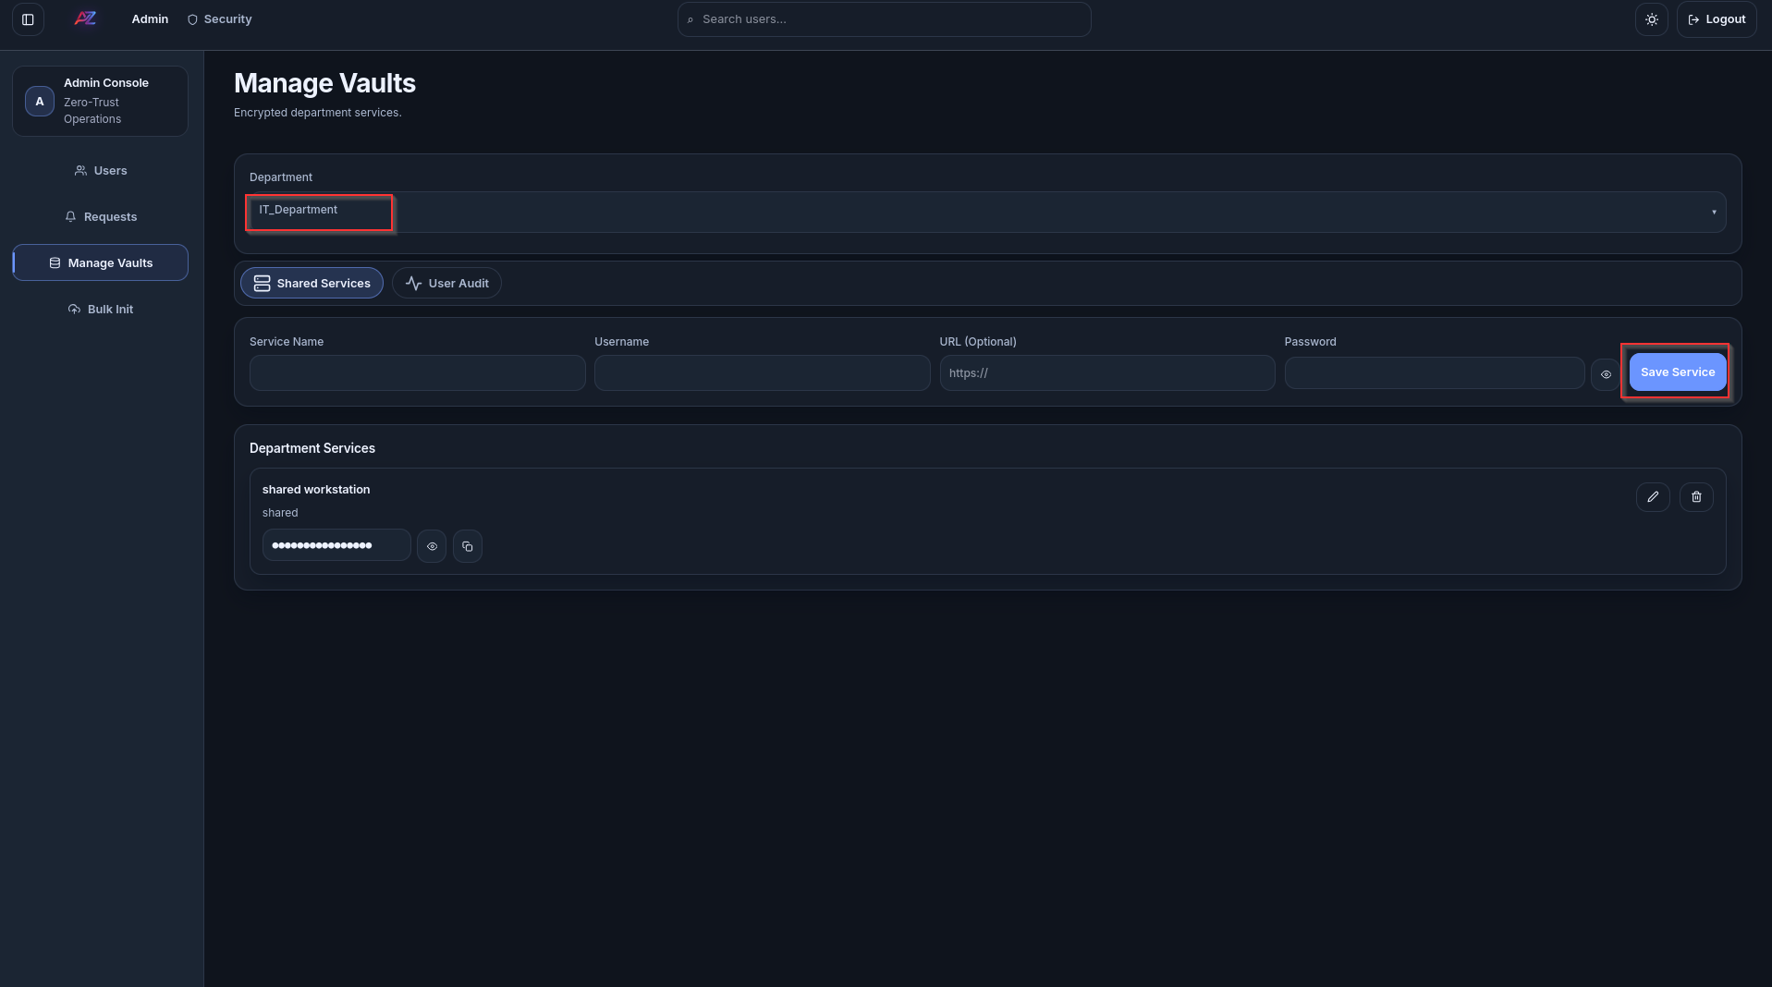
Figure 7:Admin manages Vault for shared passwords in between departments

3. Cryptographic Implementation and Code Snippets:

3.1 Client-Side Key Derivation (Argon2)
The following Web Crypto API snippet from “crypto.js” demonstrates how the master password is mathematically transformed into an “AuthKey” and “MasterEncryptionKey” using Argon2:
async function deriveKeys(masterPassword, salt, options) {
const subtle = ensureWebCrypto();
const passwordBytes = normalizeUint8(masterPassword, 'Master password');
const saltBytes = normalizeUint8(salt, 'Salt');

// Argon2 memory-hard hashing
const result = await argon2.hash({
pass: passwordBytes, salt: saltBytes,
time: 3, mem: 65536, hashLen: 64, parallelism: 1, type: 2 // Argon2id
});

const combinedKeyBytes = new Uint8Array(result.hash);
const authKeyBytes = combinedKeyBytes.slice(0, 32);
const masterKeyBytes = combinedKeyBytes.slice(32, 64);

const masterEncryptionKey = await subtle.importKey(
'raw', masterKeyBytes, { name: 'AES-GCM', length: 256 }, false, ['encrypt', 'decrypt']
);

return { authKey: toBase64(authKeyBytes), masterEncryptionKey };
}

3.2 AES-GCM Encryption / Decryption
Vault records are encrypted using AES-256-GCM before ever leaving the browser
async function encryptAesGcm(plaintext, key, options) {
const subtle = ensureWebCrypto();
const iv = globalScope.crypto.getRandomValues(new Uint8Array(12));
const plaintextBytes = textEncoder.encode(JSON.stringify(plaintext));

const ciphertext = await subtle.encrypt(
{ name: 'AES-GCM', iv: iv, tagLength: 128 },
key, plaintextBytes
);

return { iv: toBase64(iv), ciphertext: toBase64(new Uint8Array(ciphertext)) };
}

3.3 Server-Side Storage of AuthHash
The server protects the incoming “AuthKey” utilizing PBKDF2 as seen in app/auth_utils.py:
def hash_auth_key(auth_key_b64: str, salt: bytes | None = None) -> str:
if salt is None:
salt = secrets.token_bytes(16)
derived = hashlib.pbkdf2_hmac(
"sha256",
auth_key_b64.encode("utf-8"),
salt,
200_000, # 200,000 iterations for computational hardness
)
return f"{salt.hex()}${derived.hex()}"

4. System Architecture Diagrams

4.1 UML Sequence Diagram
This UML sequence diagram illustrates the Zero-Trust authentication and encryption flow between the user, client browser, and server.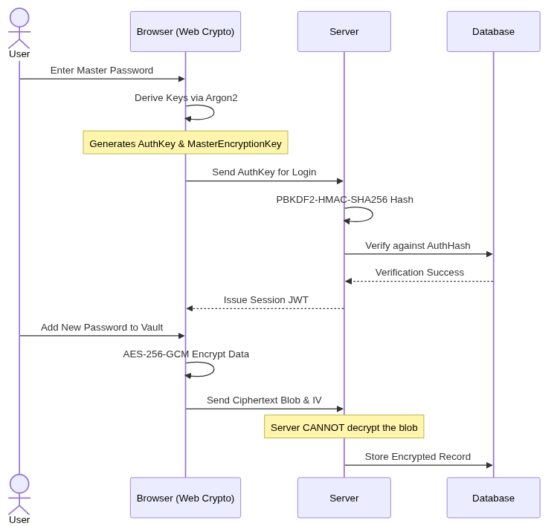

4.2 Data Flow Diagram (DFD)
This DFD maps out how data transitions through the application boundaries.
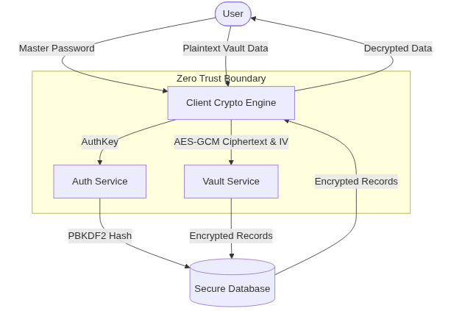

5. Analysis

The cryptographic implementation provides exceptional resistance against several attack vectors:
- Database Leaks: Since the server only stores PBKDF2 hashes of Argon2-derived keys, a compromised database yields zero plaintext passwords. The attacker would have to brute-force a memory-hard function (Argon2) combined with a computation-hard function (PBKDF2) just to login as a user.
- Network Interception: Because encryption happens inside the client browser using the Web Crypto API, any data intercepted in transit is simply AES-GCM ciphertext. Without the user's MasterEncryptionKey, the data is mathematically indecipherable (World Wide Web Consortium, 2017).
- Data Integrity: The usage of AES-GCM instead of AES-CBC ensures that an attacker cannot maliciously modify the ciphertext in the database. Any modification will cause the authentication tag verification to fail during decryption, alerting the client.

6. Conclusion and Future Work

The A2Z Password Manager successfully implements a highly secure, zero-trust architecture that definitively serves its purpose as a modern organizational password manager. By relying heavily on client-side Web Crypto API operations, Argon2 for memory-hard key derivation, and authenticated encryption via AES-GCM, the system comprehensively protects sensitive user information even in the event of a catastrophic server breach. The architectural choices strictly comply with advanced cryptographic best practices and successfully safeguard data against network interception and server compromise.

6.1 Future Work: Mitigating Memory Scraping
While web-based architecture is highly secure, web browsers inherently lack the ability to lock memory at the operating system level. This leaves the “MasterEncryptionKey” theoretically vulnerable to memory scraping if an attacker completely compromises the user's device with advanced malware. To further strengthen the application in the future, the following enhancements could be implemented:
- Native Desktop Client: Transitioning to a native application like Electron would allow the software to utilize OS-level memory locking APIs to prevent keys from being exposed to other processes or paged to the hard drive.
- WebAssembly (Wasm) Memory Management: Shifting cryptographic operations to WebAssembly would provide finer control over memory, allowing the application to instantly erase the key buffers the exact millisecond an encryption or decryption task finishes, drastically shrinking the window of vulnerability.
- Hardware-Backed Cryptography: Integrating with hardware security modules, such as TPMs or physical security keys, would ensure that private cryptographic keys never enter the computer's volatile RAM, neutralizing the threat of memory scraping entirely.

7. References

- Rose, S., Borchert, O., Mitchell, S., & Connelly, S. (2020). Zero trust architecture (NIST Special Publication 800-207). National Institute of Standards and Technology. https://doi.org/10.6028/NIST.SP.800-207
- Grassi, P. A., Garcia, M. E., & Fenton, J. L. (2017). Digital identity guidelines: Authentication and lifecycle management (NIST Special Publication 800-63B). National Institute of Standards and Technology. https://doi.org/10.6028/NIST.SP.800-63b
- McKay, K., & Cooper, D. (2019). Guidelines for the selection, configuration, and use of Transport Layer Security (TLS) implementations (NIST Special Publication 800-52 Rev. 2). National Institute of Standards and Technology. https://doi.org/10.6028/NIST.SP.800-52r2
- W3C. (2017). Web Cryptography API. World Wide Web Consortium. Available at: https://www.w3.org/TR/WebCryptoAPI/
- Biryukov, A., Dinu, D., Khovratovich, D., & Josefsson, S. (2022). The Argon2 password hash and proof-of-work function (RFC 9106). Internet Engineering Task Force. https://doi.org/10.17487/RFC9106
- Moriarty, K., Kaliski, B., Jonsson, J., & Rusch, A. (2016). PKCS #1: RSA cryptography specifications version 2.2 (RFC 8017). Internet Engineering Task Force. https://doi.org/10.17487/RFC8017

