Apexchart current situation

+Lisans

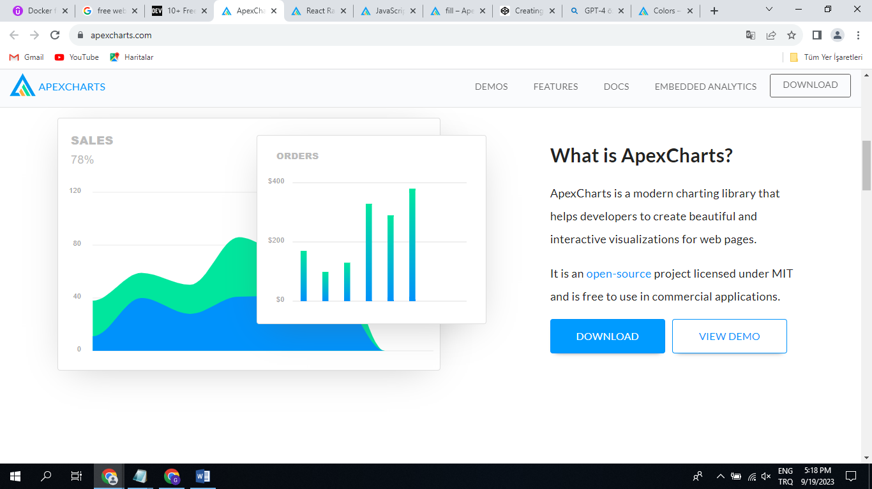

+Zaman (line) grafigi

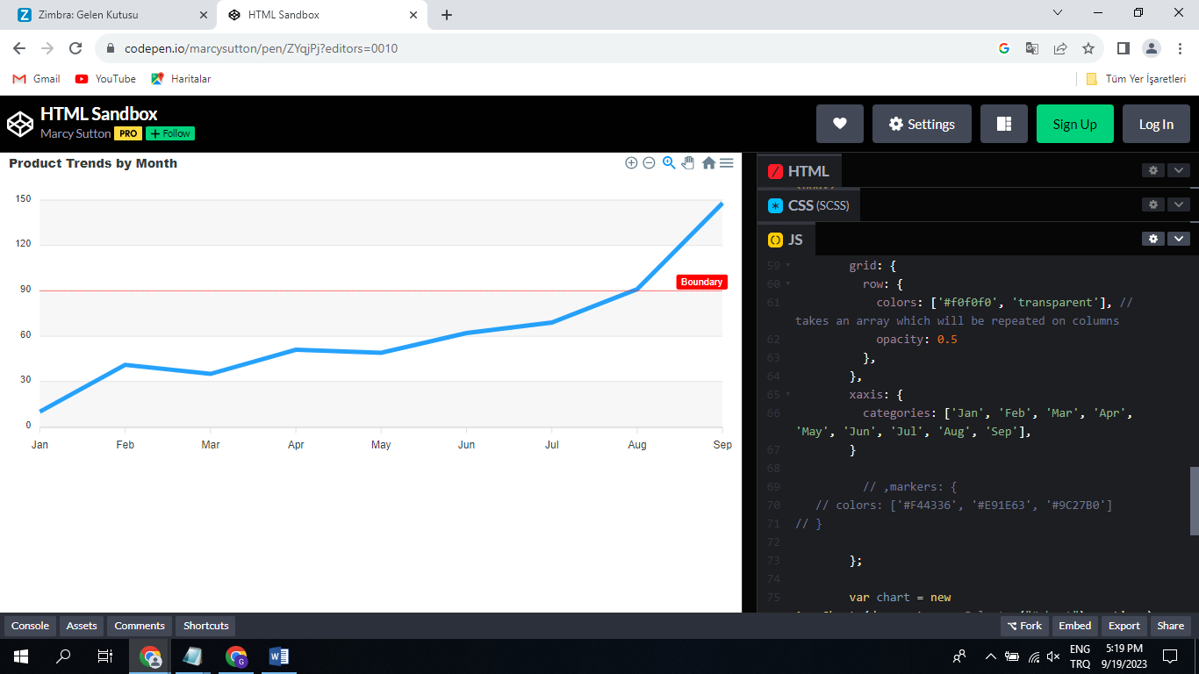

+Multiline özelligi

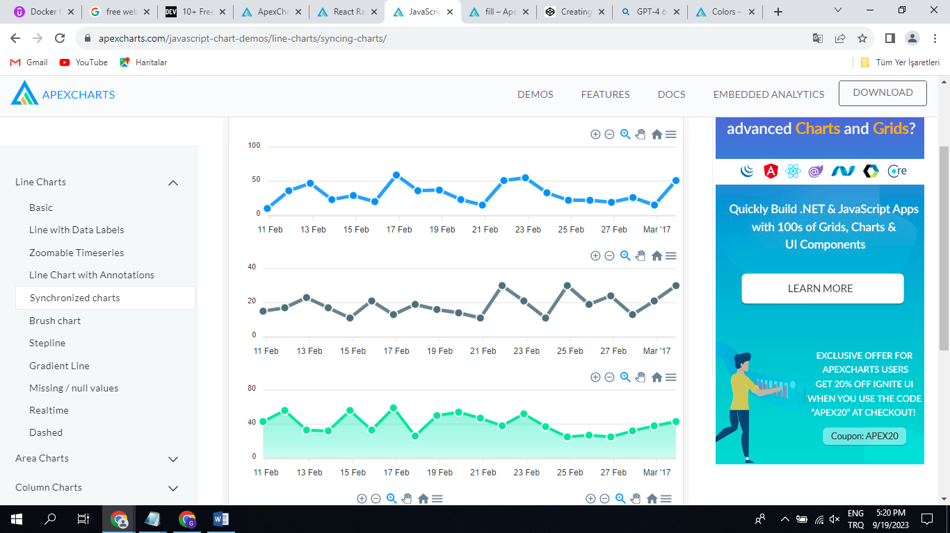

+X-Y grafigi

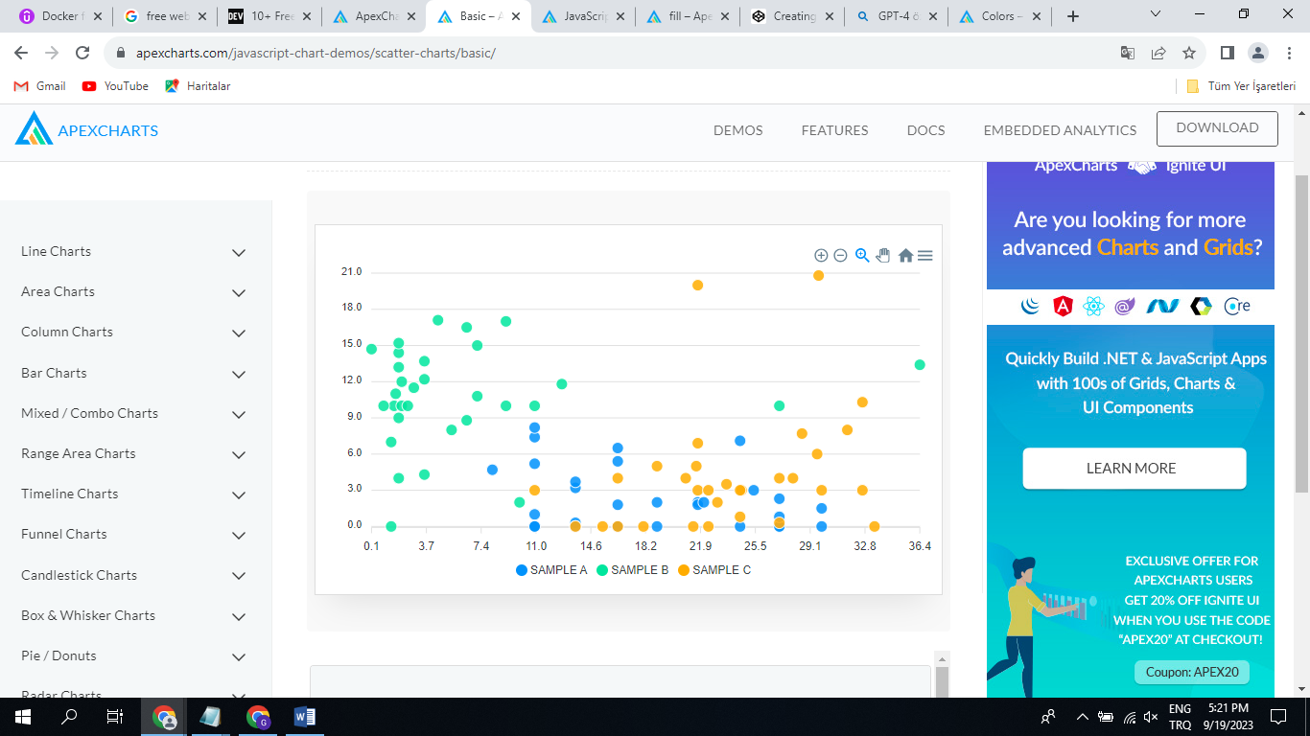

+Candlestick(Mum) grafigi(borsada kullanilana benzer, min-max-avarage göstermek için)

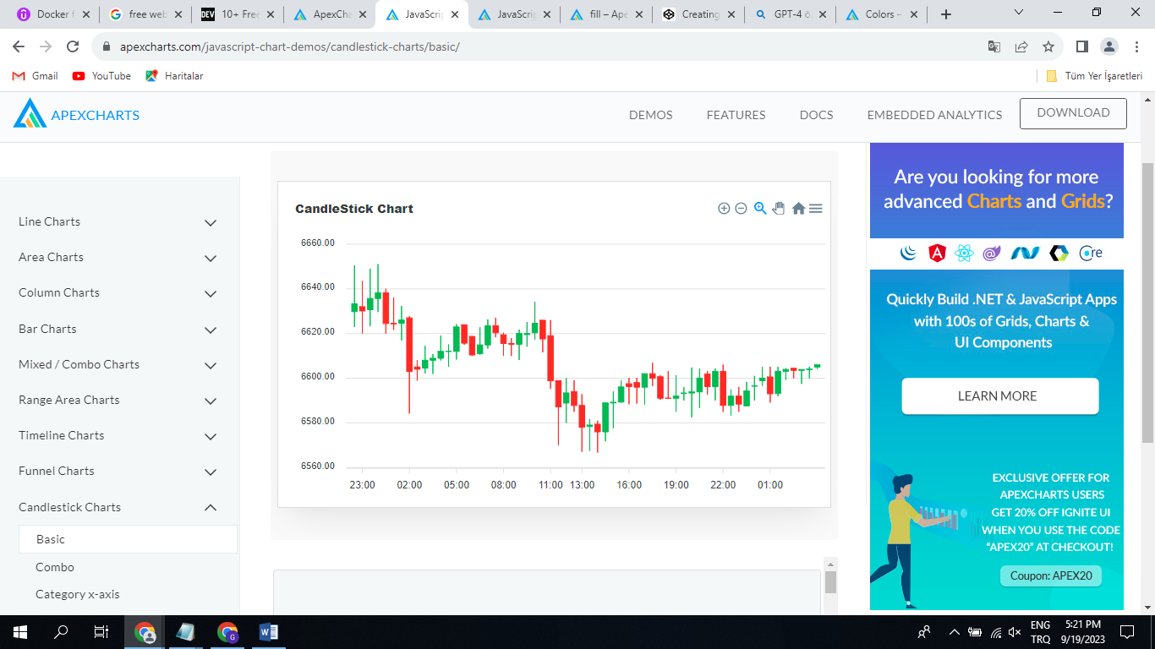

?Otomatik ölçeklendirme(Auto scale)

Not tested properly for now. It needs crowded dataset.

+Ayarlanabilir ölçek(scale)

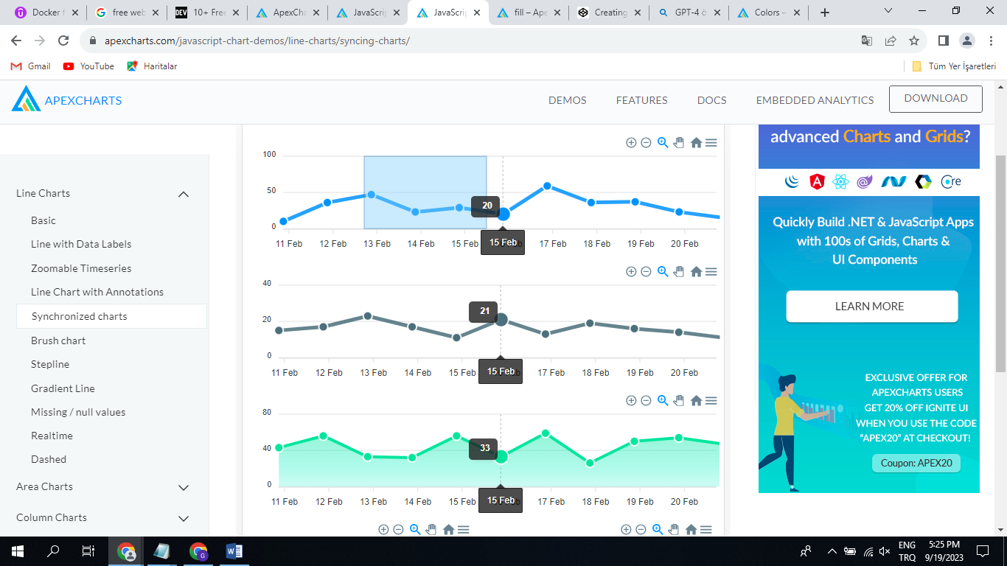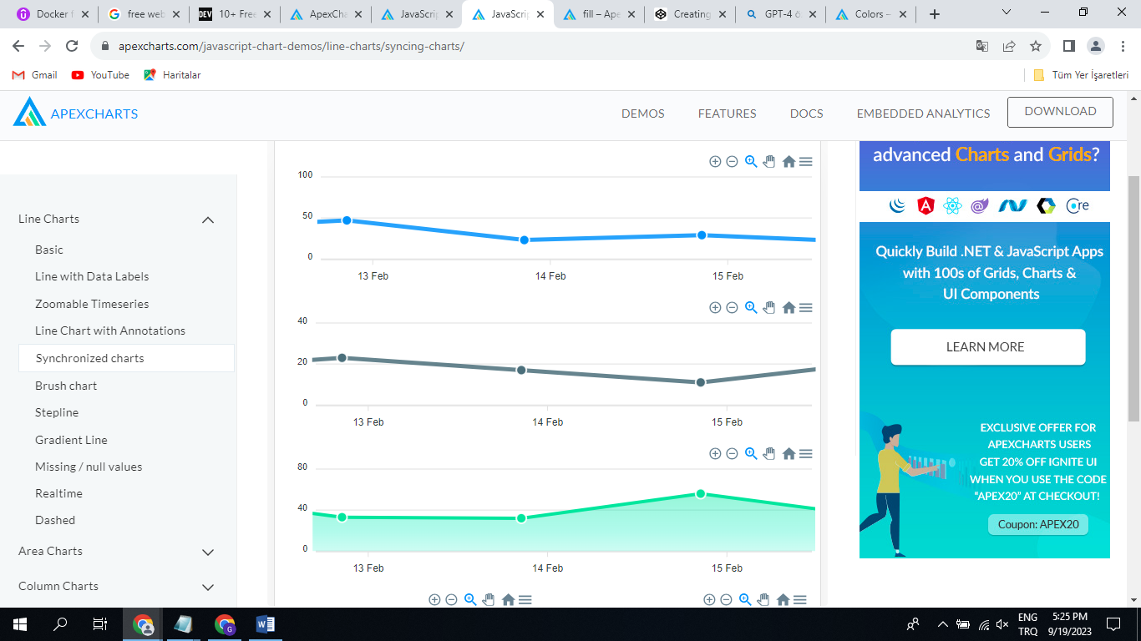

-Stil degisikligi(css dosyasindan vs kolaylikla yapilabiliyor mu)

There are a lot of customization options but it is not easy to customize.

?Label kullanisliligi(Bazilarinda sorunlu oluyor. içiçe geçebiliyor, yazilari üstüste yazabiliyor.)

Not tested properly for now. It needs crowded dataset.

?Line grafikte farkli deger araliklarini farkli renkte gösterim

DESIRED CHART from AMCHART:

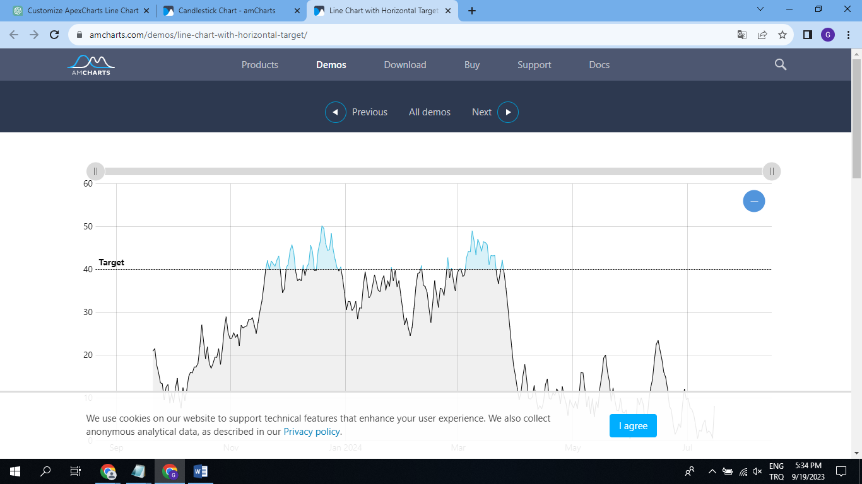

CURRENT CUSTOMIZED chart at APEXCHARTS:

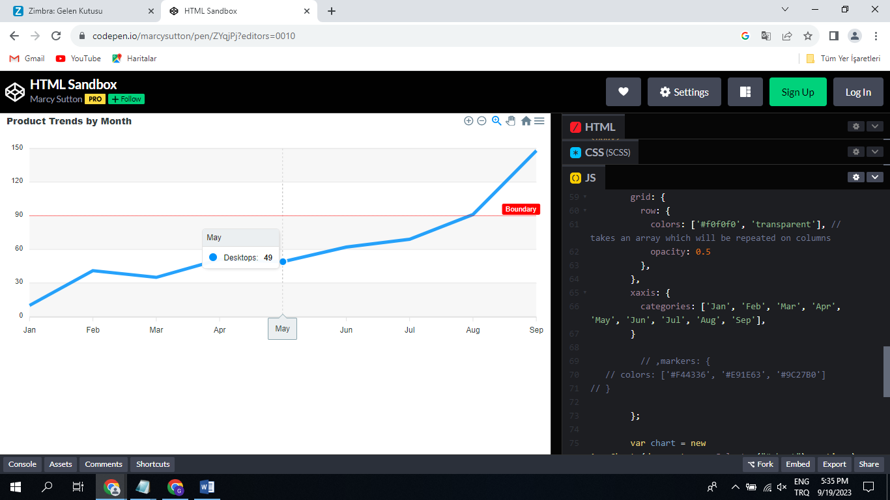

Not build in chart for this. It can be done with the customizations. For now, I am not able to create such chart.

+Out of limit çizgileri

With the helps of the annotations it can be done.

Example link: https://apexcharts.com/javascript-chart-demos/line-charts/line-chart-annotations/

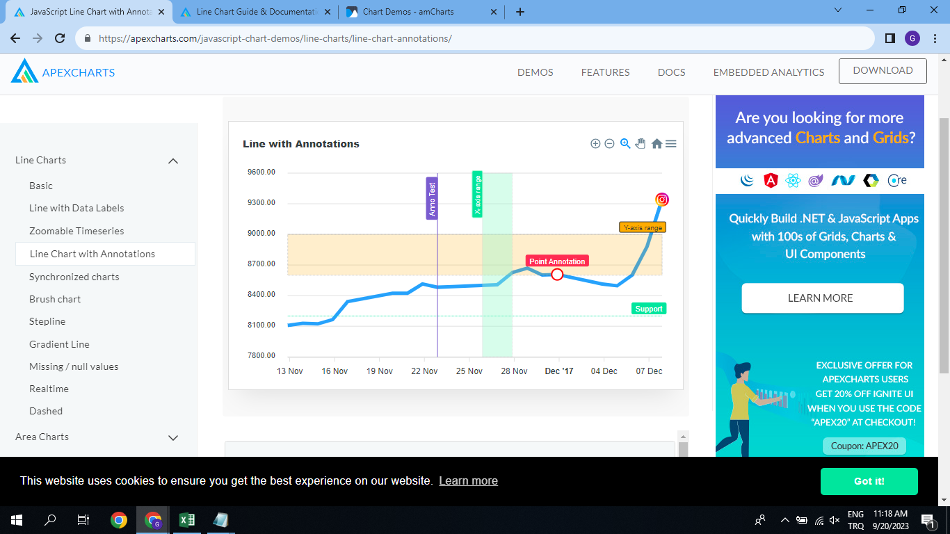

+Zoom

