Course Project Activity: Competitive Analysis Part 1: Types and Navigation

In this activity you will identify a type of information you are interested in and analyze the way it is managed by others

# What’s your type?

A type of information is one variety that is worth your effort to structure and deliver to an important kind of person to meet some information need they have.

To get to an information type, you can

* Think of an important kind of person and what sort of information they need (a customer needs product descriptions, patrons need book reviews, mothers need expert advice, etc.).
* Think of a kind of information that that interests you (product descriptions, book reviews, expert advice, etc.)
* Think about an information need and what kind of information it implies (to know about our product line, to know about good books, to know how to raise healthy kids, etc.)

From any of these angles, choose a kind of information you want to work on this quarter and enter it in the space below:

|  |  |
| --- | --- |
| Information Type | Top-50 travel sites |

# Who else manages your type?

To get educated on your type and gather up good ideas for how to work with it, you need to see what others have done. That is, you need to do a competitive analysis of others who manage the same sort of information that you do.

Find three Web sites where the kind of information you care about is managed and list them below

|  |  |
| --- | --- |
| **Organization** | **Site URL** |
| Gogobot | http://www.gogobot.com/eiffel-tower-paris-attraction |
| Expedia | https://www.expedia.com/things-to-do/emp-museum.a193436.activity-details?srp=true&location=Seattle%20(and%20vicinity),%20Washington,  %20United%20States%20of%20America&startDate=12/14/2016&endDate=12/19/2016&categories=Attractions%7C |
| Tripadvisor | http://www.tripadvisor.com/Attraction_Review-g143034-d1603722-Reviews-Hawaii_Volcanoes_National_Park-Hawaii_Volcanoes_National_Park_Island_of_Hawaii_Ha.html |

# How is the type represented?

It is not enough to know what type of information you want to manage, you also have to know what parts each item of that type needs to have.

|  |  |
| --- | --- |
| **What is a full-view of an info item?** | A full-view of an info item shows one view of an info item at a time and includes all the details that comprise the information item that make it part of the information type. The details of the info item can be distinct or similar to other information items in the information type, but the full-view of the info item shows the data within the details. In this example, the full-view of an info item is one distinct animal’s adoption listing with the additional parts and included data about those parts. |

Find a “full-view” of an item of your chosen type. For each of the three sites:

1. Take a screen shot of the item apart from the page it is on
2. Paste the screen shot into the appropriate section below
3. Name the parts of the item and list the names below the image you pasted in. I give you two parts for free.

## Site 1: http://www.gogobot.com/eiffel-tower-paris-attraction

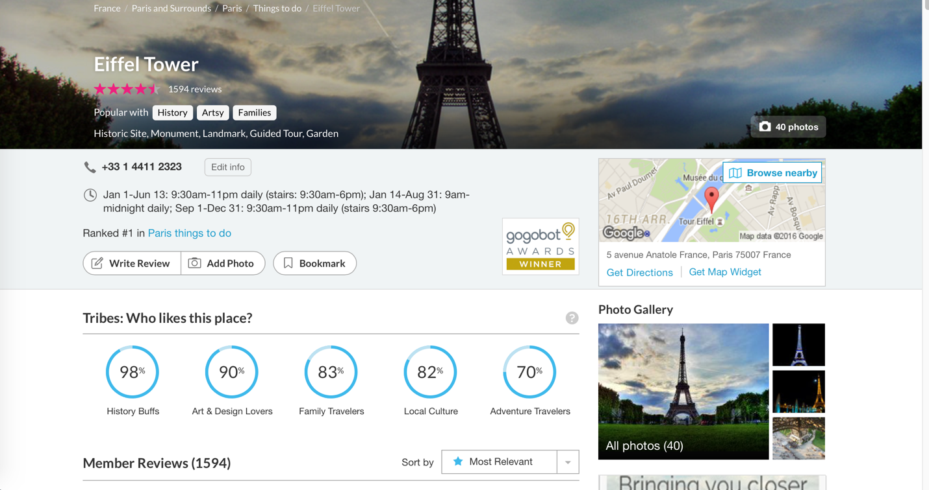

Named parts of the item shown in the image above **(10 minimum)**

* Title
* Id
* description
* Stars
* Popular with
* Tag
* Review
* Rank
* Photo
* Map
* Phone NO.
* Tribe

## Site 2: https://www.expedia.com/things-to-do/emp-museum.a193436.activity-details?srp=true&location=Seattle%20(and%20vicinity),%20Washington,%20United%20States%20of%20America&startDate=12/14/2016&endDate=12/19/2016&categories=Attractions%7C../../../Desktop/Screen%20Shot%202016-01-27%20at%2015.41.../../../Desktop/Screen%20Shot%202016-01-27%20at%2015.47.

Named parts of the item shown in the image above **(10 minimum)**

* Title
* Id
* Description
* Map
* Address
* Price
* Open time
* Age group
* Highlights
* Inclusions
* Location
* Cancellation Policy
* Know Before You Book

## Site 3: http://www.tripadvisor.com/Attraction_Review-g143034-d1603722-Reviews-Hawaii_Volcanoes_National_Park-Hawaii_Volcanoes_National_Park_Island_of_Hawaii_Ha.html

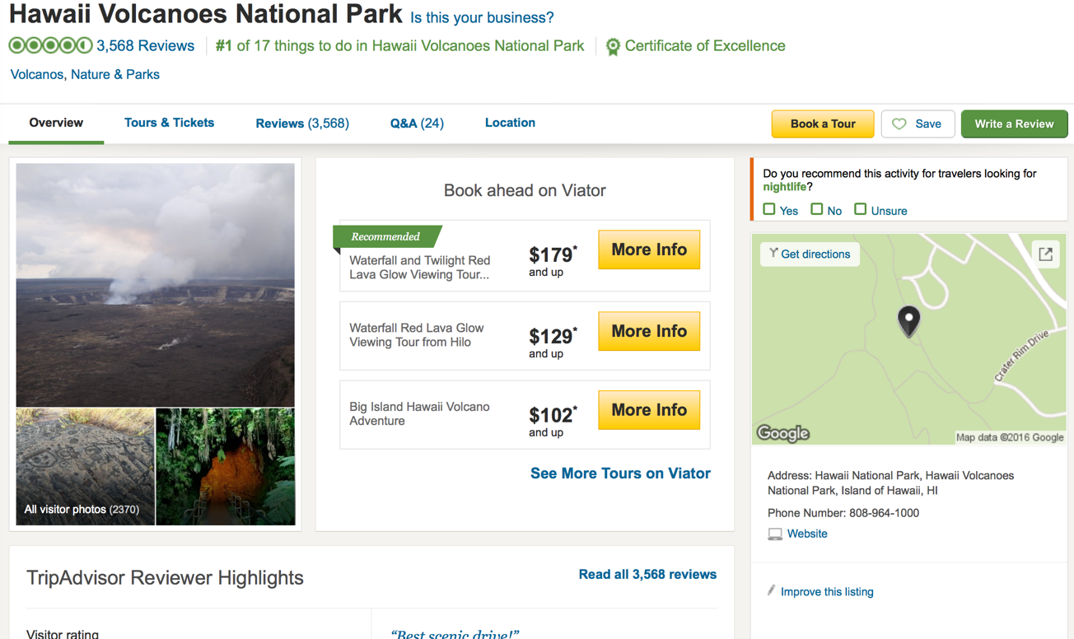

Named parts of the item shown in the image above **(10 minimum)**

* Title
* Id
* Description
* Picture
* Book
* Review
* Map
* Phone
* Address
* Tag
* Rank

# Tag lists

|  |  |  |
| --- | --- | --- |
| Gogobot | Expedia | Tripadvisor |
| * Title * Id * description * Stars * Popular with * Tag * Review * Rank * Photo * Map * Phone NO. * Tribe | * Title * Id * Description * Map * Address * Price * Open time * Age group * Highlights * Inclusions * Location * Cancellation Policy * Know Before You Book | * Title * Id * Description * Picture * Book * Review * Map * Phone * Address * Tag * Rank |

Named parts of the item shown in the image above

# “Best of” Tags

You need at least 15 tags below that you decide on from the best of the lists you compiled. **Notice that you must include id, title and description**

1. Id
2. Title
3. Location
4. Country
5. Address
6. Description
7. Picture
8. Best Visiting Time
9. Rank
10. Ticket Price
11. Tag
12. Open Time
13. Reviews
14. Review
15. Highlights
16. Website
17. Tip
18. Transportation
19. Phone NO.
20. Things to do
21. Thing to do
22. Highlight

# Schema Specification

Turn your list of tag names into something that you can use to construct your first schema.

* Make sure all tag names are in camelCase
* You need at least 5 attributes and 10 elements
* If a tag is an attribute, say what element it will be an attribute of.
* For data types, you only need to use
  + xs:ID for ids
  + xs:Boolean for true/false
  + xs:String for enumerated lists
  + You can use other data types as you wish
  + Type in default if you will leave the data type blank (meaning, basically, text)

|  |  |  |  |
| --- | --- | --- | --- |
| **Tag name (use camelCase)** | **Element or attribute?**  **If attribute, say what element** | **Data type** | **Controlled vocabulary (Enumerated list)?** |
| 1. id | Attribute of sight | xs:ID |  |
| 1. title | Element | Default |  |
| 1. description | Element | Default |  |
| 1. location | Element | Default |  |
| 1. address | Attribute of location | Default |  |
| 1. country | Attribute of location | Default |  |
| 1. picture | Element | Default |  |
| 1. bestVisitingTime | Element | Default |  |
| 1. rank | Attribute of sight | xs: Integer | 1, 2, 3, 4, 5 |
| 1. ticketPrice | Element | Default |  |
| 1. tag | Attribute of sight | Default |  |
| 1. openTime | Element | Default |  |
| 1. reviews | Element | Default |  |
| 1. review | Attribute of reviews |  |  |
| 1. highLights | Element | Default |  |
| 1. highLight | Attribute of highLights | Default |  |
| 1. website | Element | Default |  |
| 1. tip | Element | Default |  |
| 1. transportation | Element | Default |  |
| 1. phoneNumber | Element | xs: String |  |
| 1. thingsToDo | Element | Default |  |
| 1. thingToDo | Attribute of thingsToDo | Default |  |