Using BTS to Make your own System

Contents

Step 1: Info systems conceptually 2

Step 2: Info systems physically 2

An info system has these parts: 2

Step 3: BTS 2

Step 4: Prepare to make your own system using BTS. 3

Step 5: Make your own system using BTS 4

## Step 1: Info systems conceptually

All systems:

* **Represent Information.** They take a type of information, like “animal” and decide how to divide it into parts. In the BTS system, there is only one type, "animal." Each type of information has some number of items. In the Animal House system, there are only a few items of type “animal.”
* **Organize Information.** They interrelate items of each type of information in order to allow the end-user to find them. In the Animal House system, there is only one type of organization, index The index is an alphabetical list of "animal" items.
* **Present Information.** They lay out information from the InfoBase on a screen or other output. The Animal House system, creates a very simple Web site with a home page and a full-view page for each animal.

## Step 2: Info systems physically

All info system have these parts:

* An infoBase where the content of the system is stored. In this course we will usually store content in an XML file.
* Templates that move information is moved out of the infoBase and onto a screen (like a Web page).
* A template processor which is a program that "runs" the template and executes the commands that are in it.

## Step 3: BTS

BTS is a generalized platform for making simple info systems. Animal House is but one system out of an infinite number that BTS can create.

So, what’s the difference between the Animal House system and another system you might use BTS to create?

* The template processor is the same no matter what system you create. That’s good. You don’t have to change the program to change the system
* The infoBase must be in JSON, but what is in the InfoBase is up to you
* The BTS must use the same kinds of commands, but
  + The info in the InfoBase will be different in different systems.
  + The HTML and CSS in the templates will be different for different look and feels
  + The media files (images, etc.), of course, will be different in different systems.

## Step 4: Prepare to make your own system using BTS.

Your goal is to create a new system using BTS.

To prepare

1. Decide how adventurous to be. If you are already unsure of yourself be less adventurous
2. Choose a new info type. The less adventurous you feel the more your type should be like an animal. What does it mean to be like an animal? It means that the attributes of your info type should not be so different from those an animal has.
3. Make a sketch of your home page. The less adventurous you feel the more your home page should look like the Animal House page
4. Make a sketch of your full-view page. The less adventurous you feel the more your full-view page should look like the Animal House page. On your sketches:

* Outline the main areas of the page
* Use <> notation to show where various attributes of your info type and “about” information will go

Here is an example of a sketch of the current Animal House home page

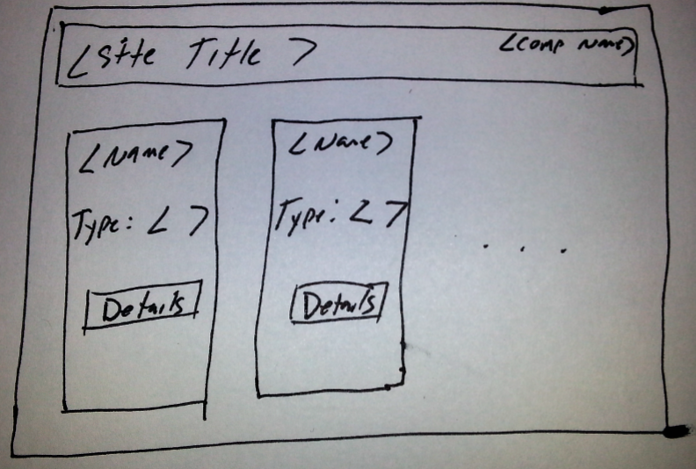

Paste your sketches here

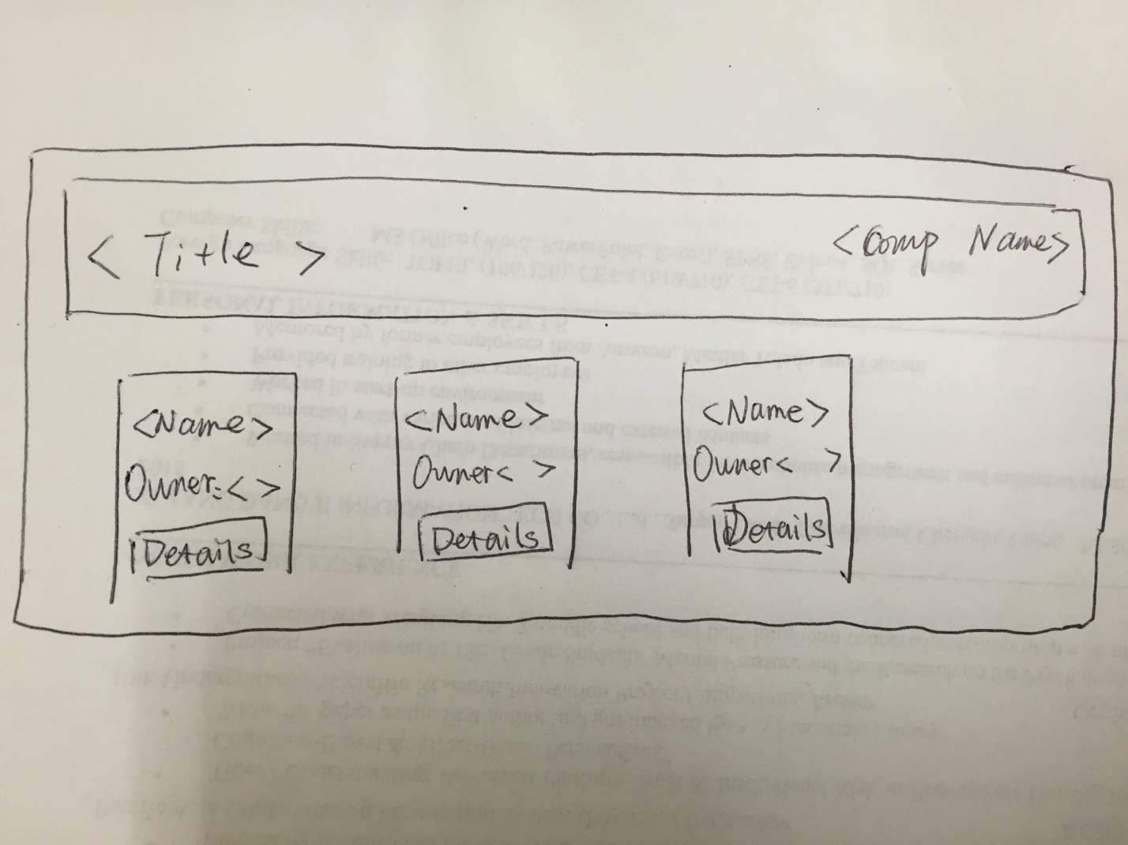

1. Make a list of all the attributes you will need for your info type. For example, here is a list of the attributes for the animal type:
   1. Id
   2. type
   3. name
   4. range
   5. description
   6. image
      1. id
      2. name
      3. filename
      4. stars
      5. caption

Type your list here

1. Id
2. owner
3. name
4. description
5. image
   * 1. id
     2. name
     3. filename
     4. stars
     5. caption

## Step 5: Make your own system using BTS

With all this preparation, you have what you need to create a system using BTS. Whether you are feeling adventurous or not, for the most pleasant experience please:

* Morph the Animal House system to your own in very small steps.   
    
  In other words, take one small step at a time to change one thing about Animal House to something like your own. For example
  1. Change one attribute name in the InfoBase to the one you want
  2. Make sure the InfoBase is still valid in Oxygen.
  3. Change the same attribute in a template. Then run the template again and make sure it worked
* When something goes wrong (like no display) back up to the last step where it was working. Then try something different to move forward
* Do layout and style changes last. First make sure your InfoBase is all good and all your items and attributes display. Then and only then, play with the look and feel.