Waste Management Plan
For Agencies, Builders & Contractors designing & building AO temporary infrastructure

Prepared for Tennis Australia
Meg Dennis | ESG_FUTURE
April-26 Draft V1

____________________________________________________________
Table of Contents

1. What is the purpose of waste planning 2
1.1 AO Waste Reduction Targets 2
1.2 Circular Design 2
1.3 Target Materials 3
1.4 Responsible Methods 3
1.5 AO Waste services 4
2. Waste planning template 5
2.1 Design waste out – waste management plan 5
START HERE 2.1.1 About you 6
2.1.2 Materials & assets waste management plan 6
2.1.3 Comments & feedback 9
2.1.4 Timeframes & next steps 9
FAQS 10

1. What is the purpose of waste planning
Tennis Australia’s Climate Action vision is Maximum Play, Minimum Footprint.
We recognise that everything we design and build for the AO has impacts on people, the planet and our ability to play tennis and enjoy our events into the future. As the organiser of a mega-event, TA is entrusting Agencies, Designers and Builders to deliver the AO. Waste planning is highly effective when done during design. Use this template to contribute to the waste targets.

1.1 AO Waste Reduction Targets
Our waste reduction targets to reduce total waste volume by 10% every year.
The circular design target is to increase reuse by 10% every year.

Why it matters
- Cost savings: Circularity can demonstrate Return on Sustainable Investment (ROSI) over time through the diversion of assets & materials from waste.
- Landfill costs: Landfill tariffs are increasing over 20% every year.
- Supply Chain shocks: The global geopolitical situation is putting pressure on both the price and availability of materials – which is exactly circular design and resource recovery make commercial sense.
- Revenue potential: Every time we bin a material we throw money away. Recovered materials and assets can be resold, creating value within the circular economy.

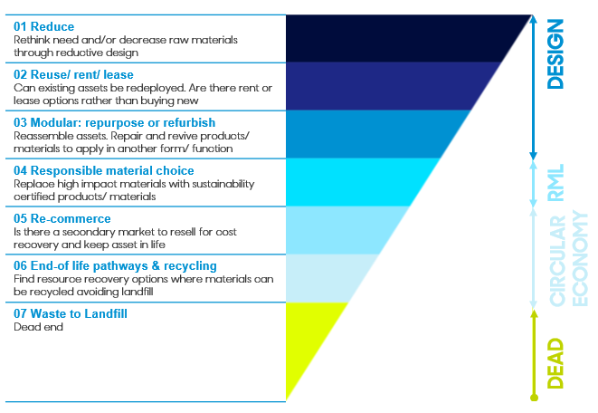
1.2 Circular Design
Circularity reduces material use, redesigns materials, products and services to be less resource intensive, and so better for the environment (and the balance sheet).
Circular design considers all stages of a product’s lifecycle to design out waste and pollution, keep products and materials in use and regenerate natural systems. It aims to create assets which are durable, reusable, repairable and recyclable.

The Circular Design Hierarchy
Circular design decisions should follow this hierarchy - starting at the top to achieve the most cost-effective and low-impact outcomes.

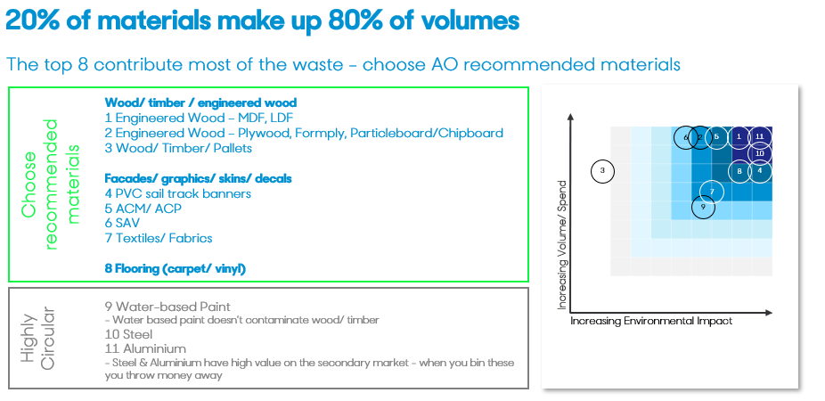
1.3 Target Materials
Analysis of waste from the temporary venue overlay reveals a small number of material types make up most of the waste.
The AO’s top 3 waste categories are:
- Wood/ timber/ engineered wood
- Cladding and facades
- Flooring

Target Materials List.
Review the recommended target materials and indicate for these top 3 waste categories which ones you will procure.
If you plan to use a material that isn’t AO recommended provide the material name and reason for using it
Go to the Target materials list

1.4 Responsible Methods
Many of the materials in the AO waste streams today can be recycled or recovered, it is our design and disassembly process that is turning them into waste.
Agencies, Designers and Builders are required to follow responsible methods:
- Designers Design waste out. Designers have a key role designing waste out. Design and material choices made upfront determine what's possible at bump-out. Lock these in the brief with builders. Complete this waste management plan during design.
- Builders Modular Design and Design for Disassembly (DfD) create reusable systems and reduce waste, review and update the waste management plan as you procure materials. It is also your responsibility to brief your team and subcontractors.
- Asset & material tracking The waste management plan is the baseline to track assets. Effective resource management starts with accurate tracking. Post event Agencies and builders will be requested to report on material/ asset status.
- Incremental implementation Review the responsible materials and materials implementation plan to stage your adoption to operationalise your waste targets.

1.5 AO Waste services
The waste services provided by Tennis Australia has limitations. A high volume of materials cannot be recovered. A strategic approach to reducing waste is segregation of materials on bump out to be shipped direct to a waster recovery partner. This increases the recovery rate significantly and reduces wast to landfill. AO26 PVC banners, water-based paint and Timber were segregated. This year more materials will be considered to be expanded. Keep across the updates to include in your waste management plan.

2. Waste planning template

2.1 Design waste out – waste management plan
Agencies, Designers and Builders have a key role designing waste out. Giving thought to which materials will end up in waste streams upfront is a deliberate design process. Designers start the waste stream outline during design phase and builders update it during build.

The following waste management plan makes it clear which materials/ assets will be reused and which ones will go to a waste stream.

The following is an example only – do not fill in here start at section 2.1.1
1. Material category | 2. Application | 3. AO Location/ precinct | 4. Description  (include quantity if applicable) | 5. Material name | 6. Volume  (sq/m, l/m, kg) | 7. Is the material AO recommended? | 8. Expected material status | 9. Responsible methods:  What will happen to the material at the end of the event? | 10. Actual outcome  (Complete post event)
Branding/ Graphics/ skins on facades | All applications | Garden Sq | Thematic branding | ACM + Structural (A-Bond) Ply 9mm | 50sqm ACM  100sqm ply | Yes | Recycle | Split the ply from ACM and recycle both materials
Engineered wood | Joinery/ Cabinetry/ wall flats | Garden Sq | 2 x FOH reception desk | MDF | 30sqm | No | Unable to reuse or recycle - Landfill | Single use bespoke structure
Engineered wood | Modular structures (Space Cubes/Highline) & Marquee projections | Garden Sq | Marquee extension | Particleboard (A-Bond) 12mm | 30sqm | Yes | Intend to reuse next AO | Can be reused at AO or repurposed for another client

START HERE

2.1.1 About you

Business details
Date
Business name
Who is the owner of this plan?  Ideally the same person who will report post event  (responsible & accountable) | Signed off by
Contact email address
Role in the AO design and build
(e.g. Agency, Builder, Designer)
What is your AO27 waste reduction target? | The AO target is 10% reduction of waste
What is your AO27 reuse target? | The AO target is 10% reuse
For reuse materials/ assets provide storage details (TA/ your storage)

2.1.2 Materials & assets waste management plan

Keep in mind the 80/20 to reduce waste (Ref section 1.3). Focus on the top 3 material categories (Wood materials, cladding/ façades, flooring) which make up approximately 80% of waste volume. You don't need to achieve perfection across every material - targeted effort on these three will have the greatest impact
If you plan to use a material that isn’t AO recommended (#7) include here the material name and reason for using it.
Complete 1-9 leaving 10 to complete post-event.

Your ref # | 1. Material category | 2. Application | 3. AO Location/ precinct | 4. Description  (include quantity if applicable) | 5. Material name | 6. Volume  (sq/m, l/m, kg) | 7. Is the material AO recommended? | 8. Expected material status | 9. Responsible methods:  What will happen to the material at the end of the event? | 10. Actual outcome  (Complete post event)
 | Select | All applications |  |  |  |  | Select | Select
 | Select | All applications |  |  |  |  | Select | Select
 | Select | All applications |  |  |  |  | Select | Select
 | Select | All applications |  |  |  |  | Select | Select
 | Select | All applications |  |  |  |  | Select | Select
 | Select | All applications |  |  |  |  | Select | Select
 | Select | All applications |  |  |  |  | Select | Select
 | Select | All applications |  |  |  |  | Select | Select
 | Select | All applications |  |  |  |  | Select | Select
 | Select | All applications |  |  |  |  | Select | Select
 | Select | All applications |  |  |  |  | Select | Select
 | Select | All applications |  |  |  |  | Select | Select
 | Select | All applications |  |  |  |  | Select | Select
 | Select | All applications |  |  |  |  | Select | Select
 | Select | All applications |  |  |  |  | Select | Select
 | Select | All applications |  |  |  |  | Select | Select
 | Select | All applications |  |  |  |  | Select | Select
 | Select | All applications |  |  |  |  | Select | Select
 | Select | All applications |  |  |  |  | Select | Select
 | Select | All applications |  |  |  |  | Select | Select
 | Select | All applications |  |  |  |  | Select | Select
 | Select | All applications |  |  |  |  | Select | Select
 | Select | All applications |  |  |  |  | Select | Select
 | Select | All applications |  |  |  |  | Select | Select
 | Select | All applications |  |  |  |  | Select | Select
 | Select | All applications |  |  |  |  | Select | Select
 | Select | All applications |  |  |  |  | Select | Select
 | Select | All applications |  |  |  |  | Select | Select
 | Select | All applications |  |  |  |  | Select | Select
 | Select | All applications |  |  |  |  | Select | Select
 | Select | All applications |  |  |  |  | Select | Select
 | Select | All applications |  |  |  |  | Select | Select
 | Select | All applications |  |  |  |  | Select | Select
 | Select | All applications |  |  |  |  | Select | Select
 | Select | All applications |  |  |  |  | Select | Select
 | Select | All applications |  |  |  |  | Select | Select
 | Select | All applications |  |  |  |  | Select | Select
 | Select | All applications |  |  |  |  | Select | Select
 | Select | All applications |  |  |  |  | Select | Select
 | Select | All applications |  |  |  |  | Select | Select
 | Select | All applications |  |  |  |  | Select | Select
 | Select | All applications |  |  |  |  | Select | Select
 | Select | All applications |  |  |  |  | Select | Select
 | Select | All applications |  |  |  |  | Select | Select
 | Select | All applications |  |  |  |  | Select | Select
 | Select | All applications |  |  |  |  | Select | Select
 | Select | All applications |  |  |  |  | Select | Select
 | Select | All applications |  |  |  |  | Select | Select
 | Select | All applications |  |  |  |  | Select | Select
 | Select | All applications |  |  |  |  | Select | Select
 | Select | All applications |  |  |  |  | Select | Select
 | Select | All applications |  |  |  |  | Select | Select
 | Select | All applications |  |  |  |  | Select | Select
 | Select | All applications |  |  |  |  | Select | Select
 | Select | All applications |  |  |  |  | Select | Select
 | Select | All applications |  |  |  |  | Select | Select
 | Select | All applications |  |  |  |  | Select | Select
 | Select | All applications |  |  |  |  | Select | Select
 | Select | All applications |  |  |  |  | Select | Select
 | Select | All applications |  |  |  |  | Select | Select
 | Select | All applications |  |  |  |  | Select | Select
 | Select | All applications |  |  |  |  | Select | Select
 | Select | All applications |  |  |  |  | Select | Select
 | Select | All applications |  |  |  |  | Select | Select
 | Select | All applications |  |  |  |  | Select | Select
 | Select | All applications |  |  |  |  | Select | Select
 | Select | All applications |  |  |  |  | Select | Select
 | Select | All applications |  |  |  |  | Select | Select
 | Select | All applications |  |  |  |  | Select | Select
 | Select | All applications |  |  |  |  | Select | Select
 | Select | All applications |  |  |  |  | Select | Select
 | Select | All applications |  |  |  |  | Select | Select
 | Select | All applications |  |  |  |  | Select | Select
 | Select | All applications |  |  |  |  | Select | Select
 | Select | All applications |  |  |  |  | Select | Select
 | Select | All applications |  |  |  |  | Select | Select
 | Select | All applications |  |  |  |  | Select | Select
 | Select | All applications |  |  |  |  | Select | Select
 | Select | All applications |  |  |  |  | Select | Select
 | Select | All applications |  |  |  |  | Select | Select
 | Select | All applications |  |  |  |  | Select | Select
 | Select | All applications |  |  |  |  | Select | Select
 | Select | All applications |  |  |  |  | Select | Select
 | Select | All applications |  |  |  |  | Select | Select
 | Select | All applications |  |  |  |  | Select | Select
 | Select | All applications |  |  |  |  | Select | Select
*Insert more rows as needed

2.1.3 Comments & feedback

To support continuous improvement, provide any comments or feedback that are relevant to your plan

Comments & feedback

Timeframes & next steps
- Complete the waste management plan following shortlilstin and send to TA procurement as per the RFP timeframes
- Keep current during procurement – this can serve as the basis for asset tracking
- Closer to the event targeted materials waste services will be communicated
- Post-event reporting will use this baseline

FAQS

- Will following Circular Design practices need investment of effort and resources?
This will depend on how much your business operations already apply circular practices. If it is new there will be investment of effort to shift over time to circular practices, incorporating design for disassembly and modular fabrication. How much depends on your 3 year action plan you are working toward. We recommend starting gradually, the learnings will compound beyond year one setting you up for future years.
TIP: Take advantage of TA support, tools and education to help you

- Will using AO Recommended Materials cost more?
Most AO Recommended Materials are priced on par with what you already use. Where there is a premium, it's usually offset by what you save at bump-out: less waste to dispose of, lower landfill fees, and materials that can be recovered and reused at the next event. Focus on the 20% of materials that make up 80% of your waste volume - timber, cladding, flooring. Get the big-ticket items right and you'll hit the targets.
If a recommended material does cost more, materials priced up to 20% above standard can be approved where they're intended for use across three or more events. Talk to your TA project lead before ruling anything out on cost.
Tip: The earlier you start comparing materials, the more options you have. Lock in quotes on your main volume items before build.

- How do I start with Circular Design?
There are two parts to the recommended materials and methods. The first covers recommended materials and suppliers with preferred pricing. The second covers responsible practices that reduce waste and increase reuse such as modular design and design for disassembly.

- How do I track assets?
This waste management plan is a high level asset tracker, it will be used for post event report and can be expanded for your own records.
- On-site material segregation instructions
As event planning develops updates on which materials should be separated during bump-out will be provided. Waste streams, subcontractor training and contamination prevention will be provided.

- Why should my business adopt Circular Design?
Great question! Global events like the AO have a responsibility to reduce impact and mitigate the impacts of climate change, it is no longer optional. Circular Design is mega-event best practice, used by the Olympics, FIFA, F1 and other Victorian major events, it is long term strategic approach that will increase efficiency and reduce operating costs. Every time we bin a material, we throw money away.

