HPC
LAB-2
E21CSEU0751
Parallel Matrix Multiplication
Code: E21CSEU0751_HPC_LAB_2_1.cpp
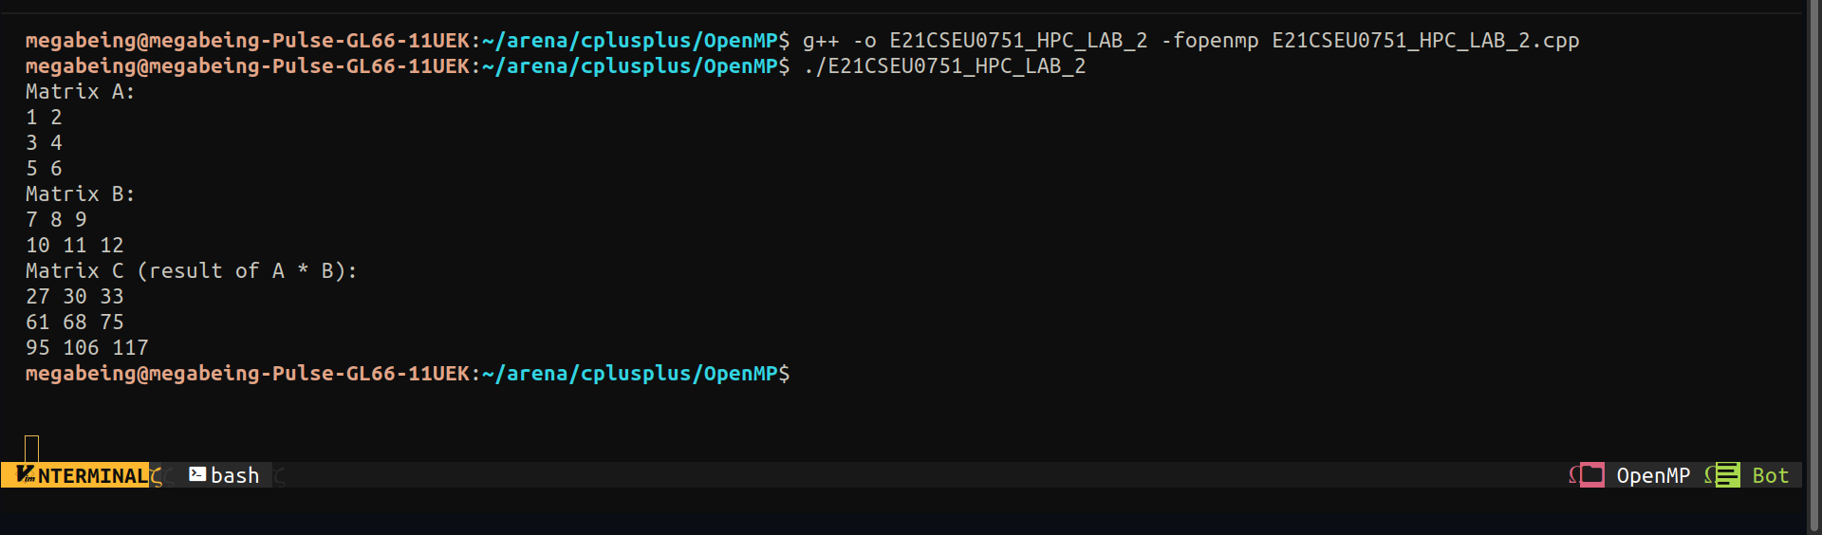

Parallel Linear Search
Code: E21CSEU0751_HPC_LAB_2_2..cpp

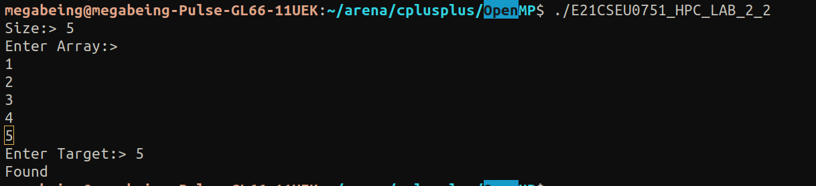
Parallel Array Sum
Code: E21CSEU0751_HPC_LAB_2_3.cpp

