

TOM Service - FileUpload Flow PCF Migration

Technical View

Document Version: | Version 0.11.0
Publication Date: | November, 2020
Authors: | Nicolas Viel  Cédric Leburton
Document Classification: | Internal

Document Change Log
Version | Date | Author | Description of Change
1.0 | 2020-11-09 | Nicolas Viel | Creation of initial document

Overview

This project concerns the migration to PCF of the file upload flow initially present in the TOM Service component.

Scope

Some incidents in production happened in the last years because of too much load on the trade flows. Each time, the TOM Service component has to be restarted after some database session kill. Split such flow to a dedicated application in PCF will allow more flexibility to handle the load. What’s more, in the long term, all the ISO Legacy will be migrated in PCF.

The out of scope components are:
Lux Tom Service: The file upload for Luxembourg is not concerned

GIT repository

https://rbcgithub.fg.rbc.com/ZXN0-VF/TomServiceCommon
https://rbcgithub.fg.rbc.com/ZXN0-VF/TomFileUpload

Screens impacted

Custody or Fund Accounting > Transactions Upload

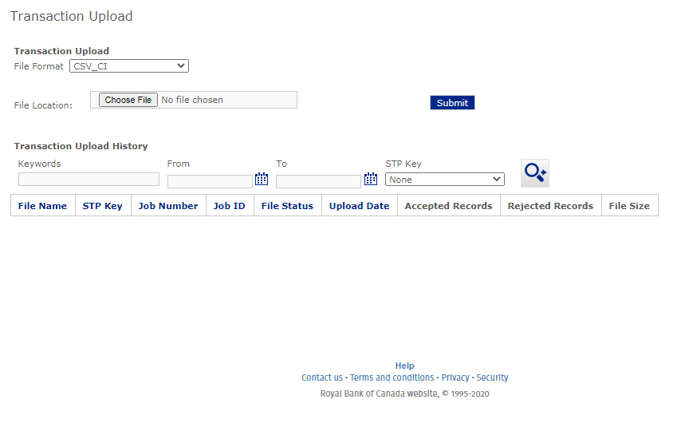

The screen here is the File Upload screen. The flow is migrated to PCF. There is no modification on the screen itself. The Testing Team will have to use this screen to validate that no regression happens.

Components

As Is:

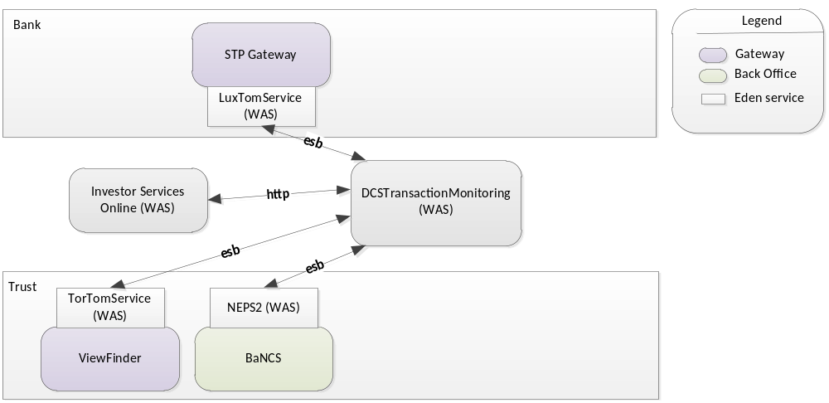

To Be:

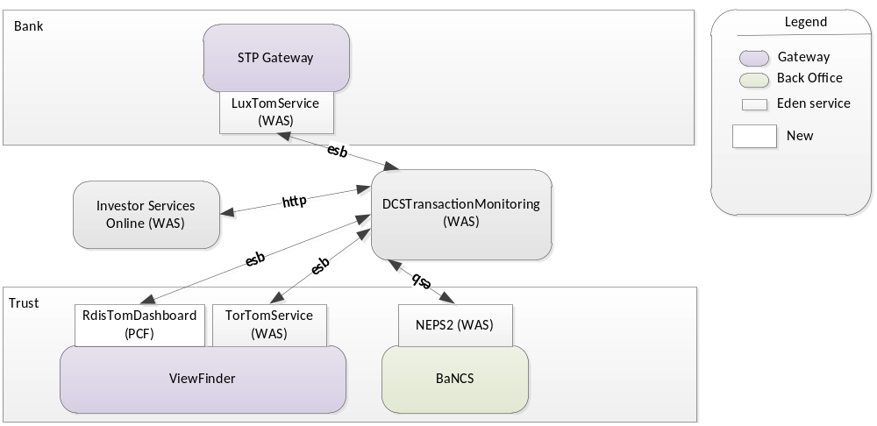

The RdisTomDashboard component contains the Dashboard flow previously packaged into the TorTomService. An adaptation is done also on the DCSTransactionMonitoring component to send the messages to the new destination. The other components are unchanged.
The TRUST Dashboard flow is done through 3 components:

As Is: (Investor Services Online) ←→ (DCS Transaction Monitoring) ←→ (Tor Tom Service)

To Be: (Investor Services Online) ←→ (DCS Transaction Monitoring) ←→ (Rdis Tom Dashboard)

The change is done for Trust flow only, the Dashboard flow for BANK remains unchanged as it uses a Luxembourg component LuxTOMService. The BANCS flow is unchanged as well.

Connectivity

Global view

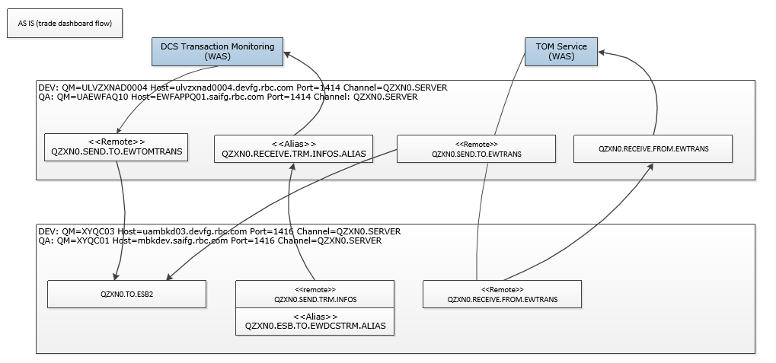

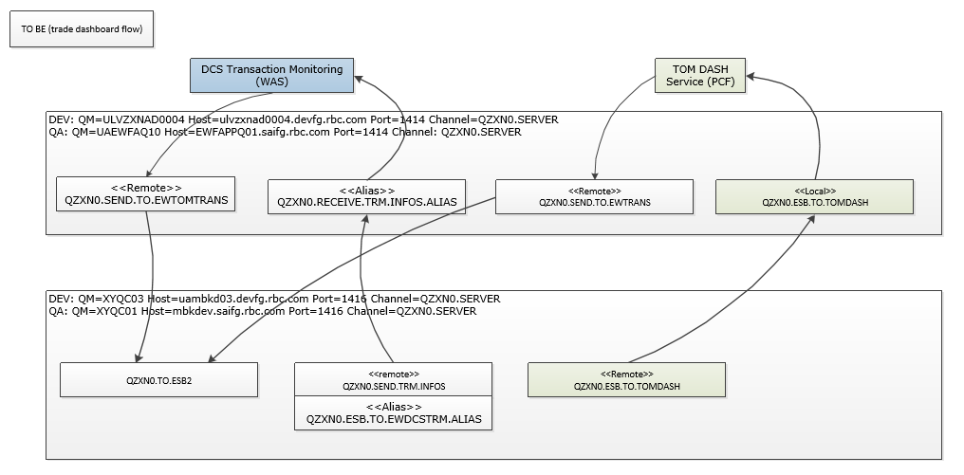

MQ Requests

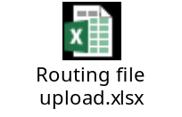

DEV JUNA requests:
Local Queues
https://juna.fg.rbc.com/viewTicket.action?show=view&id=177831
https://juna.fg.rbc.com/viewTicket.action?show=view&id=177833
https://juna.fg.rbc.com/viewTicket.action?show=view&id=177834

Remote Queues
https://juna.fg.rbc.com/viewTicket.action?show=view&id=177835
https://juna.fg.rbc.com/viewTicket.action?show=view&id=177836
https://juna.fg.rbc.com/viewTicket.action?show=view&id=177837

Access
https://juna.fg.rbc.com/viewTicket.action?show=view&id=177838

DLQ
https://juna.fg.rbc.com/viewTicket.action?show=view&id=177839
https://juna.fg.rbc.com/viewTicket.action?show=view&id=177840
https://juna.fg.rbc.com/viewTicket.action?show=view&id=177841

PCF deployment

The component is connected to ViewFinder database and to MQ.

Dev environment

DEV VF settings:

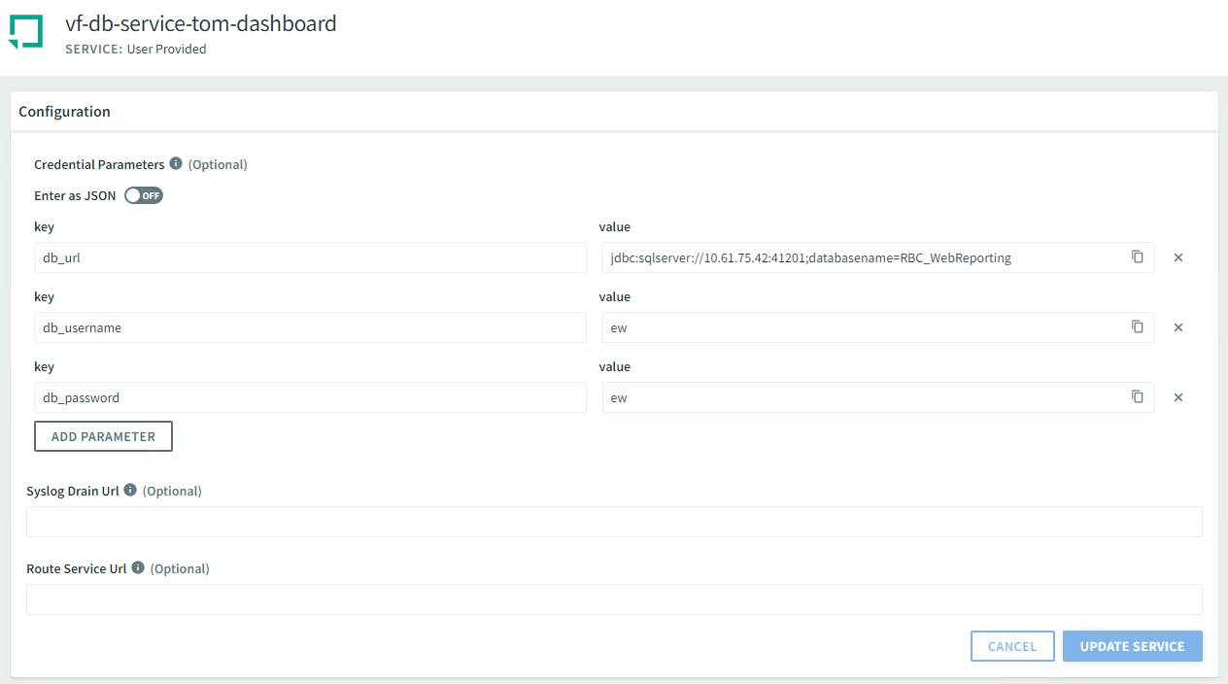

DEV MQ settings:

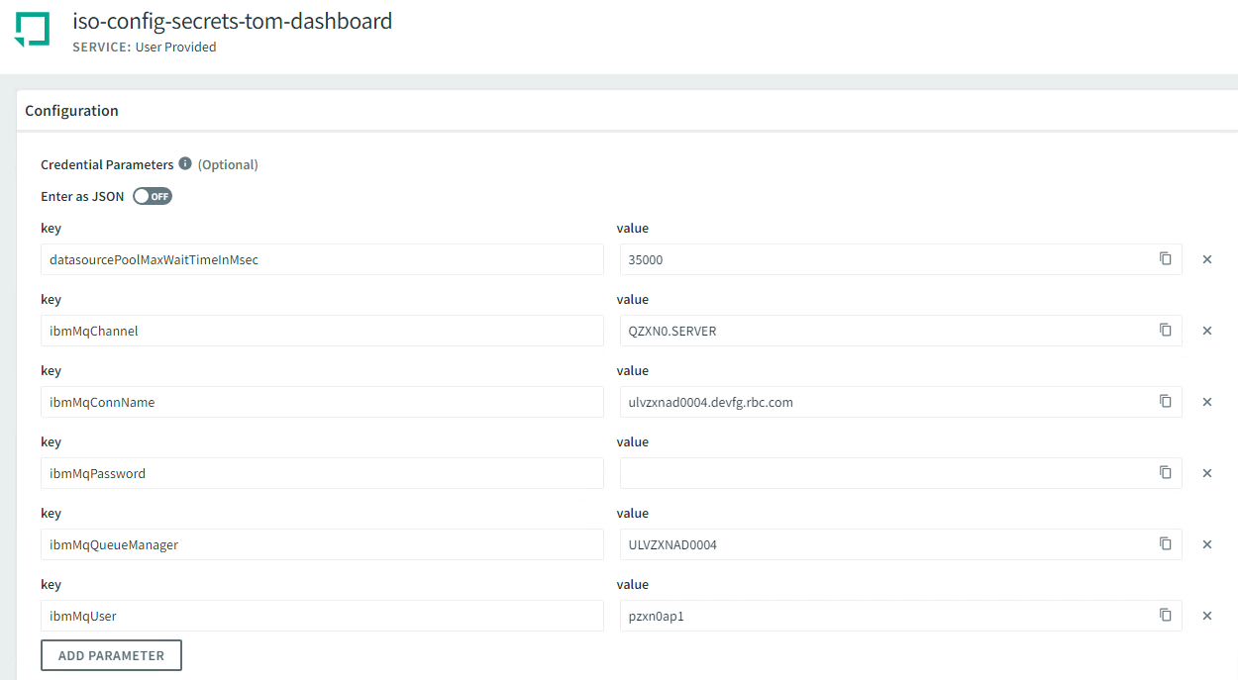

QA environment

PROD environment

SOA console testing

In dev, connect to the SOA console: https://ucon-dev.devfg.rbc.com/SOAmc/
In QA only SCM team has access.
To request access please contact richard.king@rbc.com

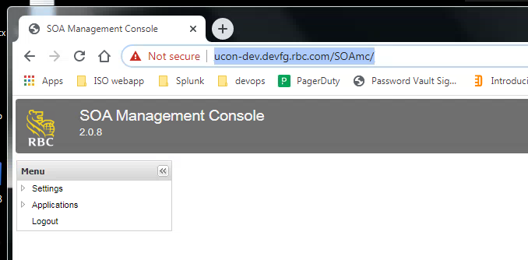

Expand the Application item, then All, then click on Monitoring App Queue:

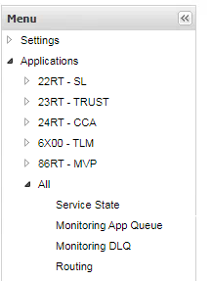

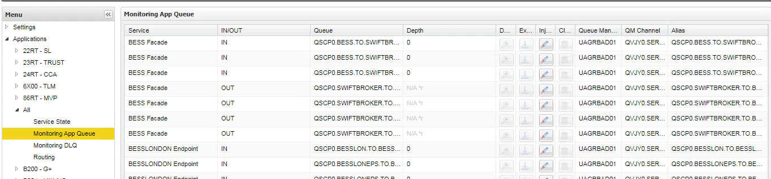

Double click on the Queue column header then enter: QVJY0.TO.ESB.STD in the search field.

Click on the Injector button:

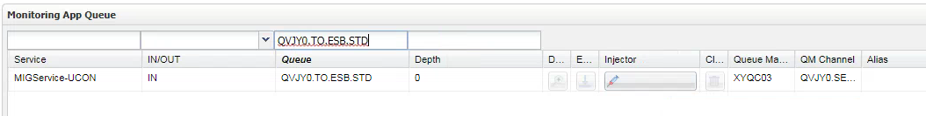

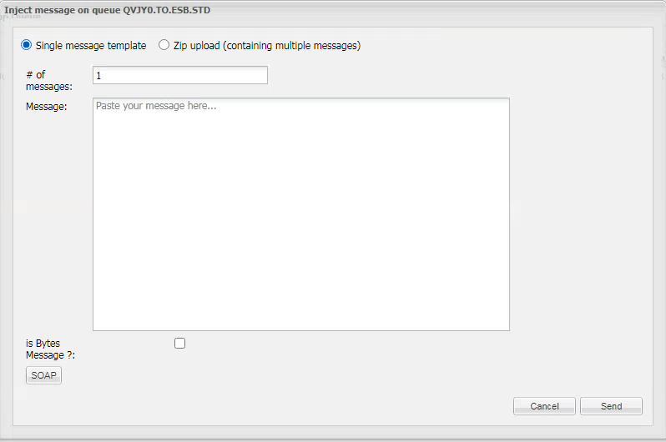
Click on the Soap button and replace these 3 tags:

<tns:From>
<tns:Address>EWDCSTRM</tns:Address>
</tns:From>
<tns:To>EWTORTOMDASH</tns:To>
<tns:Action>TransactionStat</tns:Action>

In the Body tag, insert a TransactionStat message (can be found in splunk by searching for TransactionStatusStatsSearchRequest):

<m:TransactionStatusStatsSearchRequest xmlns:m="http://www.iso.rbcits.com" xmlns:ns3="http://www.rbcdo.rbcdexia.com" xmlns:ns5="http://www.rbcdexia.com" xmlns:rbc="http://www.rbcits.com">
<m:Header>
<m:WebUserId>241758</m:WebUserId>
<m:WebUserName>test</m:WebUserName>
<m:MessageDate>2020-09-10T04:30:20-04:00</m:MessageDate>
</m:Header>
<m:SearchCriteria>
<m:Product>GC</m:Product>
<m:AccountSection>
<m:AccountsAndTradeTypePair>
<m:Accounts>
<m:MultiAccount>
<m:AccountIds>000664803HKD;UK0504</m:AccountIds>
<rbc:BranchCode>RYLTOR</rbc:BranchCode>
<rbc:CorpId>RBSTE </rbc:CorpId>
</m:MultiAccount>
<m:MultiAccount>
<m:AccountIds>000663335EUR;000663335DKK;000663335CNY</m:AccountIds>
<rbc:BranchCode>RYLUK</rbc:BranchCode>
<rbc:CorpId>RBSTE </rbc:CorpId>
</m:MultiAccount>
</m:Accounts>
<m:Types>
<rbc:Type>MT210</rbc:Type>
<rbc:Type>INTERNAL</rbc:Type>
<rbc:Type>MT100</rbc:Type>
<rbc:Type>MT202</rbc:Type>
</m:Types>
</m:AccountsAndTradeTypePair>
</m:AccountSection>
<m:StatusSection>
<m:WebStatus>ENTERED</m:WebStatus>
</m:StatusSection>
<m:DateSearch>
<m:DateSearchQualifier>CreationDate</m:DateSearchQualifier>
<m:DateRange>
<m:DateFrom>2020-08-10T00:00:00+01:00</m:DateFrom>
<m:DateTo>2020-09-10T00:00:00+01:00</m:DateTo>
</m:DateRange>
</m:DateSearch>
</m:SearchCriteria>
</m:TransactionStatusStatsSearchRequest>

Then click on Send

The message is sent to the MQ infra.

To check that the new component received and processed it, need to check in the logs and database.

PCF dev: https://login.sys.cf2.devfg.rbc.com/login

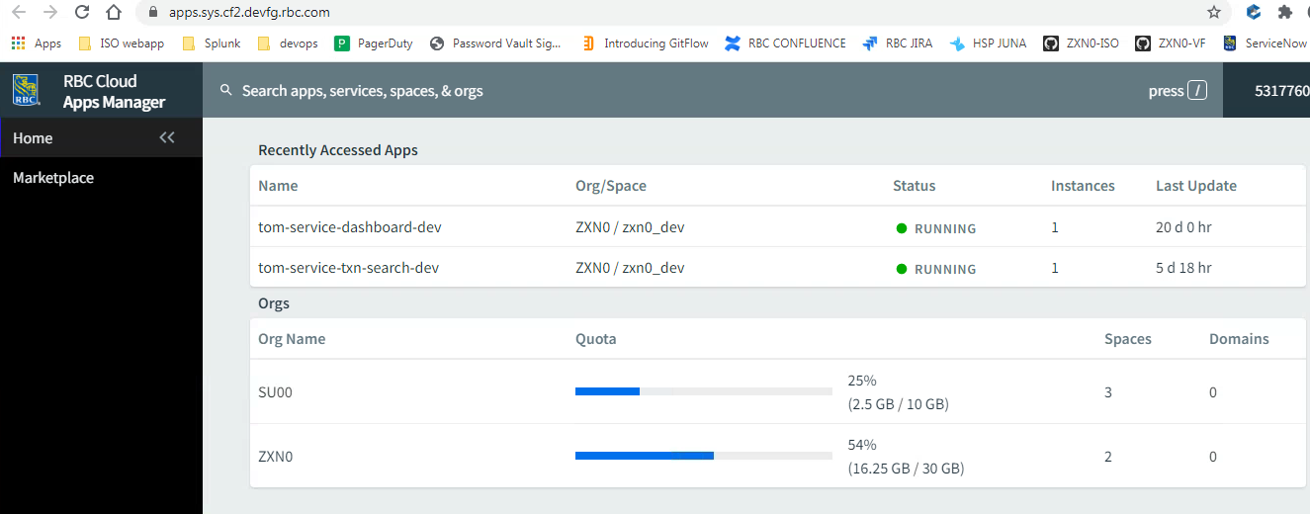

Click on tom-service-dashboard-dev then Logs (and Tail logs at the right with arrow icon):

2020-10-26T10:53:17.296+01:00 [APP/PROC/WEB/0] [OUT] 2020-10-26 09:53:17.295 - INFO --- [enerContainer-2] com.rbc.iso.eden.EdenMessageConverter : fromMessage() call
2020-10-26T10:53:17.297+01:00 [APP/PROC/WEB/0] [OUT] 2020-10-26 09:53:17.296 - INFO --- [enerContainer-2] com.rbc.iso.eden.util.JmsMessageDebuger : Receiving message with payload <?xml version='1.0' encoding='UTF-8'?><soap:Envelope xmlns:soap="http://www.w3.org/2003/05/soap-envelope" xmlns:eden="http://www.rbcdexia.com/eden" xmlns:tns="http://www.w3.org/2005/08/addressing">
2020-10-26T10:53:17.297+01:00 [APP/PROC/WEB/0] [OUT] <soap:Header>
2020-10-26T10:53:17.297+01:00 [APP/PROC/WEB/0] [OUT] <tns:MessageID>SOAMC0016037059972432312</tns:MessageID>
2020-10-26T10:53:17.297+01:00 [APP/PROC/WEB/0] [OUT] <tns:From>
2020-10-26T10:53:17.297+01:00 [APP/PROC/WEB/0] [OUT] <tns:Address>EWDCSTRM</tns:Address>
2020-10-26T10:53:17.297+01:00 [APP/PROC/WEB/0] [OUT] </tns:From>
2020-10-26T10:53:17.297+01:00 [APP/PROC/WEB/0] [OUT] <tns:To>EWTORTOMDASH</tns:To>
2020-10-26T10:53:17.297+01:00 [APP/PROC/WEB/0] [OUT] <tns:Action>TransactionStat</tns:Action>
2020-10-26T10:53:17.297+01:00 [APP/PROC/WEB/0] [OUT] <tns:RelatesTo RelationshipType="http://www.w3.org/2005/08/addressing/reply">MY_EDEN_REPLY_IF_RESPONSE</tns:RelatesTo>
2020-10-26T10:53:17.297+01:00 [APP/PROC/WEB/0] [OUT] <eden:PropagationID>SOAMC-PPGID-1603705997244-2312</eden:PropagationID>
2020-10-26T10:53:17.297+01:00 [APP/PROC/WEB/0] [OUT] <eden:Path>1.1</eden:Path>
2020-10-26T10:53:17.297+01:00 [APP/PROC/WEB/0] [OUT] </soap:Header>
2020-10-26T10:53:17.297+01:00 [APP/PROC/WEB/0] [OUT] <soap:Body>
2020-10-26T10:53:17.297+01:00 [APP/PROC/WEB/0] [OUT] <m:TransactionStatusStatsSearchRequest xmlns:m="http://www.iso.rbcits.com" xmlns:ns3="http://www.rbcdo.rbcdexia.com" xmlns:ns5="http://www.rbcdexia.com" xmlns:rbc="http://www.rbcits.com">
2020-10-26T10:53:17.297+01:00 [APP/PROC/WEB/0] [OUT] <m:Header>
2020-10-26T10:53:17.297+01:00 [APP/PROC/WEB/0] [OUT] <m:WebUserId>241758</m:WebUserId>
2020-10-26T10:53:17.297+01:00 [APP/PROC/WEB/0] [OUT] <m:WebUserName>test</m:WebUserName>
2020-10-26T10:53:17.297+01:00 [APP/PROC/WEB/0] [OUT] <m:MessageDate>2020-09-10T04:30:20-04:00</m:MessageDate>
2020-10-26T10:53:17.297+01:00 [APP/PROC/WEB/0] [OUT] </m:Header>
2020-10-26T10:53:17.297+01:00 [APP/PROC/WEB/0] [OUT] <m:SearchCriteria>
2020-10-26T10:53:17.297+01:00 [APP/PROC/WEB/0] [OUT] <m:Product>GC</m:Product>
2020-10-26T10:53:17.297+01:00 [APP/PROC/WEB/0] [OUT] <m:AccountSection>
2020-10-26T10:53:17.297+01:00 [APP/PROC/WEB/0] [OUT] <m:AccountsAndTradeTypePair>
2020-10-26T10:53:17.297+01:00 [APP/PROC/WEB/0] [OUT] <m:Accounts>
2020-10-26T10:53:17.297+01:00 [APP/PROC/WEB/0] [OUT] <m:MultiAccount>
2020-10-26T10:53:17.297+01:00 [APP/PROC/WEB/0] [OUT] <m:AccountIds>000664803HKD;UK0504</m:AccountIds>
2020-10-26T10:53:17.297+01:00 [APP/PROC/WEB/0] [OUT] <rbc:BranchCode>RYLTOR</rbc:BranchCode>
2020-10-26T10:53:17.297+01:00 [APP/PROC/WEB/0] [OUT] <rbc:CorpId>RBSTE </rbc:CorpId>
2020-10-26T10:53:17.297+01:00 [APP/PROC/WEB/0] [OUT] </m:MultiAccount>
2020-10-26T10:53:17.297+01:00 [APP/PROC/WEB/0] [OUT] <m:MultiAccount>
2020-10-26T10:53:17.297+01:00 [APP/PROC/WEB/0] [OUT] <m:AccountIds>000663335EUR;000663335DKK;000663335CNY</m:AccountIds>
2020-10-26T10:53:17.297+01:00 [APP/PROC/WEB/0] [OUT] <rbc:BranchCode>RYLUK</rbc:BranchCode>
2020-10-26T10:53:17.297+01:00 [APP/PROC/WEB/0] [OUT] <rbc:CorpId>RBSTE </rbc:CorpId>
2020-10-26T10:53:17.297+01:00 [APP/PROC/WEB/0] [OUT] </m:MultiAccount>
2020-10-26T10:53:17.297+01:00 [APP/PROC/WEB/0] [OUT] </m:Accounts>
2020-10-26T10:53:17.297+01:00 [APP/PROC/WEB/0] [OUT] <m:Types>
2020-10-26T10:53:17.297+01:00 [APP/PROC/WEB/0] [OUT] <rbc:Type>MT210</rbc:Type>
2020-10-26T10:53:17.297+01:00 [APP/PROC/WEB/0] [OUT] <rbc:Type>INTERNAL</rbc:Type>
2020-10-26T10:53:17.297+01:00 [APP/PROC/WEB/0] [OUT] <rbc:Type>MT100</rbc:Type>
2020-10-26T10:53:17.297+01:00 [APP/PROC/WEB/0] [OUT] <rbc:Type>MT202</rbc:Type>
2020-10-26T10:53:17.297+01:00 [APP/PROC/WEB/0] [OUT] </m:Types>
2020-10-26T10:53:17.297+01:00 [APP/PROC/WEB/0] [OUT] </m:AccountsAndTradeTypePair>
2020-10-26T10:53:17.297+01:00 [APP/PROC/WEB/0] [OUT] </m:AccountSection>
2020-10-26T10:53:17.297+01:00 [APP/PROC/WEB/0] [OUT] <m:StatusSection>
2020-10-26T10:53:17.297+01:00 [APP/PROC/WEB/0] [OUT] <m:WebStatus>ENTERED</m:WebStatus>
2020-10-26T10:53:17.297+01:00 [APP/PROC/WEB/0] [OUT] </m:StatusSection>
2020-10-26T10:53:17.297+01:00 [APP/PROC/WEB/0] [OUT] <m:DateSearch>
2020-10-26T10:53:17.297+01:00 [APP/PROC/WEB/0] [OUT] <m:DateSearchQualifier>CreationDate</m:DateSearchQualifier>
2020-10-26T10:53:17.297+01:00 [APP/PROC/WEB/0] [OUT] <m:DateRange>
2020-10-26T10:53:17.297+01:00 [APP/PROC/WEB/0] [OUT] <m:DateFrom>2020-08-10T00:00:00+01:00</m:DateFrom>
2020-10-26T10:53:17.297+01:00 [APP/PROC/WEB/0] [OUT] <m:DateTo>2020-09-10T00:00:00+01:00</m:DateTo>
2020-10-26T10:53:17.297+01:00 [APP/PROC/WEB/0] [OUT] </m:DateRange>
2020-10-26T10:53:17.297+01:00 [APP/PROC/WEB/0] [OUT] </m:DateSearch>
2020-10-26T10:53:17.297+01:00 [APP/PROC/WEB/0] [OUT] </m:SearchCriteria>
2020-10-26T10:53:17.297+01:00 [APP/PROC/WEB/0] [OUT] </m:TransactionStatusStatsSearchRequest>
2020-10-26T10:53:17.297+01:00 [APP/PROC/WEB/0] [OUT] </soap:Body>
2020-10-26T10:53:17.297+01:00 [APP/PROC/WEB/0] [OUT] </soap:Envelope>
2020-10-26T10:53:17.304+01:00 [APP/PROC/WEB/0] [OUT] 2020-10-26 09:53:17.303 - INFO --- [enerContainer-2] com.rbc.iso.eden.EdenMessageConverter : fromMessage() ######## javax.xml.bind.JAXBElement@1836b9a5
2020-10-26T10:53:17.305+01:00 [APP/PROC/WEB/0] [OUT] 2020-10-26 09:53:17.304 - INFO --- [enerContainer-2] t.t.d.m.i.TransactionStatMessageTypeImpl : Received JMS message
2020-10-26T10:53:17.305+01:00 [APP/PROC/WEB/0] [OUT] 2020-10-26 09:53:17.304 - INFO --- [enerContainer-2] t.t.d.m.i.TransactionStatMessageTypeImpl : Received EdenMessage to notify about Transaction Stat query, for request: SOAMC0016037059972432312

