1. Every complete statement ends with a
A) period
B) # symbol
C) semicolon
D) ending brace

2. Which of the following statements is correct?
A) #include (iostream)
B) #include <iostream>
C) #include {iostream}
D) #include [iostream]
E) All of the above

3. Every C++ program must have a
A) cout statement
B) function main
C) #include statement
D) All of the above

4. Preprocessor directives begin with a
A) #
B) !
C) <
D) *
E) None of the above

5. The following data
72
'A'
"Hello World"
2.8712
are all examples of
A) Variables
B) Literals or constants
C) Strings
D) None of the above

6. A group of statements, such as the contents of a function, is enclosed in
A) Parentheses ()
B) Brackets <>
C) Braces {}
D) All of the above will do

7. Which of the following are not valid assignment statements? (Circle all that apply.)
A) total = 9;
B) 72 = amount;
C) profit = 129
D) letter = 'W';

8. Which of the following are not valid cout statements? (Circle all that apply.)
A) cout << "Hello World";
B) cout << "Have a nice day"\n;
C) cout < value;
D) cout << Programming is great fun;

9. Assume w = 5, x = 4, y = 8, and z = 2. What value will be stored in result in each of
the following statements?
A) result = x + y;
B) result = z * 2;
C) result = y / x;
D) result = y − z;
E) result = w % 2;

10. The negation operator is
A) Unary
B) Binary
C) Ternary
D) None of the above

11. A(n) ___________ is like a variable, but its value is read-only and cannot be changed
during the program’s execution.
A) secure variable
B) uninitialized variable
C) named constant
D) locked variable

12. When do preprocessor directives execute?
A) Before the compiler compiles your program
B) After the compiler compiles your program
C) At the same time as the compiler compiles your program
D) None of the above

Answers:
- C
- B
- B
- A
- B
- C

- B, C
- B, C, D
- A = 12, B = 4, C = 2, D = 6, E = 1
- A
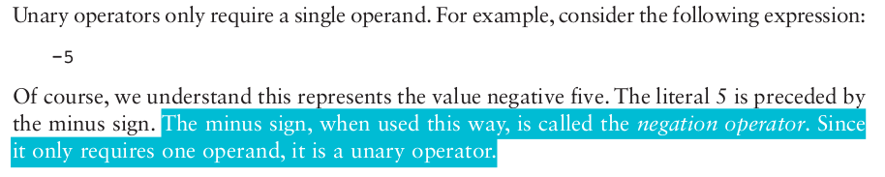

Question 10, was confusing because the books wording was ambiguous. Since right after this statement the book had this chart.
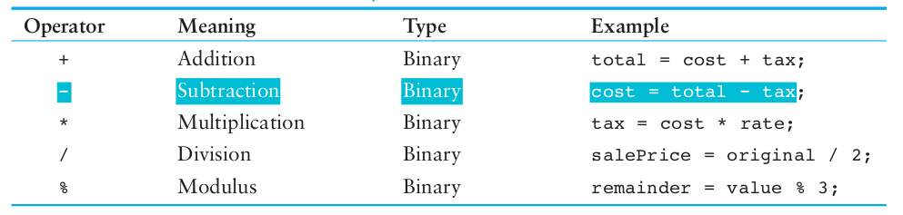

- C
- A

