Scientific Python Interactive Data Acoustic Modeling
<public url to your Github repository>

Project Report
COP2080
Florida Polytechnic University
Fall 2023

submitted by:
[Team Name]
[Member 1 – Discipline]
[Member 2 – Discipline]
[Member 3 – Discipline]
[Member 4 – Discipline]
[Member 5 – Discipline]
…

submitted to:
[Discipline instructor]
[Date]

- Introduction [group]
The introduction of your report should be approximately 2 – 3 paragraphs that briefly describes your project, activities completed, highlights learning experience, your final product, and concluding remarks. The entire report should be 5 pages or less, single spaced, have 1-inch margins, and use Cambria 11 point font. Body text of the report should be justified. Use a single line space between paragraphs and before sections. Any figures and tables that are included in the body of the report should be numbered (sequentially for both tables and figures) and called out in the text before they appear. Figure titles are placed directly below the figure and table titles are placed directly above the table. See example :
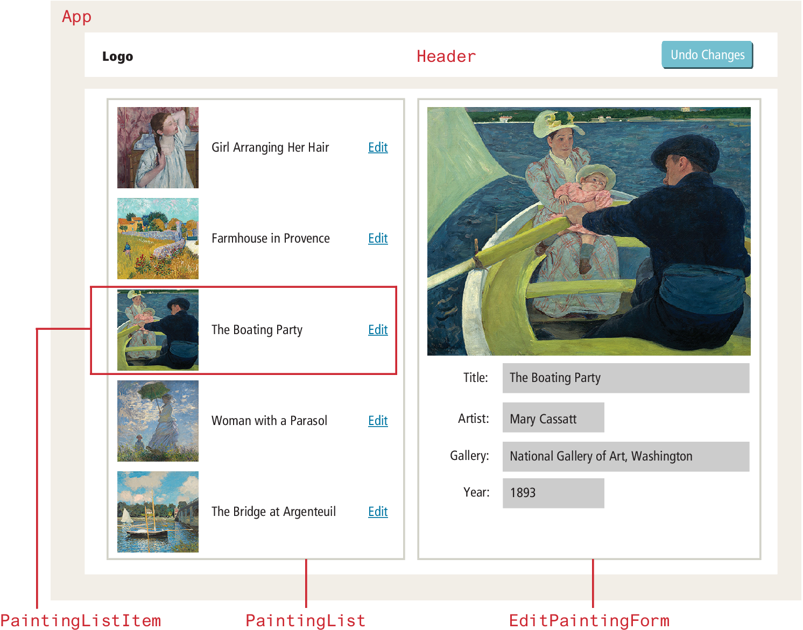

Figure 1. React output from Painting array

2.1 Business Needs
1 paragraph. Describe the business needs based on input from professor. Example includes a brief description of the proposed project's purpose, goals, and scope as well as rough order of magnitude estimate for schedule, and basic technical skill requirements.

2.2 Design Objectives
1 paragraph. State the engineering requirements stated by the professor or interpreted through business needs statements. Design objectives will be in the form of engineering requirements and are not subjective, stating what and how the data is to be measured.

2.3 Functional Requirements
Use this section to describe the functional requirements of your project. This includes the user interface requirements.

2.4 Limitations
Use this section to describe the major assumptions and limitations of the project.

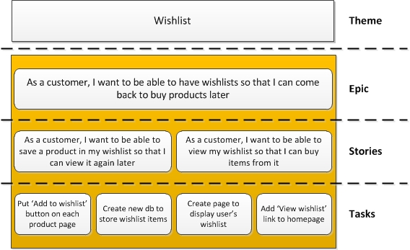
3.0 Agile User Stories
In this section,
1) describe two agile epics
2) At least 3 user stories derived for each epic
3) Tasks derived from each user story
4) Developer name assigned task
5) Explanation of each task
Example of Epic vs Task ->

- Results
State the location of your audio recording. Show a wide image that includes the space recorded (such as a room or hall), the recording position (person holding recording device) and the person creating the clap.

State the numerical output from your measurements and show screenshots of all plots, tables, etc. Label each one appropriately. Use seconds or Db as units of measurement.

6.1 Final Product Testing
This section should describe how you tested your final product and your results. Did your product meet the design objectives and specifications? If they did great, if they didn’t, why?

7.0 Conclusions and Project Summary
Summarize your team’s efforts and results of this project.

7.1 Individual Contribution Table

This section should have a table with a percentage for each group members contribution. The total contribution should add up to 100%. See the table below for an example.

Team Member | Contribution
- Jane Doe | 30%
- Pedro Gonzales | 15%
- Ferrel Isami | 55%

7.2 Individual contribution Reports

Each group member should write a 1 - 2 paragraph individual contribution section to discuss what you contributed.

7.3 Individual Reflection Reports

This section should contain a 2 - 3 paragraph reflection report from each member. What did you learn from this project? What worked well? What was most challenging?

