**Backend Engineer Coding Challenge**

***Development Procedure of the API***.

1. Used Flask’s restx as it is still maintained well updated till 2023
2. Next as mentioned in the requirements and looking at the working, I chose SQlite db.
3. With my base code ready, I had access to the swagger page. But nothing else since I did not define any endpoints yet.

Now I built all my endpoints and modules, additionally according to the requirements made product module, its ID similarly added item and id etc.

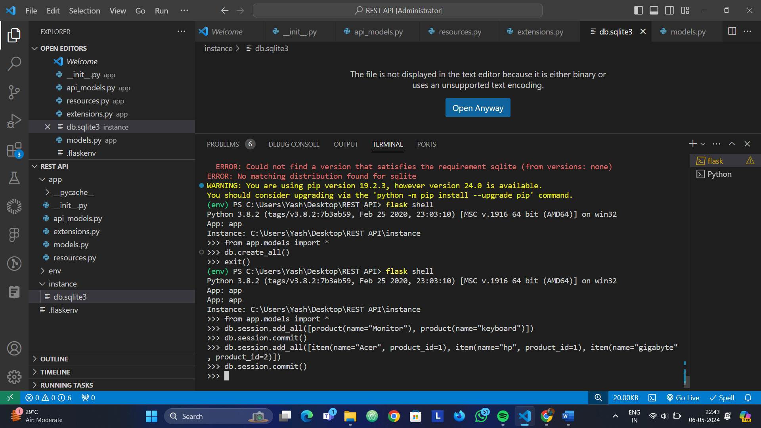

To test the working I had a test rout

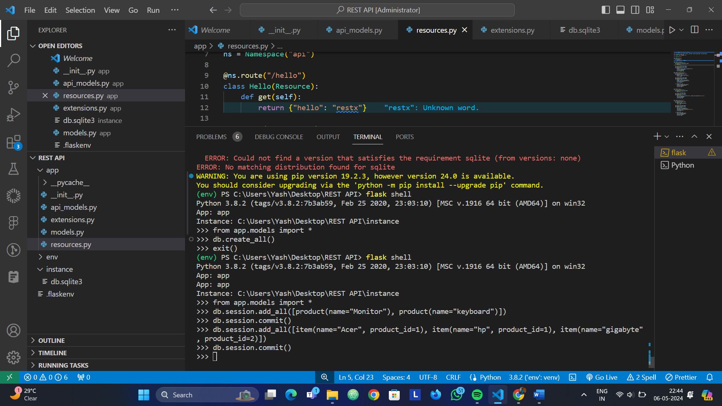

The output is given such: when you tryout the get function

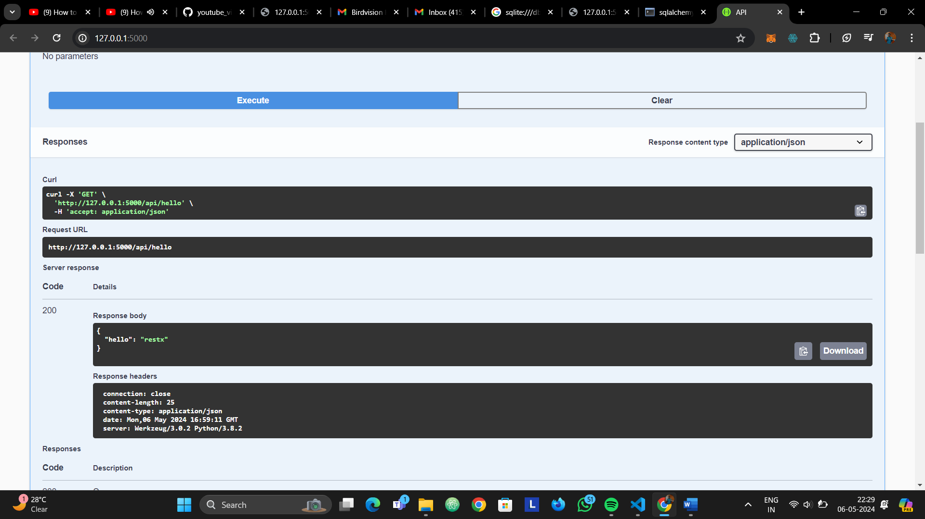

Now to test for the products and items I gave a feed of some data in the db in the terminal itself



You can see some product and items are added/commited

And now if you go and check the GET function for product or items you can see and fetch the data on the browser in json format…

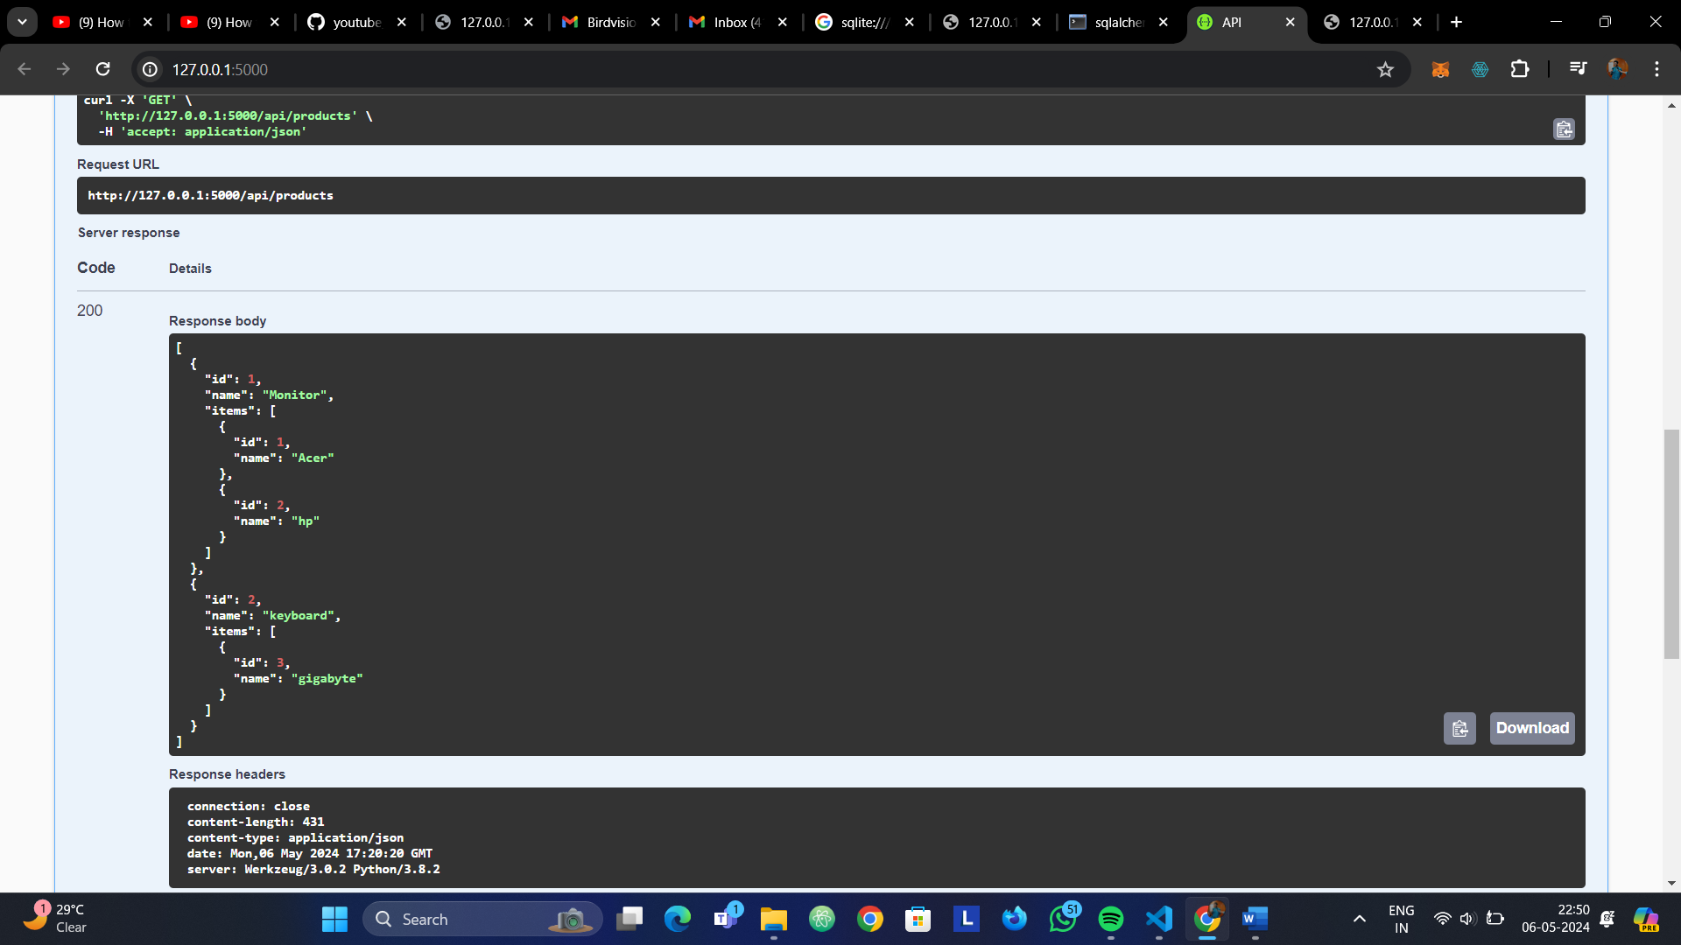

Similarly other functionalities like fetching a particular item from product id, adding an item on a product id, deleting it also works flawlessly.