Проект

„Roulette“

От: Илия Василев

Пловдив 2024

Съдържание

1. Описание на проекта
2. Блокова схема
3. Електрическа схема
4. Списък съставни части
5. Сорс код – описание на функционалността
6. Заключение

Описание на проекта

Проектът представлява електронна рулетка, базирана на Arduino платформата и светодиодни диоди (LED). Това е интерактивно устройство, което симулира класическата игра на рулетка, позволявайки на играчите да залагат на цветове и след това да въртят рулетката, за да видят резултата от техните залози.

Връзка към симулация може да намерите [тук.](https://www.tinkercad.com/things/13xOghsTjlu-roulette/editel?sharecode=YIh3DS4DxfR0I5tZ6jEbiZrP9-OAD84Gjs1Y3E23h9I)

Блокова схема

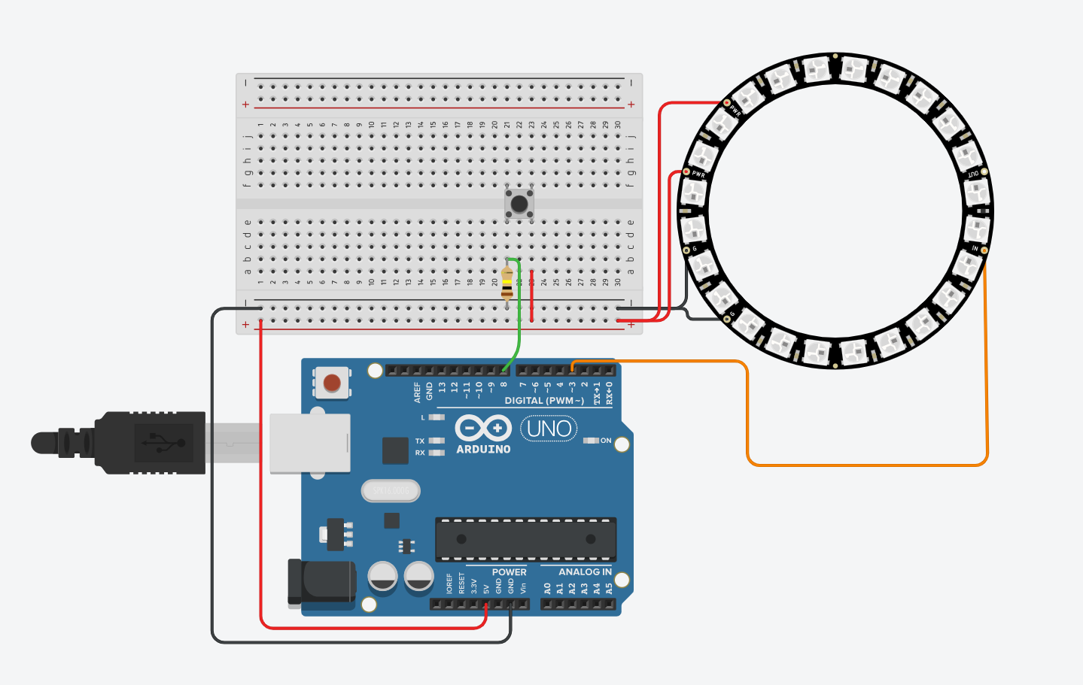

Електрическа схема

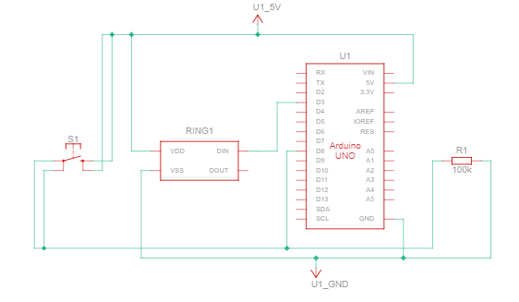

Списък с части

1. Arduino Uno R3: 1
2. NeoPixel Ring 24: 1
3. Pushbutton: 1
4. 100 kΩ Resistor: 1

Сорс код



#include <Adafruit_NeoPixel.h>

#define PIN 3

#define NUMPIXELS 24

#define DELAYVAL 100

Adafruit_NeoPixel pixels(NUMPIXELS, PIN, NEO_GRB + NEO_KHZ800);

int taster=8;

int tasterstatus=0;

long randomzahl=0;

bool status=false;

int i = 0;

int i;

void setup(){

pinMode(taster, INPUT);

pixels.begin();

}

void loop(){

tasterstatus=digitalRead(taster);

pixels.clear();

pixels.setPixelColor(0, pixels.Color(255,0 ,0));

pixels.setPixelColor(1, pixels.Color(0,0 ,255));

pixels.setPixelColor(2, pixels.Color(255,0 ,0));

pixels.setPixelColor(3, pixels.Color(0,0 ,255));

pixels.setPixelColor(4, pixels.Color(255,0 ,0));

pixels.setPixelColor(5, pixels.Color(0,0 ,255));

pixels.setPixelColor(6, pixels.Color(255,0 ,0));

pixels.setPixelColor(7, pixels.Color(0,0 ,255));

pixels.setPixelColor(8, pixels.Color(255,0 ,0));

pixels.setPixelColor(9, pixels.Color(0,0 ,255));

pixels.setPixelColor(10, pixels.Color(255,0 ,0));

pixels.setPixelColor(11, pixels.Color(0,0 ,255));

pixels.setPixelColor(12, pixels.Color(255,0 ,0));

pixels.setPixelColor(13, pixels.Color(0,0 ,255));

pixels.setPixelColor(14, pixels.Color(255,0 ,0));

pixels.setPixelColor(15, pixels.Color(0,0 ,255));

pixels.setPixelColor(16, pixels.Color(255,0 ,0));

pixels.setPixelColor(17, pixels.Color(0,0 ,255));

pixels.setPixelColor(18, pixels.Color(255,0 ,0));

pixels.setPixelColor(19, pixels.Color(0,0 ,255));

pixels.setPixelColor(20, pixels.Color(255,0 ,0));

pixels.setPixelColor(21, pixels.Color(0,0 ,255));

pixels.setPixelColor(22, pixels.Color(255,0 ,0));

pixels.setPixelColor(23, pixels.Color(0,0 ,255));

pixels.show();

if(tasterstatus==HIGH){

dreh();

}

}

void dreh(){

randomzahl=random(24,50);

int i=18;

for(randomzahl >= 1; randomzahl--;){

if(i==24){i=0;}

if(randomzahl==0){

pixels.setPixelColor(0, pixels.Color(255,0 ,0));

pixels.setPixelColor(1, pixels.Color(0,0 ,255));

pixels.setPixelColor(2, pixels.Color(255,0 ,0));

pixels.setPixelColor(3, pixels.Color(0,0 ,255));

pixels.setPixelColor(4, pixels.Color(255,0 ,0));

pixels.setPixelColor(5, pixels.Color(0,0 ,255));

pixels.setPixelColor(6, pixels.Color(255,0 ,0));

pixels.setPixelColor(7, pixels.Color(0,0 ,255));

pixels.setPixelColor(8, pixels.Color(255,0 ,0));

pixels.setPixelColor(9, pixels.Color(0,0 ,255));

pixels.setPixelColor(10, pixels.Color(255,0 ,0));

pixels.setPixelColor(11, pixels.Color(0,0 ,255));

pixels.setPixelColor(12, pixels.Color(255,0 ,0));

pixels.setPixelColor(13, pixels.Color(0,0 ,255));

pixels.setPixelColor(14, pixels.Color(255,0 ,0));

pixels.setPixelColor(15, pixels.Color(0,0 ,255));

pixels.setPixelColor(16, pixels.Color(255,0 ,0));

pixels.setPixelColor(17, pixels.Color(0,0 ,255));

pixels.setPixelColor(18, pixels.Color(255,0 ,0));

pixels.setPixelColor(19, pixels.Color(0,0 ,255));

pixels.setPixelColor(20, pixels.Color(255,0 ,0));

pixels.setPixelColor(21, pixels.Color(0,0 ,255));

pixels.setPixelColor(22, pixels.Color(255,0 ,0));

pixels.setPixelColor(23, pixels.Color(0,0 ,255));

pixels.setPixelColor(i, pixels.Color(0,255 ,0));//win color

pixels.show();

delay(5000);

}

pixels.setPixelColor(0, pixels.Color(255,0 ,0));

pixels.setPixelColor(1, pixels.Color(0,0 ,255));

pixels.setPixelColor(2, pixels.Color(255,0 ,0));

pixels.setPixelColor(3, pixels.Color(0,0 ,255));

pixels.setPixelColor(4, pixels.Color(255,0 ,0));

pixels.setPixelColor(5, pixels.Color(0,0 ,255));

pixels.setPixelColor(6, pixels.Color(255,0 ,0));

pixels.setPixelColor(7, pixels.Color(0,0 ,255));

pixels.setPixelColor(8, pixels.Color(255,0 ,0));

pixels.setPixelColor(9, pixels.Color(0,0 ,255));

pixels.setPixelColor(10, pixels.Color(255,0 ,0));

pixels.setPixelColor(11, pixels.Color(0,0 ,255));

pixels.setPixelColor(12, pixels.Color(255,0 ,0));

pixels.setPixelColor(13, pixels.Color(0,0 ,255));

pixels.setPixelColor(14, pixels.Color(255,0 ,0));

pixels.setPixelColor(15, pixels.Color(0,0 ,255));

pixels.setPixelColor(16, pixels.Color(255,0 ,0));

pixels.setPixelColor(17, pixels.Color(0,0 ,255));

pixels.setPixelColor(18, pixels.Color(255,0 ,0));

pixels.setPixelColor(19, pixels.Color(0,0 ,255));

pixels.setPixelColor(20, pixels.Color(255,0 ,0));

pixels.setPixelColor(21, pixels.Color(0,0 ,255));

pixels.setPixelColor(22, pixels.Color(255,0 ,0));

pixels.setPixelColor(23, pixels.Color(0,0 ,255));

pixels.setPixelColor(i, pixels.Color(255,255 ,0));//roteter color

pixels.show();

i++;

delay(DELAYVAL);

}

}

Заключение

Проектът представлява успешна реализация на електронна рулетка, която не само предоставя забавление и развлечение, но и допринася за развитието на уменията за програмиране и електроника. Чрез използването на Arduino платформата и светодиодни диоди, съчетани с мотори и сензори, успяхм да създадем функционално устройство, което симулира класическата игра на рулетка.