Documentation

Note: I am using full HD mode

Assets I used:

tower-defense-kit by kenney <https://kenney.nl/assets/tower-defense-kit>

Texsture:

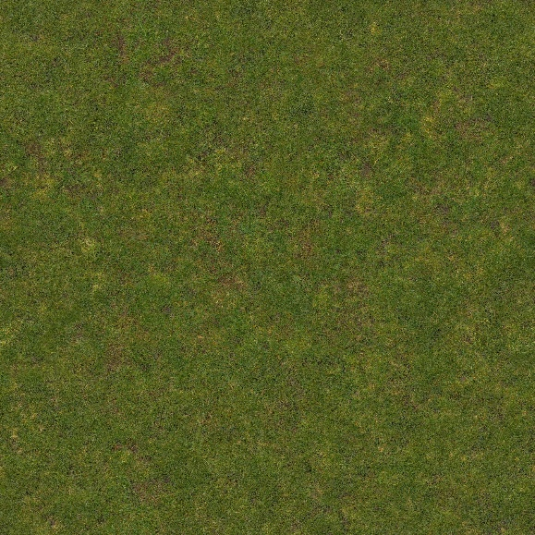

Figure 1: Poliigon.[US]. *Poliigon_GrassPatchyGround_4585_BaseColor.* (Poliigon, 2025)

# References

Poliigon, 2025. *Flat Grass Texture-Poliigon.* [Online]   
Available at: <https://www.poliigon.com/texture/flat-grass-texture/4585>  
[Accessed 08 September 2025].

List of Figures:

Figure 1: Poliigon.[US]. *Poliigon_GrassPatchyGround_4585_BaseColor.*