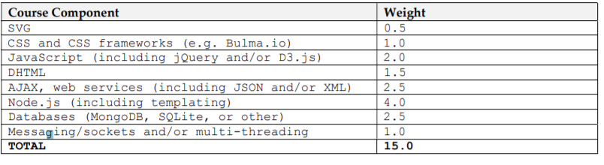

Harrith Input:
0011am.co
Wants Policy, About me, Instagram, Home,
Not a priority:
Home: Wants a recording of him tagging looping,
Logo on top of video,
Sliders, clickables,
Little description of the brand at the end
Logo: Have
Clothing:
Wants to have hoverable item;
