Galactic Destruction

Yan Sun

May 14th, 2018

Table of Contents

* Demonstrations (pg. 2-4)
  + Screen Mockups
  + UML Diagram
  + Class and functions
* Game Introduction (pg. 4-5)
  + Platform
  + Mode
  + Canvas
  + Storyline
  + Controls/User Interface
  + Sounds
  + Level
  + Scoring
  + Audience

Screen Mockups:

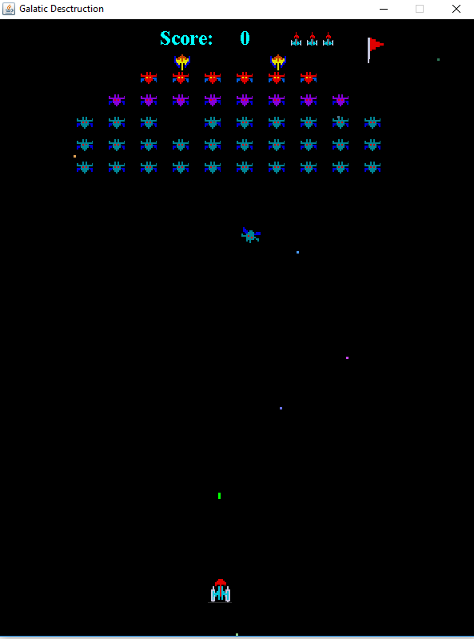

UML Diagrams

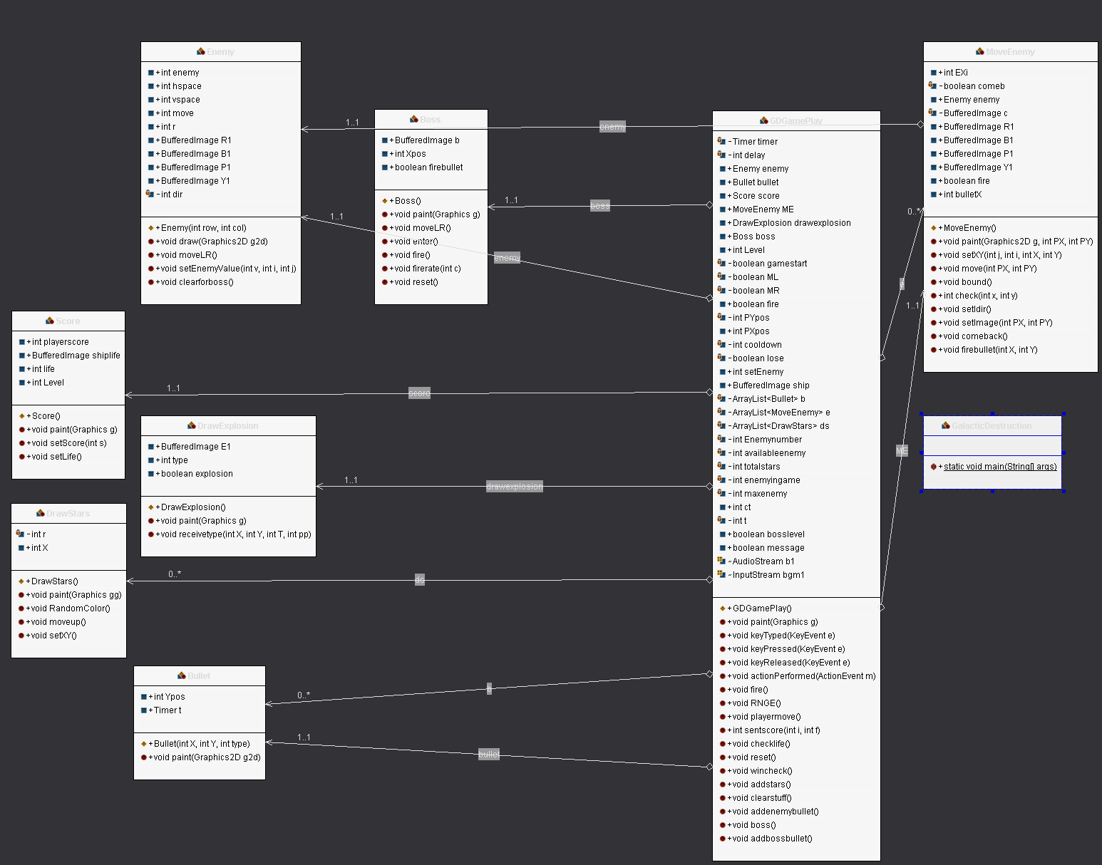

Class and functions

The game is consisted of one driver class and eight classes. The “GDGamePlay” class interacts with the other seven classes, including: Enemy, MoveEnemy, Bullet, Boss, DrawExplosion, DrawStars, and Score.

Class Enemy is responsible for drawing enemy formation and moving them left and right.

Class MoveEnemy is responsible for calling and moving random enemy from the formation. It also reaches out to the “addenemybullet” method in GDGamePlay class to fire bullet.

Class Bullet draws bullets fired by player, boss, and moving enemies. The Integer “type” indicates the type of bullet that the class is drawing.

Class Boss draws the mothership, move the mothership left and right, and allows it to fire bullet.

Class DrawExplosion is responsible for drawing explode animation when player’s bullet hits an enemy or the boss, or when player’s ship got hit by enemies’ bullet or enemies ship.

Class DrawStars is responsible for drawing background stars in random color and position. It also moves the starts downward in a fixed rate.

Class Score is responsible for keeping track of player’s life, player’s score, and current level.

Game Introduction

* Platform
  + Any computer with JDK built in.
* Mode
  + V1.0 support single player mode.
* Canvas
  + An inter-galaxy fighter is flying in a deep path of a Galaxy and fighting its way to eliminate the enemies on its path.
* Storyline
  + A long time ago, in a galaxy fart, fart away…
    - A Galaxian fighter took the mission of challenging the greatest evil of its time. After it went through a worn hole, it arrived to the Galaxy R78 and began its journey of bringing back justice.
    - Your mission is to fly the fighter and destroy all the enemies on your path.
* Control/User Interface
  + Keyboard: Standard Qwerty U.S. English Keyboard.
    - Key “A” and “D” are used for moving the fighter left and right.
    - Key “Space” starts the game and fire green bullets.
* Sounds
  + Sound is not supported in V1.0
* Level
  + As player enter higher level, the number of moving ships will increase.
  + Player will not gain additional lives in higher levels.
  + After being hit by a bullet, player will not have “spawn time” to protect his or her fighter.
  + No maximum level is set in V1.0.
* Timing
  + No time limit is set in this game.
* Scoring
  + Moving Enemies
    - Yellow – 120 points
    - Red – 100 points
    - Purple – 80 points
    - Blue – 60 points
  + Enemies in formation
    - Yellow – 60 points
    - Red – 50 points
    - Purple – 40 points
    - Blue – 30 points
  + Boss – 1000 points
* Life Indicator
  + Players will have three lives when the game starts.
  + Boss’s health bar is displayed on the top of the screen during the boss level.
* Level Indicator
  + The flags on the top right corner indicate current game level.
* Death Event
  + Every time the fighter is hit by enemy bullets or enemy ships, the fighter will explode, and life indicator will subtract one ship.
  + If player runes out of lives, the game will be over, and pressing key “Space” will start a new game.
  + No spawn time protection.
* Hits
  + Bad hits (explained in section “Death Event”)
  + Good hits
    - Fight’s green bullets hit moving or static enemies or boss.
* Images
  + Images of ships of different kinds are drawn in the game.
  + Background images is not provided.