Prepared by:
Wiid de Wet - 43700292
One Stop Events
CMPG223 Project Documentation
Contents
1. Project description and scope 2
2. Data model 3
3. Process Models 4
4. Database Schema 6
5. SQL 6
6. Reports 10
7. User Manual 10
Setup and start-up 10
Application workflow 10
8. Project Development Summary 10
Implementation overview 10
Quality controls 10

Project description and scope
One Stop Events is a Windows Forms information system that supports the day-to-day administration of an events business. It maintains clients, partners, partner professions, venues and event bookings, and produces date-filtered reports to support operational decisions.

The system's functionality will include the following:
- Maintain events.
- Maintain partners.
- Maintain clients.
- Maintain venues.
- Maintain Partner professions.
- Generate date-filtered reports for highest-earning partners, popular venues, popular events and highest-spending clients.

Additionally, the system must meet the following non-functional requirements:
- Maintainability: configuration and data-access responsibilities should be kept consistent so the application can be set up and supported reliably.
- Reliability: the system's information must be accurate and reliable at all times as a double-booking could be detrimental to the organization's operations
- Performance: common maintenance and reporting operations should respond quickly for the expected coursework data volume.

Data model
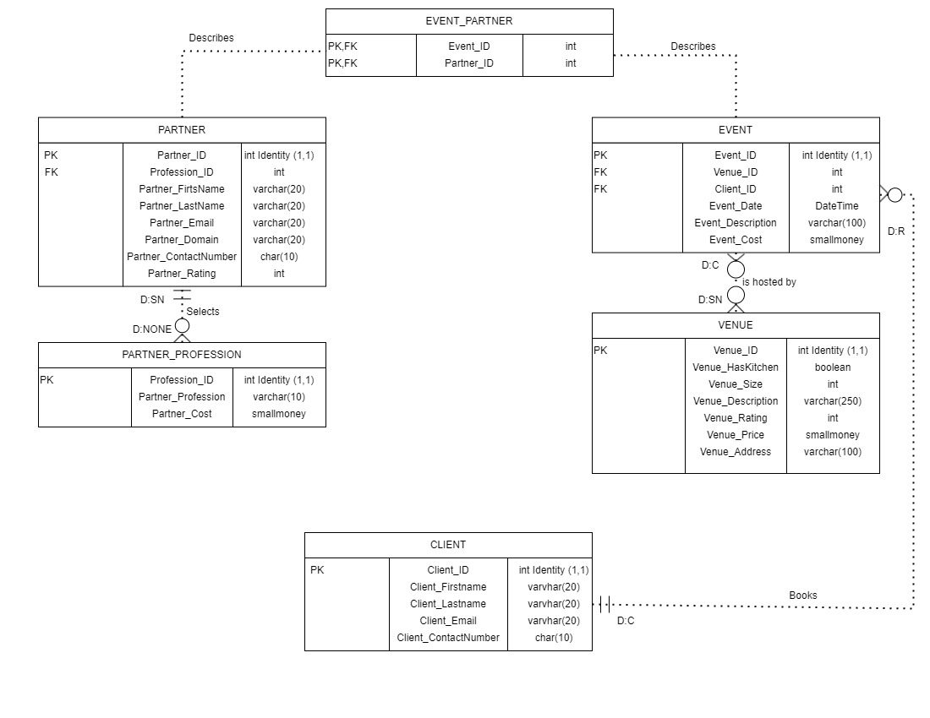

Process Models
Venues:
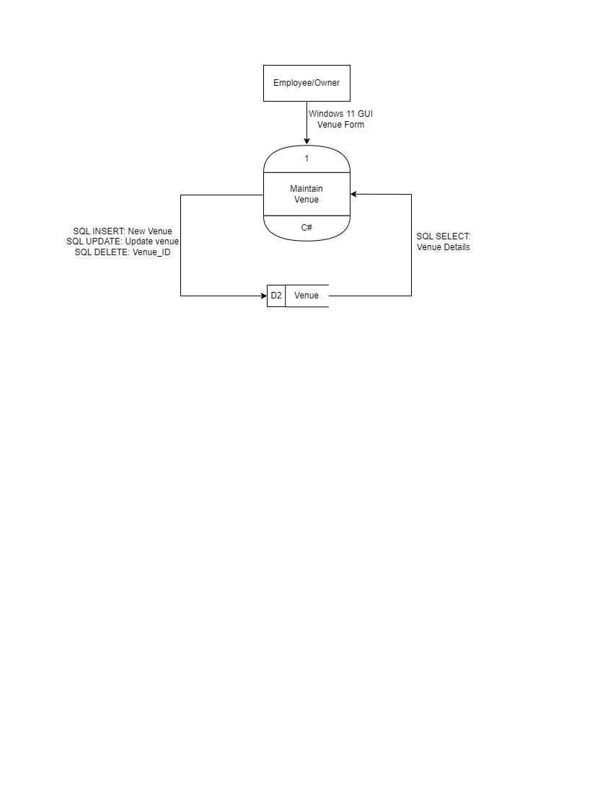

Events:
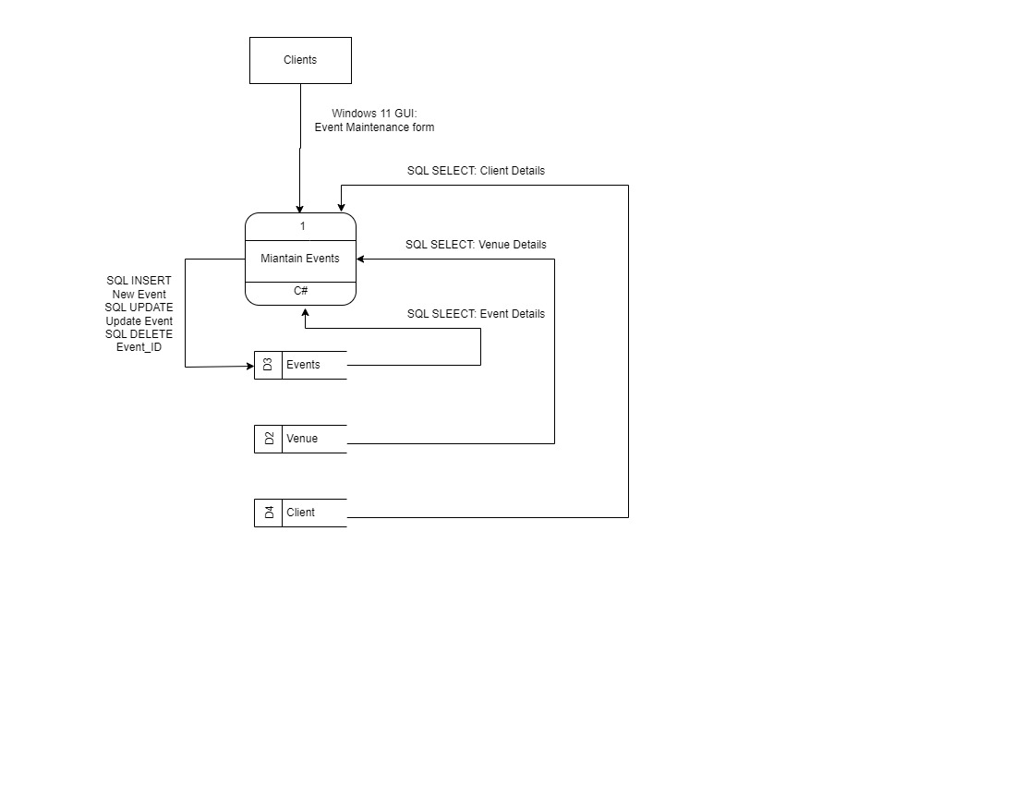

Clients:
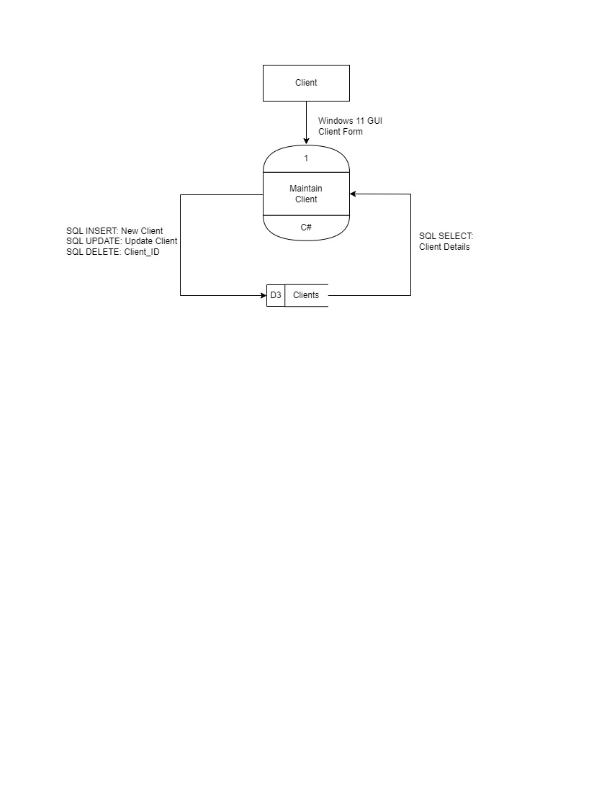

Partners:
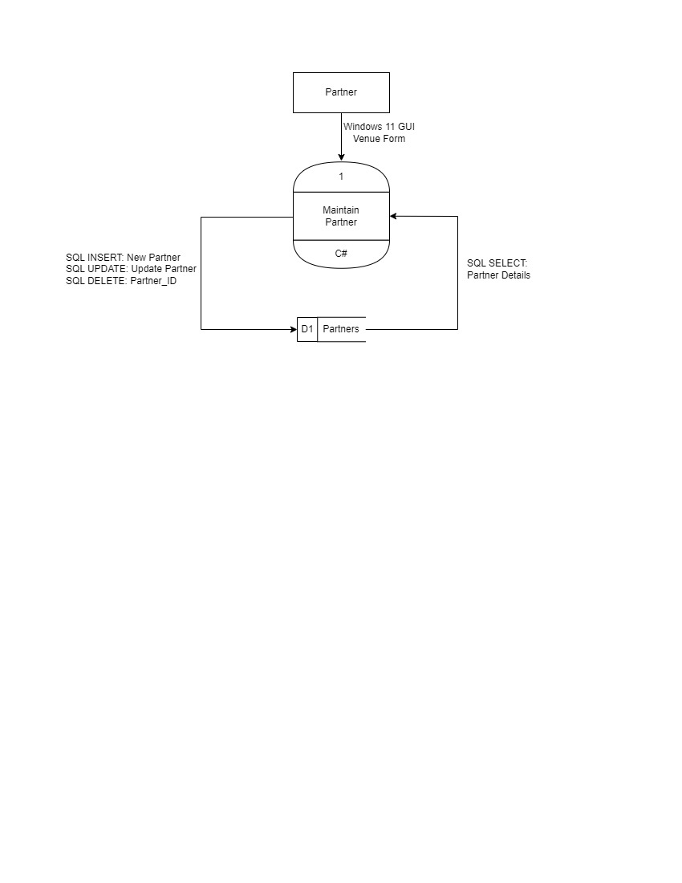

Database Schema

SQL
-- Insert sample data into CLIENTS table
INSERT INTO CLIENTS (Client_FirstName, Client_SurName, Client_Email, Client_ContactNumber)
VALUES
('John', 'Doe', 'john.doe@example.com', '1234567890'),
('Jane', 'Smith', 'jane.smith@example.com', '0987654321'),
('Alice', 'Johnson', 'alice.johnson@example.com', '1122334455'),
('Bob', 'Brown', 'bob.brown@example.com', '5566778899');

-- Insert sample data into PARTNER_PROFESSIONS table
INSERT INTO PARTNER_PROFESSIONS (Partner_Profession, Partner_Cost)
VALUES
('Photographer', 500.00),
('Caterer', 1500.00),
('Decorator', 800.00),
('DJ', 600.00);

-- Insert sample data into VENUES table
INSERT INTO VENUES (Venue_Name, Venue_HasKitchen, Venue_Size, Venue_Description, Venue_Rating, Venue_Price, Venue_Address)
VALUES
('The Grand Hall', 'Y', 300, 'Spacious hall with modern amenities', 9.00, 2000.00, '123 Grand St, Cityville'),
('Riverside Pavilion', 'N', 150, 'Elegant pavilion by the river', 8.50, 1500.00, '456 Riverside Dr, Townsville'),
('Country Estate', 'Y', 500, 'Rustic estate with beautiful gardens', 9.50, 3000.00, '789 Country Rd, Countryside'),
('City Loft', 'N', 100, 'Trendy loft in downtown area', 7.75, 1200.00, '101 City Ave, Metropolis');

-- Insert sample data into PARTNERS table
INSERT INTO PARTNERS (Profession_ID, Partner_FirstName, Partner_SurName, Partner_Email, Partner_Domain, Partner_ContactNumber)
VALUES
(1, 'Emily', 'Clark', 'emily.clark@example.com', 'emilyclarkphoto.com', '2233445566'),
(2, 'Michael', 'Davis', 'michael.davis@example.com', 'michaeldavis.cater.com', '3344556677'),
(3, 'Olivia', 'Martinez', 'olivia.martinez@example.com', 'oliviamartinez.decor.com', '4455667788'),
(4, 'James', 'Wilson', 'james.wilson@example.com', 'jameswilson.dj.com', '5566778899');

-- Insert sample data into EVENTS table
INSERT INTO EVENTS (Event_Name, Venue_ID, Client_ID, Partner_ID, Event_Date, Event_Description, Event_Cost)
VALUES
('Summer Gala', 1, 1, 1, '2024-06-15', 'Annual summer gala with a formal dinner and entertainment', 3500.00),
('Wedding Reception', 3, 2, 2, '2024-07-20', 'Elegant wedding reception in a country estate', 5000.00),
('Corporate Meeting', 2, 3, 3, '2024-08-10', 'Business meeting with refreshments and decor', 2500.00),
('Birthday Party', 4, 4, 4, '2024-09-05', 'Casual birthday party with DJ and snacks', 1800.00);

-- Create CLIENT table
CREATE TABLE CLIENTS (
Client_ID INT IDENTITY(1,1) CONSTRAINT Client_pk PRIMARY KEY,
Client_FirstName VARCHAR(50),
Client_SurName VARCHAR(50),
Client_Email VARCHAR(100) CONSTRAINT chk_client_email_format CHECK (Client_Email LIKE '%_@__%.__%'),
Client_ContactNumber VARCHAR(10)
);

-- Create PARTNER_PROFESSION table
CREATE TABLE PARTNER_PROFESSIONS (
Profession_ID INT IDENTITY(1,1) CONSTRAINT Profession_pk PRIMARY KEY,
Partner_Profession VARCHAR(150),
Partner_Cost MONEY
);

-- Create VENUE table
CREATE TABLE VENUES (
Venue_ID INT IDENTITY(1,1) CONSTRAINT Venue_pk PRIMARY KEY,
Venue_Name VARCHAR(50),
Venue_HasKitchen CHAR(1) CHECK (Venue_HasKitchen IN ('Y', 'N')),
Venue_Size INT,
Venue_Description VARCHAR(255),
Venue_Rating DECIMAL(4, 2) CHECK (Venue_Rating >= 0 AND Venue_Rating <= 10),
Venue_Price MONEY,
Venue_Address VARCHAR(255)
);

-- Create PARTNER table
CREATE TABLE PARTNERS (
Partner_ID INT IDENTITY(1,1) CONSTRAINT Partner_pk PRIMARY KEY,
Profession_ID INT,
Partner_FirstName VARCHAR(50),
Partner_SurName VARCHAR(50),
Partner_Email VARCHAR(100) CONSTRAINT chk_partner_email_format CHECK (Partner_Email LIKE '%_@__%.__%'),
Partner_Domain VARCHAR(50),
Partner_ContactNumber VARCHAR(15),
CONSTRAINT fk_profession_id FOREIGN KEY (Profession_ID) REFERENCES PARTNER_PROFESSIONS(Profession_ID)
);

-- Create EVENT table
CREATE TABLE EVENTS (
Event_ID INT IDENTITY(1,1) CONSTRAINT Event_pk PRIMARY KEY,
Event_Name VARCHAR(50),
Venue_ID INT,
Client_ID INT,
Partner_ID INT,
Event_Date DATE,
Event_Description VARCHAR(255),
Event_Cost MONEY,
CONSTRAINT fk_venue_id FOREIGN KEY (Venue_ID) REFERENCES VENUES(Venue_ID),
CONSTRAINT fk_partner_id FOREIGN KEY (Partner_ID) REFERENCES PARTNERS(Partner_ID),
CONSTRAINT fk_client_id FOREIGN KEY (Client_ID) REFERENCES CLIENTS(Client_ID)
);

-- Drop tables in the correct order to avoid foreign key constraints issues

DROP TABLE IF EXISTS EVENTS;
DROP TABLE IF EXISTS PARTNERS;
DROP TABLE IF EXISTS CLIENTS;
DROP TABLE IF EXISTS VENUES;
DROP TABLE IF EXISTS PARTNER_PROFESSIONS;

Reports

User Manual

Setup and start-up
1. Install Visual Studio with .NET Framework 4.7.2 development support.
2. Restore or create the OnestopEvents SQL Server database using the supplied database artifacts.
3. Open ONESTOPEVENTS.sln and confirm the configured SQL Server connection.
4. Build the Release configuration and run the ONESTOPEVENTS project.

Application workflow
Use the home screen to maintain professions, partners, clients and venues before booking events. Use the reporting screen to select a report and date range, then request the results.

Project Development Summary
Prepared by Wiid de Wet (43700292).

Implementation overview
Five related SQL Server tables support clients, partner professions, partners, venues and events.
Windows Forms screens provide add, update, view and delete workflows for the maintained records.
Parameterized SQL operations and input validation protect the integrity of stored information.
Four reports summarize event activity for a selected date range.

Quality controls
The final project is checked with a clean Release build, database setup verification, workflow smoke tests and a rendered review of this document.

