SIMATS ENGINEERING (SAVEETHA SCHOOL OF ENGINEERING)
Department of Computer Science and Engineering
CO4 ASSESSMENT TOOL 2 – CI/CD Pipeline Design Exercise

Course Code: | CSA10 / CSA1007 | Course Title: | Software Engineering
CO Assessed: | CO4 | Assessment: | Assessment Tool 2 – CI/CD Pipeline Design Exercise
Weightage: | 20% | Total Marks: | 25
CO4 Statement: | Implement robust testing, quality assurance, and DevOps practices, emphasizing security, reliability, and ethics
Student Name: | P MEGALA | Reg. No.: | 192573019
Date: | 29-08-2026 | Duration: | 60 minutes

Code of Conduct
I P ROHINI (192524147) (Name / Reg No) certify that this submission is my original work and that I have adhered to the guidelines specified for this assessment. I understand that any violation of academic integrity rules will result in disciplinary action.
Signature of the Student: P ROHINI
Annexure A – CI/CD Pipeline Design Exercise
Instructions to Students:
Each student is assigned an individual problem statement. Based on the assigned problem statement, design a CI/CD (Continuous Integration and Continuous Deployment) pipeline for the proposed software system to automate the processes of code integration, building, testing, and deployment.
The exercise should include:
- Analyze the project requirements and identify the CI/CD needs of the assigned problem statement.
- Design the CI/CD pipeline workflow showing stages such as source code management, build, testing, code quality analysis, packaging, and deployment.
- Identify suitable tools and technologies for each stage of the pipeline and justify their selection.
- Define appropriate automated testing strategies to be integrated into the pipeline.
- Design the deployment strategy, including development, testing/staging, and production environments.
- Incorporate appropriate security, quality checks, notifications, and rollback mechanisms in the pipeline.
- Prepare a CI/CD pipeline diagram and explain the workflow from code commit to deployment.
Deliverable: Submit a CI/CD Pipeline Design document containing the pipeline architecture/diagram, stages, tools, configuration/workflow, testing strategy, deployment process, and justification based on the assigned problem statement.

Rubrics for Calculation
Evaluation Criteria | Excellent (4 Marks) | Good (3 Marks) | Satisfactory (2 Marks) | Needs Improvement (1 Mark)
Requirement & Pipeline Analysis(15%) | Clearly analyzes the assigned problem and identifies comprehensive CI/CD requirements | Identifies most relevant requirements | Identifies basic requirements with some gaps | Requirements are unclear or incomplete
Pipeline Architecture & Workflow(25%) | Designs a complete, logical pipeline covering source, build, test, quality check, package, and deployment stages | Pipeline covers most major stages with minor gaps | Basic pipeline is designed but several stages are missing | Pipeline is incomplete or poorly structured
Tools & Technology Selection(20%) | Selects appropriate tools for each stage and provides clear justification | Appropriate tools selected with reasonable justification | Tools are identified but justification is limited | Tools are inappropriate or not clearly identified
Automated Testing & Quality Integration(15%) | Effectively integrates automated testing and code-quality/security checks into the pipeline | Includes major testing and quality checks | Includes basic testing with limited integration | Testing/quality checks are missing or inappropriate
Deployment, Security & Rollback Strategy(15%) | Clearly designs deployment environments, security practices, monitoring, and rollback strategy | Covers deployment and most security/rollback aspects | Basic deployment strategy with limited security/rollback details | Deployment strategy is incomplete or lacks security considerations
Pipeline Diagram & Documentation(10%) | Clear, accurate, professional diagram with excellent explanation and documentation | Well-presented diagram and documentation with minor issues | Adequate diagram/documentation but lacks clarity | Poorly presented, incomplete, or difficult to understand

Criteria | Mark
Requirement & Pipeline Analysis(15%) | /5
Pipeline Architecture & Workflow(25%) | /4
Tools & Technology Selection(20%) | /4
Automated Testing & Quality Integration(15%) | /4
Deployment, Security & Rollback Strategy(15%) | /4
Pipeline Diagram & Documentation(10%) | /4
TOTAL | /25

CO4-ASSISSMENT TOOL-2

COURSE CODE: CSA1007
COURSE NAME: SOFTWARE ENGINEERING
NAME: P MEGALA
REG NO: 192573019

40) Factory Energy Monitoring and Machine Utilization Optimization System
Industry Context
The manufacturing sector is rapidly adopting digital technologies to improve efficiency, safety, scalability, and decision making. Traditional approaches often rely on manual processes and reactive monitoring, resulting in delays, increased operational costs, resource wastage, and reduced service quality. There is a growing need for an intelligent, cloud-enabled, distributed platform capable of collecting real-time IoT and enterprise data, analyzing operational conditions, predicting risks, and supporting timely interventions.
Problem Statement
Design and develop a distributed Factory Energy Monitoring and Machine Utilization Optimization System that continuously acquires real-time operational data from connected devices, enterprise systems, and users. The platform should detect abnormal events, generate predictive insights using AI/ML, notify stakeholders in real time, provide centralized dashboards, generate reports, and support secure, scalable, fault-tolerant operation across multiple locations.

Objectives
- Collect real-time operational data.
- Monitor system performance continuously.
- Detect anomalies automatically.
- Predict failures or risks using analytics.
- Notify stakeholders immediately.
- Generate dashboards and reports.

CI/CD Pipeline Design Exercise

Project Title:
Factory Energy Monitoring and Machine Utilization Optimization System

1. Project Requirements and CI/CD Needs
The system collects real-time energy and machine data, predicts congestion, optimizes machine utilization, and provides dashboards and alerts.
CI/CD Needs
- Automate code integration.
- Automatically build the application.
- Run tests whenever code changes.
- Detect errors early.
- Deploy tested code automatically.
- Maintain reliable and repeatable releases.
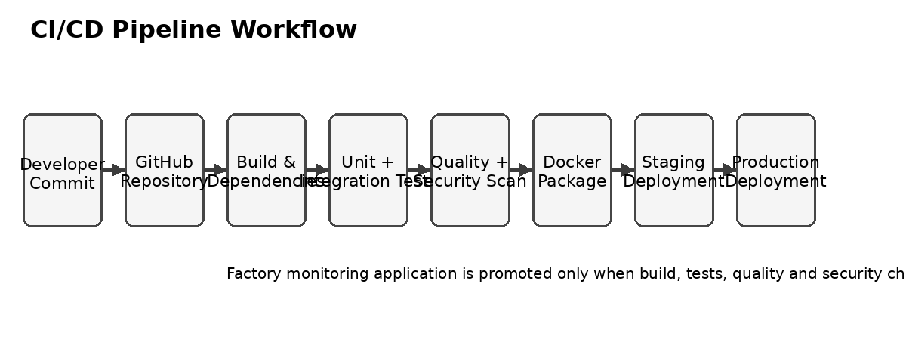

2. CI/CD Pipeline Workflow
The proposed workflow is:

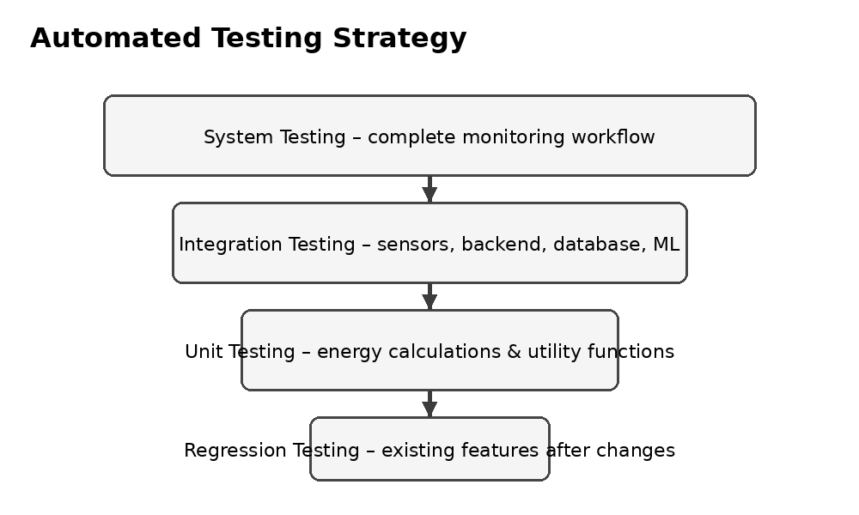

The pipeline automatically moves the application through build, testing, staging, and production stages.

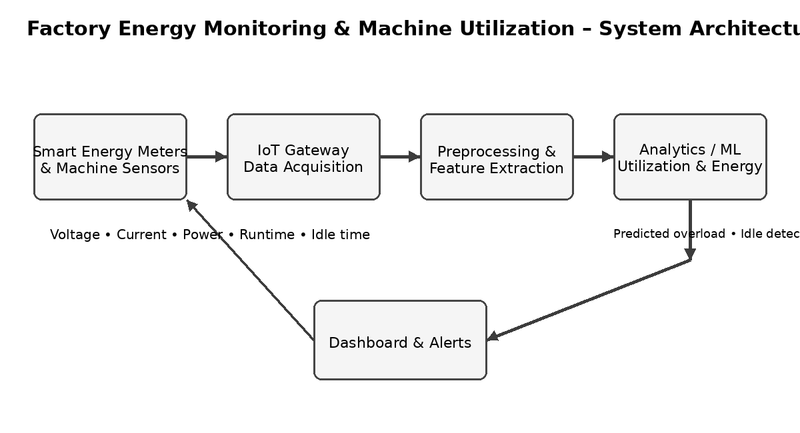

3. Tools and Technologies

Tool | Purpose
Git | Version control
GitHub | Source-code repository
Jenkins | CI/CD automation
Docker | Application containerization
Docker Compose | Manage application services
Python/Flask | Backend application
MySQL | Data storage
JUnit/PyTest | Automated testing

Justification
These tools support automated building, testing, containerization, deployment, and monitoring of the factory monitoring platform.

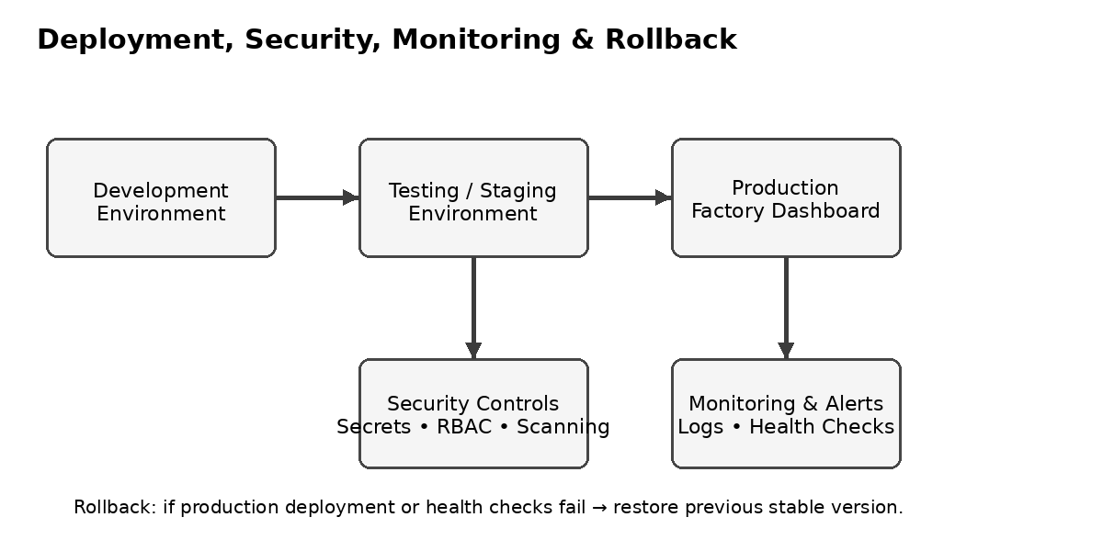

4. Automated Testing Strategy
Automated tests are executed whenever new code is pushed.
Testing Levels
Unit Testing:
Tests individual functions such as energy-data processing.
Integration Testing:
Checks communication between the sensor-data ingestion, backend, analytics module, and database.
System Testing:
Checks the complete factory monitoring platform.
Regression Testing:
Ensures that new changes do not break existing functionality.
Example
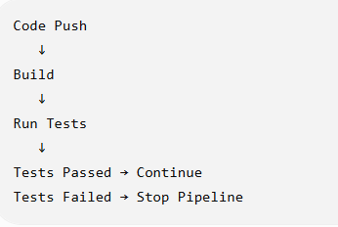

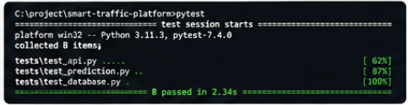

5. Development, Testing and Production Environments
Development Environment
Used by developers to create and modify features.

Developer → Git → Development

Testing/Staging Environment
Used to test the complete application before deployment.

Development → Automated Tests → Staging

Production Environment
Contains the final application used by factory operators, supervisors, and maintenance personnel.

Staging → Approval → Production

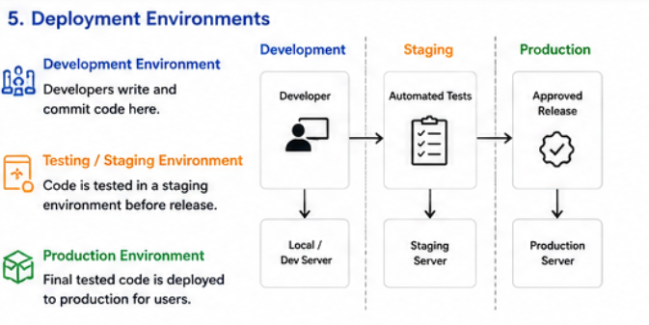

6. Security, Quality, Notifications and Rollback
Security
- Use secure credentials.
- Protect database information.
- Control user access.
- Scan dependencies for vulnerabilities.

Quality Checks
- Code quality analysis.
- Automated testing.
- Build validation.
- Security scanning.
Notifications
The pipeline can notify the development team when:
- Build succeeds.
- Tests fail.
- Deployment succeeds.
- Deployment fails.
Rollback
If a new version fails in production, the system can return to the previous stable version.

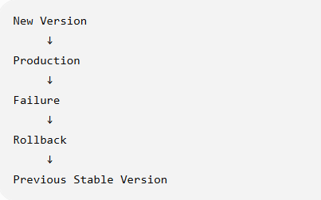

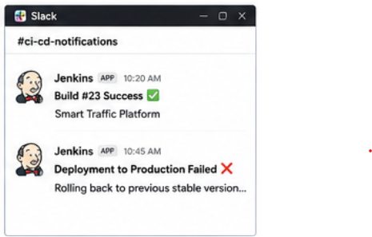

7. CI/CD Pipeline Diagram
Use this as your final architecture diagram:

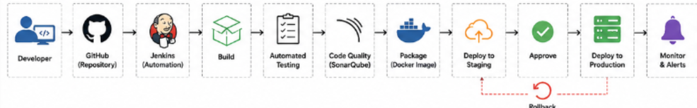

Pipeline Explanation
The developer pushes code to GitHub. Jenkins automatically starts the pipeline. The code is built and tested, followed by quality and security checks. If all checks pass, the application is deployed to the staging environment and then to production. If a production deployment fails, rollback is performed to restore the previous stable version

Conclusion:
The proposed CI/CD pipeline provides an efficient and reliable approach for developing and deploying the Factory Energy Monitoring and Machine Utilization Optimization System. By integrating Git, Jenkins, Docker, automated testing, code-quality checks, staging, and production deployment, the system can deliver changes quickly and safely. Security checks, notifications, monitoring, and rollback mechanisms further improve reliability and reduce deployment risks.

