SIMATS ENGINEERING (SAVEETHA SCHOOL OF ENGINEERING)
Department of Computer Science and Engineering
CO3 ASSESSMENT TOOL 1 – Git & Docker Technical Assignment

Course Code: | CSA10 / CSA1063 | Course Title: | Software Engineering
CO Assessed: | CO3 | Assessment: | Assessment Tool 1 – Git & Docker Technical Assignment
Weightage: | 20% | Total Marks: | 25
CO3 Statement: | Build full-stack applications with an emphasis on containerization, version control, and collaborative development
Student Name: | Megala P | Reg. No.: | 192573019
Date: | 11/8/26 | Duration: | 60 minutes

Code of Conduct
I MEGALA P (192573019) (Name / Reg No) certify that this submission is my original work and that I have adhered to the guidelines specified for this assessment. I understand that any violation of academic integrity rules will result in disciplinary action.
Signature of the Student: MEGALA P
Annexure A – Git & Docker Technical Assignment
Instructions to Students:
Each student has been assigned an individual problem statement. Based on the assigned problem statement, prepare a Git & Docker Technical Assignment by applying version control and containerization concepts. Your report should include appropriate diagrams, screenshots, commands, and explanations wherever applicable.

Assignment Questions
- Problem Analysis
  - Explain the assigned problem statement and identify the project objectives, functional requirements, and expected outcomes.
- Project Structure Design
  - Design and explain the folder structure of your project repository.
  - Justify the purpose of each major folder and file included in the repository.
- Git Repository Initialization
  - Create a Git repository for the project.
  - Explain the steps involved in repository initialization and describe the purpose of the essential Git files.
- Git Branching Strategy
  - Design a suitable branching strategy (e.g., Main, Development, Feature, Release, Hotfix).
  - Justify why the selected branching model is appropriate for the assigned project.
- Version Control Workflow
  - Demonstrate the Git workflow by performing meaningful commits, branch creation, merging, conflict resolution (if applicable), and repository synchronization.
  - Explain the purpose of each Git operation performed.
- Commit History Analysis
  - Present the commit history of the project.
  - Explain how commit messages follow good version control practices and contribute to project maintenance.
- Docker Environment Design
  - Explain why Docker is suitable for the assigned project.
  - Identify the application components that require containerization.
- Dockerfile Development
  - Design and explain the Dockerfile required to containerize the application.
  - Describe the purpose of each instruction used in the Dockerfile.
- Docker Compose Design
  - Develop a Docker Compose configuration for the project.
  - Explain the services, networking, volumes, environment variables, and dependencies used.
- Container Deployment and Testing
  - Demonstrate the execution of the application using Docker containers.
  - Explain the testing procedure and provide evidence that the application runs successfully.
- Benefits of Git and Docker
  - Discuss how Git and Docker improve collaboration, version management, portability, deployment, scalability, and maintainability for your assigned project.
- Challenges and Improvements
  - Identify the challenges encountered during implementation.
  - Suggest possible improvements and future enhancements for the Git workflow and Docker deployment.

Expected Deliverables
- Technical report (10 pages)
- Git repository with complete commit history
- Source code of the assigned project
- Dockerfile
- Docker Compose file (docker-compose.yml)
- Screenshots of Git operations and Docker execution
- Architecture and workflow diagrams

Rubrics for Calculation
Evaluation Criteria | Excellent (4 Marks) | Good (3 Marks) | Satisfactory (2 Marks) | Needs Improvement (1 Mark)
Problem Analysis & Project Design(20%) | Clearly explains the problem statement, objectives, requirements, expected outcomes, and well-organized project structure with proper justification. | Good analysis and project structure with minor omissions. | Basic analysis and repository structure with limited justification. | Incomplete or unclear analysis and project organization.
Git Repository & Branching Strategy(20%) | Repository initialized correctly with appropriate branching strategy, clear workflow, and proper repository organization. | Repository and branching strategy are mostly correct. | Basic Git setup with limited branching implementation. | Incorrect or incomplete Git repository and branching strategy.
Version Control Workflow & Commit History(10%) | Demonstrates meaningful commits, branching, merging, synchronization, conflict resolution, and professional commit messages with clear history. | Most Git operations demonstrated correctly with good commit history. | Limited Git workflow and commit practices. | Poor workflow and inadequate commit history.
Docker Implementation(20%) | Well-designed Docker environment, Dockerfile, and Docker Compose configuration with clear explanation of services, networking, volumes, and dependencies. | Functional Docker implementation with minor issues. | Basic Docker implementation with limited explanation. | Incomplete or incorrect Docker implementation.
Deployment, Testing & Results(15%) | Application successfully deployed and tested with appropriate screenshots and evidence of successful execution. | Deployment completed with minor issues. | Partial deployment and testing demonstrated. | Deployment unsuccessful or insufficient evidence.
Documentation, Challenges & Future Enhancements(15%) | Professional report (10–15 pages) with diagrams, screenshots, references, discussion of benefits, challenges, and future improvements. | Good documentation with minor omissions. | Basic documentation with limited discussion. | Poor documentation and insufficient analysis.

Criteria | Mark
System Requirement Analysis (30%) | /5
Selection of Software Architecture (25%) | /5
Architecture Diagram and Component Design (20%) | /5
Component Interaction and Quality Attribute Analysis (15%) | /5
Architectural Justification and Technical Presentation (10%) | /5
TOTAL | /25

Project Title:
Factory Energy Monitoring and Machine Utilization Optimization System.

- System Architecture
System Architecture of Factory Energy Monitoring and Machine Utilization Optimization System
The proposed system is designed to continuously monitor the energy consumption and utilization of machines in a factory. Factory machines and IoT sensors collect parameters such as energy consumption, voltage, current, machine operating status, runtime, and idle time.

The collected data is transferred to the Data Ingestion Layer through an MQTT broker or message queue. The Backend/API Layer receives and processes the data and provides communication between the frontend, database, and analytics components.

The processed information is stored in the Database Layer for future analysis and reporting. The ML/Analytics Layer analyzes energy consumption and machine utilization to identify abnormal energy usage, idle machines, and underutilized machines.
The results are displayed through a Web Dashboard, allowing factory operators to monitor machine performance and energy usage. The system also generates alerts and reports when abnormal energy consumption or machine conditions are detected.
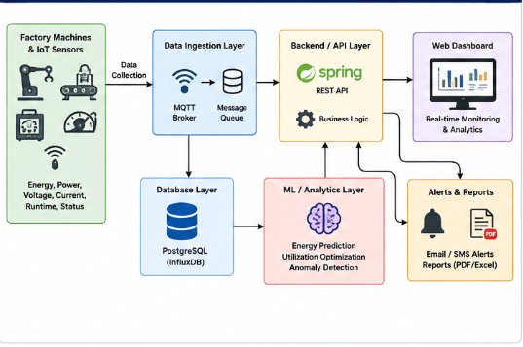
Purpose:
The architecture helps the factory continuously monitor energy usage and machine performance so that inefficient machines can be identified and corrective actions can be taken.

2.Project Repository Structure
The project repository is divided into different folders so that each component of the Factory Energy Monitoring System can be developed and maintained separately.

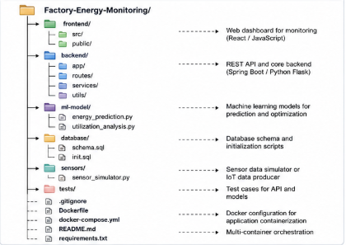
Explanation of each folder
1. frontend/
Contains the user interface of the system. It provides the dashboard for displaying energy consumption, machine utilization, alerts, and reports.
2. backend/
Contains the main application logic and REST APIs. It receives sensor data, processes requests, communicates with the database, and sends information to the frontend.
3. ml-model/
Contains analytics and machine-learning programs. It can be used for energy prediction, machine utilization analysis, and abnormal energy-consumption detection.
4. database/
Contains database-related files such as database schema and initialization scripts.
5. sensors/
Contains programs for collecting or simulating data from factory machines and IoT sensors.
6. tests/
Contains test programs used to verify the frontend, backend, database connection, APIs, and analytics functions.
7. Dockerfile
Contains instructions for creating the Docker image for the application.
8. docker-compose.yml
Defines and manages the multiple containers required by the project.
9. gitignore
Specifies files and folders that should not be uploaded to the Git repository.
10. README.md
Contains project information, setup instructions, commands, and usage details.

Purpose:
This repository structure provides a clear separation between the frontend, backend, analytics, database, sensors, and testing components. It improves project organization, maintainability, and collaboration.

3. Git Branching Strategy
Git Branching Strategy
Git branching is used to manage different stages of development and to prevent unfinished features from directly affecting the stable version of the project. The assignment allows branching models such as Main, Development, Feature, Release, and Hotfix.
Branches Used
main
The main branch contains the stable and tested version of the project.
development
The development branch is used to integrate and test features before they are added to the main branch.
feature/energy-monitoring
Used to develop the energy-monitoring functionality.
feature/machine-utilization
Used to develop machine utilization calculation and analysis.
feature/dashboard
Used to develop the monitoring dashboard.
feature/alerts
Used to develop the alert and notification functionality.
hotfix/bug-fix
Used to quickly fix critical problems found in the stable version.

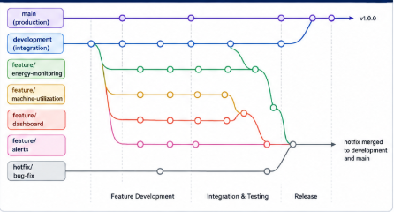

4. Docker Design
Docker Container Architecture
Docker is used to containerize the different components of the Factory Energy Monitoring and Machine Utilization Optimization System. Each major component runs inside its own container, allowing the application to be deployed consistently across different environments.
Docker Containers
Frontend Container
Runs the web dashboard through which users can view energy consumption, machine utilization, alerts, and reports.
Backend Container
Runs the backend application and REST APIs. It receives requests from the frontend and communicates with the database and analytics service.
ML/Analytics Container
Runs the energy-analysis and machine-utilization programs. It analyzes collected data and identifies abnormal energy consumption and inefficient machine operation.
Database Container
Stores machine details, sensor readings, energy consumption, operating time, idle time, and utilization information.
Redis Container
Can be used for caching or temporary message/queue processing to improve application performance.

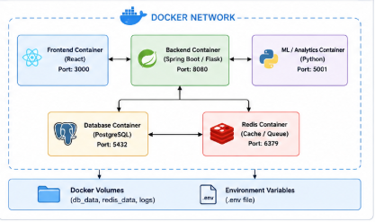

5.Docker Volumes
Docker volumes are used to preserve important data even when containers are stopped or restarted.
Examples:
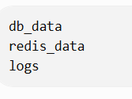
Environment Variables
Environment variables are used to store configuration information such as database host, username, password, port numbers, and application settings.
Purpose:
Docker provides a consistent and isolated environment for the application. It makes deployment easier and improves portability, scalability, and maintainability. Your assignment specifically requires explanation of Docker services, networking, volumes, environment variables, and dependencies.
6.Conclusion
The Factory Energy Monitoring and Machine Utilization Optimization System provides an efficient approach for monitoring factory energy consumption and machine performance. The system collects data from machines and IoT sensors, processes and stores the data, and analyzes energy consumption and machine utilization to identify abnormal conditions and inefficient machine operation.

OUTPUT:

