1. **The following code will search for a .txt file within each and every sub folders inside a folder with path specified.**

Private Sub CommandButton1_Click()

Call Sample

End Sub

……………………………………………………………………………………………………………………………………………………..

Sub Sample()

Dim strStartPath As String

strStartPath = "C:\Users\H223487\Documents\System_Verification_Test_suit"

Dim FS As New FileSystemObject

Dim FSfolder As Folder

Dim subfolder As Folder

Dim word As String, word1 As String, info As String

Dim FilePath As String

Dim MyFile As String

Dim FolderName As String

Dim row As Integer, cols As Integer, n As Integer

Dim Text As String, Text1 As String, TextLine As String

row = 1

n = 1

info = "Please make sure that your .feature file is in following format" & vbNewLine & "Scenario:.." & vbNewLine & "Given .." & vbNewLine & "When .. or And .." & vbNewLine & "Then .."

MsgBox (info)

Set FSfolder = FS.GetFolder(strStartPath) 'Finds Parent Folder Path

For Each subfolder In FSfolder.SubFolders 'For Each and Every Subfolders

FilePath = subfolder

FilePath = FilePath & "\"

MyFile = Dir(FilePath)

FolderName = subfolder.Name 'Gets current Subfolder Name

Do While MyFile <> ""

If MyFile Like "*.feature" Then 'Opens only .feature file

Open FilePath & MyFile For Input As #1

Cells(1, 1) = "Name"

Cells(1, 2) = "Scenario"

Cells(1, 3) = "Prerequisite"

Cells(1, 4) = "Step Action"

Cells(1, 5) = "Step Expected Result"

Cells(1, 6) = "Notes"

Do Until EOF(1)

row = row + 1

cols = 1

While word <> "Scenario:" 'Read File until it reaches Scenario

Line Input #1, TextLine

word = Left(TextLine, 9)

Wend

Text = TextLine

Cells(row, cols) = FolderName

If word = "Scenario:" Then

While word <> "Given" And Not EOF(1)

Input #1, TextLine

word = Left(TextLine, 5)

If word <> "Given" Then

Text = Text & TextLine

End If

Wend

Text1 = TextLine

Cells(row, cols + 1) = Right(Text, Len(Text) - 9)

Text = ""

End If

If word = "Given" Then

While word <> "When" And word1 <> "And" And Not EOF(1)

Input #1, TextLine

word = Left(TextLine, 4)

word1 = Left(TextLine, 3)

If word <> "When" Or word1 <> "And" Then

Text1 = Text1 & TextLine

End If

Wend

Text = TextLine

Cells(row, cols + 2) = Text1

Text1 = ""

End If

If word = "When" Or word1 = "And" Then

While word <> "Then" And Not EOF(1)

Input #1, TextLine

word = Left(TextLine, 4)

If word <> "Then" Then

Text = Text & TextLine

End If

Wend

Text1 = TextLine

Cells(row, cols + 3) = Text

Text = ""

End If

If word = "Then" Then

While word <> "Scenario:" And word <> "Feature:" And Not EOF(1)

Input #1, TextLine

word = Left(TextLine, 9)

word1 = Left(TextLine, 8)

If word <> "Scenario:" Then

Text1 = Text1 & TextLine

End If

Wend

Cells(row, cols + 4) = Text1

Text = ""

End If

Loop

Close #1

End If

MyFile = Dir

Loop

Next subfolder

Set FSfolder = Nothing

End Sub

……………………………………………………………………………………………………………………………………………………..

**INPUT:**

Feature file with following format

Feature: Access the fire panel as a operator

Scenario: Access fire panel as a Operator with valid password

Given fire panel up and running

When select menu for login

Then select the operator and enter password

Scenario: Access fire panel as a Operator with invalid password

Given fire panel up and running

When select menu for login

Then select the operator and invalid password

**OUTPUT:**

Data under Name is the subfolder name.

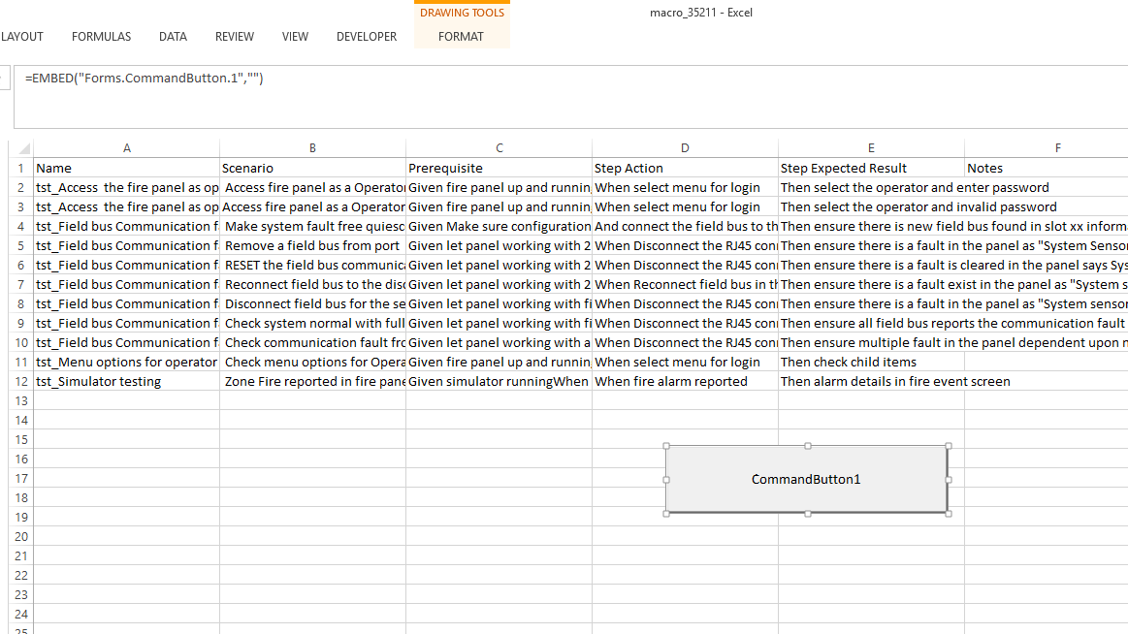

1. **The following code will copy the data from worksheet 1 to worksheet 2.**

Private Sub CommandButton1_Click()

Call sample

Call Workbook_Open

End Sub

……………………………………………………………………………………………………………………………………………………..

Sub sample()

Dim FilePath As String

Dim i As Integer

Dim Str() As String

FilePath = "C:\Users\H223487\Documents\task2.xltm"

Open FilePath For Input As #1

Numrows = Range("A1", Range("A1").End(xlDown)).Rows.Count

MsgBox (Numrows)

Range("A1").Select

For i = 1 To Numrows

If Len(ActiveCell.value) Then

Str = VBA.Split(ActiveCell.value, vbLf)

ActiveCell.Resize(1, UBound(Str) + 1).Offset(0, 1) = Str

End If

ActiveCell.Offset(1, 0).Select

Next

Close #1

End Sub

……………………………………………………………………………………………………………………………………………………..

Sub Workbook_Open()

Dim i As Long

Dim LastRow As Integer

Dim value As String

Dim Str As String

Sheets("Sheet2").Range("A2:I500").ClearContents

Sheets("Sheet1").Activate

With ThisWorkbook.Sheets("Sheet1")

LastRow = .Range("B1", .Range("B1:I500").End(xlDown)).Rows.Count

End With

With ThisWorkbook.Sheets("Sheet1")

.Range("B1:I500").Select

End With

With ThisWorkbook.Sheets("Sheet2")

.Cells(1, 1) = "Scenario"

.Cells(1, 2) = "Step Action"

.Cells(1, 3) = "Step Expected result"

End With

For i = 1 To LastRow

With ThisWorkbook.Sheets("Sheet1")

value = .Cells(i, "D").value

End With

If (value <> "") Then

Range("B1:I500").Rows(i).Copy Destination:=Sheets("Sheet2").Range("A" & Rows.Count).End(xlUp).Offset(1)

End If

Next i

End Sub

……………………………………………………………………………………………………………………………………………………..

**INPUT**

Input will be a worksheet

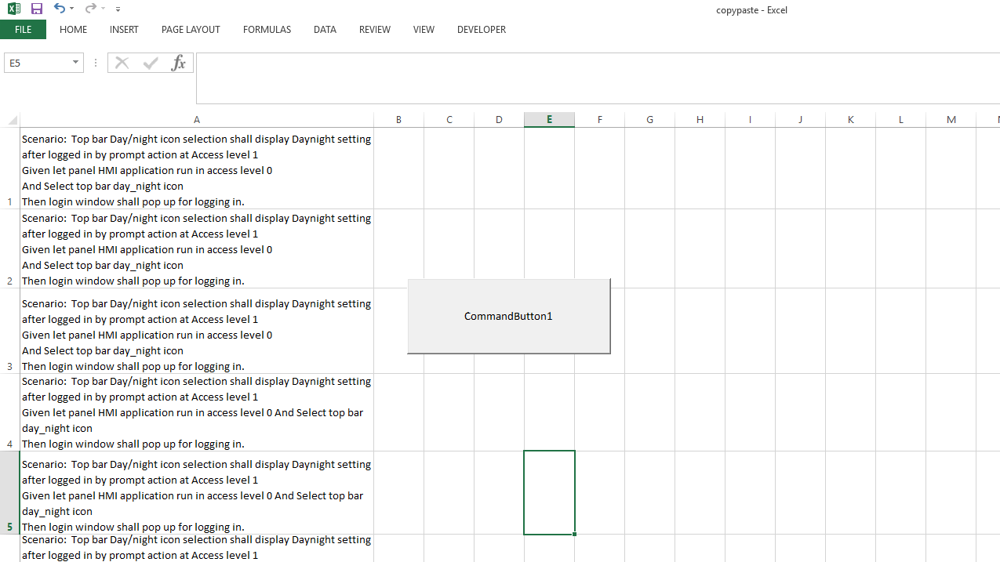

**OUTPUT**

Output will be as follows

Sheet1:

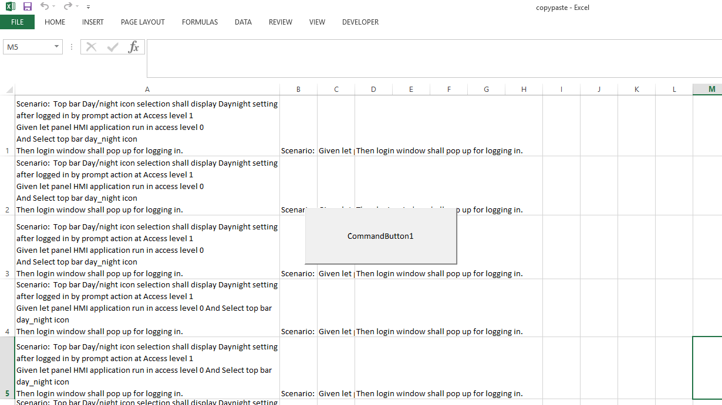

Sheet2: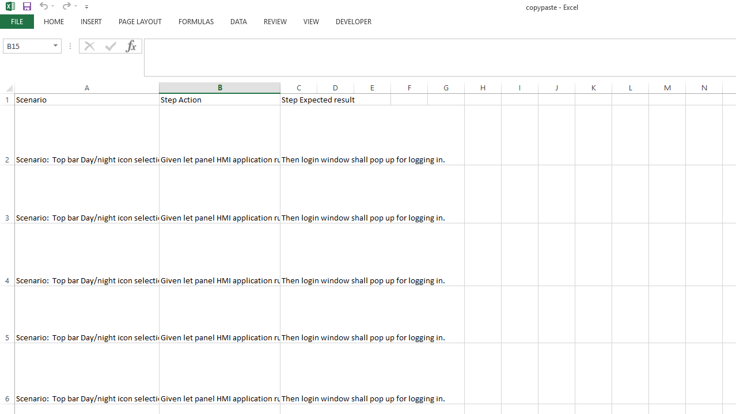

**3.The output of a following code will be a button, on clicking a button automatically a dialog box will prompt us to open a required feature file, after selecting a file, it will be automatically imported to worksheet**

Private Sub CommandButton1_Click()

Call Sample

End Sub

……………………………………………………………………………………………………………………………………………………..

Sub Sample()

Dim strStartPath As String

strStartPath = "C:\Users\H223487\Documents\System_Verification_Test_suit"

Dim FS As New FileSystemObject

Dim word As String, word1 As String, info As String

Dim FilePath As String

Dim FolderName As String

Dim row As Integer, cols As Integer, n As Integer

Dim Text As String, Text1 As String, TextLine As String

row = 1

n = 1

**Set MyFile = Application.FileDialog(msoFileDialogOpen)**

**With MyFile**

**.Title = "Choose File"**

**.AllowMultiSelect = False**

**If .Show <> -1 Then**

**Exit Sub**

**End If**

**FileSelected = .SelectedItems(1)**

**End With**

// Above set of code will open the dialog

Open FileSelected For Input As #1

Cells(1, 1) = "Scenario"

Cells(1, 2) = "Prerequisite"

Cells(1, 3) = "Step Action"

Cells(1, 4) = "Step Expected Result"

Cells(1, 5) = "Notes"

Do Until EOF(1)

row = row + 1

cols = 1

While word <> "Scenario:" 'Read File until it reaches Scenario

Line Input #1, TextLine

word = Left(TextLine, 9)

Wend

Text = TextLine

If word = "Scenario:" Then

While word <> "Given" And Not EOF(1)

Input #1, TextLine

word = Left(TextLine, 5)

If word <> "Given" Then

Text = Text & TextLine

End If

Wend

Text1 = TextLine

Cells(row, cols) = Right(Text, Len(Text) - 9)

Text = ""

End If

If word = "Given" Then

While word <> "When" And word1 <> "And" And Not EOF(1)

Input #1, TextLine

word = Left(TextLine, 4)

word1 = Left(TextLine, 3)

If word <> "When" Or word1 <> "And" Then

Text1 = Text1 & TextLine

End If

Wend

Text = TextLine

Cells(row, cols + 1) = Text1

Text1 = ""

End If

If word = "When" Or word1 = "And" Then

While word <> "Then" And Not EOF(1)

Input #1, TextLine

word = Left(TextLine, 4)

If word <> "Then" Then

Text = Text & TextLine

End If

Wend

Text1 = TextLine

Cells(row, cols + 2) = Text

Text = ""

End If

If word = "Then" Then

While word <> "Scenario:" And word <> "Feature:" And Not EOF(1)

Input #1, TextLine

word = Left(TextLine, 9)

word1 = Left(TextLine, 8)

If word <> "Scenario:" Then

Text1 = Text1 & TextLine

End If

Wend

Cells(row, cols + 3) = Text1

Text = ""

End If

Loop

Close #1

Set FSfolder = Nothing

End Sub

……………………………………………………………………………………………………………………………………………………..

**INPUT & OUTPUT:**

Input will be a selected feature file and output is the spreadsheet

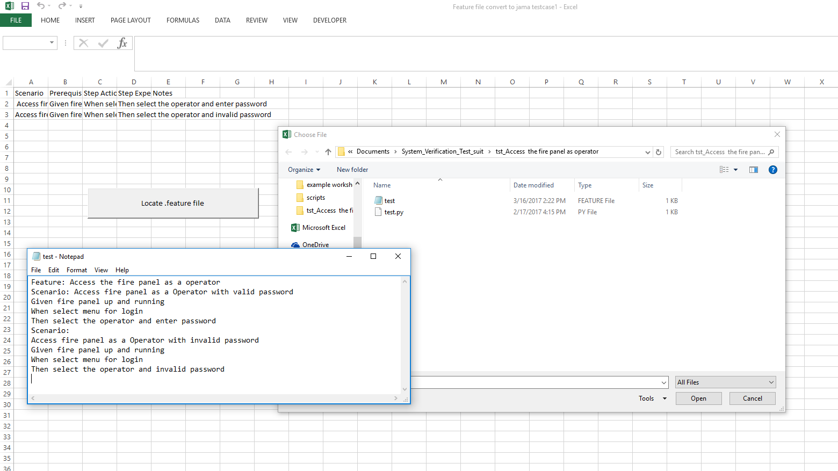

**4.The following code read row by row values from a worksheet and copy it to a text file as such**

Private Sub CommandButton1_Click()

Call VBA_write_to_a_text_file_New_Line

End Sub

……………………………………………………………………………………………………………………………………………………..

Sub VBA_write_to_a_text_file_New_Line()

Sheets("fruits").Select

MaxRange = Range("A1").Value

Dim count As Integer, lRow As Integer

count = 1

lRow = Cells(Rows.count, 1).End(xlUp).Row

MsgBox (lRow)

TextRange = 2

For count = 1 To lRow

TextWrite = Range("A" & TextRange).Value

Dim strFile_Path As String

strFile_Path = "C:\Users\H223487\Documents\fruit.txt"

Open strFile_Path For Append As #1

Range("A" & TextRange).Select

Write #1, TextWrite

Close #1

TextRange = TextRange + 1

Next count

End Sub

……………………………………………………………………………………………………………………………………………………..

**INPUT :**

Input is a worksheet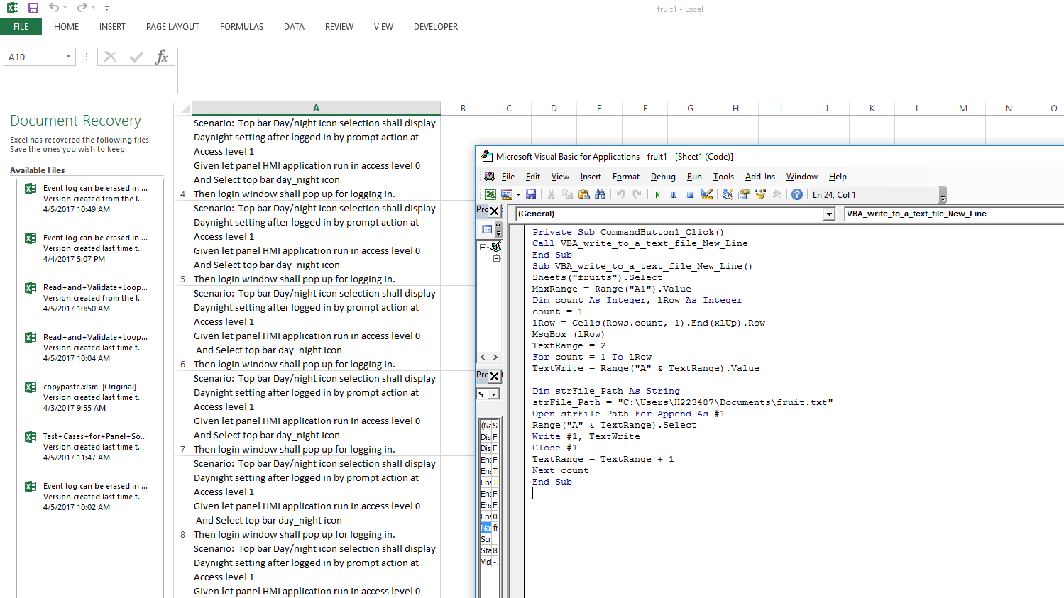

**OUTPUT:**

Output is a feature file.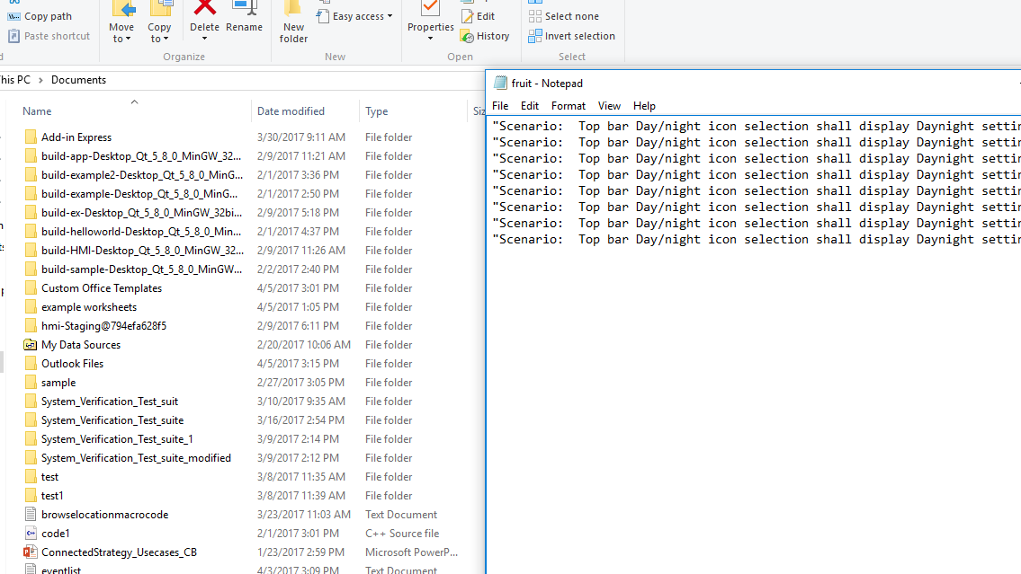

**5.The following code will code Worksheet to Feature file, highlight is on clicking a button the code will prompt us to select a required file and automatically convert it into a feature file**

Private Sub CommandButton1_Click()

Call openbook

End Sub

……………………………………………………………………………………………………………………………………………………..

Sub openbook()

Dim sTextPath As String

Dim sText As String

Dim Str As String

Dim sLine As String, sLine1 As String, sLine2 As String

Dim Temp As String, filename As String

Dim row As Long, col As Long

Dim wb As New Workbook

Dim wrkst As New Worksheet

Dim Numrows As Long

Set MyFile = Application.FileDialog(msoFileDialogOpen)

With MyFile

.Title = "Choose File"

.AllowMultiSelect = False

If .Show <> -1 Then

Exit Sub

End If

FileSelected = .SelectedItems(1)

End With

Set wb = Workbooks.Open(FileSelected)

sTextPath = Application.GetSaveAsFilename("featurefile.txt", "Text Files, *.txt")

If sTextPath = "False" Then Exit Sub

sText = ""

sLine1 = "Feature :"

sLine1 = sLine1 & wb.Sheets("Sheet1").Cells(3, 1).Text & vbNewLine

Numrows = wb.Sheets("Sheet1").UsedRange.Rows.Count

For row = 5 To Numrows

sLine = ""

For col = 1 To Columns("X").Column

'MsgBox ("hello")

Str = Sheets("Sheet1").Cells(4, col).Text

If Str = "Name" Then

sLine = sLine & "Scenario : "

sLine = sLine & Sheets("Sheet1").Cells(row, col).Text & vbNewLine

End If

If Str = "Pre-Conditions" Then

Temp = Sheets("Sheet1").Cells(row, col).Text

If Left(Temp, 5) <> "Given" Then

sLine2 = "Given "

sLine = sLine & sLine2 & Sheets("Sheet1").Cells(row, col).Text & vbNewLine

Else

sLine = sLine & Sheets("Sheet1").Cells(row, col).Text & vbNewLine

End If

End If

If Str = "Step Action" Then

Temp = Sheets("Sheet1").Cells(row, col).Text

If Left(Temp, 4) <> "When" Then

sLine = sLine & "When "

sLine = sLine & Sheets("Sheet1").Cells(row, col).Text & vbNewLine

Else

sLine = sLine & Sheets("Sheet1").Cells(row, col).Text & vbNewLine

End If

End If

If Str = "Step Expected Result" Then

Temp = Sheets("Sheet1").Cells(row, col).Text

If Left(Temp, 4) <> "Then" Then

sLine = sLine & "Then "

sLine = sLine & Sheets("Sheet1").Cells(row, col).Text & vbNewLine

Else

sLine = sLine & Sheets("Sheet1").Cells(row, col).Text & vbNewLine

End If

End If

Next col

If Not Len(Trim(Replace(sLine, vbTab, ""))) = 0 Then

If row > 1 Then

sText = sText & vbNewLine & sLine

End If

End If

Next row

'Close #1

Set oStream = CreateObject("ADODB.Stream")

With oStream

.Type = 2

.Charset = "UTF-8"

.Open

.WriteText sLine1

.WriteText sText

.SaveToFile sTextPath, 2

.Close

End With

Set oStream = Nothing

End Sub

……………………………………………………………………………………………………………………………………………………..

**INPUTS:**

Button that opens a OPEN dialog box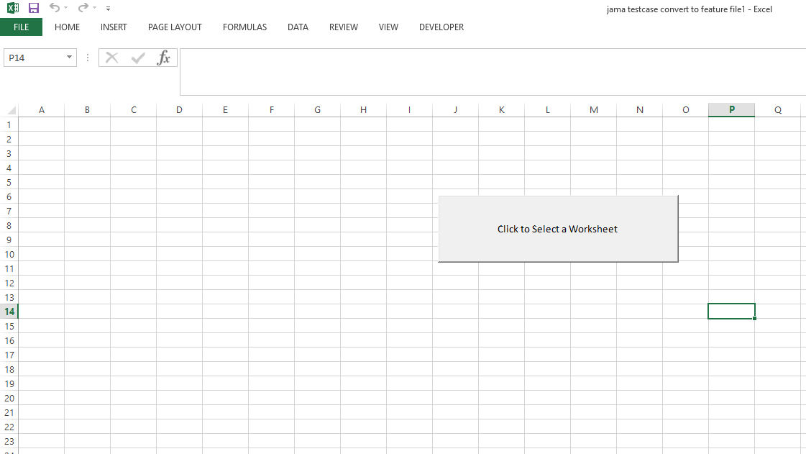

On clicking a button dialog box opens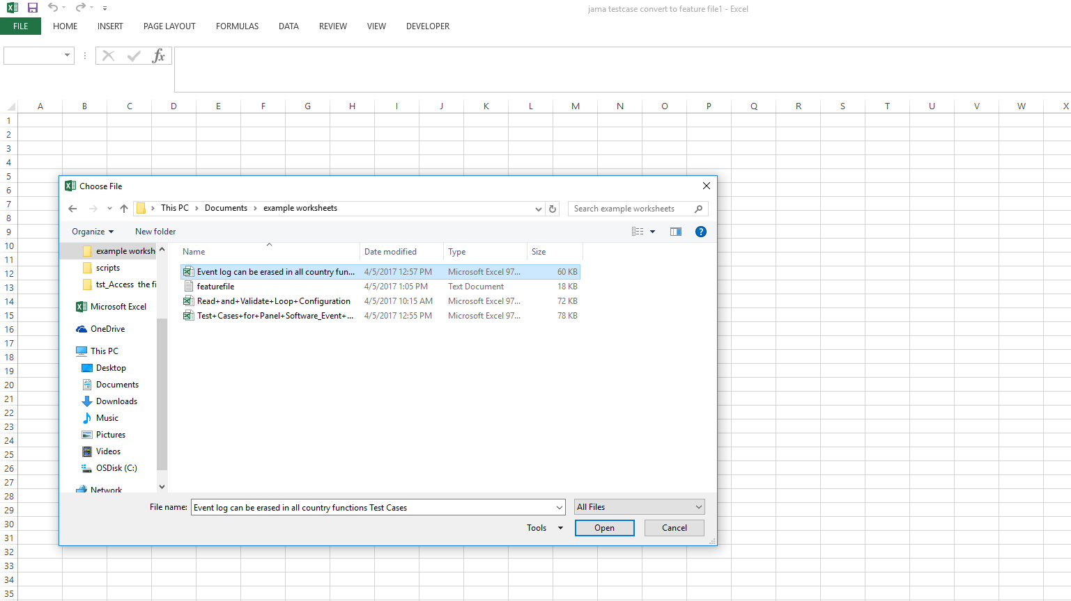

Selected Worksheet would be opened and asks for the filename in which the feature file to be saved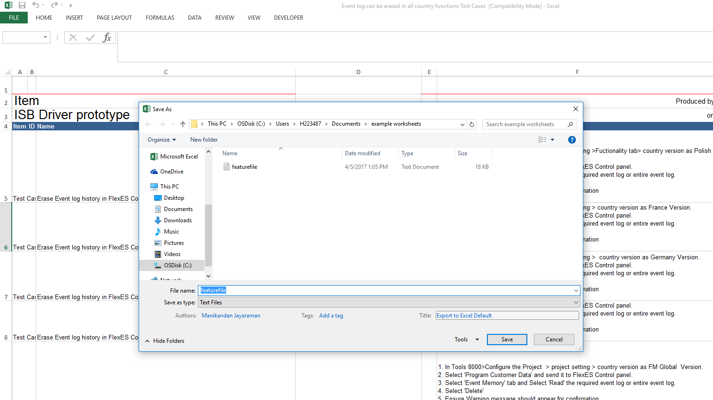

**OUTPUT:**

After giving all the inputs, datas will be successfully stored in feature file

