**Cover Sheet**

**Faculty name :** Faculty of Computers and Artificial Intelligence

**Course name :** Selected Topics CS-2

**Team number :** 23

|  |  |
| --- | --- |
| **Team members’ IDs** | **Names** |
| 201900624 | محمد احمد عبدالعظیم شاكر |
| 201900440 | عبدالرحمن مصطفى صبحي |
| 201900760 | محمود اشرف شوقي |
| 201900610 | مایكل ممدوح عاطف صبحي |
| 201900645 | محمد جاسر محمد عبدالله |
| 201900831 | مصطفي محمد قطب صلاح |

**Paper details**

**Authors name :** 1- HONGGUANG PAN

2- XINYU LEI

3- XIANGDONG HUANG

**Paper name :** A Dilated CNN Model for Image Classification

**Publisher name :** Corresponding author: Hongguang Pan (hongguangpan@163.com)

**Year of publication :**  July 8, 2019, date of current version September 13, 2019.

**The dataset used :** Mnist handwritten digital recognition data set

**The implemented algorithms :** convolution  
neural network (CNN) plays an important role. However, the classical CNN has the problem of consuming too much computing resources. To solve this problem, first, this paper proposed a dilated CNN model which is built through replacing the convolution kernels of traditional CNN by the dilated convolution kernels, and then, the dilated CNN model is tested on the Mnist handwritten digital recognition data set. Second, to solve  
the detail loss problem in the dilated CNN model, the hybrid dilated CNN (HDC) is built by stacking dilated convolution kernels with different dilation rates.

**Its results :**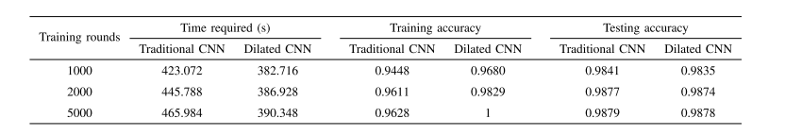

**Project Description Document**

**1- General Information on the selected dataset:**

# The name of the dataset used: Traffic Sign Classification and Recognition

**The link of dataset :** <https://www.kaggle.com/datasets/wjybuqi/traffic-sign-classification-and-recognition>

**The total number of samples in the dataset :** 6358

**The dimension of images :** (50,50,3)

**Number of classes :** 10

**Their labels :** 'GuideSign','M1','M4','M5','M6','M7','P1','P10_50','P12','W1'

**2- Implementation details:**

**Ratio used for training :** 4062

**Ratio used for Validation :** 1270

**Ratio used for testing :** 1016

**block diagram :**

CNN block diagram Dilated CNN block diagram HDC block diagram

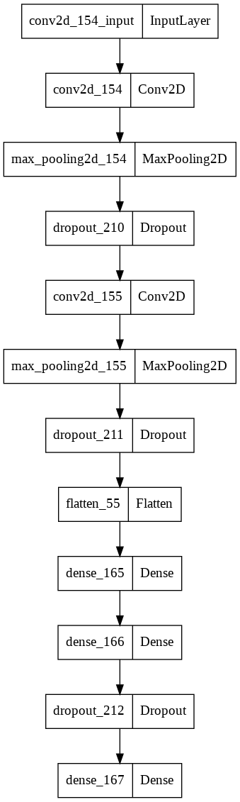 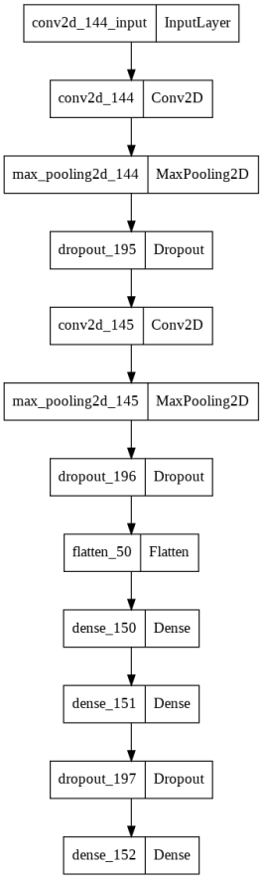 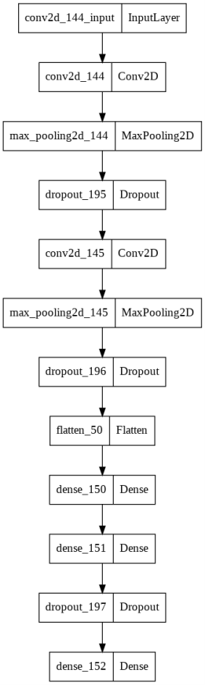

**hyperparameters used in your model :** 1- Adam (Learning rate =0.001)

2- Droupout (0.25)

3- epochs :35

4- batchSize=32

5- Adding additional hidden layer

6- activation =relu

7- use validation .20 of dataset

8- increasing # of units in hidden layer to 128

**3- Results details**

**Before optimization :** compare between CNN ,Dilated , HDC in epochs Respectively.

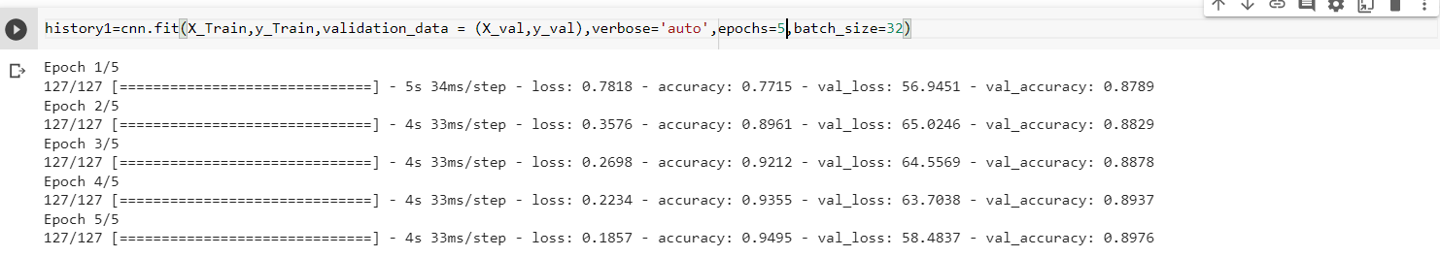

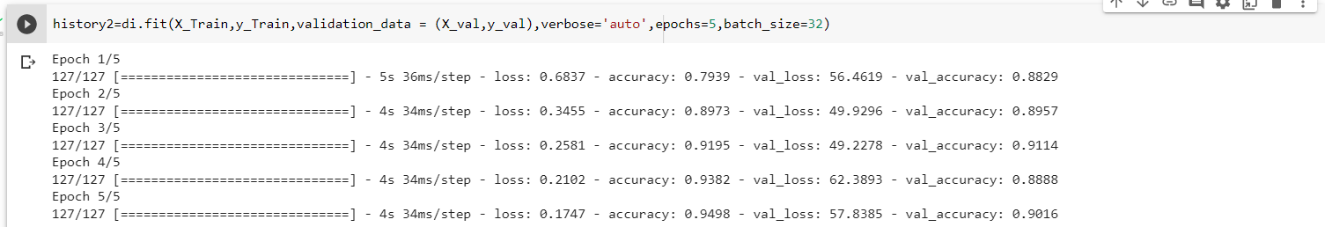

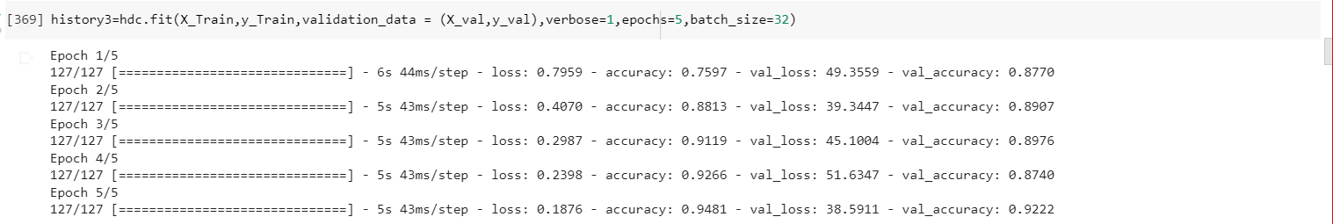

**Before optimization :** compare between CNN ,Dilated , HDC in confusion matrix Respectively.

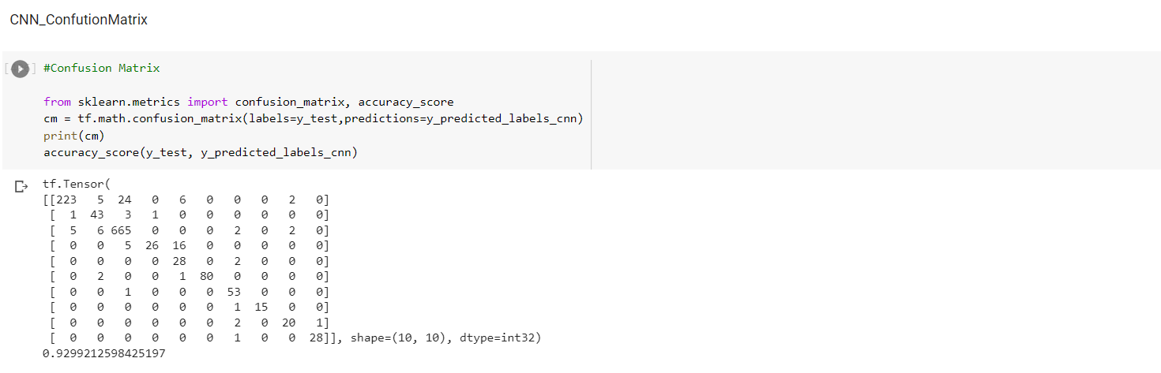

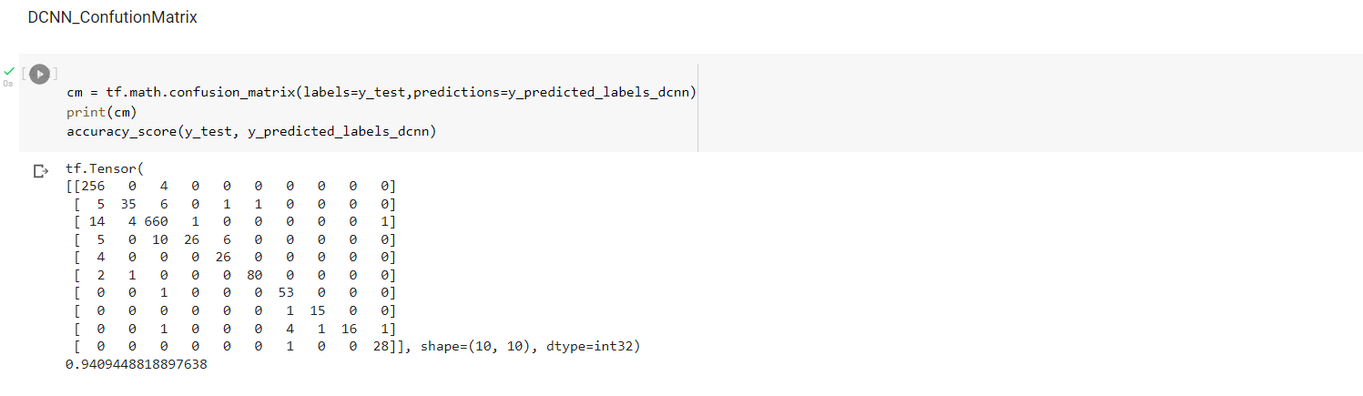

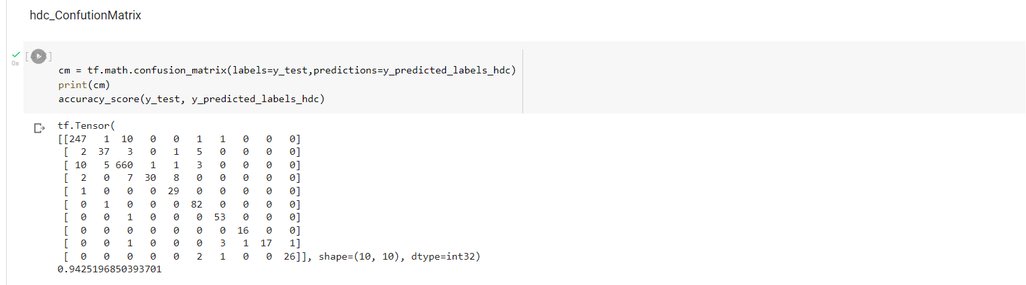

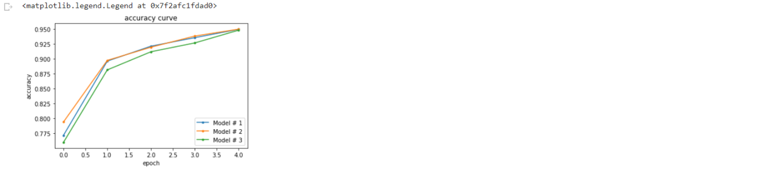

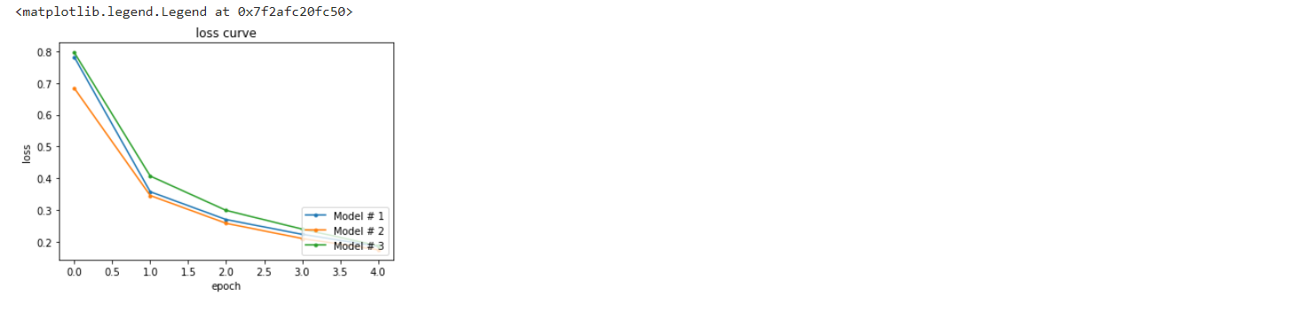

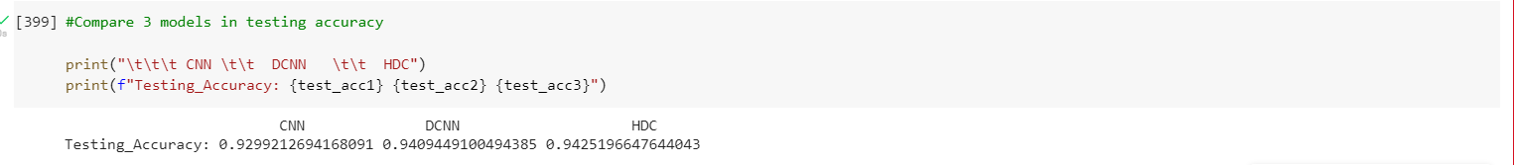

**After optimization :** compare between CNN ,Dilated , HDC in epochs Respectively.

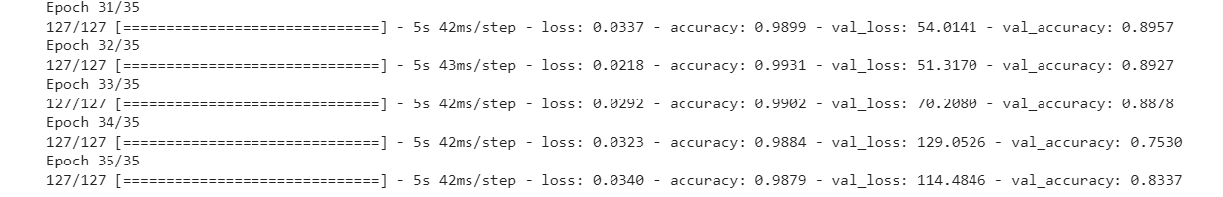

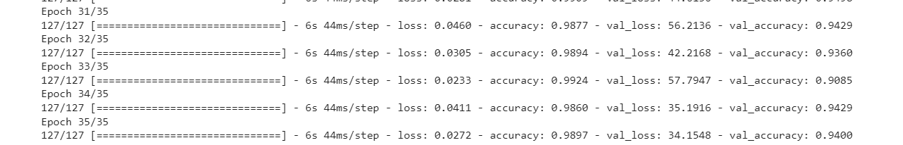

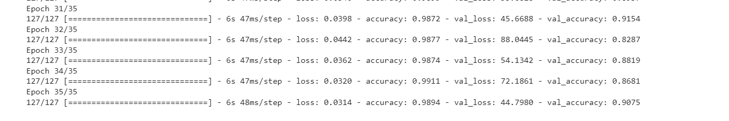

**After optimization :** compare between CNN ,Dilated , HDC in confusion matrix Respectively.

