**1- Architecture used in the Paper**

**Traditional CNN Model**

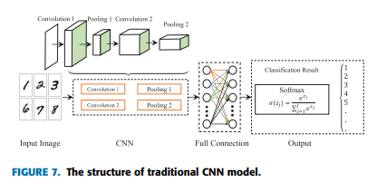

**Dilated CNN Model**

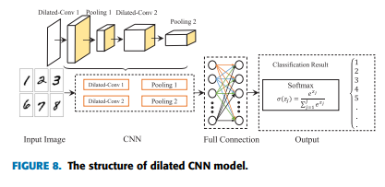

**HDC Model**

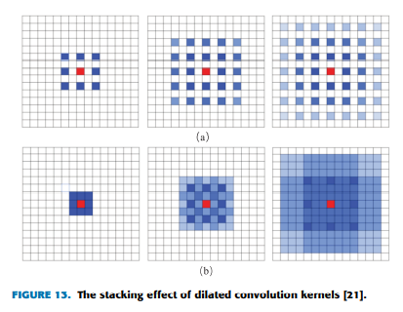

**2- Dataset details**

This data set contains 6358 manually labeled category labels. The labels include the following 10 categories: “GuideSign” , “M1”, “M4, “M5”, “M6”, “M7”, “P1”, “P10_50”, “P12”, “W1”, corresponding to ten Different traffic sign categories .The data set contains one folders include 6358 images, and in the model separate it into training, validation, and testing.

Traffic light classification is the process of automatically identifying traffic lights along a road, including speed limit signs (label in dataset P10_50), start signs (label in dataset m1), merging signs (label M4), and signs for people walking (label in dataset m7), no-parking signs(label in dataset p1),etc. The ability to Automatically recognize traffic lights .

# The name of the dataset used: Traffic Sign Classification and Recognition

**The link of dataset :** <https://www.kaggle.com/datasets/wjybuqi/traffic-sign-classification-and-recognition>

**The total number of samples in the dataset :** 6358

**The dimension of images :** (50,50,3)

**Number of classes :** 10

**Their labels :** 'GuideSign','M1','M4','M5','M6','M7','P1','P10_50','P12','W1'

**3- Implementation details**

**Ratio used for training :** 4062

**Ratio used for Validation :** 1270

**Ratio used for testing :** 1016

**hyperparameters used in your model :** 1- Adam (Learning rate =0.001)

2- Droupout (0.25)

3- epochs :35

4- batchSize=32

5- Adding additional hidden layer

6- activation =relu

7- use validation .20 of dataset

8- increasing # of units in hidden layer to 128

**4- Results and visualizations**

