***Documentation***

* **Project Name**: Courses Management System

**Project Details :**

This system helps to manage student, instructor and rooms in any educational place. It mainly contains important modules like

Controller (test):

**1. Admin Module**

a) Login and logout (when login student, instructor, and admin see view different for each other).

b) The Admin can (Add, Update, delete) student or instructor and users.

**2. Courses Module**

a) (Add, delete, update) parent courses.

b) Show all Instructor.

c) Show all students.

d) Create page to save courses with its details (instructor, room, branch, price, parent course, price, students, and grades of course, start date, days of course, end date).

e) Report to display courses that near to start.

f) Report to display courses that near to end.

**3. Student Module**

a) See his grades of specific course.

b) Make survey about specific course.

c) See all courses and update his information.

**4. Instructor Module**

a) Can add grades and publish.

Viewer (GUI):

It has all the Gui of the project

**First (adminGui):**

**include only Gui for the method that admin apply it like:** addStudent() , addInstructor() , deleteStudent(), deleteInstructort(), updateStudent() , updateInstructor() , shwoAllInstractor() , shwoAllStudent() .

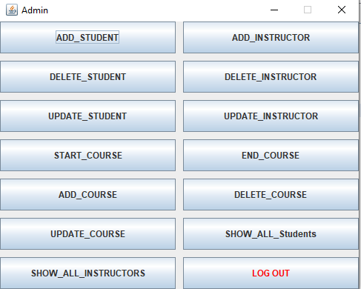

**Second (instructorGui):**

**include only Gui for the method that instructor apply it like :**

addGrade() , puplishGrades() .

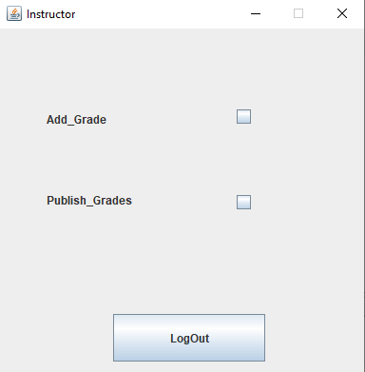

**Third (studentGui):**

**include only Gui for the method that student apply it like :**

showGrade() , makeSurvey() , showAllCourses() .

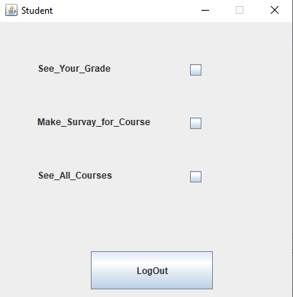

**Fourth (loginGui):**

**include only Gui for the username or password to connect with Database :**

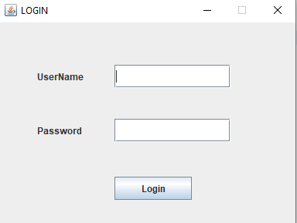

Modules (Database):

**include all Database classes for each modules like:**

1- class AdminSQl have all Query of the method that admin apply it .

2- class InstructorSQl have all Query of the method that Instructor apply it .

3- class StudentSQl have all Query of the method that Student apply it .

4- class DatabaseConnection have connection to Database .

5- class CourseSQl have all Query of the method about course .

**Database Schema :**

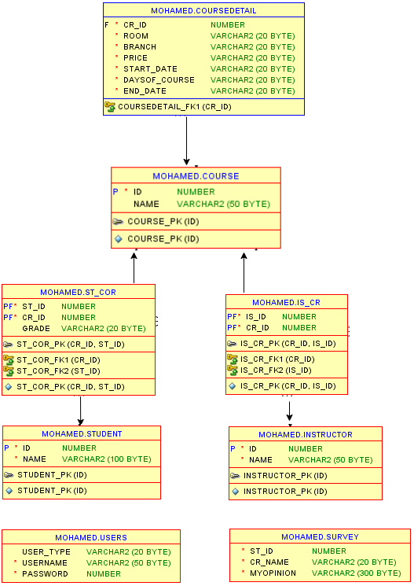

**Class Diagram :**

