Girl Geek Dinner Workshop

July 20, 2016

Prerequisites

Healthcare Bluebook is excited to welcome you to the Girl Geek Dinner workshop. To make the most of our time together at the event, please complete the following steps before arriving.

Please bring your own laptop. It can be a Macbook or a PC.

Minimum Hardware Requirements:

* 4 GB of Ram (8 Recommended)
* 6 GB of free hard disk space
* 1280x800 resolution

1. Install Java SE Development Kit 8 (<http://www.oracle.com/technetwork/java/javase/downloads/jdk8-downloads-2133151.html>). Get the latest version. At the time of this writing, the latest is 8u92.
2. Install Android Studio (<https://developer.android.com/studio/index.html>)

Be sure and install the Android Studio, Android SDK and Android Virtual Device.

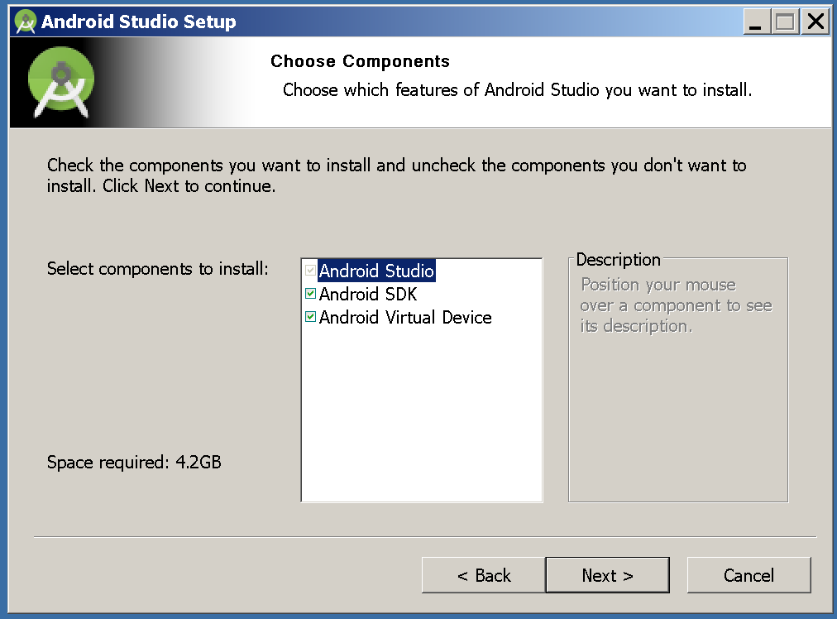

1. First Time Set Up. After the install is complete, launch Android Studio to run the first time setup. Choose the Standard setup and let the process run to completion.

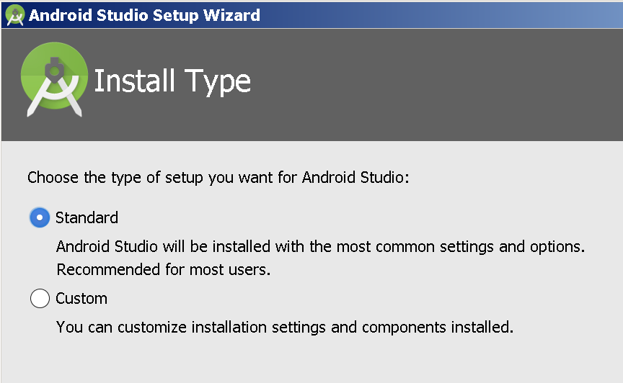

1. Install API and Emulator: From the Start screen, select Configure > SDK Manager.

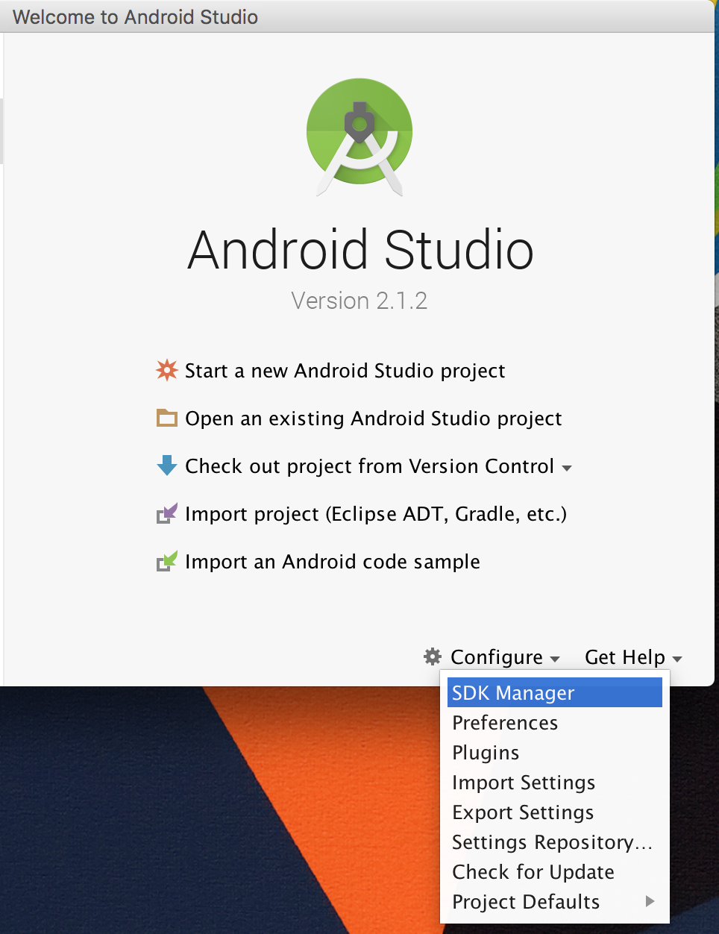

Check the “Show Package Details” box at the bottom of the screen. Then make sure the following items under “Android 6.0 (Marshmallow) are checked and installed.

Android SDK Platform 23

Intel x86 Atom_64 System Image

If they are not checked and installed, check them and click the OK button.

