Ran a query to get the total sales of each category:

Look for where it can branch off, where do different whiskes sell better? Add in a new wrinke

SELECT DISTINCT pr.category_name as category,

CAST(SUM(sa.total)as MONEY) as total_sales

FROM products as pr

INNER JOIN

sales as sa

USING(category_name)

GROUP BY pr.category_name

ORDER BY total_sales desc;

Grabbed the top 15 since they all seemed well above the median of total sales, and eliminated the decanter packages, which left me with the following 14 categories and their sales:

|  |  |
| --- | --- |
| **Category** | **Total Sales** |
| CANADIAN WHISKIES | $12,541,849,158.51 |
| TEQUILA | $12,075,952,692.96 |
| 80 PROOF VODKA | $12,011,383,127.50 |
| IMPORTED VODKA | $11,080,099,428.32 |
| STRAIGHT BOURBON WHISKIES | $8,327,943,115.62 |
| FLAVORED VODKA | $7,119,722,907.89 |
| MISC. IMPORTED CORDIALS & LIQUEURS | $6,804,555,679.08 |
| SCOTCH WHISKIES | $3,289,091,359.50 |
| PUERTO RICO & VIRGIN ISLANDS RUM | $3,118,622,826.20 |
| FLAVORED RUM | $2,834,425,149.00 |
| AMERICAN COCKTAILS | $2,702,396,652.36 |
| IMPORTED VODKA - MISC | $2,695,947,093.18 |
| SPICED RUM | $2,654,451,954.00 |

From there I took a look a look at how those top 14 compared to the rest of the sales, and they make up a whopping 82% of all sales

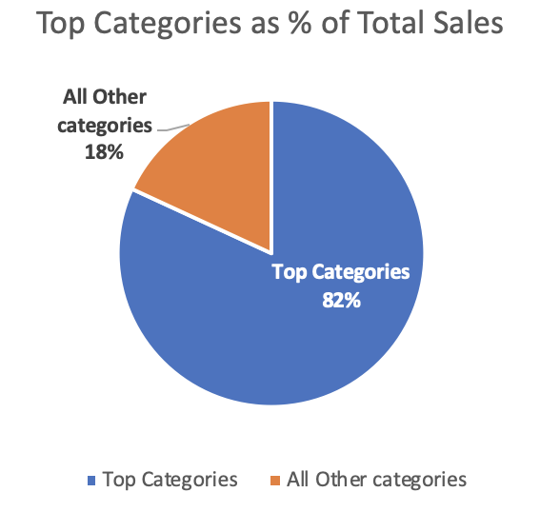

After a second look, it appears that four categories stand out and they’re not very surprising: Whiskey, Tequila, Vodka, and Rum, and here’s what percentage they make up of the top categories:

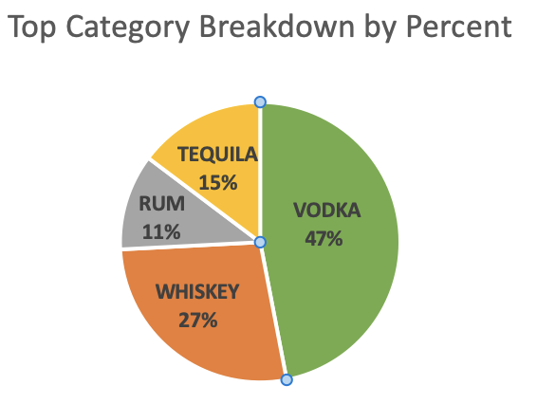

I wanted to get a feel for how these stand up on their own with all of the other categories

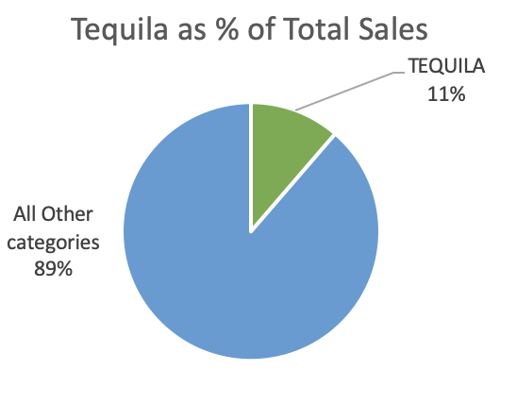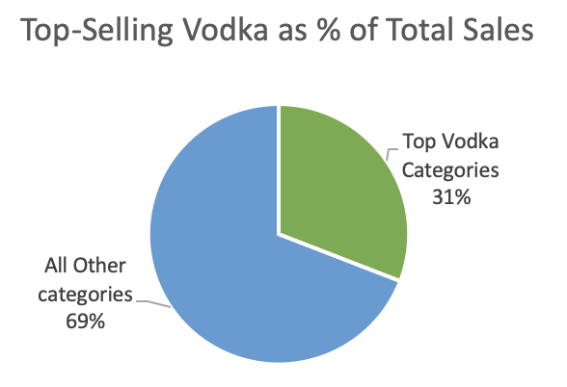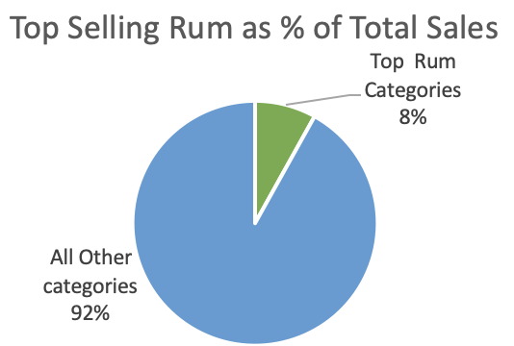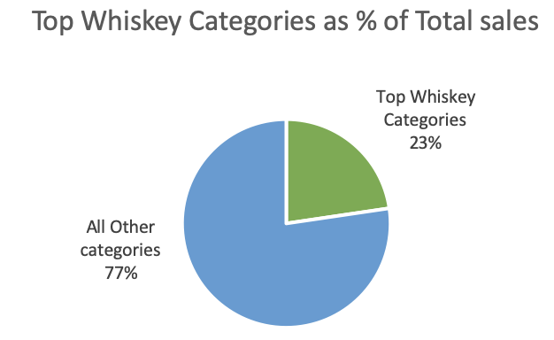

So what we know is that Iowans like whiskey, but not as much as vodka. But that’s probably because they’re driving Canadian whiskey. Canada is really only known for maple syrup and unintelligible French, whereas people will travel to Scotland and Ireland just for the Whiskey. So how is it that Scotch is not at the top and Irish whiskey didn’t even make it in the top 15? (It didn’t even hit 1 Billion!)

A closer look at whiskey:

SELECT DISTINCT pr.category_name as whiskey_category,

CAST(SUM(sa.total)as MONEY) as total_sales

FROM products as pr

INNER JOIN

sales as sa

USING(category_name)

WHERE pr.category_name LIKE '%WHISK%'

OR pr.category_name LIKE '%SCOTCH%'

OR pr.category_name LIKE 'BOURBON'

GROUP BY pr.category_name

ORDER BY total_sales desc;

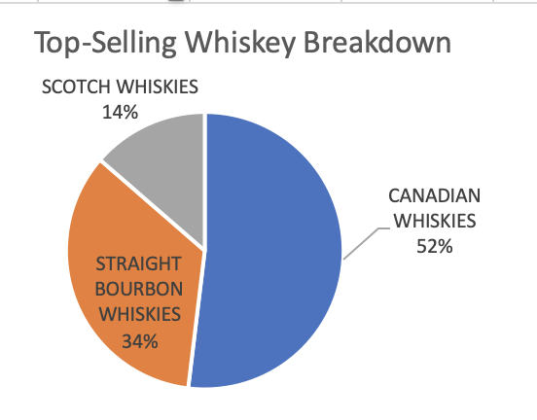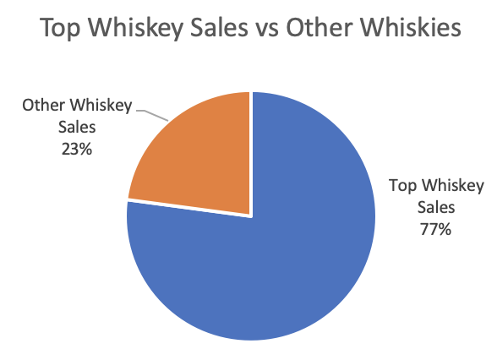

There’s a lot of room for growth in terms of Whiskey, I think that certain vendors can help bump the top whiskey sales above vodka sales

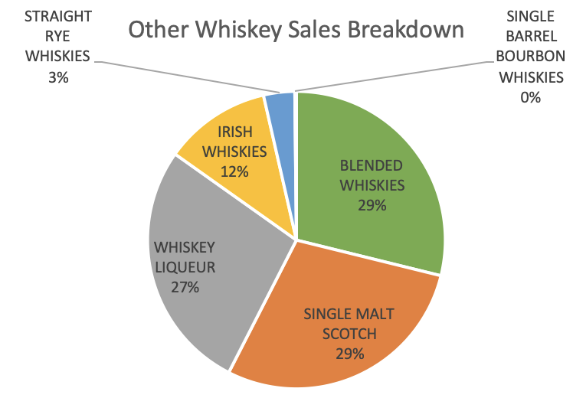

Things to look in to:

Vendors of different whiskey categories

What different counties are drinking whiskey-wise

Seeing if 23andMe has and open data, and see if there might be an opportunity to do a Tourism-23andMe-Whiskey ad campaign?