Assignment 6

Megan Marziali

Feb 17, 2021

## Assignment Set-Up

library(tidyverse)  
library(NHANES)  
library(Amelia)  
library(caret)  
library(rpart)  
library(rpart.plot)  
library(pROC)  
library(e1071)  
  
data(NHANES)  
  
set.seed(100)

## Problem 1: Import and Restrict Data

nhanes = NHANES %>%   
 janitor::clean_names() %>%   
 select(  
 age, race1, education, hh_income, weight, height,   
 pulse, bmi, phys_active, smoke100, diabetes  
 )

The NHANES data has 10,000 observations. To investigate missingness, I used the mapping function.

missmap(nhanes)

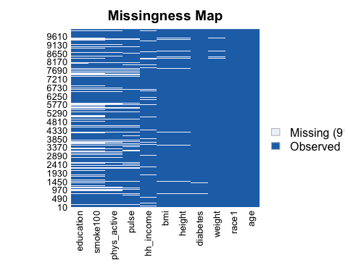

It seems that education, smoking and pulse have a large amount of missing observations. However, I opted to keep all variables and exclude missing observations.

nhanes_restr = nhanes %>% na.omit()

With missing observations remove, the total number of observations in this dataset is 6356. I next checked the balance of the outcome observations within the dataset:

summary(nhanes_restr$diabetes) %>%   
 knitr::kable()

|  |  |
| --- | --- |
|  | x |
| No | 5697 |
| Yes | 659 |

There are 5697 “no” responses, and 659 “yes” responses, for a prevalence of diabetes within this sample of 11.6%. This could be considered a rare outcome, and thus the analysis is conducted assuming rare outcome.

train.indices = createDataPartition(y = nhanes_restr$diabetes,p = 0.7,list = FALSE)  
  
training = nhanes_restr[train.indices,]  
testing = nhanes_restr[-train.indices,]

## Problem 2/3/4: Model Fit, Cross-Validation and Accuracy Testing

### Part 1: Classification Tree

The following code chunk runs through model fitting of a classification tree, and selecting appropriate hyperparameters using cross-validation. Final accuracy testing is also accomplished.

set.seed(100)  
  
# Creation of the train.control object to be carried through all modeling steps  
train.control = trainControl(method = "cv", number = 10, sampling = "down")   
# (Using sampling down method because rare outcome)  
  
# Exploring appropriate hyperparameters via cross-validation   
grid.2 = expand.grid(cp = seq(0.001, 0.3, by = 0.01))  
tree.diabetes = train(diabetes~., data = training, method = "rpart",trControl = train.control, tuneGrid = grid.2)  
tree.diabetes$bestTune

## cp  
## 1 0.001

tree.diabetes

## CART   
##   
## 4450 samples  
## 10 predictor  
## 2 classes: 'No', 'Yes'   
##   
## No pre-processing  
## Resampling: Cross-Validated (10 fold)   
## Summary of sample sizes: 4004, 4005, 4005, 4005, 4006, 4006, ...   
## Addtional sampling using down-sampling  
##   
## Resampling results across tuning parameters:  
##   
## cp Accuracy Kappa   
## 0.001 0.7195369 0.2380176  
## 0.011 0.7089821 0.2327628  
## 0.021 0.6660480 0.2057886  
## 0.031 0.6332637 0.1856743  
## 0.041 0.6002512 0.1666378  
## 0.051 0.5768515 0.1536312  
## 0.061 0.5768515 0.1536312  
## 0.071 0.5768515 0.1536312  
## 0.081 0.5768515 0.1536312  
## 0.091 0.5768515 0.1536312  
## 0.101 0.5768515 0.1536312  
## 0.111 0.5768515 0.1536312  
## 0.121 0.5768515 0.1536312  
## 0.131 0.5768515 0.1536312  
## 0.141 0.5768515 0.1536312  
## 0.151 0.5768515 0.1536312  
## 0.161 0.5768515 0.1536312  
## 0.171 0.5768515 0.1536312  
## 0.181 0.5768515 0.1536312  
## 0.191 0.5768515 0.1536312  
## 0.201 0.5768515 0.1536312  
## 0.211 0.5768515 0.1536312  
## 0.221 0.5768515 0.1536312  
## 0.231 0.5768515 0.1536312  
## 0.241 0.5768515 0.1536312  
## 0.251 0.5768515 0.1536312  
## 0.261 0.5768515 0.1536312  
## 0.271 0.5768515 0.1536312  
## 0.281 0.5768515 0.1536312  
## 0.291 0.5768515 0.1536312  
##   
## Accuracy was used to select the optimal model using the largest value.  
## The final value used for the model was cp = 0.001.

# Exploring hyperparameters with smaller steps  
grid.3 = expand.grid(cp = seq(0.0005, 0.02, by = 0.001))  
tree.diabetes.2 = train(diabetes~., data = training, method = "rpart",trControl = train.control, tuneGrid = grid.3)  
tree.diabetes.2$bestTune

## cp  
## 2 0.0015

tree.diabetes.2

## CART   
##   
## 4450 samples  
## 10 predictor  
## 2 classes: 'No', 'Yes'   
##   
## No pre-processing  
## Resampling: Cross-Validated (10 fold)   
## Summary of sample sizes: 4005, 4006, 4005, 4006, 4004, 4005, ...   
## Addtional sampling using down-sampling  
##   
## Resampling results across tuning parameters:  
##   
## cp Accuracy Kappa   
## 0.0005 0.7229455 0.2312364  
## 0.0015 0.7278863 0.2363016  
## 0.0025 0.7236070 0.2380192  
## 0.0035 0.7213599 0.2370257  
## 0.0045 0.7159727 0.2340518  
## 0.0055 0.7024839 0.2294559  
## 0.0065 0.7051725 0.2326477  
## 0.0075 0.7004473 0.2274627  
## 0.0085 0.7004423 0.2273646  
## 0.0095 0.7004423 0.2273646  
## 0.0105 0.7076359 0.2341902  
## 0.0115 0.6993212 0.2317778  
## 0.0125 0.7031374 0.2336077  
## 0.0135 0.7031374 0.2325521  
## 0.0145 0.6947996 0.2217910  
## 0.0155 0.6912030 0.2182481  
## 0.0165 0.6927761 0.2195420  
## 0.0175 0.6927761 0.2195420  
## 0.0185 0.6813154 0.2128686  
## 0.0195 0.6822143 0.2124048  
##   
## Accuracy was used to select the optimal model using the largest value.  
## The final value used for the model was cp = 0.0015.

varImp(tree.diabetes.2)

## rpart variable importance  
##   
## only 20 most important variables shown (out of 38)  
##   
## Overall  
## age 100.0000  
## bmi 72.8776  
## weight 66.5032  
## height 29.0924  
## phys_activeYes 23.4883  
## pulse 21.7577  
## race1White 14.7678  
## hh_incomemore 99999 12.0110  
## educationSome College 10.7135  
## educationCollege Grad 8.9685  
## hh_income55000-64999 2.8480  
## hh_income15000-19999 1.8785  
## smoke100Yes 1.8173  
## race1Other 1.8071  
## hh_income75000-99999 1.3721  
## education9 - 11th Grade 1.1087  
## hh_income25000-34999 0.9776  
## hh_income10000-14999 0.9392  
## hh_income45000-54999 0.7633  
## hh_income35000-44999 0.6446

rpart.plot(tree.diabetes.2$finalModel)

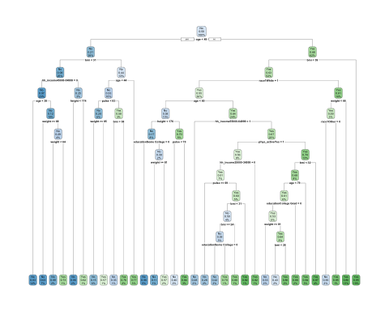

# Using best fit model from above with testing data  
pred.diabetes = predict(tree.diabetes.2, testing)  
pred.diabetes.prob = predict(tree.diabetes.2, testing, type = "prob")  
  
# Evaluating in testing data with confusion matrix  
eval.results = confusionMatrix(pred.diabetes, testing$diabetes, positive = "Yes")  
print(eval.results)

## Confusion Matrix and Statistics  
##   
## Reference  
## Prediction No Yes  
## No 1184 54  
## Yes 525 143  
##   
## Accuracy : 0.6962   
## 95% CI : (0.675, 0.7168)  
## No Information Rate : 0.8966   
## P-Value [Acc > NIR] : 1   
##   
## Kappa : 0.2035   
##   
## Mcnemar's Test P-Value : <2e-16   
##   
## Sensitivity : 0.72589   
## Specificity : 0.69280   
## Pos Pred Value : 0.21407   
## Neg Pred Value : 0.95638   
## Prevalence : 0.10336   
## Detection Rate : 0.07503   
## Detection Prevalence : 0.35047   
## Balanced Accuracy : 0.70935   
##   
## 'Positive' Class : Yes   
##

# ROC curve  
analysis = roc(response = testing$diabetes, predictor = pred.diabetes.prob[,2])

## Setting levels: control = No, case = Yes

## Setting direction: controls < cases

plot(1 - analysis$specificities,  
 analysis$sensitivities,  
 type = "l",  
 ylab = "Sensitiviy",  
 xlab = "1-Specificity",  
 col = "black",  
 lwd = 2,  
 main = "Classification Tree ROC Curve for Diabetes") %>%   
 abline(a = 0,b = 1)

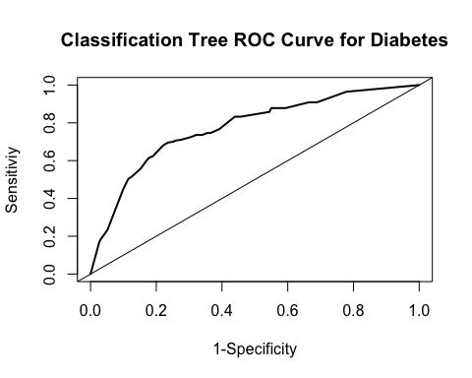

The calculated accuracy of this model is **0.70**.

### Part 2: Support Vector Classification

set.seed(100)  
  
# Exploring appropriate hyperparameters via cross-validation   
svm.diabetes =   
 train(diabetes ~ .,   
 data = training,   
 method = "svmLinear",   
 trControl = train.control,   
 preProcess = c("center", "scale"))  
svm.diabetes

## Support Vector Machines with Linear Kernel   
##   
## 4450 samples  
## 10 predictor  
## 2 classes: 'No', 'Yes'   
##   
## Pre-processing: centered (26), scaled (26)   
## Resampling: Cross-Validated (10 fold)   
## Summary of sample sizes: 4004, 4005, 4005, 4005, 4006, 4006, ...   
## Addtional sampling using down-sampling prior to pre-processing  
##   
## Resampling results:  
##   
## Accuracy Kappa   
## 0.7173003 0.2427984  
##   
## Tuning parameter 'C' was held constant at a value of 1

# Incorporate different values for cost  
svm.diabetes.2 =   
 train(diabetes ~ .,   
 data = training,   
 method = "svmLinear",   
 trControl = train.control,  
 preProcess = c("center", "scale"),   
 tuneGrid = expand.grid(C = seq(0.00001,2, length = 30)))  
svm.diabetes.2

## Support Vector Machines with Linear Kernel   
##   
## 4450 samples  
## 10 predictor  
## 2 classes: 'No', 'Yes'   
##   
## Pre-processing: centered (26), scaled (26)   
## Resampling: Cross-Validated (10 fold)   
## Summary of sample sizes: 4005, 4006, 4005, 4006, 4004, 4005, ...   
## Addtional sampling using down-sampling prior to pre-processing  
##   
## Resampling results across tuning parameters:  
##   
## C Accuracy Kappa   
## 0.00001000 0.8465211 0.2474822  
## 0.06897517 0.7116752 0.2437939  
## 0.13794034 0.7143850 0.2386892  
## 0.20690552 0.7161843 0.2480221  
## 0.27587069 0.7166231 0.2448385  
## 0.34483586 0.7195500 0.2486279  
## 0.41380103 0.7242797 0.2597925  
## 0.48276621 0.7161777 0.2548571  
## 0.55173138 0.7172952 0.2517097  
## 0.62069655 0.7141618 0.2546076  
## 0.68966172 0.7233627 0.2582612  
## 0.75862690 0.7137038 0.2460302  
## 0.82759207 0.7110056 0.2382769  
## 0.89655724 0.7163994 0.2483410  
## 0.96552241 0.7170710 0.2543951  
## 1.03448759 0.7137043 0.2460297  
## 1.10345276 0.7170715 0.2464798  
## 1.17241793 0.7121282 0.2497368  
## 1.24138310 0.7125781 0.2404351  
## 1.31034828 0.7186426 0.2505035  
## 1.37931345 0.7175275 0.2514435  
## 1.44827862 0.7179800 0.2473664  
## 1.51724379 0.7190970 0.2485434  
## 1.58620897 0.7163994 0.2450864  
## 1.65517414 0.7177371 0.2468851  
## 1.72413931 0.7127958 0.2462404  
## 1.79310448 0.7132574 0.2473582  
## 1.86206966 0.7186496 0.2541806  
## 1.93103483 0.7186421 0.2477779  
## 2.00000000 0.7202161 0.2521596  
##   
## Accuracy was used to select the optimal model using the largest value.  
## The final value used for the model was C = 1e-05.

svm.diabetes.2$finalModel

## Support Vector Machine object of class "ksvm"   
##   
## SV type: C-svc (classification)   
## parameter : cost C = 1e-05   
##   
## Linear (vanilla) kernel function.   
##   
## Number of Support Vectors : 924   
##   
## Objective Function Value : -0.0092   
## Training error : 0.351732

# Found accuracy to be better for the second model, using this going forward.  
  
# Testing the second SVM model in the testing dataest  
svm.pred = predict(svm.diabetes.2, newdata = testing[,1:10])  
  
svm.pred.prob = predict(svm.diabetes.2, testing, type = "raw")  
  
table(svm.pred, testing$diabetes)

##   
## svm.pred No Yes  
## No 1559 126  
## Yes 150 71

confusionMatrix(svm.pred, testing$diabetes, positive = "Yes")

## Confusion Matrix and Statistics  
##   
## Reference  
## Prediction No Yes  
## No 1559 126  
## Yes 150 71  
##   
## Accuracy : 0.8552   
## 95% CI : (0.8386, 0.8707)  
## No Information Rate : 0.8966   
## P-Value [Acc > NIR] : 1.0000   
##   
## Kappa : 0.2587   
##   
## Mcnemar's Test P-Value : 0.1662   
##   
## Sensitivity : 0.36041   
## Specificity : 0.91223   
## Pos Pred Value : 0.32127   
## Neg Pred Value : 0.92522   
## Prevalence : 0.10336   
## Detection Rate : 0.03725   
## Detection Prevalence : 0.11595   
## Balanced Accuracy : 0.63632   
##   
## 'Positive' Class : Yes   
##

The calculated accuracy of this model is **0.86**.

### Part 3: Logistic Regression

set.seed(100)  
  
# Building logistic regression model  
lr.diabetes =   
 train(diabetes ~ .,   
 data = training,   
 trControl = train.control,   
 method = "glm",   
 family = binomial())  
  
# Running with testing data  
lr.pred = predict(lr.diabetes, testing, type = "raw")  
confusionMatrix(lr.pred, testing$diabetes, positive = "Yes")

## Confusion Matrix and Statistics  
##   
## Reference  
## Prediction No Yes  
## No 1218 43  
## Yes 491 154  
##   
## Accuracy : 0.7198   
## 95% CI : (0.6991, 0.7399)  
## No Information Rate : 0.8966   
## P-Value [Acc > NIR] : 1   
##   
## Kappa : 0.2465   
##   
## Mcnemar's Test P-Value : <2e-16   
##   
## Sensitivity : 0.7817   
## Specificity : 0.7127   
## Pos Pred Value : 0.2388   
## Neg Pred Value : 0.9659   
## Prevalence : 0.1034   
## Detection Rate : 0.0808   
## Detection Prevalence : 0.3384   
## Balanced Accuracy : 0.7472   
##   
## 'Positive' Class : Yes   
##

The accuracy of this model is **0.72**.

## Problem 5

Given the output above, the best-fitting model is the **support vector classification model**. One limitation of using an SVC model involves limited interpretability. While this model can be used to understand the performance of a single variable, interpretability could be challenging for the reader of the analysis if they are not well-versed in machine learning techniques. An additional limitation of this technique is that SVMs are not suitable for large datasets. Applying this technique for an analysis within a large dataset may result in long computational times when training.